Procedure for Evaluation of Blocaïne
(The open source solution for automation)

Table of contents
1 General information 2
2 Prerequisites 2
2.1 Python3? 2
3 Installation of Blocaïne 3
3.1 Dwonloading Blocaïne 3
3.2 Installing Python librairies 4
4 Network Configuration 5
5 Launching the Blocaîne Interpreter 6
6 Launching the Block Editor 6
7 Uninstalling Blocaïne 6

General information
To evaluate Blocaïne, you only need a single PC running two Python interpreters, one for the Blocaïne Interpreter and one for the Block Editor.

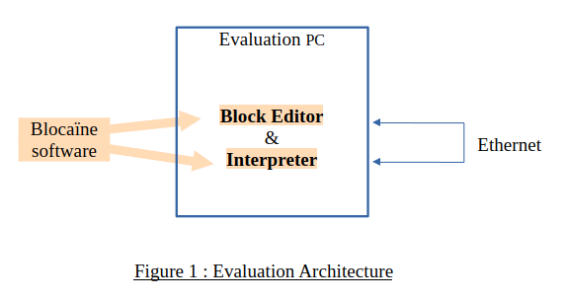

Prerequisites
You need a computer with at least 100 Mo of free disk and Python3 programming languange installed.

Python3?
Check that Python3 is properly installed on our computer.
- One windows, open a command prompt (cmd)
- One Linux, open a terminal
Then type in the console :
python3 --version
The response should be like :
Python 3.xx.xx

Installation of Blocaïne
Strictly speaking, there is no real installation process. You simply need to download a ZIP file from GitHub and unzip it. Follow the steps below :

Dwonloading Blocaïne
Using your browser, go to:
https://github.com/jbar78/blocaine.git
You will arrive on the following page :
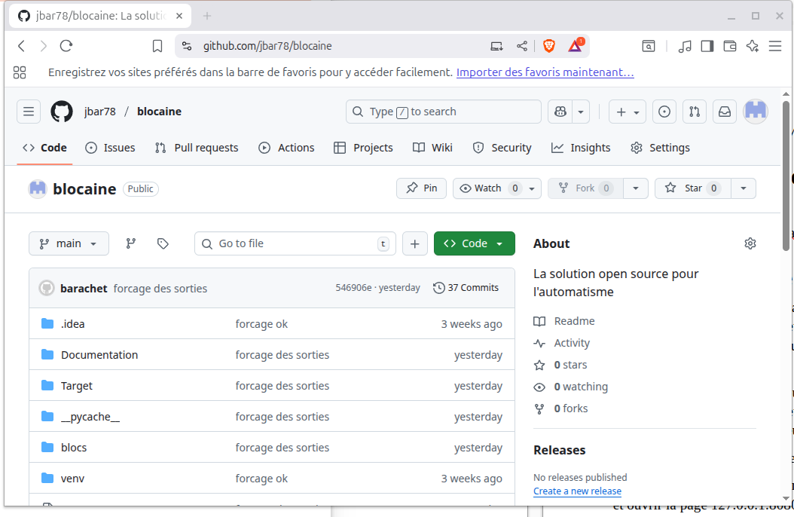
Click the green « code » button.


A popup window will appear. :
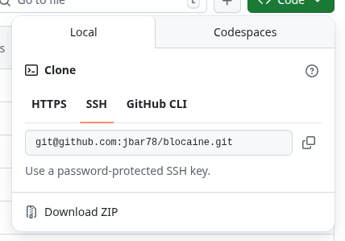

Click « Download ZIP », select here you want to save ZIP file and once downloaded, unzip it. you should then have a new directory named «blocaine-main ».

Installing Python librairies
You must install all Python3 librairies/module used by Blocaïne, such as :
- pymodbus.client
One windows type in the console:
pip install pymodbus

One Ubuntu type:
sudo apt install python3-pymodbus
One other Linux type :
Python3 -m pip install pymodbus

Congratulation, Blocaïne installation is finished !

Network Configuration
The HTTP and TCP/IP servers within the Blocaïne interpreter must use the following IP address: 127.0.0.1
The file « PARAM_NETWORK.py » located in both the « projet » directory and the « Target » sub-directory must be identical and contain this line :
PARAM_TCP_HOST_IP = "127.0.0.1"

Launching the Blocaîne Interpreter
- On Linux: Open the folder “blocaine-main/Target” in the file explorer, right-click on “launcher.sh”, then select “Run as a program.”
The Python3 interpreter will start, and a terminal window will appear.
- On Windows: Open the folder “blocaine-main/Target”, double-click “main.py.” If the firewall detects new connections, click Allow.
- On Mac: Run “main.py” inside the “blocaine-main/Target” directory using the Python3 interpreter.
Once launched, the Interpreter is operational. You can now open your web browser and go to http://127.0.0.1:8080 (port 8080) to navigate through the Interpreter’s menu

Launching the Block Editor

- On Linux: Open the “blocaine-main” directory in your file explorer, right-click on “launcher.sh," then select “Run as a program.”
- On Windows: Open “blocaine-main”, then double-click “main.py.”
- On Mac: Run “main.py” in the “blocaine-main” project directory using Python3
The Python interpreter will start, and both a terminal and the Block Editor’s graphical interface will appear. The Block Editor automatically connects to the Blocaïne interpreter.
You can now create your first user blocks, upload them, and execute them in the interpreter.

Uninstalling Blocaïne
Since installation only involves downloading and unzipping a ZIP file to obtain the “blocaine-main” directory, uninstalling Blocaine simply consists of deleting the ZIP file and the “blocaine-main” folder.

