Data Portal Version 5 Design Plan for Core and Web Interface modules

Aims & Objectives
Data Portal Version5 (DP5) aims to take off where DP4 left. To be the Grid aware software infrastructure that serves the Data Search and Retrieve (DSR) requirements of the CCLRC facilities with wider possible applicability to other research groups institutions.
In the primary instance this will be exposed to the user as a web portal where they can login using a certificate, search for data across facilities and retrieve the data.

Aims
These are some aims and objectives for data portal 5 (they maybe subject to change in further meetings)
- Developed for facilities and research groups
- Installable by System Admin and Power users (e.g. for internal use)
- Use proven Grid and Best Practise IT technologies (e.g. EJB, GT4, maven, subversion …)
- Architecture as simple as possible.
  - Also as complicated as necessary but not more complex
- To be robust and resilient

Design

Overall Design
The Data Portal will move from its current design to a more conventional Java Enterprise Edition architecture. The core modules will be housed on an application server with the data access layer and the Web Interface (View) on a servlet container. See Figure 1 (Need much better arch picture—better now but few mistakes).

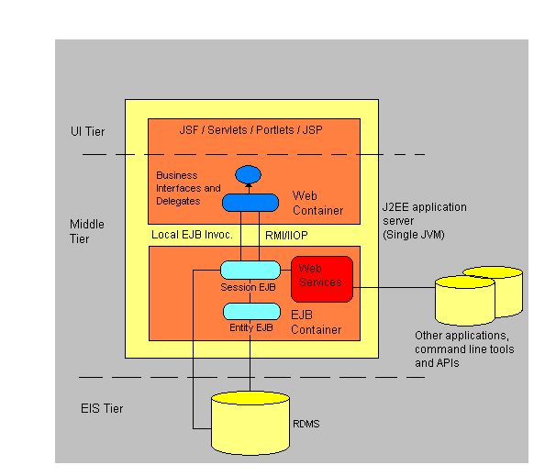
Figure 1: Data Portal 5 Architecture

The application will be a stateful, collocated architecture using stateless business objects. State will be held on the Web Tier, the same as DP 4, through the HttpSession Object. In this architecture all of the business logic and overhead will be removed from the WI (web server, tomcat) which will allow higher through put on the web container whilst the EJB core modules can be scaled if need with extra pooling or containers. The application (WI, core) will be housed on a single server to provide higher performance and scalability.

Architecture
The code modules will be written using EJB 3, and housed on a JBoss Application server, which is open source. The Web Interface (WI) will communicate through the EJBs local interface (I.e. inside the JVM). Under development the WI could communicate through EJBs transport language RMI (I.e. on another computer). This gives the WI the ability to communicate with the core modules via java classes and exceptions, something missing when using Web Services. This will also help speed up all of the development cycles.
Other applications wishing to use the Data Portal core modules can use normal Web Services, EJB 3 spec (JSR 181) allows EJBs to be presented by the application server as a web service. Using JAXB the java beans that the web interface will use would be turned into XML so that other Java applications or other programming applications can understand the data. Since the WI will be running on the same machine as the core EJB modules it is not recommended that we use the web services interface. This would be similar to using the remote interface of the EJB instead of the local.
Since the core modules and WI would communicate via java classes (with exception of the query which is XML (Could be a java string or speed ? Marshalling and unmarshalling of XML doc could be cpu and memory intensive if invocation is over RMI)) the web services would need to represent a sight change in its approach. It is not desirable to send objects over web services that are not java beans. The Web Service Interface would basically map the EJB Session Bean methods but change slightly any objects that do not adhere to this.
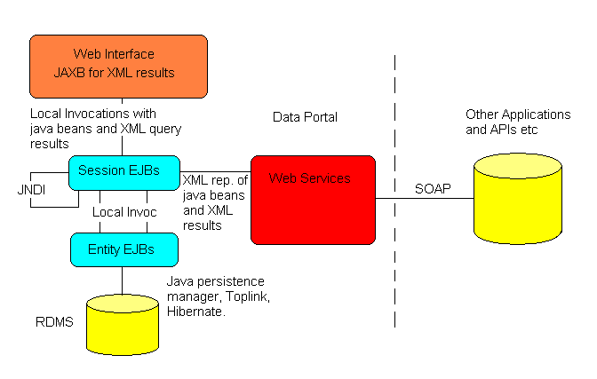
Figure 2: Data Portal 5 communication

The web interface communicates with the Session and Message Driven Beans via JNDI through their local interface (i.e inside a single JVM). The information that’s passed are Java simple types, Strings and integers as well as java beans for more complex information. XML elements will be passed back for query results. These will be turned into java objects using JAXB (see section 2.6.8) and then displayed to the user using standard java iterations for tables.
Session beans will communicate to other Session beans via JNDI again and with Entity Beans through normal java beans calls. The Entity beans will be stored in a database by the EJB container which will use a persistence framework like hibernate or Toplink (depending on the EJB container).
The Session Beans will be exposed to other applications and APIs etc via web services using JSR 181. The java beans that are used with the Web Interface will be transformed to XML using a standard convention to represent beans so that other applications can understand the information other than java.

Re-engineering DP4
The DP4 core modules are consisted of a list of web services:
- SM - session manager
- AA - authentication & authorisation
- QR – Query & Reply
- SC – Shopping Cart
- DT- Data Transfer
- LU – Look up.
- Core API
These need re-engineering to internally not use web-services but maintain an external web-services interface that allows different interfaces to be created for the dataportal (e.g. a command line dp client so complement the web interface e.g. for programmatic interaction).
Some discussed steps to achieve this goal are:
- Internal calls should not be web services
- Get rid of UDDI
- Session manager incorporates AA
- Devise a core schema for dataportal covering the needs of the internal modules including but not limited to:
  - Users (e.g. DN’s)
  - Data references (e.g. URL’s)
  - Book marks (e.g. for studies)
  - User preferences (e.g. results per page / timeout values / default facility)
  - Session History ( allowing for auditing and tracking)
  - Session information (i.e. session id)
  - Module lookup for external facilities (ACM & Wrappers)
    - In place of UDDI

Core Modules (Session Beans)
The core modules are going to Stateless Session Beans (EJB version 3). This means that after each invocation of a method, no state is kept by the bean, similar to web services. The advantage is gained by better performance and much simpler design and implementation of the core modules. The WI can communicate as if the classes were local, catch exceptions if thrown and therefore make the application seem a normal java app than a bespoke, haphazard distributed app that we have in DP 4. This also creates a clean separation of client UI and business logic.
Type of EJB Beans
- Name of beans
  - Methods
    - Method name
      - In out parameters

List of EJB Session Beans:
- Session
  - This beans will provide access to the session information
  - Functions:
    - StartSession
      - In parameters
        - Username
        - Password
      - Out parameters
        - Sessionid
    - EndSession
      - In parameters
        - Sessionid
    - GetSession
      - In parameters
        - Sessionid
      - Out parameters
        - ObjectBean sessionBean – sessionid, credential etc
    - GetUserPrefs
      - In parameters
        - Sessionid
      - Out parameters
        - ObjectBean userPrefBean – User pref info
    - SetUserPrefs
      - In parameters
      - Out parameters

- Query
  - This will query wrapper for results, if two, use two separate beans
    - Search
      - In parameters
        - List facilities
        - Query
        - Sessionid
      - Out parameters
        - XML resultsOfSearch
    - Advanced??
      - In parameters
      - Out parameters
- Data Centre
  - This will be able to add and get stuff from previous searches
    - AddDataUrl
      - In parameters
        - Sessionid
        - DataBean databean
      - Out parameters
    - AddBookmark
      - In parameters
        - Sessionid
        - BookmarkBean
      - Out parameters
    - GetBookmarks
      - In parameters
        - Sessionid
      - Out parameter
        - List BookmarkBeans
    - GetDataUrls
      - In parameters
        - Sessionid
      - Out parameters
        - List DataBeans
    - GetNote
      - In parameters
        - Sessionid
        - Dataid
      - Out parameters
        - Note
    - AddNote
      - In parameter
        - Sessionid
        - Dataid

- Transfer
  - Transfers data from SRB, GSIFTP (NOTE: should this be on web tier?)
    - Download
      - In parameters
        - Sessionid
        - Dataid
      - Out parameters
        - File / Zipped dataset
    - Transfer
      - In parameters
        - Sessionid
        - Dataid
      - Out parameters
- LookUp
  - Looks up wrapper wsdl and endpoint locations
    - getLocations
      - In parameters
        - Dataportalid
      - Out parameters
    - getFacilityLocation
      - In parameters
      - Out parameters
    - getACMLocations
      - In parameters
      - Out parameters
    - getFacilityACMLocation
      - In parameters
      - Out parameters

List of EJB Message Driven Beans:
- Query
  - This will query wrapper for results, if two, use two separate beans
    - Search
      - In parameters
        - List facilities
        - Query
        - Sessionid
      - Out parameters
        - XML resultsOfSearch
    - Advanced??
      - In parameters
      - Out parameters

This bean could take the query and then the WI could pole the bean for its results. This option means that the query results can be displayed to the user, but the bean is still trying to get the results from facilities that have not replied. Once all of the facilities have returned to data could be stored in a database and the user could have a look at the results later.

Entity Beans (Schema)
This is a preliminary schema design but will undergo major addition and refactoring prior to the next design meeting.
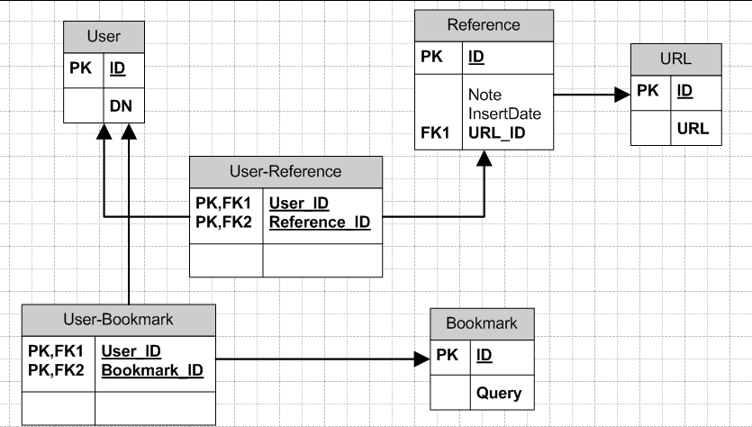
Figure 3: core schema artefact

There will be an Entity Bean for each table, hence a Bookmark Entity Bean would look like Figure 3 shown below. This is a simple POJO, which in EJB 3 is now turned into an Entity Bean by the container. Session Beans can use this bean to search for data using the NamedQuery tag in the code. This query is EJB QL, similar to SQL but with Classes. So this is a simple query that would return a List<Bookmarks> of all of the rows in this table.
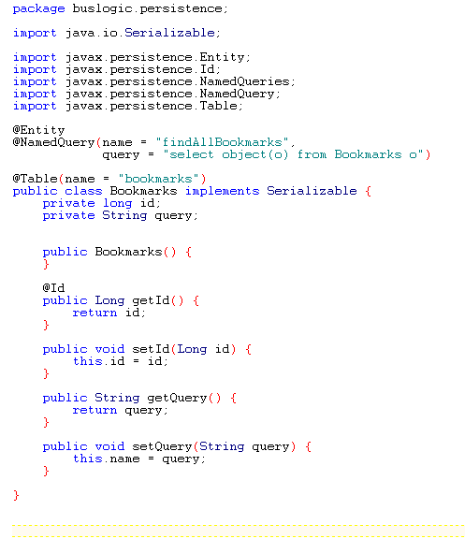

User Interface

Specification
The internal structure of DP4 used JSP technology in a very haphazard way leading to one of the main criticisms of JSP the problem with spaghetti page flow (as well as in the case of DP4 creating large JSP pages with repeated presentation logic in multiple pages).
To overcome this problem DP5 hopes to use the Apache templates /ADF Faces /MyFaces and Sun JSF standard to produce a more standardised and logically organised Web Interface.
DP 5 to use backing beans grouped by functionality and not page/form. Ie. Authentication, Session, Data Transfer beans which can be used by multiple pages and not grouped in form/page to allow one bean to each page. This creates a simpler application.

Mock up of DP5 WI
This is a mock up of the DP5 WI using oracles ADF Faces. ADF Faces has been donated to the Apache Software Foundation and is now open source. It provides over 100 UI components for trees, tables, buttons etc. This component is a page component. It provides menus, navigation bars, tab bars and help buttons etc. This page was created using JDeveloper with its RAD approach to JSF.
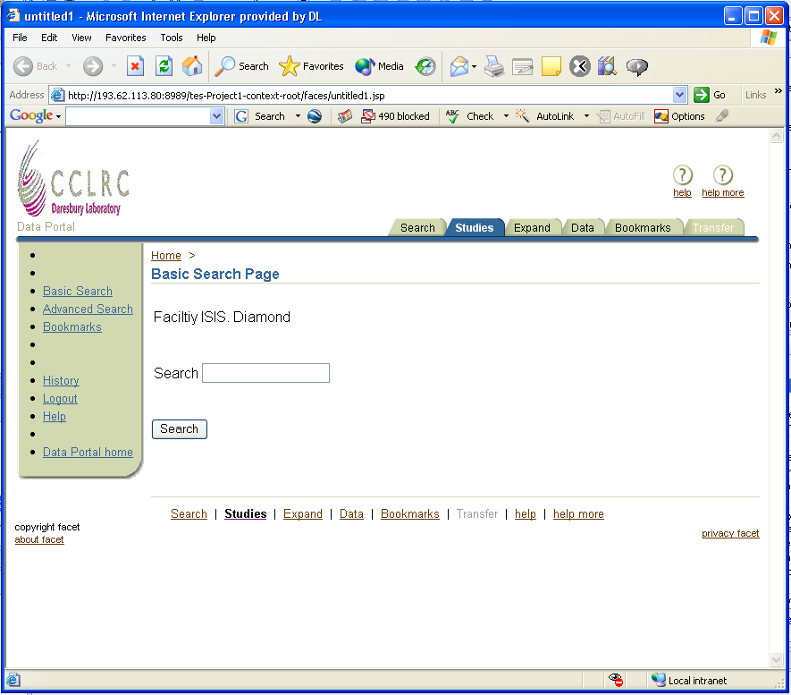

User Interface Pages
The WI should have the following views:
- Login
- Basic Search
- Advanced Search
- Results
  - Studies
  - Expanded
  - Data
- Bookmarks
- Data Urls
- Transfer
- History
- Preferences
- Help
When a user login in the user is taken to the Basic Search page. On every page but the Login we need to provide navigation to all other pages, either with the tabs, or side navigation. A list of all of the functions and corresponding resulting pages are show below.

Function | JSF function or link (F or L) | Display page | Comments
Login | F | Basic search | User logins in and goes to basic search page
Logout | F | Login | From all pages except login
View History | L | History
Add bookmark | F | Bookmarks
Add data url | F | Data Urls
Run Basic Search | F | Studies (Results)
Run Advanced Search | F | Studies (Results)
View Expand | L | Expand (Results)
View Data | L | Data (Results)
Transfer Data | F | Transfer
View Transfer Options | F | Transfer
View bookmark | L | Bookmarks
View data url | L | Data Urls
Change prefs | F | Preferences
View Prefs | L | Preferences
View Help | L | Help
Search Help | L | Help
Table 1: Data Portal 5 functions and what pages they result in

This table shows the flow control of the application. Most of these functions can be done using simple JSF links (L) and results and is achieved using JSF navigation and are accessible in the navigation bars.

Workflow
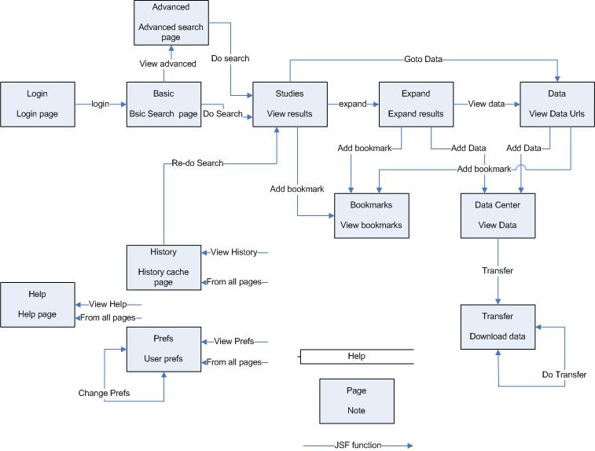
Figure 2: Basic Data Portal 5 UML work flow

Every page, except the Login page can be accessible from any other page using the navigation and tabs. These represent links and are not function calls. Even Login page should be accessible from the logout command??
A JSF link would be a static action link and a JSF function would be a dynamic action link. For example, link to view the Bookmarks Center would be
<h:commandButton value=”View Bookmarks” action=”viewBookmarks” />
But a dynamic action link to add bookmarks would be
<h:commandButton value=”View Bookmarks” action=”#{bookmarkBean.addBookmark}” />
where bookmarkBean would be the instance of a BackingBean and addBookmark would be a method call to dynamically call the Bookmark bean to add the data, and if the data was added with out an exception thrown then the JSF action result would be ‘viewBookmarks’, the same as the static link.

Error Handling
An error page with the basic mock up WI should be displayed with a message that an error has occurred and the try again (or something). At no point should the user see any Error 404, 500 pages. These should be added in the web.xml file for error pages. Invalid URLs also should be done in this way and the user offered to go to login page or go back.

Screens

Login
Screen name | Login
Purpose | Authenticates the user to the system,
URL | /index.jsp
Data Displayed | None
Session state | No
Effect on refresh | None
Effect on back | None

Basic Search
Screen name | Basic search
Purpose | Gives user input for search
URL | /protected/search.jsp
Data Displayed
Session state | Yes
Effect on refresh | None, screen showed again
Effect on back | None, back to last screen

Advanced Search
Screen name | Advanced Search
Purpose | Gives user input for search etc
URL | /protected/advancedSearch.jsp
Data Displayed | None
Session state | Yes
Effect on refresh | None, screen showed again
Effect on back | None, goes back to last screen

Studies
Screen name | Studies
Purpose | Shows study list of search
URL | /protected/studies.jsp
Data Displayed | List of study information. Study name, PI, Institute etc
Session state | Yes
Effect on refresh | None, screen showed again
Effect on back | None, goes back to last screen

Expand
Screen name | Expand
Purpose
URL
Data Displayed
Session state | Yes
Effect on refresh | None, screen showed again
Effect on back | None, goes back to last screen

History
Screen name | History
Purpose | Shows last X searches. Can access the cache of the search from EJBs and also resend query.
URL | /protected/history.jsp
Data Displayed | History of previous searches and times
Session state | Yes
Effect on refresh | None, screen showed again
Effect on back | None, goes back to last screen

Internationalization and Locale
Easy to implement this with JSF. Support only EN at the moment.

Bookmark and Data Access for other users
Additional ability for users to grant access to their Bookmarks and Data Centre to other data portal users. This would allow PIs to grant access to one of their students for a limited time to down load data etc. This needed to be added to the databases so that on viewing Bookmarks for Data Centre a list of granted access appears. Could generate tickets for user, then other user wanting to see the Cart has to type in this ticket when prompted.

Web Interface XML results parsing. - NOT NEEDED WITH NEW DATA ACCESS
Currently XML is returned to the Web Interface and is then shown to the users via an XSLT transformation to HTML. This is difficult create good looking HTML with CSS and often the resulting pages are not too pretty.
A preferred way is to use JAXB (Java API for XML Binding). With any schema JAXB can generate classes that directly map to an instance of the schema. Because the java classes are only created for that schema, the parsing of the data can be as fast as SAX but with the ability to manipulate it as it was DOM without the memory over head.
JSF table component is a full comprehensive component that allows configurations with numbers show, sorting, etc. This can only be achieved with database result sets and java Lists etc and not with XML transformations with XSLT. Using JAXB the WI can now use the JSF table to show the data by just iterating over the java classes. I.e. a method getStudies() would return a java list of studies. Iterating over this and the extracting names and PI to insert into the JSF table. This would allow the JSF component to deal with the table creation and rendering.
JAXB could be used on the wrapper side to build up the initial XML.

Security
Application to use filters to check if use I logged in and if role is allowed to view pages and directories. JSF PhaseEvents could also check roles and logged in status.

Authorisation
The data portal will still use the Authorisation tokens but upgrade to the newest version- NOT NEEDED WITH NEW DATA ACCESS, DN sent with query to SP which check for access with schema

Authentication
Again the data portal will use GSI credentials taken from the MyProxy server.

Administration
Admin functionality in DP. Ability for admin to log on and have extra functionality to add or remove facilities. Database user table could have admin tag?
Roles assigned to each user. Admin, user etc. Should be in db

Data Access

Data Access
Access to Data will be via stored procedures (SPs) on each oracle database. The core dataportal will execute the SP and run through the resultset and generate a javabean array containing the results. Each facility is contacted in this way and the results collated into an array of javabean objects representing the results.
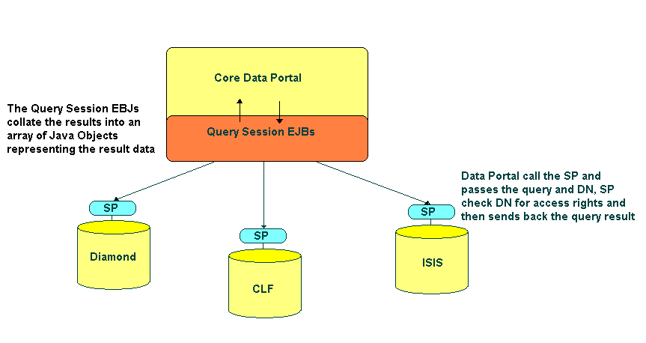

Stored Procedures
This is a list of the SP that the Data Portal will call. They will all first check the user’s DN has a role in the database and that role has access to view the data. Then the SP will run the query. The first SP ‘GetStudy’ is the only SP that searches data. Their might be many SPs, a basic key word search, PI search etc. Once the ‘GetStudies’ search is done, if a user wants to view in more detail the study the ‘GetInvestigation’ SP is called which returns in more detail the investigation, and so on with the data sets.

List of Stored Procedures
- GetStudy
  - Basic Search
    - key word
  - Advanced Search
    - PI
    - Dates
    - Etc.
- GetInvestigation
- GetDataSet

Data Information
This is the information that will be returned to the DP from the SP, JavaBean classes need to be developed to store this information.

Study
- Id
- Name
- PI
- Institute

- Facility name – for DP
- Query – for DP
- Id
- Name

DataSet/Atomic Object
- Id
- Name
- DataSets / Atomic Objects
- URLs
- Types

Future development
The access to the data in future can be done with Entity EJBs been called from the Data Portal or if needed remotely if the facility is remote and no direct access to the database is allowed. See figure x. The java code will look identical when searching the two different databases, the lookup to the EJBs will be slightly different as one is local and one remote, but this will be sorted in a database.
A query EJB section is needed to be developed to query the entire database schema that replaces the SP in the previous version. This allows the access to be independent of the database vendor and the SP will all of the data access and business logic within the application server(s). No SP would need to be compiled or developed for other databases other than oracle.
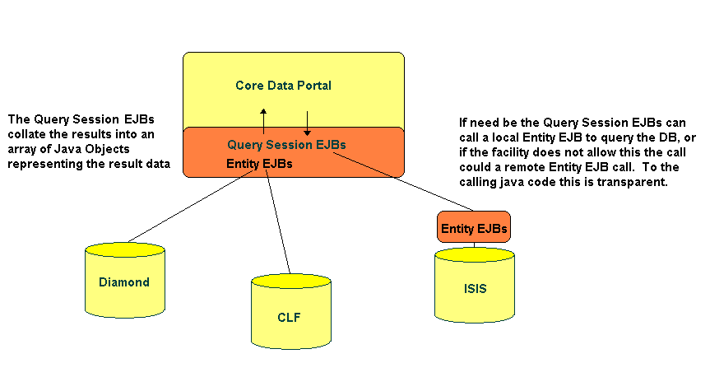

Hardware and Software
To be deployed on a JBoss 4.0x application server with postgreSQL 7 database as the persistence archive.
NB: Also investigate Oracle XE with Sun Application Server 9 (GlassFish)

IDEs
EJB section to be written using Netbeans 5.5. Web Interface with Netbeans/Sun Creator

Software Stack
- Java Enterprise Edition 5 – EJB 3, Hibernate, JSF, JSP etc
- Java Standard Edition 6
- JAX-WS – web services
- JAXB – Java to/from XML
- Java Cog Kit – interaction with Grid
- Jargon – interaction with SRB
- MyFaces / ADF – web front end JSF components
- Shale? – JSF compatible
- Maven – for web site creation and automated build and test

