DataPortal Version 5 Development Plan
Meeting1(HL), Meeting 2(HL), and update1(SAS)

Minutes: written by Li, H (Hongmei), updated by Sufi, SA(Shoaib)
Attendants: Drinkwater, GJ (Glen)
Li, H (Hongmei)
Sufi, SA (Shoaib) –Chairman
Time: 25th January 2006 10:00-12:00 & 1500-16:30
Place: Boardroom – DL & CR4 – DL, S Block
Meeting Date and Contents
Meeting 1 | 2005-10-25  @10:30-12:30  Place: CR5 - DL, E Block (8)  Drinkwater, GJ (Glen)  Sufi, SA (Shoaib)  Li, H (Hongmei) | Section 1 target  2: Manpower  3: Software  5. Development
Meeting 2.1 | 2006-01-25  @10:00-12:00  Place: Boardroom – DL  Attendees (same as 1) | Revised S1: target  Section 4 Design  6. Test and Documentation  7 Project Management  8 Action  9 Next Meeting
Meeting 2.2 | 2006-01-25  @15:00-16:30  Place: CR4 - DL, S Block (16)  Attendees (same as 1)

Aims & Objectives
DataPortal Version5 (DP5) aims to take off where DP4 left. To be the Grid aware software infrastructure that serves the Data Search and Retrieve (DSR) requirements of the CCLRC facilities with wider possible applicability to other research groups institutions.
In the primary instance this will be exposed to the user as a web portal where they can login using a certificate, search for data across facilities and retrieve the data.

Aims
These are some aims and objectives for data portal 5 (they maybe subject to change in further meetings)
- Developed for facilities and research groups
- Installable by System Admin and Power users (e.g. for internal use)
- Use proven Grid and Best Practise IT technologies (e.g. GT4, maven, subversion …)
- Architecture as simple as possible; but no simpler
  - Also as complicated as necessary but not more complex
- To be robust and resilient

MAN POWER

Development
The aims is for DataPortal version 5 to require 2 FTE of effort in total for development.
This will be slip into the following areas (each holding requiring 0.67 FTE)
- Interfaces (e.g. Web Interface)
- Internal Modules (e.g. current DP4 core module stack re-engineering)
- External Modules (e.g. Wrapper & Authorisation Control)

Maintenance
Like any software project the actual end product i.e. DP5 will require maintenance.
The stated aim is that maintenance (keeping the software running, bug fixing and possibly some minor enhancements) will require much less effort than development. The effort required is very much dependent on how many facilities are served by DP5. For Example if ISIS and CLF are served by the DP5 then a reasonable estimate would be 0.3 FTE per year for maintenance.

SOFTWARE

How long will the stack live
DP5 from Jan 2006 total 3 years: 2years of development and 1 year of maintenance
DP5 aims to run from March 2006 for a total of 3 years initially. Development will be for 2 years and an initial maintenance cycle of 1 year.

Review stack
The software stack is aimed to be reviewed every 6 months. It was decided that this will give the right balance a stable platform to develop against and keeping up to date with the latest platform releases; moving platform will inevitably require build testing, re-engineering any deprecated features (if not too onerous) and full regression testing.
The aim is to move to stable and still relevant releases not to necessarily the latest release or beta releases (unless the team feels that this is necessary and safe based on for example tackling a particular bug, security or performance issue etc).

Initial stack & environment
These are the agreed constituents of an initial software stack:
- Sun Java JDK 1.5
- Apache Tomcat 5.5
- Apache Axis 1.2
- Globus Toolkit 4
Current considerations for software environment are:
- Linux (Red Hat Workstation 3 or maybe 4)
- Subversion (for version control)
- PostgreSQL/& or hypersonic (for the core database)
- Oracle/PostgreSQL for the intermediate database

Design

External Module

Wrapper

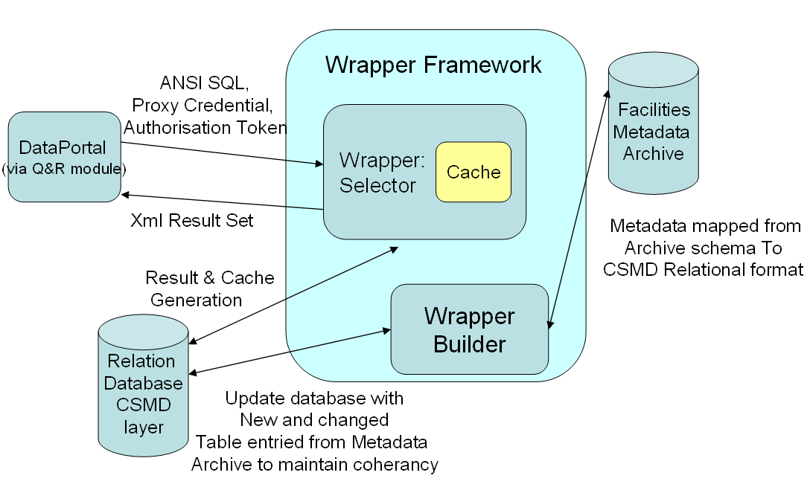
Figure 1: DataPortal 5 Wrapper Architecture

The intermediate layer of the wrapper is no longer XML but Relational. Also the DataPortal core via Q&R now query via ANSI SQL over web services. Perhaps some functions are needed (but they need to be database independent). The result set is sent back using XMLResultSet (this could be adopted from OGSA-DAI – but this needs more investigation)

Core Modules
4.2.1 Re-engineering DP4
The DP4 core modules are consisted of a list of web services:
- SM - session manager
- AA - authentication & authorisation
- QR – Query & Reply
- SC – Shopping Cart
- DT- Data TransferData transfer
- LU – Look up.
- Core API
These need re-engineering to internally not use web-services but maintain an external web-services interface that allows different interfaces to be created for the dataportal (e.g. a command line dp client so complement the web interface e.g. for programmatic interaction).
Some discussed steps to achieve this goal are:
- Internal calls should not be web services
- Get rid of UDDI
- Devise a core schema for dataportal covering the needs of the internal modules including but not limited to:
  - Users (e.g. DN’s)
  - Data references (e.g. URL’s)
  - Book marks (e.g. for studies)
  - User preferences (e.g. results per page / timeout values / default facility)
  - Session History ( allowing for auditing and tracking)
  - Session information (i.e. session id)
  - Module lookup for external facilities (ACM & Wrappers)
    - In place of UDDI
4.2.2 Schema
This is a preliminary schema design but will undergo major addition and refactoring prior to the next design meeting.
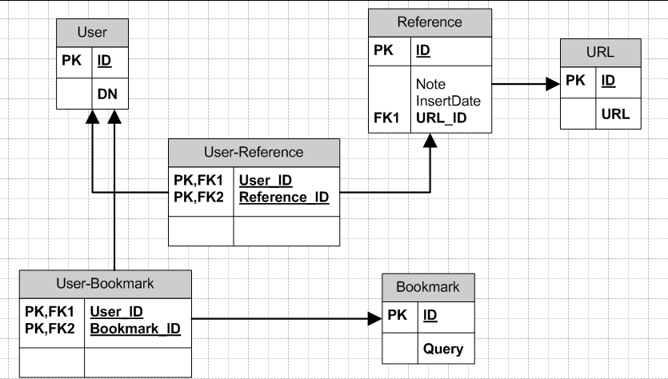
Figure 2: core schema artefact
4.3 User Interface
4.3.1 Specification
The internal structure of DP4 used JSP technology in a very haphazard way leading to one of the main criticisms of JSP the problem with spaghetti page flow (as well as in the case of DP4 creating large JSP pages with repeated presentation logic in multiple pages).
To overcome this problem DP5 hopes to use the Apache templates and Sun JSF standard to produce a more standardised and logically organised Web Interface
The integration of JSR-168 Portlets with the JSF are also envisaged. Possible portlets being:
- Search
- Advanced Search
- Data Centre
- Bookmark Centre

Development

Continue use Tiber and Volga
Tiber.dl.ac.uk and Volga.dl.ac.uk will continue to be used as deployment and development servers for dataportal. Some tricks to access the subversion repository are necessary from such machine (e.g. ssh tunnelling via condor.dl.ac.uk) to bridge the 192.68.125.x to 192.68.113.x subnets.

Test and Performance

Unit test:
There are a number of testing approaches and scenarios needed to make sure bugs are discovered as early as possible and things which are working are not broken while fixing or adding other functionality:
- Unit testing
- Regression testing
There are a number of tools of interest and relevance to the work on DP5
- Junit - http://www.junit.org/
  - To run automated testing during development to pick up build and functionality issues
- Apache Cactus - http://jakarta.apache.org/cactus/
  - Jsp and servlet testing
- Apache Jmeter - http://jakarta.apache.org/cactus/
  - http testing (load and perhaps other facets)

Performance & Scalability
In terms of performance there are only two metrics at the moment chosen as targets for success, these are based partly on the technologies available, staff resources, hardware resources and user expectations. Those metrics are:
- Number of concurrent connections to DP
- We are aiming to support 20 concurrent connections
- Query time 20 people concurrently access DP.
- Query time average of less than 5 seconds on average, maximum of 10 seconds, although this will be user configurable by users adjusting preferences.

Documentation
The overall aim of the documentation of DP5 is not to burden the developers with too much overly detailed explanations of the design and implementation; however plans, overall design documents and user documentation are seen as key to easy promotion, maintenance and adoption.

Development Plan documentation
This is represented by this document; this comprises of minutes from a series of meetings (3 in total) which are then refactored and then added to by all members of the team until we have a release document which should remain fairly static for the duration of DP5.

Specification & Design
The aim is for each aspect (i.e. interfaces, core modules and external modules) to have an associated specification and design document. This would detail what the interface/module hopes to achieve and how it plans to go about that with out being a detailed code level design document.

DP5 Web Interface
Covering specification (based on successful user requirements driven DP4 interface) and new page layout strategy (based on apache templates and JSF /portlets) and different pages

Core Modules
Refactoring of DP4 modules covering the web services interface and perhaps some typical work flows

Core Schema
Covers the DP schema (diagram and explanation) of the core schema meeting the needs of the core modules

External Modules (ACM & Wrappers)
Details the working of the ACM (or references to) and explanation about facility requirements for integration (additional tables and perhaps setting up reciprocal trust).
Wrappers cover new design and perhaps reference an intermediate relational representation based on CSMD V2 with information about XMLResultSet.

Developers Guide
- This would cover platform issues such as:
- Software stack history
- Tools used for development
- Platforms for development and deployment
- Maven best use guide
- Code layout & statement about code commenting using javadoc
- User of version control

User Guide
This would explain the use of certificates and myproxy, the bookmarks system and how download worked. Essentially this would then become the source for the user help pages.

Project Software Management
This section will form the basis of one of the developer documentation chapters where it can be expanded.

Version Control
Subversion will be the way that software versions are managed below is the initial module hierarchy:

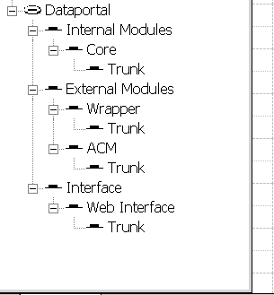
Figure 3: Initial module hierarchy

Maven
Maven is a software project management and comprehension tool. Based on the concept of a project object model (POM), Maven can manage a project's build, reporting and documentation from a central piece of information. The current version is 2.0.1. This will be used for running automated test, code formatting and producing reports at the time of writing. Ant will still be used to perform the actual build (due to tight integration in relevant tools e.g. Netbeans 5.x)

Actions

Hongmei
To look into Apache templates and JSF
Download Sun Java Studio Creator and gain experience in its use for possible use as front end ide development environment for DP5

Glen
To report on will finish the core module design and development part in two months
To report on Axis (the version which GT use) and Sun J2EE WS to see if they are interoperable; this is with regards to seeing whether or not Sun WS could be used as part of the DP5 Software Stack.
To report on whether scarab supports document management for the project
To come up with 1 page (or e-mail) about best use for Maven in the project – perhaps this would be added to the developers guide later

Shoaib
Preliminary schema design for the core schema
To find out how standard the XMLResultSet object is from OGSA-DAI and whether it refers to any other specification.

Next meeting
Schema design, Core module design, review of the results of the actions.

