Data Portal Web Service Tutorial

- Import the WSDL file to generate the client stubs.
  - Alpha release user location
    - https://volga.dl.ac.uk:7181/DataPortalService/DataPortal?wsdl
  - This contains all the available methods in one WSDL file

- The import needs to be done with the wsimport utility
  - https://jax-ws.dev.java.net/jax-ws-ea3/docs/wsimport.html
  - I use Netbeans 5.5, which does the importing for you.

- Download the keystore containing volga’s glassfish’s public key
  - Ill email it you when needed.

- Add the java environment variable:
  - -Djavax.net.ssl.trustStore=location of downloaded keystore

- Log on to the system with your myproxy username and password with something like this:
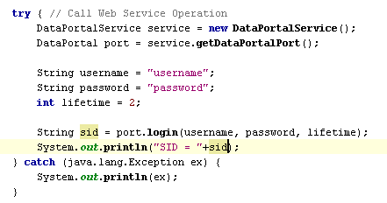
- With the session id you can now access the other services.
  - Searching for investigations

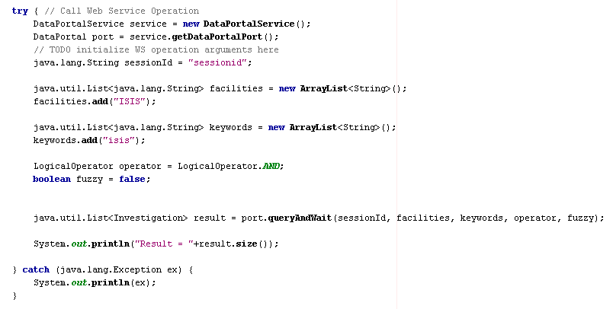

- To list all keywords from facility

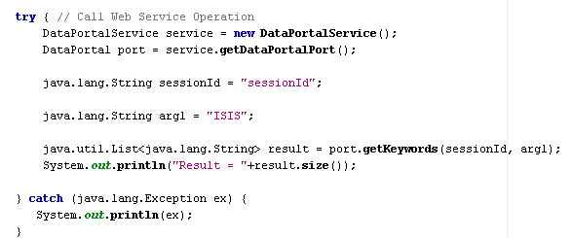

- To list all facilities, use getSession
