Schema facilityAdmin.xsd

schema location: | C:\CygWin\home\maw24\dataportal\facility\facilityAdmin.xsd

Elements | Complex types
facilityAdmin | serviceType

element facilityAdmin
diagram | 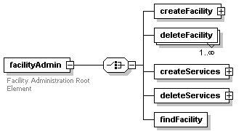
children | createFacility deleteFacility createServices deleteServices findFacility
annotation
  documentation | Facility Administration Root Element
source | <xs:element name="facilityAdmin">  <xs:annotation>  <xs:documentation>Facility Administration Root Element</xs:documentation>  </xs:annotation>  <xs:complexType>  <xs:choice>  <xs:element name="createFacility">  <xs:complexType>  <xs:sequence>  <xs:element name="facilityName"/>  <xs:element name="facilityDescription"/>  <xs:element name="service" type="serviceType" maxOccurs="unbounded"/>  </xs:sequence>  </xs:complexType>  </xs:element>  <xs:element name="deleteFacility" maxOccurs="unbounded">  <xs:complexType>  <xs:attribute name="facilityID" type="xs:string" use="required"/>  </xs:complexType>  </xs:element>  <xs:element name="createServices">  <xs:complexType>  <xs:sequence>  <xs:element name="service" type="serviceType" maxOccurs="unbounded"/>  </xs:sequence>  <xs:attribute name="facilityID" type="xs:string" use="required"/>  </xs:complexType>  </xs:element>  <xs:element name="deleteServices">  <xs:complexType>  <xs:sequence>  <xs:element name="service" maxOccurs="unbounded">  <xs:complexType>  <xs:attribute name="serviceID" type="xs:string" use="required"/>  </xs:complexType>  </xs:element>  </xs:sequence>  </xs:complexType>  </xs:element>  <xs:element name="findFacility"/>  </xs:choice>  </xs:complexType>  </xs:element>

element facilityAdmin/createFacility
diagram | 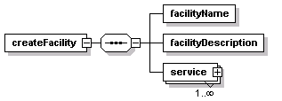
children | facilityName facilityDescription service
source | <xs:element name="createFacility">  <xs:complexType>  <xs:sequence>  <xs:element name="facilityName"/>  <xs:element name="facilityDescription"/>  <xs:element name="service" type="serviceType" maxOccurs="unbounded"/>  </xs:sequence>  </xs:complexType>  </xs:element>

element facilityAdmin/createFacility/facilityName
diagram
source | <xs:element name="facilityName"/>

element facilityAdmin/createFacility/facilityDescription
diagram
source | <xs:element name="facilityDescription"/>

element facilityAdmin/createFacility/service
diagram | 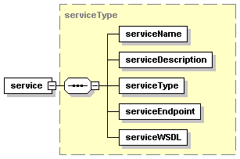
type | serviceType
children | serviceName serviceDescription serviceType serviceEndpoint serviceWSDL
source | <xs:element name="service" type="serviceType" maxOccurs="unbounded"/>

element facilityAdmin/deleteFacility
diagram
attributes
  Name | Type | Use | Default | Fixed | Annotation
  facilityID | xs:string | required
source | <xs:element name="deleteFacility" maxOccurs="unbounded">  <xs:complexType>  <xs:attribute name="facilityID" type="xs:string" use="required"/>  </xs:complexType>  </xs:element>

element facilityAdmin/createServices
diagram | 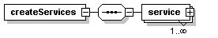
children | service
attributes
  Name | Type | Use | Default | Fixed | Annotation
  facilityID | xs:string | required
source | <xs:element name="createServices">  <xs:complexType>  <xs:sequence>  <xs:element name="service" type="serviceType" maxOccurs="unbounded"/>  </xs:sequence>  <xs:attribute name="facilityID" type="xs:string" use="required"/>  </xs:complexType>  </xs:element>

element facilityAdmin/createServices/service
diagram
type | serviceType
children | serviceName serviceDescription serviceType serviceEndpoint serviceWSDL
source | <xs:element name="service" type="serviceType" maxOccurs="unbounded"/>

element facilityAdmin/deleteServices
diagram | 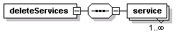
children | service
source | <xs:element name="deleteServices">  <xs:complexType>  <xs:sequence>  <xs:element name="service" maxOccurs="unbounded">  <xs:complexType>  <xs:attribute name="serviceID" type="xs:string" use="required"/>  </xs:complexType>  </xs:element>  </xs:sequence>  </xs:complexType>  </xs:element>

element facilityAdmin/deleteServices/service
diagram
attributes
  Name | Type | Use | Default | Fixed | Annotation
  serviceID | xs:string | required
source | <xs:element name="service" maxOccurs="unbounded">  <xs:complexType>  <xs:attribute name="serviceID" type="xs:string" use="required"/>  </xs:complexType>  </xs:element>

element facilityAdmin/findFacility
diagram
source | <xs:element name="findFacility"/>

complexType serviceType
diagram | 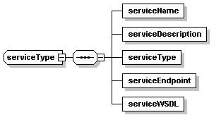
children | serviceName serviceDescription serviceType serviceEndpoint serviceWSDL
used by
  elements | facilityAdmin/createFacility/service facilityAdmin/createServices/service
source | <xs:complexType name="serviceType">  <xs:sequence>  <xs:element name="serviceName"/>  <xs:element name="serviceDescription"/>  <xs:element name="serviceType"/>  <xs:element name="serviceEndpoint"/>  <xs:element name="serviceWSDL"/>  </xs:sequence>  </xs:complexType>

element serviceType/serviceName
diagram
source | <xs:element name="serviceName"/>

element serviceType/serviceDescription
diagram
source | <xs:element name="serviceDescription"/>

element serviceType/serviceType
diagram
source | <xs:element name="serviceType"/>

element serviceType/serviceEndpoint
diagram
source | <xs:element name="serviceEndpoint"/>

element serviceType/serviceWSDL
diagram
source | <xs:element name="serviceWSDL"/>

XML Schema documentation generated with XML Spy Schema Editor http://www.altova.com/xmlspy

