Attack on Techno City Game Design Document

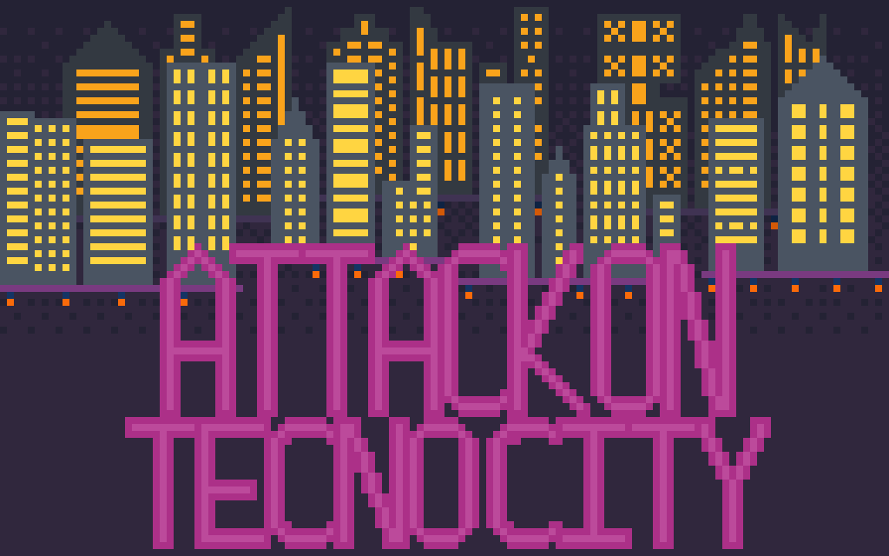

***‘It’s like Skyrim, but 2D…and not fantasy…and not open world…or an rpg…or anything like Skyrim’*** - Jacob Barger

This page: Table of Contents and Team Member Listing

|  |  |  |
| --- | --- | --- |
| Table of Contents  [1 Game Overview](https://n-xovwktmtjsnaxyc2mwes2xu7pohqedmdm6zjw5q-2lu-script.googleusercontent.com/userCodeAppPanel)  [2 High Concept](https://n-xovwktmtjsnaxyc2mwes2xu7pohqedmdm6zjw5q-2lu-script.googleusercontent.com/userCodeAppPanel)  [3 Unique Selling Points](https://n-xovwktmtjsnaxyc2mwes2xu7pohqedmdm6zjw5q-2lu-script.googleusercontent.com/userCodeAppPanel)  [4 Platform Minimum Requirements](https://n-xovwktmtjsnaxyc2mwes2xu7pohqedmdm6zjw5q-2lu-script.googleusercontent.com/userCodeAppPanel)  [5 Competitors / Similar Titles](https://n-xovwktmtjsnaxyc2mwes2xu7pohqedmdm6zjw5q-2lu-script.googleusercontent.com/userCodeAppPanel)  [6 Synopsis](https://n-xovwktmtjsnaxyc2mwes2xu7pohqedmdm6zjw5q-2lu-script.googleusercontent.com/userCodeAppPanel)  [7 Game Objectives](https://n-xovwktmtjsnaxyc2mwes2xu7pohqedmdm6zjw5q-2lu-script.googleusercontent.com/userCodeAppPanel)  [8 Game Rules](https://n-xovwktmtjsnaxyc2mwes2xu7pohqedmdm6zjw5q-2lu-script.googleusercontent.com/userCodeAppPanel)  [9 Game Structure](https://n-xovwktmtjsnaxyc2mwes2xu7pohqedmdm6zjw5q-2lu-script.googleusercontent.com/userCodeAppPanel)  [10 Game Play](https://n-xovwktmtjsnaxyc2mwes2xu7pohqedmdm6zjw5q-2lu-script.googleusercontent.com/userCodeAppPanel)  [10.1 Game Controls](https://n-xovwktmtjsnaxyc2mwes2xu7pohqedmdm6zjw5q-2lu-script.googleusercontent.com/userCodeAppPanel)  [10.2 Game Camera](https://n-xovwktmtjsnaxyc2mwes2xu7pohqedmdm6zjw5q-2lu-script.googleusercontent.com/userCodeAppPanel)  [10.2.1 HUD](https://n-xovwktmtjsnaxyc2mwes2xu7pohqedmdm6zjw5q-2lu-script.googleusercontent.com/userCodeAppPanel)  [10.2.2 Maps](https://n-xovwktmtjsnaxyc2mwes2xu7pohqedmdm6zjw5q-2lu-script.googleusercontent.com/userCodeAppPanel)  [11 Players](https://n-xovwktmtjsnaxyc2mwes2xu7pohqedmdm6zjw5q-2lu-script.googleusercontent.com/userCodeAppPanel)  [11.1 Characters](https://n-xovwktmtjsnaxyc2mwes2xu7pohqedmdm6zjw5q-2lu-script.googleusercontent.com/userCodeAppPanel)  [11.2 Metrics](https://n-xovwktmtjsnaxyc2mwes2xu7pohqedmdm6zjw5q-2lu-script.googleusercontent.com/userCodeAppPanel)  [11.3 States](https://n-xovwktmtjsnaxyc2mwes2xu7pohqedmdm6zjw5q-2lu-script.googleusercontent.com/userCodeAppPanel)  [11.4 Weapons](https://n-xovwktmtjsnaxyc2mwes2xu7pohqedmdm6zjw5q-2lu-script.googleusercontent.com/userCodeAppPanel)  [12 Player Line-up](https://n-xovwktmtjsnaxyc2mwes2xu7pohqedmdm6zjw5q-2lu-script.googleusercontent.com/userCodeAppPanel)  [13 NPC](https://n-xovwktmtjsnaxyc2mwes2xu7pohqedmdm6zjw5q-2lu-script.googleusercontent.com/userCodeAppPanel)  [13.1 Enemies](https://n-xovwktmtjsnaxyc2mwes2xu7pohqedmdm6zjw5q-2lu-script.googleusercontent.com/userCodeAppPanel)  [13.1.1 Enemy States](https://n-xovwktmtjsnaxyc2mwes2xu7pohqedmdm6zjw5q-2lu-script.googleusercontent.com/userCodeAppPanel)  [13.1.2 Enemy Spawn Points](https://n-xovwktmtjsnaxyc2mwes2xu7pohqedmdm6zjw5q-2lu-script.googleusercontent.com/userCodeAppPanel)  [13.2 Allies / Companions](https://n-xovwktmtjsnaxyc2mwes2xu7pohqedmdm6zjw5q-2lu-script.googleusercontent.com/userCodeAppPanel)  [13.2.1 Ally States](https://n-xovwktmtjsnaxyc2mwes2xu7pohqedmdm6zjw5q-2lu-script.googleusercontent.com/userCodeAppPanel)  [13.2.2 Ally Spawn Points](https://n-xovwktmtjsnaxyc2mwes2xu7pohqedmdm6zjw5q-2lu-script.googleusercontent.com/userCodeAppPanel)  [14 Art](https://n-xovwktmtjsnaxyc2mwes2xu7pohqedmdm6zjw5q-2lu-script.googleusercontent.com/userCodeAppPanel)  [14.1 Setting](https://n-xovwktmtjsnaxyc2mwes2xu7pohqedmdm6zjw5q-2lu-script.googleusercontent.com/userCodeAppPanel)  [14.2 Level Design](https://n-xovwktmtjsnaxyc2mwes2xu7pohqedmdm6zjw5q-2lu-script.googleusercontent.com/userCodeAppPanel)  [14.3 Audio](https://n-xovwktmtjsnaxyc2mwes2xu7pohqedmdm6zjw5q-2lu-script.googleusercontent.com/userCodeAppPanel)  [15 Procedurally Generated Content](https://n-xovwktmtjsnaxyc2mwes2xu7pohqedmdm6zjw5q-2lu-script.googleusercontent.com/userCodeAppPanel)  [15.1 Environment](https://n-xovwktmtjsnaxyc2mwes2xu7pohqedmdm6zjw5q-2lu-script.googleusercontent.com/userCodeAppPanel)  [15.2 Levels](https://n-xovwktmtjsnaxyc2mwes2xu7pohqedmdm6zjw5q-2lu-script.googleusercontent.com/userCodeAppPanel)  [15.3 Artificial Intelligence NPC](https://n-xovwktmtjsnaxyc2mwes2xu7pohqedmdm6zjw5q-2lu-script.googleusercontent.com/userCodeAppPanel)  [15.4 Visual Arts](https://n-xovwktmtjsnaxyc2mwes2xu7pohqedmdm6zjw5q-2lu-script.googleusercontent.com/userCodeAppPanel)  [15.5 Audio](https://n-xovwktmtjsnaxyc2mwes2xu7pohqedmdm6zjw5q-2lu-script.googleusercontent.com/userCodeAppPanel)  [15.6 Minimum Viable Product (MPV)](https://n-xovwktmtjsnaxyc2mwes2xu7pohqedmdm6zjw5q-2lu-script.googleusercontent.com/userCodeAppPanel)  [16 Wish List](https://n-xovwktmtjsnaxyc2mwes2xu7pohqedmdm6zjw5q-2lu-script.googleusercontent.com/userCodeAppPanel)   |  | | --- | |  | | Game Development Team Members    PRODUCER  Jacob Barger    PRODUCTION MANAGER  Jacob Barger    PRODUCTION COORDINATOR  Jacob Barger  GAME DESIGNERS  Jacob Barger  SYSTEMS/IT COORDINATOR  Jacob Barger  PROGRAMMERS  Jacob Barger  TECHNICAL ARTISTS  Jacob Barger  AUDIO ENGINEERS  Jacob Barger  UX TESTERS  Jacob Barger |

|  |
| --- |
|  |

# 1 Game Overview

Title: Attack on Techno City

Platform: PC Standalone

Genre: 2D platformer shooter

Rating: (10+) ESRB

Target: Casual to Serious gamer (aging from 12 - 30)

Release date: April, 2020

Publisher: Brown Bag Studios

Description: Attack on Techno City is a 2D platformer/shooter where the player takes control of police bot RC34256 or ‘RC’ for short. The futuristic utopia of Techno City is being torn apart by an unknown force that is corrupting the technology of the city, and it is the player’s job, through RC, to put a stop to it. The player must not only navigate the increasingly perilous terrain of the crumbling metropolis, but also avoid succumbing to the violent hordes brewing within. This latter task is made easier with RC’s powerful pulse cannon and battlefield maintenance protocols.

# 2 High Concept

Attack on Techno City puts the player in a 2D futuristic city in the midst of a supernatural/eldritch calamity. This event has turned mundane pieces of technology like toasters and TVs into the enemies which the player must fight while traversing the levels. Familiar platforming gameplay with damage being dealt and progress reset upon failure to avoid falling off the level tiles. The enemies of the levels are present to deal damage, present an additional challenge, and generally impede the player. The player must deal with the enemies with the main weapon and manage a healing resource. The healing ability also presents the player with the decision of when to use it as well as letting it dictate playstyle(blow through the level and rely on the resource when mistakes are made or conserve it and play more cautiously).

# 3 Unique Selling Points

* Pixel art sprites and backgrounds
* Simple and familiar gameplay with minor addition

# 4 Platform Minimum Requirements

OS: Windows 10

Graphics: Anything within the last decade should work

Processor: Intel(R) Core(TM) i5-8250U CPU @ 1.60GHz

# 5 Competitors / Similar Titles / Genre

The 2D platformer is a genre is one of the most prolific and well known with series such as Mario and Mega Man belonging to its ranks. Though simple in its most basic premise (getting the character from point A to B jumping over obstacles without dying) many titles have expanded upon it by adding mechanics or some sort of twist. For example, Shovel Knight put more focus on attacking and bouncing off enemies from above which is a mechanic that can be found in many other games and arguably trace its origins to Mario titles. Other games have added more combat mechanics and even some rpg-like leveling systems and progression to give the 2D platformer many interesting flavors.

# 6 Synopsis

The technology of the city has been corrupted and is attacking. You are a riot control robot tasked with eliminating the threat and taking back the city.

# 7 Game Objectives

Traverse each level without dying and eliminate the enemies

# 8 Game Rules

Each level is a linear environment that the player must move traverse start to finish. They can move left ad right as well as jump in order to do this. To keep moving forward the player must also defeat enemies which they can do by shooting with the main weapon to the left and right only. The player can also avoid death by using the energy resource to heal damage taken, and replenish energy with pickups found on some of the levels. The different enemies attack the player differently and have different health and damage stats. Once the player has moved through a level and reaches the end, the next level is loaded and the process begins again. If he or she falls off the level tiles at any point, the character takes damage and is sent to the beginning of the level.

# 9 Game Structure

Game started->Gameplay->Player completes all levels and wins

->Player dies and must restart

# 10 Game Play

## 10.1 Game Controls

‘A’ – Move character to the left

‘D’ – Move character to the right

‘W’ – Jump

‘Space’ – Shoot

‘LCtrl’ – Use energy to heal

‘P’ – Bring up pause menu

## 10.2 Game Camera

When the first level is loaded the camera places the player in the left half of the screen and follows the player as he or she moves or jumps with a slight delay. The delay helps make movement feel smoother and give better indication that the player is actually moving the level, as well as keep the player from feeling disoriented.

### 10.2.1 HUD

Player Health – red bar that decreases when player takes damage or falls off of level tiles

Player Energy – blue bar that decrease when player presses appropriate button to heal and increases when an energy pickup is contacted

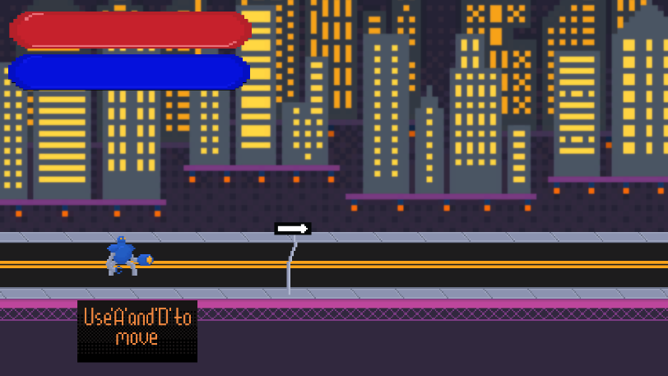

### 10.2.2 Maps

# 11 Players

## 11.1 Characters

The player character is a police riot control robot armed with extremely lethal weapons to give a weird sense of humor similar to ED 209 from RoboCop or RoboCop himself.

## 11.2 Metrics

Max Health: 100

Max Energy: 100

Damage: 10

## 11.3 States

Idle: Idle state triggers when no player input is received. The state is a cycled animation where the character and its limbs move up and down

Moving: When input to move left or right is received, the character moves in that direction while a cycled running animation plays

Jumping: When jump input is received while the player is grounded, a jump animation plays and the character jumps up or up and in the direction the player is holding

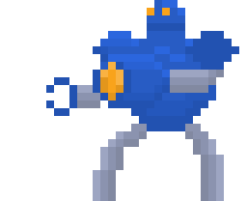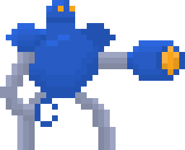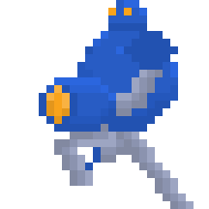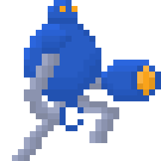Shooting: Cycled shooting animation plays while shoot input is received in the direction the character is facing. Projectiles are also spawned in the same direction.

## 11.4 Weapons

# 12 Player Line-up

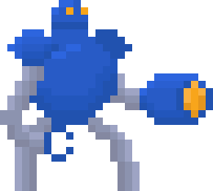RC34256(‘RC’)

# 13 NPC

## 13.1 Enemies

The enemies wait at their spawn locations in each level and attack the player in different ways. The toaster enemy always fires at a constant rate and maintains a certain distance from the player by moving left or right depending on where the player is. The tv enemy attacks the player by moving towards them and dealing damage on contact once the player reaches a certain distance from the enemy. For both enemies movement towards or away from the player is restricted by boundaries on the map tiles to prevent them from blinding moving off the edges.

TV – Health: 30, Speed: 15, Attack Damage: 20

Toaster – Health: 20, Speed: 5, Attack Damage: 10

### 13.1.1 Enemy States

Idle: Enemies are in the idle state until the player’s proximity triggers movement. While in idle the tv enemy paces back and forth while bobbing up and down. The toaster enemy shoots while slightly bobbing up and down.

Moving: Once player proximity triggers movement, the enemies either move toward or away from the player depending on the enemy’s type and the proximity.

Death: When the enemy’s health drops to zero, a death animation plays and the enemy prefab in the scene is destroyed.

### 13.1.2 Enemy Spawn Points

The enemies spawn at predetermined points throughout each level when the level loads and only then.

## 13.2 Allies / Companions

### 13.2.1 Ally States

### 13.2.2 Ally Spawn Points

# 14 Art

## 14.1 Setting

The game takes place in a futuristic city with much of it being hovering streets and buildings in the sky. Because of the implications of abundant technology in a futuristic city, household devices and others serve as the basis for the enemies of the game.

## 14.2 Level Design

The levels will be made up of segments of a broken road system to create obstacles and pitfalls for the player to navigate. Later levels will be populated with enemies and energy pickups to force the player to divert their attention, make decisions, and make the platforming less trivial. The floating city in the background of each level makes the levels themselves(floating roads and highways) feel more plausible.

## 14.3 Audio

|  |  |  |
| --- | --- | --- |
| Name | Category | Description |
| Battle | Background Music | Plays during gameplay and in main menu |
| Retro gun laser slingshot 01 | FX | Plays when player shoots |
| Retro explosion short 15 | FX | Plays when enemies die |
| Retro pickup 18 | FX | Plays when player picks up energy |
| Retro electric burst 05 | FX | Plays when player uses energy |
| Retro weapon laser 36 | FX | Plays when enemy shoots |

# 15 Procedurally Generated Content

## 15.1 Environment

## 15.2 Levels

## 15.3 Artificial Intelligence NPC

## 15.4 Visual Arts

## 15.5 Audio

## 15.6 Minimum Viable Product (MPV)

- One player character

- Two enemy types

- Four levels

- Energy mechanic

- Built for PC

# 16 Wish List

Add more weapons to player character

* Give the player character different fire modes or ways of dealing damage, possibly tied to the energy system to give the player more choices to make during gameplay

Add more levels with boss enemies after certain levels

* Make the game feel more fleshed out with more levels based around different locations within a city(going from the highways into a residential area for instance)
* Create more challenge with boss battles in which the player must observe the boss enemy’s behavior to find patterns and weak points

# 17 Asset Bibliography

Artwork:

Me

Music and Sound:

Goose Ninja. “Space Music Pack by Goose Ninja.” Itch.io, gooseninja.itch.io/space-music-pack.

Kronbits. “200 Free SFX by Kronbits.” Itch.io, kronbits.itch.io/freesfx.

Scripts:

Mostly Me except for:

Audio;262588213843476, bowlandcereal. “AudioManager.” Gist, gist.github.com/bowlandcereal/73f70cbda205241f95a6e77aefbd7241.

Splash Screens:Vegas, Jimmy. “Mini Unity Tutorial - How To Create Splash Screens.” YouTube, YouTube, 27 Nov. 2017, www.youtube.com/watch?v=ADJ2SYm0oBU.

DeathAnimations:vElumi. “Delete Object After Animation (2D).” Delete Object After Animation (2D) - Unity Answers, answers.unity.com/questions/670860/delete-object-after-animation-2d.html.