Puzzle Box Design Document (GDD)

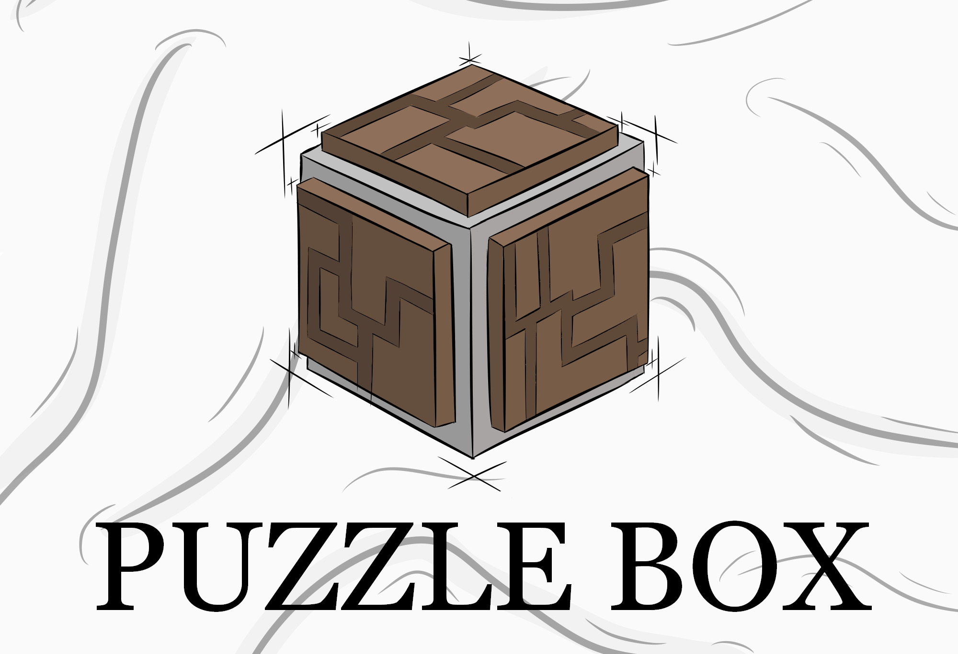

***‘Did you enjoy those mazes on the paper placemats at restaurants when you were a kid? Well, this is kind of like that...but in 3D...and without crayons...or food.’*** - Jacob Barger

This page: Table of Contents and Team Member Listing

|  |  |  |
| --- | --- | --- |
| Table of Contents  [1 Game Overview](https://n-xovwktmtjsnaxyc2mwes2xu7pohqedmdm6zjw5q-2lu-script.googleusercontent.com/userCodeAppPanel#)  [2 High Concept](https://n-xovwktmtjsnaxyc2mwes2xu7pohqedmdm6zjw5q-2lu-script.googleusercontent.com/userCodeAppPanel#)  [3 Unique Selling Points](https://n-xovwktmtjsnaxyc2mwes2xu7pohqedmdm6zjw5q-2lu-script.googleusercontent.com/userCodeAppPanel#)  [4 Platform Minimum Requirements](https://n-xovwktmtjsnaxyc2mwes2xu7pohqedmdm6zjw5q-2lu-script.googleusercontent.com/userCodeAppPanel#)  [5 Competitors / Similar Titles](https://n-xovwktmtjsnaxyc2mwes2xu7pohqedmdm6zjw5q-2lu-script.googleusercontent.com/userCodeAppPanel#)  [6 Synopsis](https://n-xovwktmtjsnaxyc2mwes2xu7pohqedmdm6zjw5q-2lu-script.googleusercontent.com/userCodeAppPanel#)  [7 Game Objectives](https://n-xovwktmtjsnaxyc2mwes2xu7pohqedmdm6zjw5q-2lu-script.googleusercontent.com/userCodeAppPanel#)  [8 Game Rules](https://n-xovwktmtjsnaxyc2mwes2xu7pohqedmdm6zjw5q-2lu-script.googleusercontent.com/userCodeAppPanel#)  [9 Game Structure](https://n-xovwktmtjsnaxyc2mwes2xu7pohqedmdm6zjw5q-2lu-script.googleusercontent.com/userCodeAppPanel#)  [10 Game Play](https://n-xovwktmtjsnaxyc2mwes2xu7pohqedmdm6zjw5q-2lu-script.googleusercontent.com/userCodeAppPanel#)  [10.1 Game Controls](https://n-xovwktmtjsnaxyc2mwes2xu7pohqedmdm6zjw5q-2lu-script.googleusercontent.com/userCodeAppPanel#)  [10.2 Game Camera](https://n-xovwktmtjsnaxyc2mwes2xu7pohqedmdm6zjw5q-2lu-script.googleusercontent.com/userCodeAppPanel#)  [10.2.1 HUD](https://n-xovwktmtjsnaxyc2mwes2xu7pohqedmdm6zjw5q-2lu-script.googleusercontent.com/userCodeAppPanel#)  [10.2.2 Maps](https://n-xovwktmtjsnaxyc2mwes2xu7pohqedmdm6zjw5q-2lu-script.googleusercontent.com/userCodeAppPanel#)  [11 Players](https://n-xovwktmtjsnaxyc2mwes2xu7pohqedmdm6zjw5q-2lu-script.googleusercontent.com/userCodeAppPanel#)  [11.1 Characters](https://n-xovwktmtjsnaxyc2mwes2xu7pohqedmdm6zjw5q-2lu-script.googleusercontent.com/userCodeAppPanel#)  [11.2 Metrics](https://n-xovwktmtjsnaxyc2mwes2xu7pohqedmdm6zjw5q-2lu-script.googleusercontent.com/userCodeAppPanel#)  [11.3 States](https://n-xovwktmtjsnaxyc2mwes2xu7pohqedmdm6zjw5q-2lu-script.googleusercontent.com/userCodeAppPanel#)  [11.4 Weapons](https://n-xovwktmtjsnaxyc2mwes2xu7pohqedmdm6zjw5q-2lu-script.googleusercontent.com/userCodeAppPanel#)  [12 Player Line-up](https://n-xovwktmtjsnaxyc2mwes2xu7pohqedmdm6zjw5q-2lu-script.googleusercontent.com/userCodeAppPanel#)  [13 NPC](https://n-xovwktmtjsnaxyc2mwes2xu7pohqedmdm6zjw5q-2lu-script.googleusercontent.com/userCodeAppPanel#)  [13.1 Enemies](https://n-xovwktmtjsnaxyc2mwes2xu7pohqedmdm6zjw5q-2lu-script.googleusercontent.com/userCodeAppPanel#)  [13.1.1 Enemy States](https://n-xovwktmtjsnaxyc2mwes2xu7pohqedmdm6zjw5q-2lu-script.googleusercontent.com/userCodeAppPanel#)  [13.1.2 Enemy Spawn Points](https://n-xovwktmtjsnaxyc2mwes2xu7pohqedmdm6zjw5q-2lu-script.googleusercontent.com/userCodeAppPanel#)  [13.2 Allies / Companions](https://n-xovwktmtjsnaxyc2mwes2xu7pohqedmdm6zjw5q-2lu-script.googleusercontent.com/userCodeAppPanel#)  [13.2.1 Ally States](https://n-xovwktmtjsnaxyc2mwes2xu7pohqedmdm6zjw5q-2lu-script.googleusercontent.com/userCodeAppPanel#)  [13.2.2 Ally Spawn Points](https://n-xovwktmtjsnaxyc2mwes2xu7pohqedmdm6zjw5q-2lu-script.googleusercontent.com/userCodeAppPanel#)  [14 Art](https://n-xovwktmtjsnaxyc2mwes2xu7pohqedmdm6zjw5q-2lu-script.googleusercontent.com/userCodeAppPanel#)  [14.1 Setting](https://n-xovwktmtjsnaxyc2mwes2xu7pohqedmdm6zjw5q-2lu-script.googleusercontent.com/userCodeAppPanel#)  [14.2 Level Design](https://n-xovwktmtjsnaxyc2mwes2xu7pohqedmdm6zjw5q-2lu-script.googleusercontent.com/userCodeAppPanel#)  [14.3 Audio](https://n-xovwktmtjsnaxyc2mwes2xu7pohqedmdm6zjw5q-2lu-script.googleusercontent.com/userCodeAppPanel#)  [15 Procedurally Generated Content](https://n-xovwktmtjsnaxyc2mwes2xu7pohqedmdm6zjw5q-2lu-script.googleusercontent.com/userCodeAppPanel#)  [15.1 Minimum Viable Product (MPV)](https://n-xovwktmtjsnaxyc2mwes2xu7pohqedmdm6zjw5q-2lu-script.googleusercontent.com/userCodeAppPanel#)  [16 Wish List](https://n-xovwktmtjsnaxyc2mwes2xu7pohqedmdm6zjw5q-2lu-script.googleusercontent.com/userCodeAppPanel#)   |  | | --- | |  | | Game Development Team Members    PRODUCER  Blake Myers, Jacob Barger, Jacob Golden-Needham, Nicholas Ricario    PRODUCTION MANAGER  Blake Myers, Jacob Barger, Jacob Golden-Needham, Nicholas Ricario    PRODUCTION COORDINATOR  Blake Myers, Jacob Barger, Jacob Golden-Needham, Nicholas Ricario  GAME DESIGNERS  Blake Myers, Jacob Barger, Jacob Golden-Needham, Nicholas Ricario  SYSTEMS/IT COORDINATOR  Jacob Golden-Needham  PROGRAMMERS  Blake Myers, Jacob Barger, Jacob Golden-Needham, Nicholas Ricario  TECHNICAL ARTISTS  Blake Myers, Jacob Barger, Jacob Golden-Needham  AUDIO ENGINEERS  Nicholas Ricario  UX TESTERS  Blake Myers, Jacob Barger, Jacob Golden-Needham, Nicholas Ricario |

|  |
| --- |
|  |

# 1 Game Overview

Title: Puzzle Box

Platform: PC Standalone

Genre: Puzzler

Rating: (10+) ESRB

Target: Casual gamer (aging from 12 - 30)

Release date: April, 2022

Publisher: Gold Games

Description: Puzzle Box gives the player the task of solving multiple mazes in as little time as possible with the added challenge of the mazes being on the different faces of a cube that the player manipulates. This adds a little extra difficulty to the game because the player uses this mechanic to move balls through the mazes, possibly changing the orientation of the other faces. In later levels, the mazes also have moving obstacles that impede or aid the player’s progress depending on the timing.

# 2 High Concept

The game allows the player to solve individual puzzles in a somewhat indirect way by manipulating the larger object that each puzzle is attached to. The player must solve each puzzle while a timer runs, and stops when all are completed.

# 3 Unique Selling Points

1. Physics based controls
2. Unique Puzzles
3. Fun for all ages

# 4 Platform Minimum Requirements

Nvidia Geforce 940m or Equivalent

Intel i5 or Equivalent

4GB of RAM

XGB of Disk space

# 5 Competitors / Similar Titles

1. [Box and Secret 3D](https://www.newgrounds.com/portal/view/732547)
2. Prism (IOS)
3. Marble Maze (Toy)

# 6 Synopsis

Try to solve the puzzles of each level in the fastest time possible.

# 7 Game Objectives

The objective of the game is to complete all the levels by rotating each puzzle along its axes in order to roll the marble through its respective goal gate. By clearing all five puzzles on a level the player will be allowed to advance to the next level until they have reached the final stage. The puzzles increase in difficulty as the levels progress as false pathways and moving gates are added to slow the player’s progress. Ideally the player will attempt to complete the puzzles in as little time as possible.

# 8 Game Rules

The player can only move the entire cube and must do so to make the ball of each maze move to the goal of the respective maze. This must be done for all faces of the cube with a maze(5). When all faces are solved, the timer stops and the player can proceed to the next level.

# 9 Game Structure

Puzzle Box consists of 3 playable levels each containing 5 maze puzzles and a Menu screen

Main Menu → Level 1(5 puzzles) → Level 2 (5 Puzzles) → Level 3 (5 Puzzles) → Main Menu

At any point while in a level the use can either return to the main menu, restart the level, or quit the game.

# 10 Game Play

## 10.1 Game Controls

Right click and drag - rotates puzzle box along its X and Y axes

Right Click - Selects a menu prompt or opens a puzzle start gate when clicked

Left click and drag - rotates puzzle box along its Z axis

Esc - Pauses the game timer and brings up the pause menu

## 10.2 Game Camera

The Game Camera is static

### 10.2.1 HUD

The HUD consists of 3 pieces of information: Puzzles completed, Current Time, and Best Time. The puzzles completed section displays the number of puzzles the player has completed in the current level. The Current time displays the Time the player has spent on the current level in seconds and if this time is below the best time the text will be displayed as green, if the current time is over the best time then it will be displayed as red. The best time for each level is set as 100 seconds and that is displayed in the HUD.

### 10.2.2 Maps

# 11 Players

Puzzle Box does not include other Player Characters

# 12 Player Line-up

Puzzle Box does not include other Player Characters

# 13 NPC

Puzzle Box does not include NPCs

# 14 Art

## 14.1 Setting

The game takes place in a mystical void of light.

## 14.2 Level Design

The levels consist of a single puzzle cube with five of its faces containing a puzzle. The cube floats in the middle of the player’s screen to be interacted with. The puzzles on the faces of the cube get more intricate, with more false pathways as the player advances through the levels. The puzzles also incorporate more obstacles as the player advances.

## 14.3 Audio

The audio provided throughout the game is as follows:  
  
Main Theme - Halo Theme ([Halo Theme Song Original - YouTube](https://www.youtube.com/watch?v=0jXTBAGv9ZQ) )

Finish Puzzle Box Face - Coin ([Super Mario Bros. - Coin Sound Effect - YouTube](https://www.youtube.com/watch?v=qfx6yf8pux4) )

Rotate Puzzle Box - Gears ([Gears sounds - YouTube](https://www.youtube.com/watch?v=LwiOCsfa_ZA) )

# 15 Procedurally Generated Content

Puzzle Box does not include Procedurally Generated Content at this time

## 15.1 Minimum Viable Product (MPV)

Three Levels each with unique maze designs

Ability to rotate center cube to solve puzzles

Built for PC platform

# 16 Wish List

More levels

Develop some way for the faces to interact(solving one changes aspects of another)

Different kinds of puzzles

Track player times/scores for levels with a badging system attached to times

Narrative element to make player feel more engaged, or playing is more purposeful

PuzzleBox Bibliography

Gears sounds. (2018, April 25). Retrieved December 5, 2019, from<https://www.youtube.com/watch?v=LwiOCsfa_ZA>.

Halo Theme Original Song. (2013, January 8). Retrieved December 5, 2019, from<https://www.youtube.com/watch?v=0jXTBAGv9ZQ>.

Super Mario Bros. - Coin Sound. (2012, June 6). Retrieved December 5, 2019, from<https://www.youtube.com/watch?v=qfx6yf8pux4>.