Crash causation with an active-inference response process: method and first results
Results document, 2026-08-24. Prepared by Claude at the request of Jonas Bärgman. Markdown is the source; Word and PDF are generated from it. This document reports what has been found; the design, the reading notes on the source papers, and the protocol live in docs/crash_causation_plan.md and are only summarized here. Provenance tags as elsewhere: [B24] Bärgman, Svärd, Lundell & Hartelius (2024), [W25a] [W26] the Wu et al. papers, [Code] the Schumann et al. released code, [OSF] their deposit, [Repo] this repository, [Opinion] a judgment.

1 The method in one page
The question: can the active-inference driver model serve as the response process inside a crash-causation model — and what does it add or cost relative to the fixed-delay response of the crash-causation model (CBM) of [B24]?
The construction, following the plan:
- Seeds. 100 rear-end pre-crash scenarios sampled weight-proportionally (stratified by initial speed) from the 5 000 synthetic QUADRIS scenarios of [W25a]; every seed carries its real-world weight ω.
- Causation components ([B24]'s four mechanisms, each switchable): off-road glances (duration distribution + a placement rule), too-close following (inherent in the seed), a maximum-deceleration cap, and a post-hoc no-response mixture (10% of crashes).
- Two response processes behind one interface: the CBM's (respond 0.5 s after eyes return to the road; ramp to the drawn deceleration) and a tier-1 surrogate of the active inference driver (the model's own preference function evaluated on the seed kinematics, fed through its evidence accumulator with the drift rate calibrated on the authors' 896 deposited trials — the calibration reproduces 69% of the closed-loop brake onsets within ±0.2 s [Repo]).
- Conditions. A: attentive active inference, no glances (the benchmark). B: active inference + all components. C: CBM response + all components (the control — a near-relative of the QUADRIS generator). D: active inference + glances only.
- Per-seed bin sweep instead of Monte Carlo (the [B24] design): each seed is run through every glance bin and every deceleration bin; outcomes carry the bin probabilities, so each seed yields a crash probability, and avoided outcomes are first-class results.
- Comparison against the full 5 000-scenario reference with the practical-equivalence framework of [W26]: quantile-binned statistics θ (worst bin) and Θ (aggregate), ROPEs 0.10 and 0.05, bootstrap HDIs; crashes weighted by [W26] Eq. 10, plus an exposure-weight variant that divides out each seed's crash probability (plan §6b).
Everything below uses the digitized real distributions of section 2, not the earlier parametric stand-ins; the stand-in results are kept in replication/causation/out/ (untagged files) for comparison.

2 Input distributions, digitized from the published figures
The SHRP2 data behind [B24] are not shareable, so the two input distributions were digitized from the published figures (replication/causation/digitize_b24.py; outputs in replication/causation/data/):
- Off-road glance durations ([B24] Fig. 1, SHRP2 baseline): the figure is vector art, so bar geometry is exact. Two independent calibrations of the value axis — tick-label geometry and the requirement that the drawn (off-road-conditional) distribution sum to 1 — agree within 0.9%. The drawn bins extend to 3.75 s; the published longest glance is 6.7 s, so a small tail (below the figure's resolution, < 0.001 per bin) is truncated. The on-road point mass is 0.80 (the figure's broken-axis tick; the caption states the CDF "would start at that value").
- Maximum decelerations ([B24] Fig. 3, 45 SHRP2 crashes, 1.5 m/s² bins): digitized from pixels and forced to integer counts — 6, 11, 12, 11, 4, 1 across bins from 3 to 12 m/s², which sum to exactly the paper's n = 45.
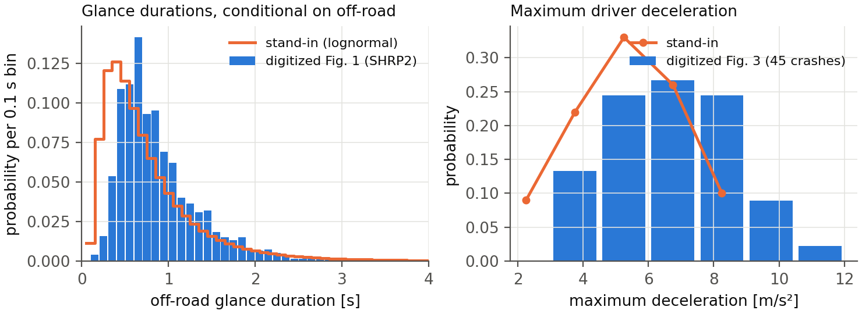
The figure shows both against the stand-ins used before today. The glance stand-in was close (its mode sits ~0.2 s early); the deceleration stand-in was not — the real distribution has substantially more mass at hard braking (24% at 7.5 m/s² and above, where the stand-in had almost none). This matters below.

3 Crash generation
condition | response | components | seeds crashing (any bin) | weighted crash prob | avoided seeds
A | active inference | decel. cap | 23/100 | 0.008 | 77
B | active inference | glances, decel. cap, no-response | 100/100 | 0.012 | 0
C | CBM (control) | glances, decel. cap, no-response | 85/100 | 0.003 | 15
D | active inference | glances, decel. cap | 100/100 | 0.012 | 0
With the renewal-process glance placement (plan §6c; the default for the active-inference conditions): C 0.003 (51/100 seeds), D 0.021 (96/100).
Findings:
- An attentive active-inference driver avoids 77 of 100 QUADRIS crash seeds across the full real deceleration sweep (up from 51 with the stand-in distribution — the real distribution's harder decelerations avoid more). The 23 that still crash in some bin are the kinematically hard core.
- The response process drives a factor ~4 in crash probability: B (active inference) 0.012 versus C (CBM) 0.003 with identical causation components. The mechanism is timing: the active-inference accumulator responds at a median of 1.25 s after the τ⁻¹ = 0.2 s⁻¹ anchor (IQR 0.55–1.90 s), where the CBM responds at a fixed 0.50 s (section 5).
- The no-response mixture (B versus D) barely moves the aggregates at its 10% share, as expected from its post-hoc construction.

4 Comparison with the original data

4.1 Summary statistics
Weighted medians (weighted mean for P_inj); reference weighted by ω, conditions by the Eq. 10 crash weights:
 | lead delta-v [m/s] | mean P_inj (MAIS2+) | t_nr [s] | follower a_min [m/s²]
QUADRIS reference (n = 5 000) | 1.77 | 0.0062 | −0.15 | −1.03
B: active inference | 0.75 | 0.0036 | −0.10 | −3.46
C: CBM control | 1.05 | 0.0040 | −0.15 | −3.75

4.2 Distributions
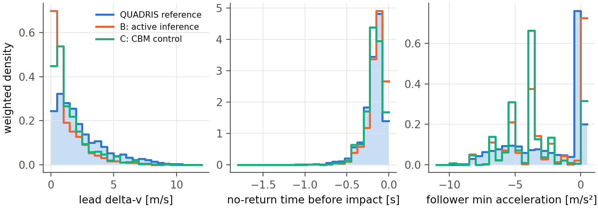
The three panels carry the substance:
- Severity (lead delta-v, left). Both response models over-produce mild crashes (density 0.55–0.70 in the lowest bins against the reference's 0.24) and under-produce the moderate 1–5 m/s range. The bin sweep generates many marginal crashes — a glance just long enough, a deceleration just too weak — whose delta-v is small.
- Urgency (t_nr, middle). The distributions essentially coincide — the time of no return is a property of the seeds more than of the follower, and both models inherit it correctly.
- Braking (follower minimum acceleration, right). The structural mismatch. The reference's crashing followers concentrate at zero braking (the [W25a] generator's non-responding and abnormal-acceleration followers) with a smooth spread of moderate braking; the generated crashes instead brake hard at the discrete cap values (the spikes at the [B24] bin centers). In words: QUADRIS crashes are mostly drivers who barely braked; the CBM-style construction generates drivers who braked hard but too late. Both routes end in a crash; they are different kinds of crash.

4.3 Equivalence statistics
No condition is practically equivalent to the reference on any metric (ROPE 0.10 for θ, 0.05 for Θ; full tables in replication/causation/out/summary_real.md and summary_real_process.md). Headline θ with 95% bootstrap HDIs, Eq. 10 weights:
condition | glance placement | P_inj | t_nr | a_f,min
A | — | 0.62 [0.47, 1.07] | 0.42 [0.26, 1.00] | 2.42 [1.85, 2.96]
B | anchored overshot | 1.44 [1.39, 1.58] | 0.66 [0.58, 0.75] | 1.00 [1.00, 1.04]
C | anchored overshot | 0.81 [0.74, 0.89] | 0.36 [0.26, 0.44] | 1.96 [1.90, 2.05]
C | renewal process | 0.40 [0.34, 0.50] | 0.37 [0.27, 0.52] | 2.03 [1.92, 2.15]
D | renewal process | 1.19 [1.10, 1.39] | 0.60 [0.52, 0.70] | 1.08 [1.00, 1.18]
How to read this:
- t_nr comes closest to equivalence (θ 0.26–0.75 against a ROPE of 0.10) for every condition — consistent with panel 2: the seeds carry this metric.
- The best severity match is the CBM control with process glances (P_inj θ = 0.40), which is expected — it is the nearest relative of the generator — and useful: it calibrates how much of the remaining distance is attributable to the framework (seeds, weighting, digitized inputs) rather than to the response model. The active inference conditions sit at θ 1.2–1.5, roughly three times the control's distance.
- a_f,min fails structurally for every condition (θ 1.0–2.4). This is the panel-3 mismatch, and no response-timing change can fix it: it comes from generating crashes through the low-deceleration mechanism while the reference generates them mostly through non-response. Under the exposure weighting (plan §6b) every θ roughly doubles, as the crash-conditioned seed set is up-weighted toward its rarely-crashing members.
One methodological note carried over from the stand-in runs and confirmed here: the choice of glance placement moves the equivalence result more than the choice of duration distribution — crash-anchored placement inflates crash probability about four-fold for the CBM without degrading θ, so the equivalence test alone would not catch that bias (plan §11.3).

5 Response timing: the two models differ exactly where it matters
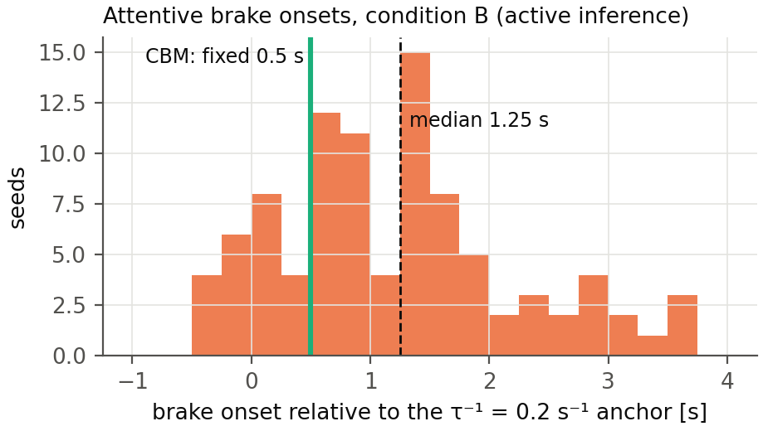
The CBM's response rule is a fixed 0.5 s after the τ⁻¹ = 0.2 s⁻¹ anchor [B24, from Markkula et al. 2016]. The active-inference accumulator, calibrated only on the authors' own closed-loop trials and never on QUADRIS, produces onsets at a median 1.25 s after that same anchor with a wide spread (IQR 0.55–1.90 s) — later and far more variable. The distribution is stable across glance placements and across the stand-in versus real distributions, because attentive timing does not involve the glance machinery at all. Which rule is right for human drivers is an empirical question the two models now pose crisply; the CBM's 0.5 s is itself empirically anchored, so the active-inference surrogate's later median is a genuine, testable disagreement, not an error [Opinion].

6 The closed loop is not the CBM with extra steps: the glance-gate finding
The tier-2 adapter (plan §11.4) runs the authors' full closed-loop model on QUADRIS seeds with the lead replaced by a replay of the seed's speed profile, and can force off-road glances through the code's own observation gate (I_factor, the mechanism of the Engström et al. 2024 visual time-sharing model).
Forcing a 1.0–3.0 s off-road glance during the conflict did not delay the response. On the test seed the driver braked at 2.4–2.6 s — inside the glance — and it did so both under the shipped observation-noise factor (3) and under an effectively total gate (factor 1000). The reason is architectural: the lead's braking had been registered before the glance began, and during the glance the belief cloud coasts forward on its own norm-shaped prediction, so the evidence accumulator keeps filling from remembered and extrapolated evidence. Looking away blocks new observations; it does not stop inference.
The CBM assumes the opposite: no information accumulates while the eyes are away, and no response can begin until 0.5 s after they return [B24]. The two architectures therefore make divergent, testable predictions that depend on glance timing:
- glance covering the conflict onset → both models delay the response until (or beyond) eyes-return; they roughly agree;
- glance beginning after the onset has been registered → the CBM still waits for eyes-return + 0.5 s, while the active-inference driver responds mid-glance on extrapolated evidence.
Naturalistic glance-conditional response data could separate these — drivers who brake while still looking away (or within less than 0.5 s of looking back) in late-glance conflicts would favor the active-inference account. To our knowledge the existing glance-response literature conditions on eyes-off at onset and does not isolate the late-glance case [Opinion]. The tier-1 pipeline mirrors this distinction explicitly: its evidence gate at weight 0 reproduces the CBM assumption, the Svärd et al. partial looming weight is an intermediate, and the tier-2 precision gate is the full active-inference behavior.
An incidental observation from the same runs, on four repeats only: the hard gate produced fewer crashes than the mild one (0/4 versus 2/4) — a warning against assuming that gate strength maps monotonically onto risk, not a result.

7 What we conclude so far
- The pipeline delivers what it was designed to deliver: switchable causation components, two response processes behind one interface, per-seed crash probabilities, and the full [W26] equivalence readout against the 5 000-scenario reference — now with digitized real input distributions.
- Substantively, the active-inference response is slower and more variable than the CBM's fixed rule, quadrupling the generated crash probability under identical causation components; and the whole CBM-style construction — under either response model — produces a crash population that differs in kind from QUADRIS's, whose crashes come predominantly from non-braking followers rather than late-but-hard brakers. Equivalence in the [W26] sense is not close for any condition; the near-generator control (θ 0.40 at best) bounds how much of that distance the framework itself accounts for.
- The architecturally interesting result is section 6: evidence gating versus inference gating during off-road glances is a real, behaviorally testable difference between the CBM and active inference, discovered by running both — it was not visible in either paper alone.

8 Limitations and next steps
- The glance and deceleration distributions are digitized from published figures; the actual SHRP2 bins would remove the (small) digitization error and restore the truncated glance tail. The deceleration distribution's provenance caveat from [B24] stands: it comes from 45 low-severity SHRP2 crashes.
- The QUADRIS reference is itself model-generated; equivalence with it is equivalence with that generator ([W25a]), and the exposure critique (plan §6b) is only mitigated, not resolved, by the reweighting. The pre-filter scenario set remains the most valuable single ask.
- Tier-1 timing is a surrogate; the tier-2 smoke test supports it within 0.1–0.9 s in the calibrated speed range, but the 20-seed tier-2 comparison (plan step 7) has not run yet, and the low-speed third of QUADRIS needs the desired-speed convention decision before tier 2 covers it.
- n = 100 seeds; the tier-1 cost (~5 s per seed) permits the full 5 000 whenever the tier-2 gate is passed.
Regeneration: replication/causation/run_quadris.py --n-seeds 100 --conditions A B C D --tag real --glance-csv replication/causation/data/b24_fig1_glances_shrp2.csv --decel-csv replication/causation/data/b24_fig3_decel.csv, then replication/causation/make_results_figures.py --tag real, then docs/build_pdf.py docs/crash_causation_results.md.

