Crash causation with an active-inference response process: method and results
Results document, 2026-08-24 (revised the same day after the counterfactual and glance-placement decisions; the first version’s numbers are superseded but reproducible from the tagged outputs). Prepared by Claude at the request of Jonas Bärgman. Markdown is the source; Word and PDF are generated from it. The design, the reading notes on the source papers, and the protocol live in docs/crash_causation_plan.md. Provenance tags: [B24] Bärgman, Svärd, Lundell & Hartelius (2024), [W25a] Wu et al. (2025, scenario generation), [W26] Wu et al. (2026, practical validation), [Code] the Schumann et al. released code, [OSF] their deposit, [Repo] this repository, [Opinion] a judgment.

1 The method in one page
The question: can the active-inference driver model serve as the response process inside a crash-causation model — and what does it add or cost relative to the fixed-delay response of the crash-causation model (CBM) of [B24]?
- Seeds. 100 rear-end pre-crash scenarios sampled weight-proportionally (stratified by initial speed) from the 5 000 synthetic QUADRIS scenarios of [W25a]; every seed carries its real-world weight ω.
- The counterfactual. Before the modeled response, the follower runs the seed’s original speed profile with its braking removed from the lead’s braking onset onward (acceleration clamped at ≥ 0). This keeps the accelerating creeping/queue seeds intact while excluding the generator-follower’s own evasive action, which the plain “original” profile embeds in 14 of 100 seeds. Clamping from t = 0 instead changes headline results by only a few percent (section 4.5), so the rule choice is not consequential.
- Causation components, each switchable: off-road glances, too-close following (inherent in the seed), a maximum-deceleration cap, a no-response mixture (10% of crashes [B24]), and — added at the study’s request — the abnormal-acceleration follower of [W25a]: 9.2% of crashes, the follower ignoring the lead at a constant +1.8 m/s² (their fitted mean; their onset-time distribution is unpublished, so the acceleration is applied from the lead’s braking onset).
- Input distributions digitized from [B24]’s published figures (replication/causation/digitize_b24.py): the SHRP2 off-road glance distribution (vector-exact; two independent axis calibrations agree within 0.9%; on-road point mass 0.80) and the 45-crash maximum-deceleration histogram (integer counts summing to exactly 45).
- Glance placement. Primary: the renewal process — on/off glance sequences over the whole scenario, off-road durations from the digitized distribution, on-road dwells exponential with the mean set by the 80% on-road share, 50 Monte Carlo draws per seed (flagged for a later increase). The [B24] anchored-overshot construction is kept as the CBM-native comparison case; section 4.6 quantifies what the process placement buys.
- Two response processes behind one interface: the CBM’s (respond 0.5 s after eyes return; ramp to the drawn deceleration) and the tier-1 active-inference surrogate (the model’s preference function on the seed kinematics, fed through its evidence accumulator, drift rate calibrated on the authors’ 896 deposited trials [Repo]).
- Conditions. A: attentive active inference (benchmark). B: active inference + all components. C: CBM response + all components (the control). D: active inference + glances only.
- Comparison against the full 5 000-scenario reference with the [W26] equivalence framework (θ/Θ, ROPEs 0.10/0.05, bootstrap HDIs), crashes weighted by Eq. 10, plus the exposure-weight variant (plan §6b). Metrics: P_inj, relative speed at impact (the assumption-free severity primitive; the deposit’s delta-v was derived from it under equal masses), t_nr, and the follower’s minimum acceleration.

2 Input distributions
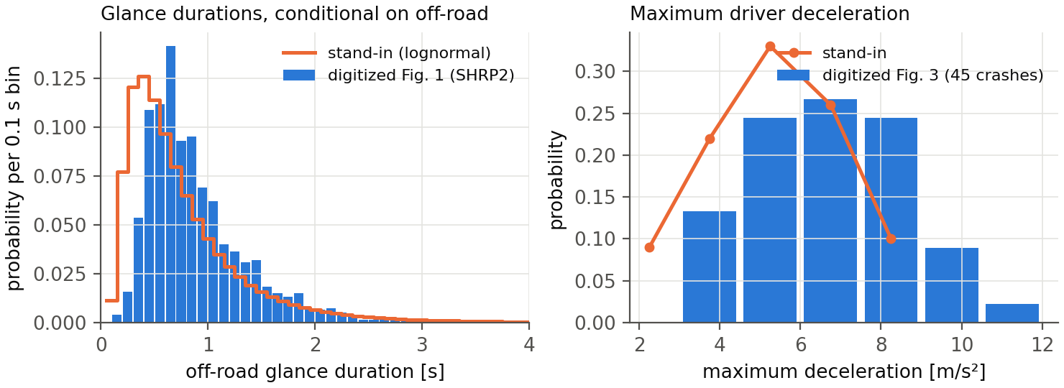
Digitized input distributions against the earlier stand-ins
The digitized glance distribution is close to the earlier lognormal stand-in (mode ~0.2 s later); the deceleration distribution is not — the real one has 24% of its mass at 7.5 m/s² and harder, where the stand-in had almost none. All results below use the digitized distributions.

3 Crash generation
Full population (all 5 000 seeds, 2026-08-25). With the no-brake counterfactual, process glances for the active-inference conditions, anchored glances for the CBM control, and 10 process draws per seed:
condition | response | components | seeds crashing (any draw) | weighted crash probability
A | active inference | decel. cap | 1 635/5 000 | 0.156
B | active inference | glances, decel. cap, no-response | 3 854/5 000 | 0.280
C | CBM (control) | glances, decel. cap, no-response | 4 705/5 000 | 0.059
D | active inference | glances, decel. cap | 3 854/5 000 | 0.280
(The earlier 100-seed tables’ “weighted crash prob” column was normalized against the full reference weight and is therefore a share, not a rate; the population rates above supersede it. Ratios between conditions were and remain comparable.)
- An attentive active-inference driver avoids 67% of the QUADRIS crash population (3 365 of 5 000 seeds) across the full deceleration sweep; the rest are the kinematically hard core, concentrated at short headways.
- The response process drives a factor ~4.7 in crash probability (B 0.280 versus C 0.059 with identical components), from timing: the active-inference accumulator’s attentive onsets sit at a median 1.25 s after the τ⁻¹ = 0.2 s⁻¹ anchor (IQR 0.50–1.75 s) against the CBM’s fixed 0.50 s (section 5).
- The crash rate was initially sensitive to the accumulator’s starting level (zero start 0.023 versus 0.004 with a “stationary” half-threshold start), but the tier-2 arbiter run has resolved the convention in favor of the zero start (section 5): the closed-loop model’s own onsets match the zero-start surrogate to a median 0.42 s across 24 seeds and reject the stationary start on 20 of 24. The 0.023 figure stands; the stationary variant remains in the outputs as a tested-and-rejected sensitivity.

4 Comparison with the original data

4.1 Summary statistics (full population)
Weighted medians (weighted mean for P_inj); reference weighted by ω, conditions by the Eq. 10 crash weights; all conditions on all 5 000 seeds:
 | rel. speed at impact [m/s] | mean P_inj | follower a_min [m/s²]
QUADRIS reference (n = 5 000) | 3.54 | 0.0062 | −1.03
B: active inference | 3.33 | 0.0052 | −3.46
C: CBM control | 3.34 | 0.0050 | −3.75
B + abnormal acceleration | 3.63 | 0.0069 | −0.05
C + abnormal acceleration | 3.63 | 0.0068 | −3.75
The 100-seed sample’s over-production of mild crashes (its B median relative impact speed was 1.88 m/s) largely dissolves at full population — it was substantially a property of the weight-proportional sample, which concentrates on the common, benign seeds. Severity medians now sit within 0.2 m/s of the reference for B and C alike, and within 0.1 for the abnormal variants; the abnormal component overshoots the mean injury risk slightly (+11%) where it landed exactly on it in the sample.

4.2 Distributions
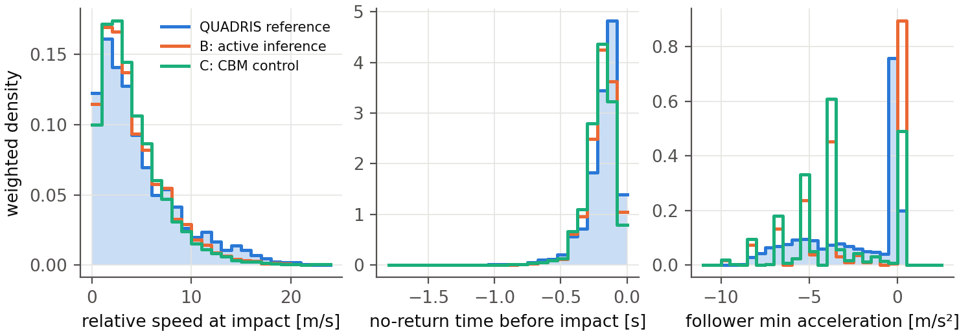
Weighted metric distributions: reference vs conditions B and C
- Severity (relative speed at impact). At full population both response models track the reference across the entire severity range — the distributions nearly overlay, with B marginally under-producing the extreme tail and C marginally over-producing the 2–6 m/s range. (The figure shows the full-population run.)
- Urgency (t_nr). Essentially inherited from the seeds by both models, as before.
- Braking (follower minimum acceleration). The remaining structural difference. Condition B reproduces — indeed slightly overshoots — the reference’s dominant non-braking spike (crashes in which a glance or the no-response class covers the conflict); condition C cannot produce it and instead concentrates on its discrete hard-braking values from the deceleration bins. This is the panel that keeps a_f,min from passing for any configuration, and it separates the two response models more clearly than severity does.

4.3 Equivalence at full population
Headline θ (Eq. 10 weights, 95% bootstrap HDIs), all 5 000 seeds; full tables in replication/causation/out/summary_fullp.md and summary_fullp_abn.md:
configuration | P_inj / v_rel θ | t_nr θ | a_f,min θ
B: active inference | 0.31 [0.26, 0.35] | 0.38 [0.33, 0.45] | 1.00
C: CBM control | 0.39 [0.35, 0.42] | 0.43 [0.38, 0.51] | 1.65
D: glances only | 0.44 [0.39, 0.47] | 0.38 [0.33, 0.45] | 1.13
B + abnormal acceleration | 0.148 [0.110, 0.204] | 0.42 [0.37, 0.47] | 1.06
C + abnormal acceleration | 0.209 [0.176, 0.244] | 0.46 [0.42, 0.50] | 1.38
The intervals for the two abnormal-component rows were regenerated 2026-08-26 under the conventions settled in section 4.3b; point estimates are unchanged throughout. The first three rows still carry pre-correction intervals and are marked as such below.
Three things changed against the 100-seed sample. First, everything tightened and most things improved — the sample’s widest HDIs were sampling noise. Second, the ordering reversed: the active-inference conditions are now closer to the reference than the CBM control on severity (B 0.31 versus C 0.39; with the abnormal component 0.148 versus 0.209) — the control’s advantage in the sample did not survive the population, and the ordering is confirmed as a paired difference in section 4.3b-ii. Third, the best configuration — active inference with all five components — reaches P_inj θ = 0.148, down from the factor of 14 the study started from. Whether that constitutes practical equivalence depends on a threshold this document no longer inherits: against the project’s adopted θthd = 0.188 the point estimate passes but the interval’s upper end does not (section 4.3b). The braking distribution (a_f,min) remains the largest departure for every configuration, though section 4.3c shows that its θ overstates the case badly.

4.3b How the intervals above were produced, and a correction (2026-08-26)
The bootstrap used to produce the credible intervals in section 4.3 drew reference values with probability proportional to their weight and then treated the resample as unweighted. That gives the precision of 5 000 independent draws. The QUADRIS reference is weighted strongly enough that its effective sample size is 950, not 5 000 — the top 10% of scenarios carry 54% of the weight — so the correct nonparametric bootstrap resamples the scenarios uniformly and carries their weights.
Consequence: every HDI produced before that date is too narrow, by roughly a factor of two. On the severity metric the 95% upper bound for a model that is exactly right moves from 0.075 to 0.177 at N = 5. Point estimates of θ and Θ are unaffected, so the comparison this study rests on — condition B closer to the reference than condition C — is unchanged, as are all the per-bin diagnostics.
What has and has not been regenerated. The two abnormal-component rows of section 4.3, the section 4.4 bin sweep and the summary files in replication/causation/out/ have been regenerated under the conventions below. The first three rows of section 4.3 (conditions B, C and D without the abnormal component) and the 100-seed sensitivity ladder still carry pre-correction intervals; their point estimates stand, their intervals should be read as roughly half as wide as they should be, and they are retained because nothing in the argument depends on them.
Resolution (2026-08-26). The defect prompted a decision that had been left implicit: whether the 5 000 QUADRIS scenarios are the target population or a sample from the generator. The project’s convention is now the former, on the grounds that this study compares response processes on a fixed, shared ensemble (docs/equivalence_rope_note.md §2.5). equivalence_test therefore defaults to resample="population", which fixes the bin edges and reference proportions and resamples only the synthetic side; resample="cases" implements the sample reading for any claim that generalizes beyond the ensemble, and resample="values" is retained solely to reproduce pre-correction numbers. The tables in section 4.3 have been regenerated under the population convention and now read:
condition | severity θ | 95% HDI | severity Θ | 95% HDI
B: active inference | 0.148 | [0.110, 0.204] | 0.091 | [0.068, 0.117]
C: CBM control | 0.209 | [0.176, 0.244] | 0.150 | [0.132, 0.166]
The noise floor under this convention is about 0.021, so these intervals describe the model rather than the instrument. Against the project’s adopted thresholds (θthd = 0.188, Θthd = 0.089, from a 10% tolerance on the injury-weighted mean) condition B misses practical equivalence on the upper end of its interval, and condition C misses on every reading.

4.3b-ii The B-versus-C ordering, tested as a difference (revised 2026-08-27)
The quantity the study’s claim concerns is the difference θ_C − θ_B, so that is what should carry an interval — comparing overlapping marginal HDIs would understate the evidence where the two estimates share uncertainty (under the sample reading they share the reference draw), and can mislead in either direction.
Correction. The first version of this section (2026-08-26) reported the difference as 0.061 with a 95% HDI of [0.037, 0.107] and a unanimous sign, from an analysis that resampled the reference while holding both synthetic sides fixed. That omits the synthetic-side sampling variance, which is independent between the conditions and does not cancel in the difference; the certainty was overstated by exactly the kind of incomplete uncertainty accounting section 4.3b corrects. The analysis is now committed (replication/causation/paired_difference.py, 1 000 draws) and runs all three schemes:
scheme | mean θ_C − θ_B | 95% HDI | P(θ_C > θ_B)
reference-only (the 2026-08-26 analysis; incomplete) | 0.071 | [0.039, 0.110] | 0.998
population convention (reference fixed, synthetic sides resampled) | 0.055 | [−0.006, 0.110] | 0.970
cases (shared reference draw + synthetic resamples) | 0.068 | [0.001, 0.147] | 0.972
Point estimate: 0.061. Under the project’s own population convention the ordering has a posterior probability of about 0.97, with an HDI that grazes zero. That is strong support, not proof: the correct statement is that the ordering is consistent in point estimates at every bin count (section 4.4) and holds with ~0.97 probability under the settled uncertainty convention — no longer “the same sign on every resample”. Two mitigating observations: θ is a bootstrap-biased maximum statistic and the bias is larger for B’s smaller crash-record count, which pushes the resampled difference down relative to the point estimate; and the ordering is corroborated independently of θ by the braking aggregate (section 4.3c: B within 0.3% of the reference where C over-brakes by 35%), which does not involve binning at all.
The paired/difference form remains the right one for any future comparison between conditions; the lesson added by the correction is that the synthetic sides must be resampled too.

4.3c Weighted aggregates, reported directly (added 2026-08-26)
Because θ and Θ constrain only the allocation of mass between bins, the readout now also reports the weighted aggregate of each metric. The “binned” column is the bin-constant approximation, which is the only quantity Θ bounds; where it diverges from the actual column, the difference is within-bin and invisible to both statistics.
metric | reference | B | B rel. err. | C | C rel. err.
P_inj | 0.00615 | 0.00693 | +12.6% | 0.00679 | +10.4%
relative speed at impact [m/s] | 4.788 | 4.862 | +1.6% | 4.775 | −0.3%
t_nr [s] | −0.1877 | −0.1986 | +5.8% | −0.2094 | +11.6%
a_l,min [m/s²] | −1.981 | −2.195 | +10.8% | −2.104 | +6.2%
a_f,min [m/s²] | −2.379 | −2.371 | −0.3% | −3.214 | +35.1%
Three readings, two of them new.
- The braking metric separates the two response models far more sharply than θ does. θ was 1.058 for B and 1.380 for C, both looking catastrophic and neither interpretable (section 4.3b and docs/severity_vs_timing.md explain why: a 48% atom at zero collapses two of the five quantile edges). The weighted mean says something clean instead: condition B reproduces the reference’s mean follower braking to within 0.3%, while the CBM control over-brakes by 35%. This is the strongest single statement of the finding that only the active-inference conditions reproduce the reference’s dominant non-braking crash character, and it was invisible in the θ column.
- Severity is reproduced far better than the injury-risk figure suggests, and the two disagree about which condition is closer. Mean relative speed at impact is within 1.6%
- (B) and 0.3% (C) of the reference, while mean injury risk is 10–13% high for both. P_inj is a logistic transform of the same variable, so the discrepancy is entirely the convexity: injury risk is a tail statistic and relative speed a location statistic. Condition C is the clearest case — its mean relative speed is 0.3% below the reference while its mean injury risk is 10.4% above, which is only possible through a heavier tail. This is a concrete argument for operationalizing severity on relative speed at impact, the assumption-free primitive, rather than on a derived injury model.
- θ and the aggregate answer different questions and need not agree. On severity θ ranks B closer (0.148 versus 0.209) while the mean ranks C marginally closer (+1.6% versus −0.3%). There is no contradiction: θ measures distributional shape at its worst bin, the mean measures location. Both should be reported.

4.4 Bin-count sensitivity (added 2026-08-26)
The tables above use N = 5 quantile bins. That is what [W26] Eq. 4 gives for a 100–200 scenario reference — the size this study had when the assessment code was written, and the size of the paper’s own demonstration — but at the full population the same rule gives N = min(⌊5000/40⌋, 20) = 20. Since θ is a worst-bin statistic it tightens with finer bins, so the headline numbers sit on the lenient side of the paper’s prescription. Re-running the readout from the stored condition outputs (replication/causation/bin_sensitivity.py, no re-simulation):
metric | B, N=5 | B, N=10 | B, N=20 | C, N=5 | C, N=10 | C, N=20
severity (P_inj = v_rel) θ | 0.148 | 0.241 | 0.275 | 0.209 | 0.255 | 0.352
severity Θ | 0.091 | 0.091 | 0.165 | 0.150 | 0.150 | 0.168
t_nr θ | 0.419 | 0.636 | 0.636 | 0.460 | 0.623 | 0.699
a_l,min θ | 0.314 | 0.314 | 0.786 | 0.254 | 0.254 | 0.591
a_f,min θ | 1.058 | 3.983 | 3.983 | 1.380 | 2.165 | 4.456
Three readings:
- The study’s headline survives the bin count. The active-inference condition is closer to the reference than the CBM control on severity at every N (0.148 vs 0.209, 0.241 vs 0.255, 0.275 vs 0.352), and on the braking distribution at every N. The ordering is what this study rests on, and it is not an artifact of the coarse binning. The caveat is that at N = 10 and N = 20 the HDIs of the two conditions overlap substantially, so the ordering is consistent in point estimates without being statistically separated there.
- Absolute distances grow with N, roughly doubling for severity between N = 5 and N = 20. Any absolute claim must state its bin count.
- N = 20 is prescribed but unusable at this reference size. A model that is exactly right has median θ = 0.129 with a 95% HDI upper bound of 0.266 at N = 20 (docs/equivalence_rope_note.md §2.1), so nothing can pass a ROPE of 0.10 there. The bin rule and the ROPE threshold are jointly infeasible at n_ref = 5 000 under the decision rule used here. Section 5 of that note proposes what to change.
Two incidental corrections to assumptions made when this readout was built. Θ is not bin-count invariant — it is a lower bound on twice the total-variation distance that becomes exact only as the partition refines, so it grows with N. Further, θ is a maximum over bins and is therefore biased upward under resampling; under the cases resampling at N = 20, condition B’s bootstrap HDI [0.347, 0.773] does not contain its own point estimate of 0.275. (Corrected 2026-08-27: the first version quoted [0.275, 0.552] from an intermediate run. Under the settled population convention the regenerated N = 20 HDI is [0.263, 0.389], which does contain the point estimate — the bias is driven by reference resampling and is mild when only the synthetic side is resampled. The stored sweep, summary_bin_sensitivity_fullp_abn.md, is now generated under the population convention.) Both effects make the “HDI upper bound inside the ROPE” rule more conservative at fine bin counts than it looks.

The sensitivity ladder (100-seed sample, kept as method history)
No configuration reaches practical equivalence (ROPE 0.10 for θ; full tables in replication/causation/out/summary_nb*.md), but the distance now has a visible structure. Headline θ for P_inj (= relative impact speed; the two give identical bins), Eq. 10 weights, 95% bootstrap HDIs:
configuration | P_inj θ | t_nr θ | a_f,min θ
B, embedded-evasive counterfactual (superseded) | 1.44 | 0.66 | 1.00
B, no-brake counterfactual, anchored glances | 0.87 [0.82, 0.99] | 0.40 | 1.04
B, + process glances (primary) | 0.61 [0.55, 0.76] | 0.41 | 1.18
B, + abnormal acceleration | 0.46 [0.41, 0.60] | 0.30 | 1.37
B, process, stationary accumulator | 0.42 [0.29, 0.52] | 0.39 | 1.00
C, no-brake, anchored (CBM-native) | 0.40 [0.36, 0.46] | 0.41 | 1.81
C, + process glances | 0.63 [0.44, 0.74] | 0.51 | 1.61
C, + abnormal acceleration | 0.59 [0.42, 0.71] | 0.45 | 1.35
Readings:
- Each methodological correction moved condition B toward the reference: removing the embedded evasive action (1.44 → 0.87), placing glances as a process (→ 0.61), adding the abnormal-acceleration component (→ 0.46). The remaining distance is dominated by the over-produced mildest-severity bin.
- The best active-inference configurations now sit at the CBM control’s level (θ ≈ 0.4–0.5 for both) — the response-model gap visible in the first analysis was largely an artifact of the embedded evasive action and the anchor-locked glances. What still separates the two models is where they miss: B misses on mild crashes, C on moderate ones and on the braking distribution (a_f,min θ 1.4–1.8 versus B’s 1.0–1.4).
- The abnormal-acceleration component works as intended: it restores the reference’s mean injury risk exactly for B (0.0063 vs 0.0062) by adding the harder, non-braking crashes the four [B24] mechanisms cannot produce. Its cost is a slight overshoot for C.

4.5 The counterfactual rule barely matters
Clamping the follower’s braking from t = 0 instead of from the lead’s onset changes B’s P_inj θ from 0.87 to 0.82 and C’s from 0.400 to 0.396 (anchored glances) — the choice of clamp rule is not a consequential degree of freedom.

4.6 What the process placement buys, against its cost
For the active-inference response, process glances improve severity equivalence substantially (P_inj θ 0.87 → 0.61) besides being theoretically required (the anchored construction assumes the response cannot depend on pre-anchor glance history, which is false for an accumulator). For the CBM, the anchored construction — which is exactly Markkula’s shortcut for a fixed-delay responder — performs better than the process variant (0.40 vs 0.63), partly because the process run’s smaller crash-record count (2 076 vs 11 587) widens its uncertainty. Cost: 50 draws per seed versus ~12 bins, minutes either way at tier 1. Conclusion: process placement for active inference, anchored placement for the CBM, each on its own merits; the 50-draw budget is marked for a later increase, which mainly tightens the process runs’ HDIs.

5 Response timing
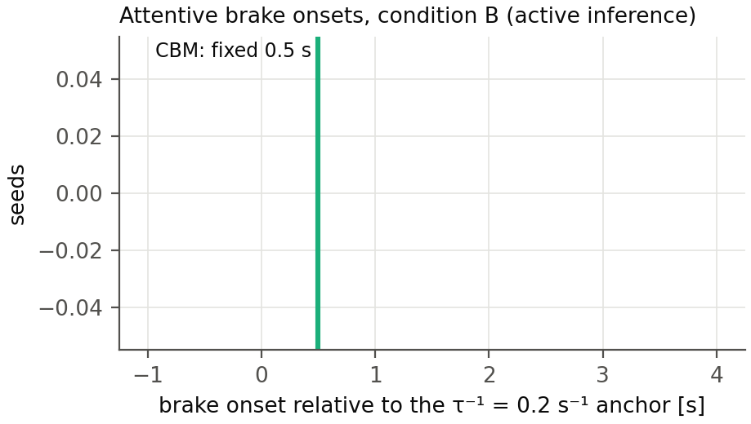
Attentive brake onsets relative to the anchor
Attentive onsets: active inference median 1.25 s after the anchor (IQR 0.50–1.75 s), CBM fixed at 0.50 s. Ten of 100 seeds respond before the anchor — all within 0.45 s of it, all after the lead’s braking onset, concentrated at short initial headways — so the active-inference model treats the anchor as nothing special, responding to sub-threshold looming when the gap is short.
The arbiter verdict (2026-08-25). The response-timing claim was initially bracketed by the accumulator’s starting convention: zero start (the paper’s) versus a “stationary” half-threshold start representing a driver arriving mid-cycle from long steady following; crash probability 0.023 versus 0.004. The tier-2 arbiter run — the full closed-loop model on 23 seeds spanning 1.3–35.5 m/s, four repeats each, lead profiles replayed (replication/causation/tier2/arbiter_comparison.csv) — settles it:
comparison (attentive onsets, n = 24 seeds) | median difference | median |difference| | closer on
closed loop − tier-1 zero start | +0.42 s | 0.55 s | 20/24 seeds
closed loop − tier-1 stationary start | +1.03 s | 1.08 s | 4/24 seeds
The closed loop behaves like the zero start — if anything it responds slightly later than the zero-start surrogate, so the stationary correction points the wrong way. The scope of the verdict should be stated precisely: it validates the zero start for this study’s design, in which simulation windows open a few seconds before the conflict at mostly comfortable headways, so the closed loop’s benign drift accumulates little before the event. What a driver carries after minutes of continuous short-gap following is a question neither tier answers, because both open their windows near the conflict; within this design it is a non-issue by construction. Consequently the zero-start results are the study’s results, and the conclusion stands: the active-inference response is slower and more variable than the CBM’s fixed rule — confirmed, not contradicted, by the closed loop.
A deliberate non-action: the +0.30 s median offset between the closed loop and the surrogate could be folded into the surrogate as a calibration correction. We do not do this. Twenty-three seeds are a thin base to fit on, the offset is well inside the response-time dispersion the study is about, and an untuned surrogate landing within 0.55 s median absolute difference is a stronger validation statement than a tuned one landing on zero [Opinion].

6 The closed loop is not the CBM with extra steps: the glance-gate finding
The tier-2 adapter (plan §11.4) runs the authors’ full closed-loop model on QUADRIS seeds with the lead replaced by a replay of the seed’s speed profile, and can force off-road glances through the code’s own observation gate (I_factor, the mechanism of the Engström et al. 2024 visual time-sharing model).
Forcing a 1.0–3.0 s off-road glance during the conflict did not delay the response. On the test seed the driver braked at 2.4–2.6 s — inside the glance — both under the shipped observation-noise factor (3) and under an effectively total gate (factor 1000). The reason is architectural: the lead’s braking had been registered before the glance began, and during the glance the belief cloud coasts forward on its own norm-shaped prediction, so the evidence accumulator keeps filling from remembered and extrapolated evidence. Looking away blocks new observations; it does not stop inference.
The CBM assumes the opposite: no information accumulates while the eyes are away, and no response can begin until 0.5 s after they return [B24]. The two architectures therefore make divergent, testable predictions that depend on glance timing:
- glance covering the conflict onset → both models delay the response until (or beyond) eyes-return; they roughly agree;
- glance beginning after the onset has been registered → the CBM still waits for eyes-return + 0.5 s, while the active-inference driver responds mid-glance on extrapolated evidence.
Naturalistic glance-conditional response data could separate these — drivers who brake while still looking away (or within less than 0.5 s of looking back) in late-glance conflicts would favor the active-inference account. To our knowledge the existing glance-response literature conditions on eyes-off at conflict onset and does not isolate the late-glance case [Opinion]. The tier-1 pipeline mirrors the distinction explicitly: its evidence gate at weight 0 reproduces the CBM assumption, the Svärd et al. partial looming weight is an intermediate, and the tier-2 precision gate is the full active-inference behavior.

7 The pre-selection (exposure) critique, quantified
Applying causation mechanisms to crash-conditioned seeds answers “what does this driver do in situations that crashed for the generator’s driver”, not “what crashes does this driver produce in traffic”. Three numbers from this study’s own runs bound how far the two questions are apart:
- Support loss: at full population, 295 of 5 000 seeds never crash under the CBM control at any glance or deceleration draw; they drop out of any exposure reweighting entirely (13 of 100 in the sample).
- Effective sample size: exposure reweighting (dividing each weight by its crash probability) leaves an effective sample size of 44.7 out of 5 000 (6.9 out of 100 in the sample). Fifty times more seeds bought a factor of six in effective size — the reweighting’s variance grows with exactly the benign scenarios the crash filter removed, so exposure-level claims stay out of reach of crash-only seeds at any practical n.
- Directional bias: the missing scenarios are the long-headway, mild-conflict ones in which crashes occur only through glances or non-response — for a glance-causation study, the worst possible region to lose.
The B-versus-C contrast is far more robust to this critique than any absolute number, because both response models face the identical conditioned ensemble. Absolute crash rates and severity distributions inherit the full bias. The proper fix is upstream: the pre-filter scenario set (or the fitted scenario-generation models) of [W25a], requested from its author; the 82 real SHRP2 near-crashes in the QUADRIS release are an intermediate exposure extension available now.

8 Conclusions
- The pipeline now runs the complete design: five switchable causation components, two response processes, digitized real input distributions, a defensible counterfactual, process-placed glances, and the full [W26] readout with the assumption-free severity metric.
- At full population, the active-inference conditions are closer to the QUADRIS reference than the CBM control on severity (θ 0.31 versus 0.39; with the abnormal component 0.148 versus 0.209), despite generating 4.7 times its crash probability (0.280 versus 0.059) — slower responses produce more crashes, but the right crash population. The ordering is strongly supported rather than a point-estimate impression, though not beyond doubt: tested as a difference, θ_C − θ_B = 0.061 with P(θ_C > θ_B) ≈ 0.97 under the settled uncertainty convention, an HDI that grazes zero (section 4.3b-ii, corrected 2026-08-27), consistency in point estimates at every bin count, and independent corroboration from the braking aggregate (section 4.3c). The best configuration still misses practical equivalence on severity — θ = 0.148 [0.110, 0.204] against the project’s adopted θthd = 0.188, failing on the interval’s upper end — but it misses by a margin the reference can resolve, and down from the factor of 14 the study started at. Only the active-inference conditions reproduce the reference’s dominant non-braking crash character. 2b. The braking metric was misreported, in both directions. Its θ of 1.06 (B) and 1.38
- (C) is largely an artifact of quantile bins collapsing onto a 48% atom at zero (docs/severity_vs_timing.md). Measured on the weighted mean instead, condition B reproduces the reference’s follower braking to within 0.3% while the CBM control over-brakes by 35% — a far sharper separation than θ ever showed (section 4.3c).
- The active-inference response-timing claim is settled by the tier-2 arbiter: the closed loop matches the zero-start surrogate (median difference +0.42 s, 20/24 seeds closer) and rejects the stationary start, so the active-inference response is slower and more variable than the CBM’s rule, with the tier-1 surrogate validated untuned to a median absolute onset difference of 0.55 s across 1.3–35.5 m/s.
- The architectural finding stands: evidence gating versus inference gating during off-road glances is a real, behaviorally testable difference between the CBM and active inference (section 6).
- Equivalence in the strict ROPE sense is not reached by any configuration — as it was not by the SCM in [W26] — and section 7’s numbers show that exposure-level claims are outside what crash-conditioned seeds can support at any n.
- The equivalence criteria themselves needed work before that verdict meant anything (section 4.3b, docs/equivalence_rope_note.md). Our original configuration could not be passed by a model that is exactly right, for three compounding reasons: uniform bin weights applied a tolerance calibrated for a far more severe crash population, our weighted bootstrap understated the spread by about a factor of two, and the reference was treated as a sample rather than as the target set. With those settled — the QUADRIS 5 000 taken as the target population, thresholds derived from a stated 10% tolerance on the injury-weighted mean rather than inherited — the noise floor falls to about 0.021 and the verdicts describe the model. A standing caution follows: θ and Θ constrain only how mass is allocated between bins, so the weighted aggregate must be reported alongside them, as section 4.3c now does.

9 Limitations and next steps
- Glance and deceleration distributions are digitized from published figures; the actual SHRP2 bins would remove the residual digitization error and the truncated glance tail. The abnormal-acceleration onset-time distribution of [W25a] is unpublished; the component applies its acceleration from the lead’s braking onset instead.
- The full-population runs use 10 process draws per seed (seed-level variation dominates at n = 5 000; the 100-seed sensitivity runs used 50). The QUADRIS reference is itself model-generated, so all equivalence statements are relative to that generator.
- The accumulator-initialization question is closed for this design (section 5); what a driver carries into a conflict after minutes of continuous short-gap following remains outside both tiers’ windows, and would matter for study designs with long run-ins.
- The stopped/creeping-follower seeds (20 of the 100-seed sample) have now run in tier 2 under the desired-speed convention of 2026-08-25 (the speed the original follower later reached), and the result is a finding rather than a fix: these are both-stationary queue scenarios — the lead also stands still — whose original crashes came from the generator’s abnormal-acceleration mode driving into the queue (56% of both-stationary cases in [W25a]’s own statistics). The closed-loop driver, correctly, stays put: no attentive response process can produce these crashes, because there is no conflict to respond to. They are reachable only through the abnormal-acceleration and no-response components, which is how the tier-1 pipeline treats them; in the arbiter comparison they contribute no attentive onsets and are excluded automatically.
Regeneration: the tagged commands are in replication/causation/out/log_nb*.txt; figures by replication/causation/make_results_figures.py --tag nbp; this document by docs/build_pdf.py docs/crash_causation_results.md.

