Why severity matches while timing and braking do not
Written 2026-08-26. Companion to docs/crash_causation_results.md, which reports the numbers this document explains. Parts of it are intended for the handbook (chapter 08). Figures are generated by replication/causation/make_dissociation_figure.py and replication/causation/severity_vs_timing.py; every number below comes from the full-population runs on all 5 000 QUADRIS seeds.

The puzzle
The full-population readout for condition B (active inference with all five causation components) against the QUADRIS reference looks internally inconsistent at first reading:
The thresholds quoted in the table below are Wu’s published pair, which is what the study used when this puzzle surfaced. The project has since derived its own (θthd = 0.188, Θthd = 0.089) and settled how the reference is treated — see docs/equivalence_rope_note.md. Nothing in this document’s argument depends on the threshold: the puzzle is why the metrics disagree with each other, not where any of them falls relative to a line.
metric | θ | Θ | verdict against ROPE 0.10 / 0.05
severity (P_inj, v_rel, dv_lead) | 0.148 | 0.091 | close
urgency (t_nr) | 0.419 | 0.296 | far
lead braking (a_l,min) | 0.314 | 0.096 | far on θ
follower braking (a_f,min) | 1.058 | 0.802 | very far
The question this raises is fair: how can the outcome of the crashes be almost right while the timing of the response and the braking that produced them are so wrong? Severity is, after all, produced by the timing and the braking.
The short answer, as I read the runs, is that the four rows are not four comparable measurements. There are three separate things going on, and only one of them is a statement about the model:
- Severity genuinely is well reproduced, for a reason that is mechanistic rather than lucky: in this population, response timing determines how many crashes happen, while the scenario determines how hard they are.
- The t_nr and a_f,min rows are largely artifacts of the statistic, not measurements of model error. θ is a worst-bin relative deviation computed on quantile bins of the reference. That construction behaves well on a smooth continuous variable and badly on a variable that is a discrete lattice (t_nr) or that carries a large atom (a_f,min).
- Underneath the artifact there is a real but much smaller braking difference, which is worth reporting — just not as θ = 1.06.

1 Severity and timing are close to independent in this population
The clearest evidence is a comparison across conditions that differ enormously in how often they crash.
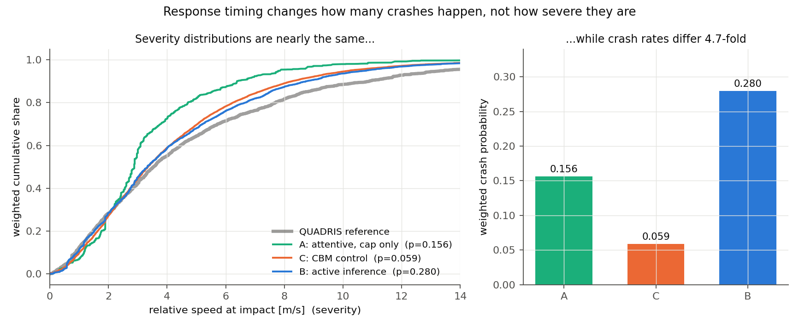
Severity distributions against crash rates
condition | weighted crash probability | v_rel p25 | p50 | p75 | mean P_inj
QUADRIS reference | — | 1.77 | 3.54 | 6.68 | 0.0062
A: attentive, deceleration cap only | 0.156 | 1.89 | 2.88 | 4.21 | 0.0040
B: active inference + glances, cap, no-response | 0.280 | 1.89 | 3.33 | 5.87 | 0.0052
C: CBM control, same components | 0.059 | 1.89 | 3.34 | 5.57 | 0.0050
B + abnormal acceleration | 0.280 | 1.97 | 3.63 | 6.49 | 0.0069
C + abnormal acceleration | 0.059 | 2.02 | 3.63 | 6.18 | 0.0068
Conditions B and C differ by a factor of 4.7 in crash probability (0.280 against 0.059) because their response processes differ: the active-inference accumulator’s attentive onsets sit at a median 1.25 s after the τ⁻¹ = 0.2 anchor, against the CBM’s fixed 0.50 s. That is a large timing difference, and it produces a large difference in crash count. It produces almost no difference in severity: the quartiles agree to within 0.30 m/s and the mean injury risk to within 4%.
The same point appears inside condition B. Splitting its crashes into quintiles of response-onset delay and asking how severe each quintile is:
onset delay vs anchor [s] | weighted median v_rel [m/s] | mean P_inj
−0.50 … 1.05 | 4.14 | 0.0052
1.05 … 1.45 | 3.35 | 0.0046
1.45 … 1.90 | 3.90 | 0.0053
1.90 … 2.85 | 3.78 | 0.0054
2.85 … 5.35 | 2.15 | 0.0043
The relationship is not monotone and the spread in mean injury risk across the whole range of onset delays is about 20%, against a five-fold range in the delay itself. A variance decomposition says the same thing: 71% of the variance in relative impact speed is between-seed, that is, inherited from the scenario, leaving 29% to the response timing and the Monte Carlo draws combined.
Why this happens. Two mechanisms seem to me to be at work, and they reinforce each other. First, all conditions run on the same 5 000 seeds, so everything the outcome inherits from the scenario — the lead’s braking profile, the initial gap and speed — is matched by construction. Second, and more interestingly, impact severity saturates. Once the response is late enough to produce a crash at all, being later adds little, because the closing speed is already close to what the geometry allows. Responding earlier does not make crashes milder so much as it removes them: the crashes that an earlier response eliminates are drawn from across the severity range, not from its top.
There is a corollary worth stating, because it cuts against a natural intuition: condition A is the exception that proves the rule. The attentive driver’s crashes are visibly milder (p75 = 4.21 against 5.87, mean P_inj 0.0040 against 0.0052). That is not a timing effect either — A differs from B by having no glances and no no-response class, so its crashes are all cases where a fully attentive driver braked and still hit. Severity in this population responds to whether the follower brakes at all, which is a question about the causation components, not to when it brakes, which is the question the response models disagree about. The abnormal-acceleration component moves severity most of all (median 3.33 → 3.63 m/s, mean P_inj 0.0052 → 0.0069), for the same reason: the follower is accelerating into the conflict rather than braking late into it.
So severity and response timing are measuring close to orthogonal things here. A model can be right about one and wrong about the other without contradiction.

2 Three of the four metrics are the wrong shape for θ
The second half of the explanation is that θ is not doing the same job in each row.
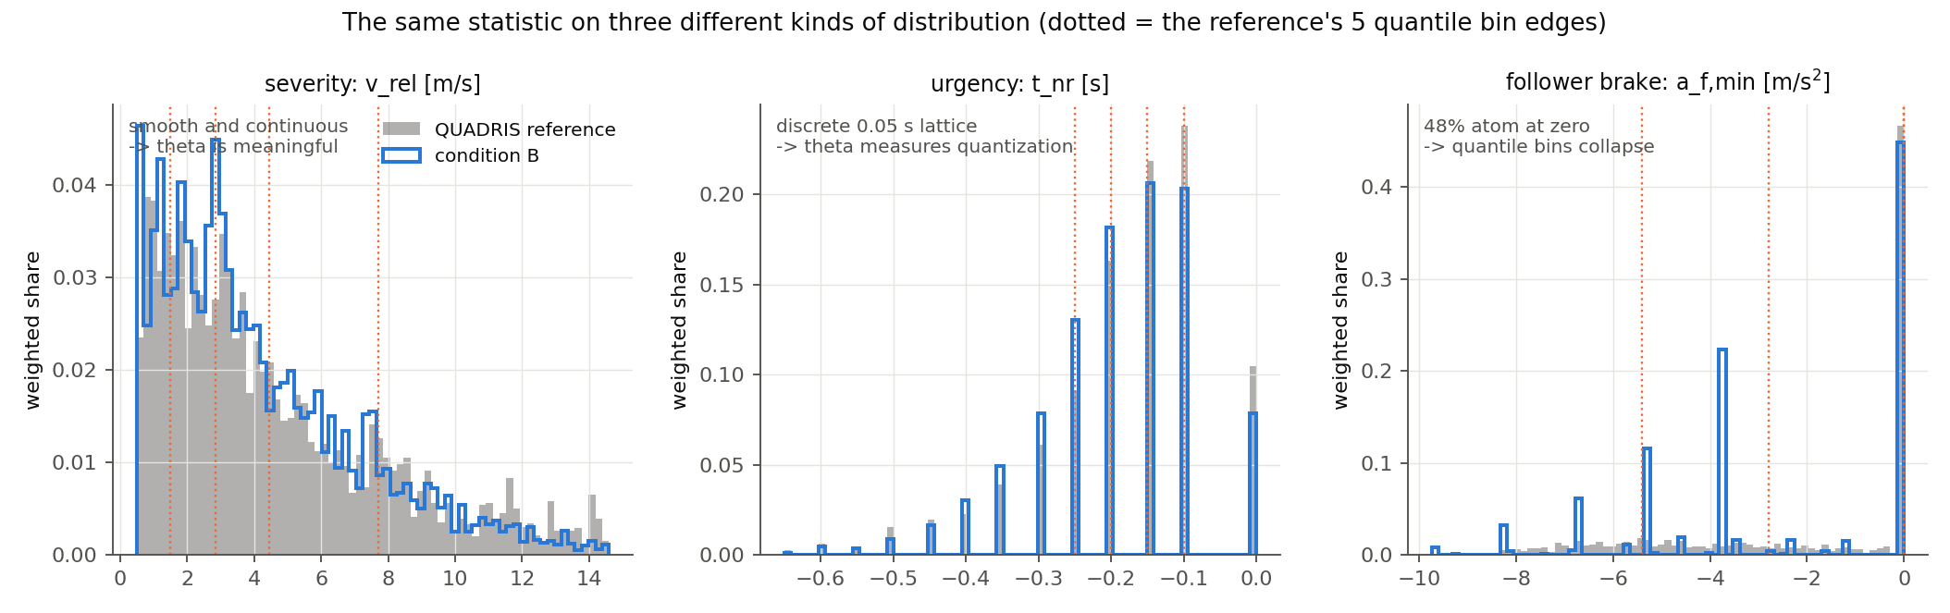
The same statistic on three kinds of distribution
Recall the construction: cut the reference into N quantile bins, apply the same edges to the model output, and take θ = max_i |ΔP_i / P_ref,i|. This assumes the reference can actually be cut into N pieces of equal weight. When it cannot, the statistic reports the failure of that assumption as if it were model error.
Severity is smooth and continuous. The bin edges land at 1.48, 2.84, 4.45 and 7.7 m/s, each bin holds almost exactly 20% of the reference, and the model’s shares are 0.174, 0.205, 0.212, 0.229, 0.180. θ = 0.148 is a real, interpretable statement: the worst bin is misallocated by 15% of its proper share. This row can be trusted.
t_nr is a discrete lattice. The no-return time is computed on the QUADRIS 20 Hz grid, and its reference distribution is a picket fence of spikes at multiples of 0.05 s — just 25 distinct values in the entire reference, against 45 in condition B. The quantile bin edges come out at −0.25, −0.20, −0.15 and −0.10 — successive lattice points. Bins cannot be equalized on a lattice, and indeed the reference shares are 0.184, 0.209, 0.140, 0.230, 0.236 rather than five 0.20s. What θ = 0.419 then measures is whether the model lands on the same 0.05 s grid points in the same proportions, which is a far finer question than any behavioral claim we would want to make. Looking at the middle panel of the figure, the reference and condition B track each other closely in shape; the disagreement θ reports is mostly quantization.
a_f,min is dominated by an atom at zero. This is the extreme case. In the reference, 48.0% of the weighted crash mass has a_f,min > −0.5 m/s² — crashes in which the follower essentially never braked, because a glance or the no-response class covered the conflict. A quantile cut cannot split an atom that large. The five bin edges come out as
-inf, -5.4, -2.8, -2.84e-14, -3.55e-15, +inf
The last two inner edges have collapsed onto zero. Bin 4 spans the interval [−2.84e-14, −3.55e-15] — numerically empty, yet holding 19.6% of the reference weight through floating-point ties — and condition B places 0.000 there, which yields θ = 1.000 for that bin mechanically. Bin 5 then gives 1.058. Neither number is a measurement of the model.

3 What the braking difference actually is
Comparing the same two distributions on quantities chosen in advance rather than on collapsed quantile bins:
 | no braking (a_f,min > −0.5) | moderate (−4, −0.5] | hard (≤ −4)
QUADRIS reference | 0.480 | 0.208 | 0.312
condition B | 0.502 | 0.259 | 0.239
relative difference | +4.6% | +24% | −23%
The headline that the results document already carries — condition B reproduces the reference’s dominant non-braking character — is confirmed and is in fact stronger than stated: the non-braking share agrees to within 4.6%, which would pass a ROPE of 0.10 comfortably. The real disagreement is a redistribution within the braking crashes: condition B produces too many moderate decelerations and too few hard ones, by roughly a quarter in each direction.
That is a genuine and explainable model difference. The follower’s deceleration magnitude is drawn from the digitized 45-crash maximum-deceleration histogram of Bärgman et al. (2024), which is a coarse discrete distribution: condition B produces 375 distinct a_f,min values against the reference’s 1 853, and only 275 distinct values among braking crashes against 1 799. The reference’s follower (a modified IDM plus the Svärd et al. brake-response model) brakes on a continuum; ours draws from about a dozen histogram bins and then executes a shared jerk-ramp. This is the a_f,min lever that the handover already lists as open item 4, and this analysis sharpens what it is: not a failure to reproduce non-braking, but a failure to reproduce the shape of the braking magnitude distribution, traceable to a discrete draw and a fixed execution model.
Re-running the same comparison on fixed physical bins (−∞, −6, −4, −2, −0.5, +∞) instead of reference quantiles separates the two contributions:
binning | θ | Θ
reference quantiles (as reported) | 1.058 | 0.802
fixed physical bins | 0.704 | 0.241
So roughly a third of the reported θ, and about two thirds of the reported Θ, was binning artifact; the remainder is the real discrete-draw difference. My reading is that a_f,min should be reported on fixed bins with the three-way summary above, and that the quantile construction should not be applied to it at all.

4 What I would change in how these results are reported
These are recommendations rather than findings, and I would want your view before acting on them:
- Report severity as one metric, not three. For the reference, v_rel is defined as 2 × dv_lead under the equal-mass assumption and P_inj is a deterministic logistic function of dv_lead (verified: maximum absolute difference 1.0e-16). The three rows are monotone transforms of one number and therefore share every bin and every θ. Printing them as three rows reads as three pieces of agreeing evidence when it is one.
- Do not apply θ to a metric with an atom or a lattice. Use pre-specified physical bins, and state them in advance. The equivalence module could refuse quantile binning when the reference’s largest tie exceeds 1/N of the weight, which would have caught a_f,min automatically.
- Report the dissociation as a result rather than an anomaly. That response timing moves crash count by a factor of 4.7 while leaving severity almost unchanged is, I think, one of the more useful things this study found. It says that a model validated only on crash severity distributions is close to unconstrained in its response timing, which matters for anyone using this kind of comparison to accept a driver model.

5 Caveats
- Everything above is conditioned on the QUADRIS crash-only seeds, so the independence of severity and timing is a property of this population and may not survive on unconditioned exposure. Section 7 of the results document bounds how far the two differ.
- The variance decomposition (71% between-seed) uses the Eq. 10 crash weights and treats the Monte Carlo glance draws as within-seed variation, so it mixes response timing with draw noise; it should be read as an upper bound on how much timing could explain.
- The t_nr lattice is shared, not a definitional mismatch: both sides use the same no_return_time function on the QUADRIS 20 Hz trajectories, and every value on both sides is an exact multiple of 0.05 s (verified). The quantization argument is therefore clean, and if anything understated — the reference has only 25 distinct t_nr values in total, so asking for five equally weighted quantile bins is asking for something the metric’s resolution cannot supply.

