The software in blocks: a map of the repository for jumping into the work
2026-09-16. Written at Jonas’s request for the two of us: what the software is, divided into blocks one can hold in the head, with a figure per block and the files to open. It explains structure and flow, not the science; the handbook (docs/handbook/) explains the model, and its chapter 12 gives the class-and-parameter table of the authors’ code. Where this document and the repository disagree, the repository wins. Figures are generated by docs/make_software_overview_figures.py into docs/software_overview_figures/; the Word and PDF versions are built from this markdown.

1 The whole thing in one picture
The repository does four kinds of work, on three kinds of input, and writes three kinds of output. The inputs are the papers, the authors’ released code with its data deposit, and human data. The engines are a reference model and our mirror of it, a library of surprise measures, the comfort-zone measurement method, and a crash-causation study; a sixth block moves work between sites that cannot share data. The outputs are tracked results, documents, and decks and tools. Underneath everything sits a floor of property tests and working rules.
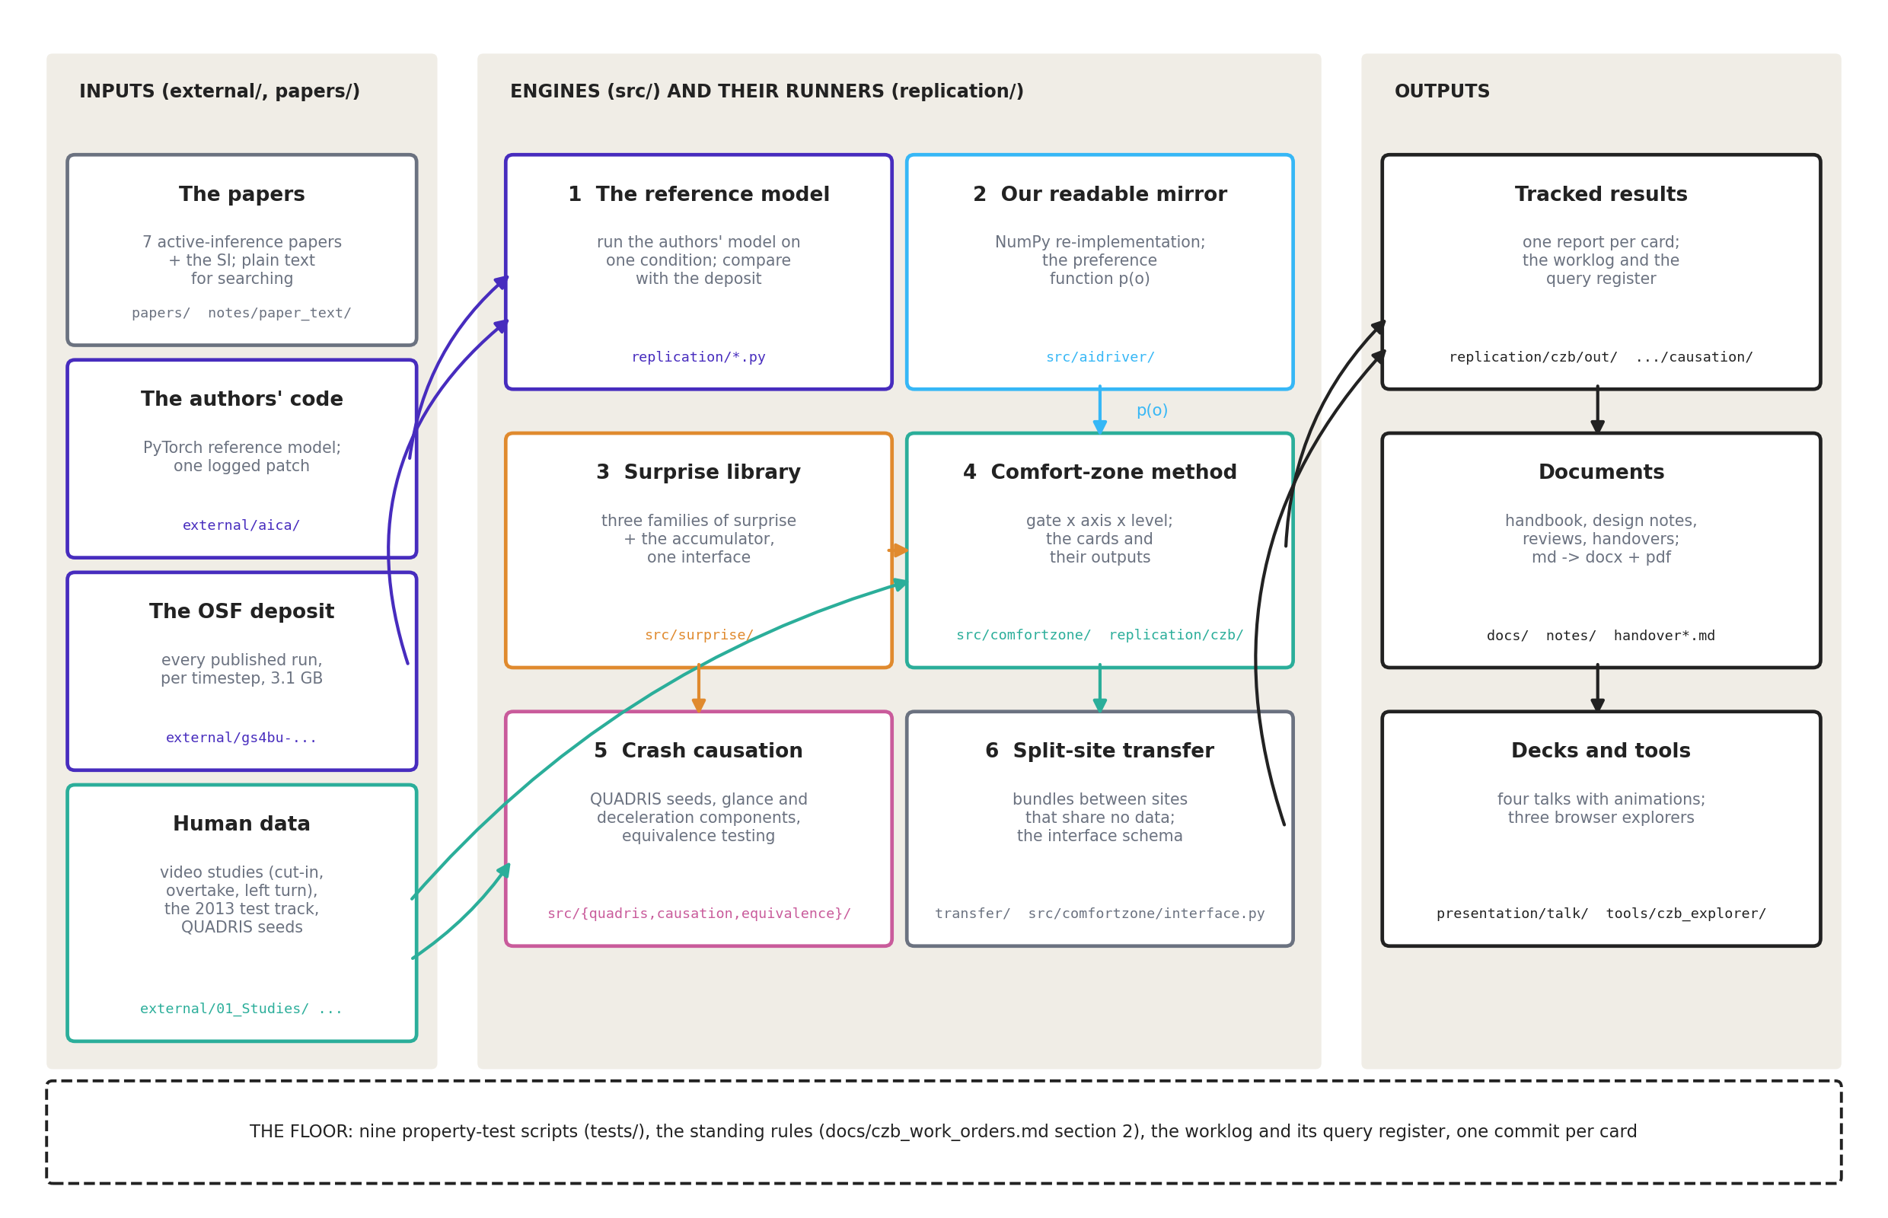
block | folder(s) | what it is for | first file to open | state
1 The reference model | external/aica/, replication/ | run the published model on one condition; compare with the paper and its deposit | replication/run_rear_end_single.py | works; two conditions replicated; one logged patch
2 Our readable mirror | src/aidriver/ | the same model in NumPy, readable and ablatable; supplies the preference function | src/aidriver/preferences.py | preferences verified; closed-loop timing not trusted
3 Surprise library | src/surprise/ | every surprise measure the papers use, on one interface | src/surprise/__init__.py | complete; 31 property tests
4 Comfort-zone method | src/comfortzone/, replication/czb/ | measure comfort-zone boundaries from human data: gate, axis, level, percentile | docs/handbook/13_glossary.md, then replication/czb/out/ | the current model of the project; two scenarios fitted
5 Crash causation | src/quadris/, src/causation/, src/equivalence/, replication/causation/ | crashes generated around an active-inference response and tested for equivalence | docs/crash_causation_results.md | complete study; the gaze probes GZ.1 and GZ.2 live here too
6 Split-site transfer | transfer/, src/comfortzone/interface.py | work with Volvo Cars without moving their data | transfer/README.md | ready; paused by Jonas 2026-09-11
Outputs | replication/*/out/, docs/, notes/, presentation/, tools/ | reports, documents, decks, explorers | handover.md | living
The floor | tests/, docs/czb_work_orders.md §2 | nine test scripts and the standing rules | handover.md §0 and §2 | 353 checks, all passing on 2026-09-16

2 Block 1: the reference model, and how it is replicated
The published model (Schumann et al., 2026) is a driver that senses, believes, predicts, evaluates and acts, once every 0.2 s, with a surprise accumulator that decides when to throw the current plan away. The authors’ PyTorch code is cloned unmodified under external/aica/ and is the ground truth for every number that will be compared or published. The figure names the file behind each stage.
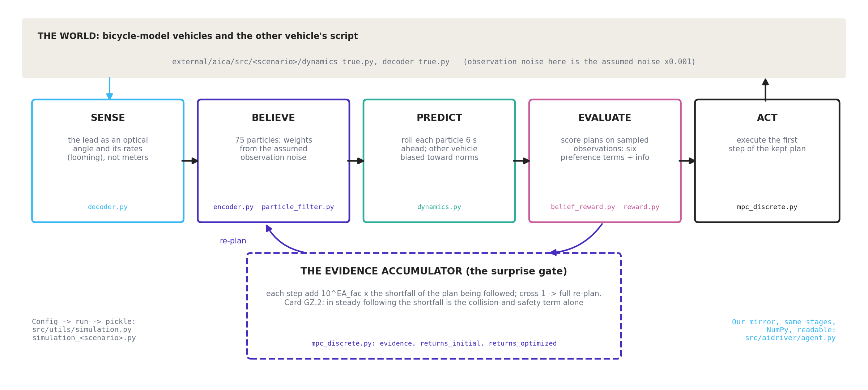
In plain words. The driver does not see the lead car in meters; it sees an optical angle and how fast that angle grows (decoder.py). It holds 75 hypotheses about where both cars are and what the lead is doing, weighted by how well each explains what was seen, given the noise the model assumes its senses have (encoder.py, particle_filter.py). Each hypothesis is rolled six seconds ahead with the other car biased toward normal behavior (dynamics.py). Candidate plans are scored on those imagined futures against six preferences and an information term (belief_reward.py, reward.py), and the first step of the best plan is executed (mpc_discrete.py). Meanwhile the accumulator adds up, every step, how far the plan being followed falls short of the preferred future; when the sum crosses one, the driver re-plans from scratch. That accumulator is the model’s response-time mechanism, and it is also the piece that card GZ.2 found re-planning by itself in steady following, driven by the collision-and-safety term alone (replication/causation/gz2/gz2_following_braking.md).
Two things about the code that are easy to get wrong. The observation noise scales in the configuration are the noise the model assumes; the world’s true observation noise is those values times 0.001 (simulation_benign.py, Decoder_true). The Supplementary Information and the released code disagree in more than a dozen places, listed in docs/method_review.md §5; the code wins, and src/aidriver/preferences.py documents each difference.
Replication runs the authors’ own simulate() for one condition at a time, because the paper’s grid costs about 18 s of CPU per simulated step per run here. Track A is that path; Track B is our mirror swept over the paper’s 28 conditions. Both are compared against the paper and against the OSF deposit, which holds the authors’ own per-timestep output for every published run and beats the printed figures whenever they disagree.
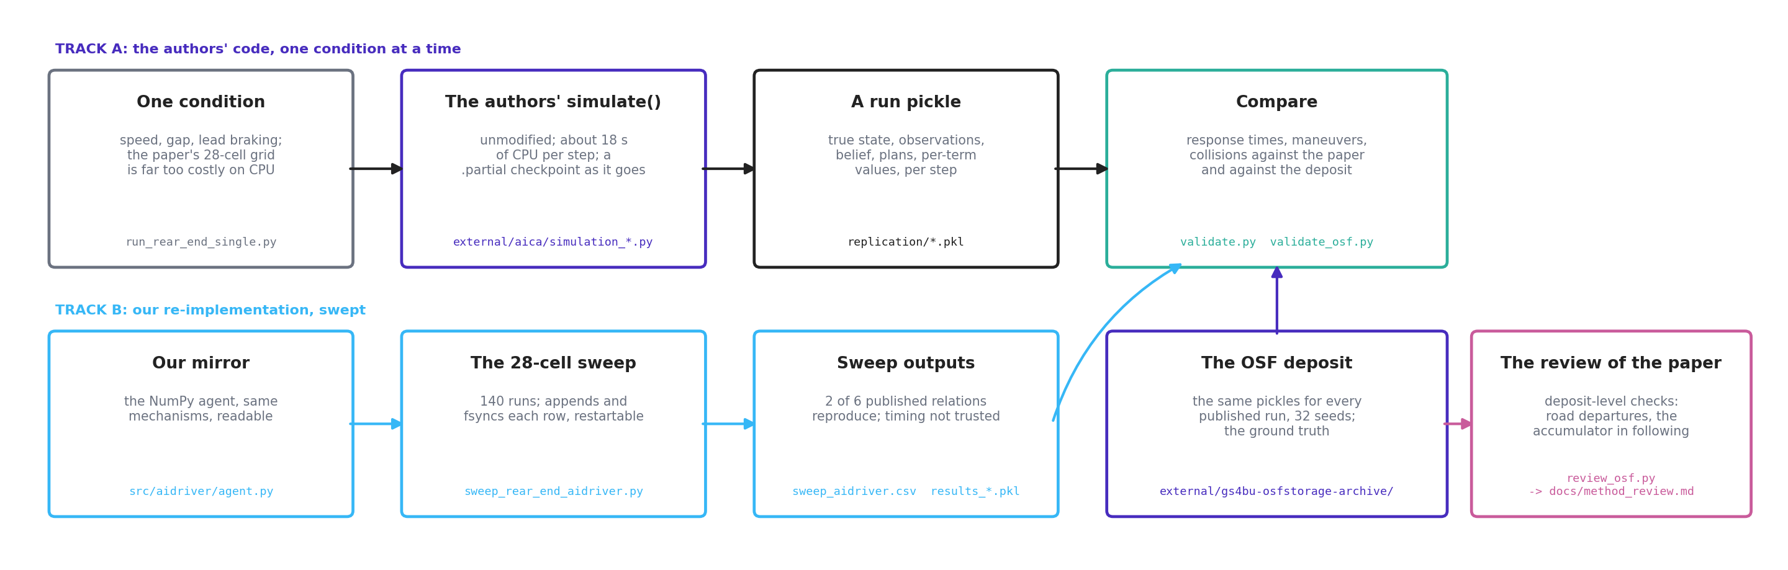
file | role
replication/run_rear_end_single.py | one condition through the authors’ code; --checkpoint-every writes a .partial pickle because long jobs get killed in this environment
replication/validate.py, validate_osf.py | compare a run, or the deposit, with the published values; replication/osf/report.md is the deposit comparison
replication/review_osf.py | the deposit-level checks behind docs/method_review.md
replication/sweep_rear_end_aidriver.py | the 140-run sweep of the mirror; appends and fsyncs each row, restartable
replication/PATCHES.md | the one local patch in external/aica/ (a hard-coded device='cuda'); keep it the only one
notes/03_replication.md, notes/05_validation.md | what matched, what did not, and why

3 Block 2: our readable mirror
src/aidriver/ re-implements the agent in NumPy so that mechanisms can be read and switched off. agent.py is the belief-plus-CEM loop; bicycle.py the vehicle model; scenarios.py the worlds; params.py the parameter objects; and preferences.py the preference function p(o), which is the one part of the model the comfort-zone work depends on. The preferences were verified against the SI and then aligned with the released code (2026-08-23); the closed-loop response timing is not trusted and should not be used for timing claims (notes/05_validation.md).
Two traps recorded in HANDOFF.md §4 apply here: the AgentParams defaults do not match the validated sweep configuration (alpha and a_other_min_assumed differ), and a_other_min_assumed in the agent and a_other_min in the preferences are different parameters that describe the same physical assumption. Rule 3 of the standing rules says never change a default in preferences.py; new behavior goes behind a flag that defaults off, as lane_entry_horizon_s does.

4 Block 3: the surprise library
src/surprise/ implements every surprise measure the papers use, organized by what is compared with what, and runs each on any of four belief representations through one protocol. The accumulator that turns preference-relative surprise into a response time lives in pragmatic.py; situational.py (card HS.1) asks when a whole situation stops unfolding as expected. The tests check the claims, not just that the code runs: the zero floor, invariance to discretization, and the published equivalences between measures.
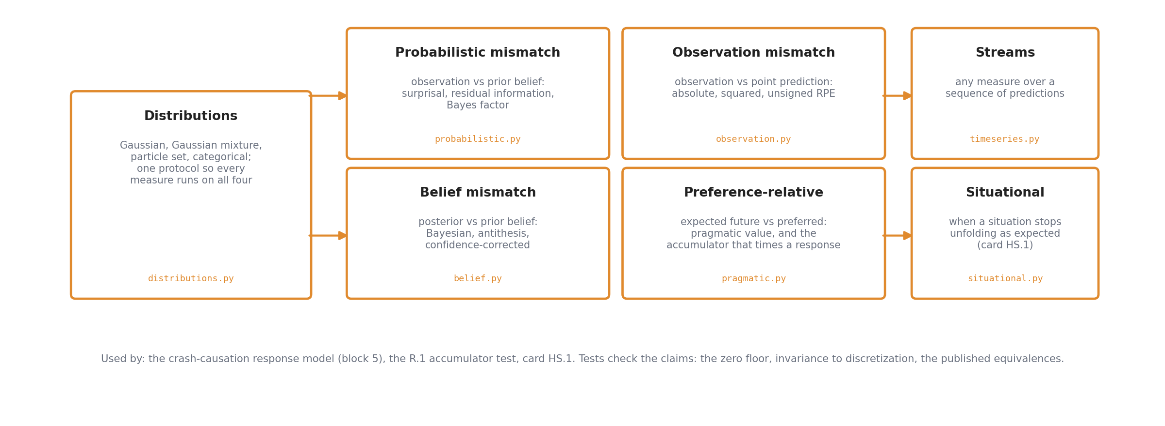
Where it is used: the crash-causation response model (block 5), the R.1 accumulator test on the cut-in data, and card HS.1. demo_surprise.py runs the measures on a cut-in and the agent on a rear-end conflict in minutes.

5 Block 4: the comfort-zone method
This is the project’s objective and its current model. It has two layers that should be kept apart in the head.
The static layer (src/comfortzone/field.py, boundary.py, calibrate.py) is the original idea: the preference function gives a scalar field over the state space, a comfort-zone boundary is a level set of that field, car following has a closed-form boundary, and the level can be calibrated from recorded kinematics alone, without running the closed loop. It works and is tested (demo_comfort_zone.py; 33 property tests). On human data, however, the field’s kinematic content was ruled out as the axis (gate R.2, docs/r2_gate_decisions.md).
The empirical layer is what the project measures now. The model is one line:
share who intervene = lapse + (1 − lapse) × GATE × Φ((AXIS − LEVEL) / spread)
The gate says whether the other vehicle counts yet; the axis is the number read off the scene (the optical expansion rate on the cut-in, the oncoming car’s distance on the left turn); the level is where one driver says “now”; the deliverable is a percentile over drivers’ levels. Every term is defined in plain words in docs/handbook/13_glossary.md.
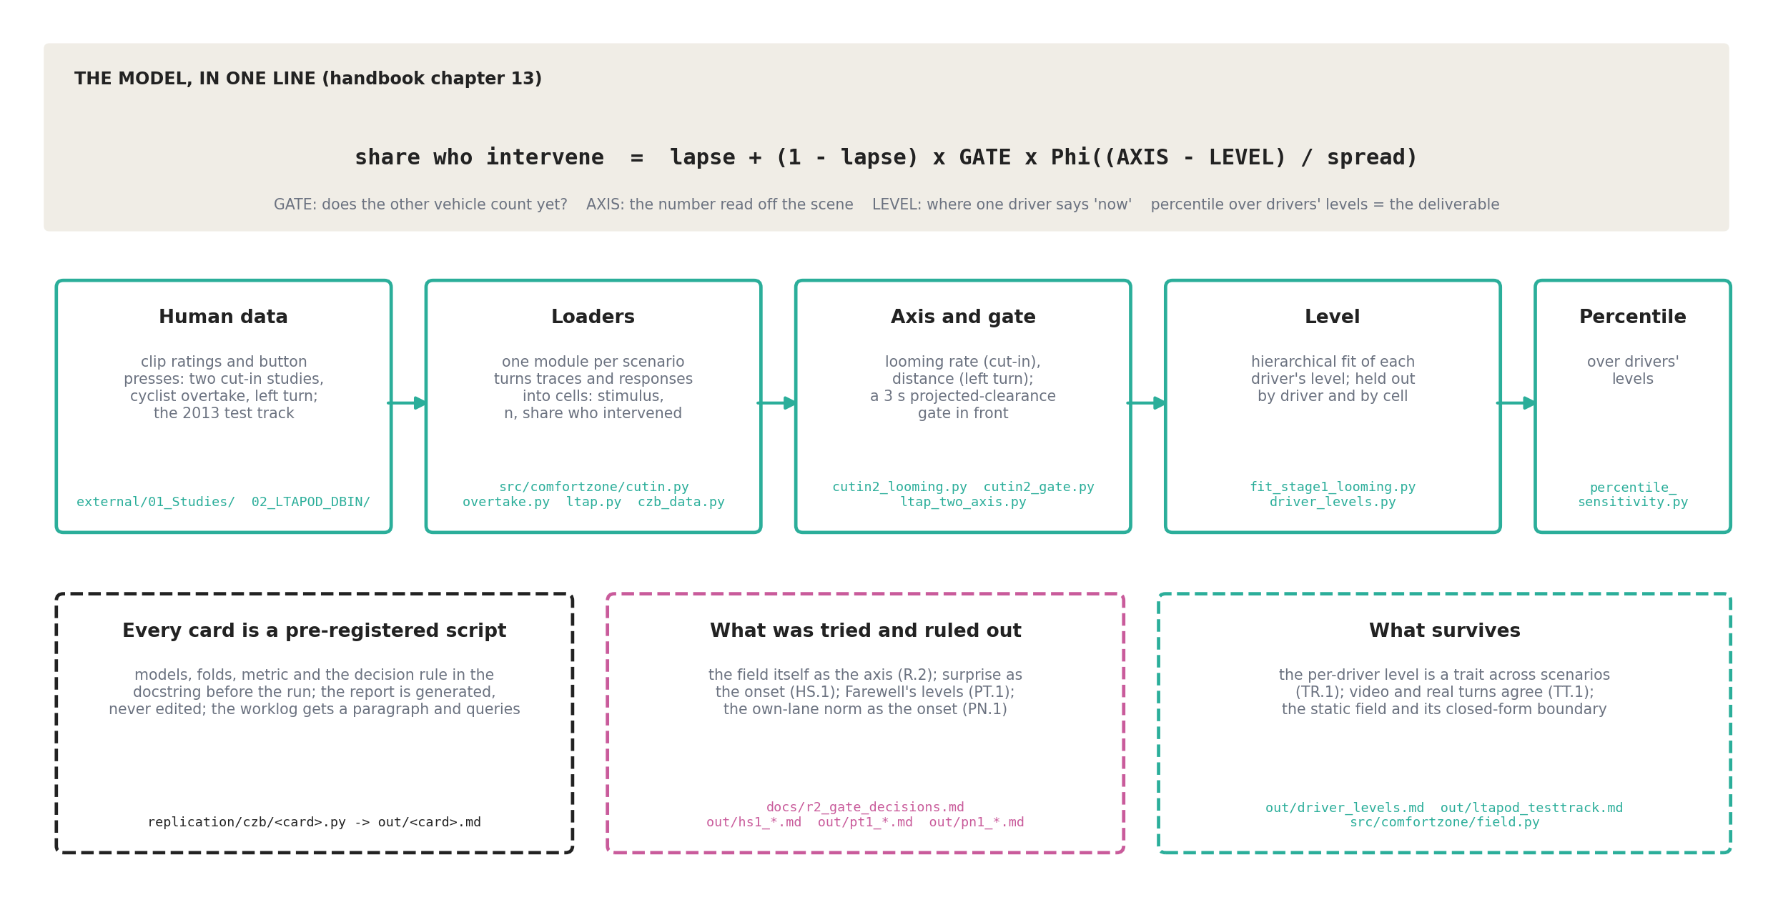
How the pipeline is built. One loader module per scenario (cutin.py, overtake.py, ltap.py, czb_data.py) turns the study traces and button presses into cells: a stimulus, how many saw it, and how many intervened. Each analysis is a card: a script in replication/czb/ whose docstring states the models, folds, metric and decision rule before it runs, and which writes its report to replication/czb/out/. The current results, each with its script, are:
what | script | report
the cut-in axis is the looming rate | cutin2_looming.py | out/cutin2_looming.md
the anticipatory gate in front of it | cutin2_gate.py | out/cutin2_gate.md
the per-driver level on the gated looming axis | fit_stage1_looming.py | out/stage1_looming.md
the left turn’s axis is distance | ltap_two_axis.py | out/ltap_two_axis.md
the level is a trait across scenarios | driver_levels.py, cross_scenario_consistency.py | out/driver_levels.md, out/cross_scenario_consistency.md
video against real turns on the test track | ltapod_testtrack.py | out/ltapod_testtrack.md
how much the percentile choice matters | percentile_sensitivity.py | out/percentile_sensitivity.md
tried and ruled out: surprise as the onset, Farewell’s levels, the own-lane norm | hs1_situational_surprise.py, pt1_farewell_thresholds.py, pn1_cutin_norm.py | out/hs1_*.md, out/pt1_*.md, out/pn1_*.md
The next card, PC.1, generalizes the gate from lateral clearance to a projected conflict between the ego’s path and the other road user’s, so that the same construction runs in all four scenarios (handover.md §4). The data itself is under external/01_Studies/ and external/02_LTAPOD_DBIN/, untracked; docs/czb_study1_data_plan.md and the studies’ own data dictionary list the traps.

6 Block 5: crash causation
A separate study with its own plan and results documents: the four crash-causation mechanisms of Bärgman et al. (2024) implemented as switchable components around two response processes, crashes generated from the QUADRIS seed scenarios, and the generated population tested for practical equivalence against the reference with the Wu et al. (2026) binning-and-ROPE framework. The equivalence package knows nothing about driving and is reusable for any metric.
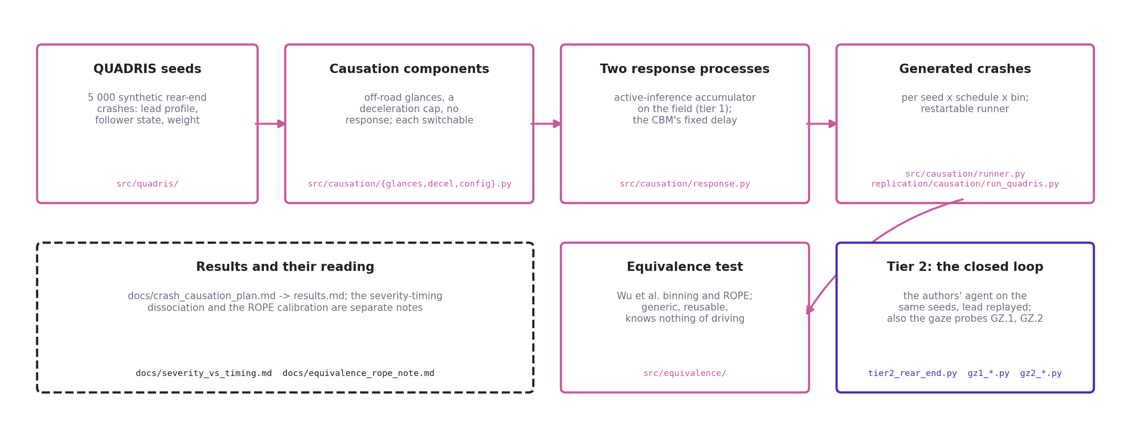
Tier 1 times the response on the seed kinematics with the surprise accumulator on the comfort-zone field, which is cheap; tier 2 runs the authors’ closed-loop agent on the same seeds with the lead vehicle replayed (replication/causation/tier2_rear_end.py), which is slow. The tier-2 adapter is also where the gaze probes of September 2026 live (gz1_gaze_choice_probe.py, gz2_following_braking.py), because it is the one place the released model can be run with a scripted lead and instrumented step by step. Results: docs/crash_causation_results.md; the severity-timing dissociation and the ROPE calibration are separate notes.

7 Block 6: working with a partner that cannot move its data
Volvo Cars holds naturalistic data that will not leave their site, and the two sides share neither a repository nor a drive. The split-site protocol (docs/split_site_protocol.md) moves code, documents and aggregate results as reviewed bundles; raw and per-event data never move. The only data shape the shared code reads is transfer/interface_schema.yaml; VCC’s adapter produces it, our synthetic fixture imitates it, and src/comfortzone/interface.py reads it into the gated-looming pipeline (card NDS.1, replication/czb/out/nds1_interface_smoke.md).
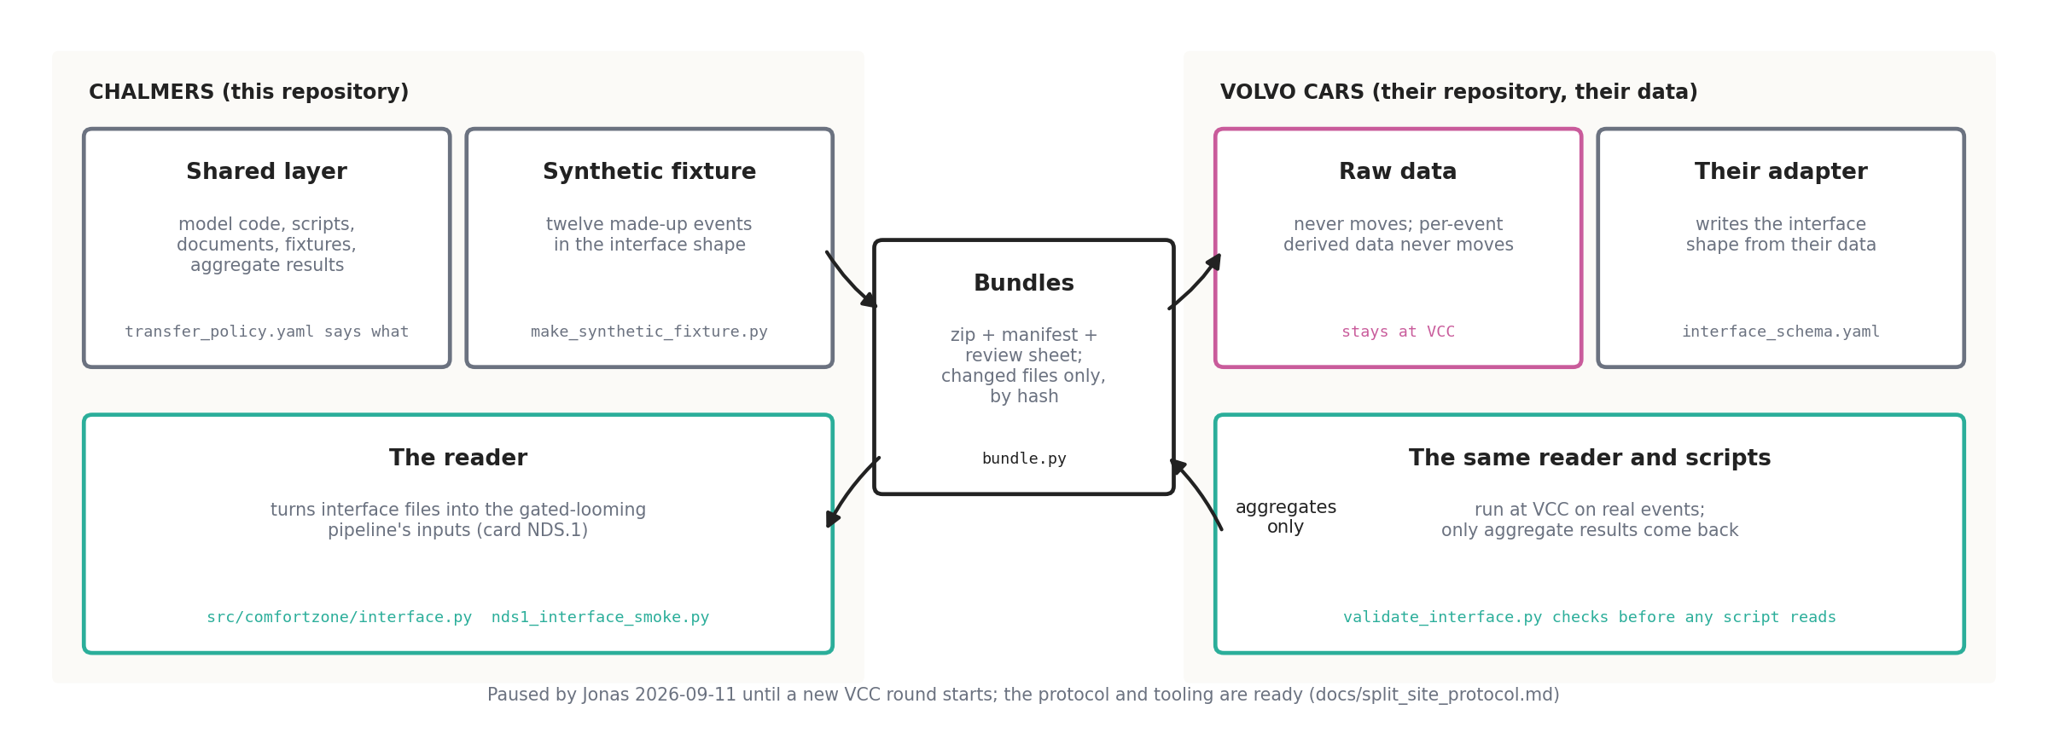
The track is paused by Jonas since 2026-09-11 until a new VCC round starts. When it resumes, the first action is to revise the interface schema with the five gaps card NDS.1 found (queries NDS.Q2 to NDS.Q5) before VCC writes their adapter.

8 Outputs: results, documents, decks and tools
Tracked results. Every card writes a report into replication/czb/out/ or replication/causation/; the worklog replication/czb/out/worklog.md is the source of truth for decisions and for the queries raised to Jonas or to a reviewing session; collect_queries.py compiles them into out/query_register.md.
Documents (docs/). Markdown is the source; Word and PDF are built from it with pandoc and docs/build_pdf.py. Three families: the handbook (docs/handbook/, the internal understanding pack, 17 chapters and appendices, built with build_handbook.py and build_combined.py) and its separate authors’ edition (docs/handbook_authors/, which does not track the internal one); the design and construction notes, one per idea, each read before the card that implements it; and the reviews and decision records (method_review.md, r2_gate_decisions.md, r2_pipeline_review.md). notes/ holds the older research notes, and the dated handover_YYYY-MM-DD.md files record each work arc.
Decks and tools. presentation/talk/ holds four decks built by script on the Chalmers template, with animations rendered once to GIF and transcoded to MP4 (the rules that keep the videos right are in docs/skill_additions_video.md). tools/czb_explorer/ holds three static browser pages: the closed-form boundary explorer, the norm-tournament sandbox, and a browser of all 224 rear-end runs in the deposit.

9 The floor: tests, the working cycle, and the rules
Nine test scripts, each a plain script that counts checks in the check(...) style, must pass before and after every card. pytest reports fewer and is not the suite.
script | checks | covers
tests/test_surprise.py | 31 | the surprise measures and their claimed properties
tests/test_comfortzone.py | 33 | the static field, its closed-form boundary, calibration
tests/test_causation.py | 40 | the causation components and the equivalence package
tests/test_cutin.py | 96 | lane entry, the cut-in and overtake loaders, the covariate window
tests/test_ltap.py | 62 | the left-turn loader and geometry
tests/test_transfer.py | 20 | the bundle tool and its policy
tests/test_interface.py | 28 | the split-site interface reader
tests/test_situational.py | 27 | situational surprise
tests/test_norms.py | 16 | the cut-in norm
The cycle every card follows is the same, and the figure shows it with the files at each step.
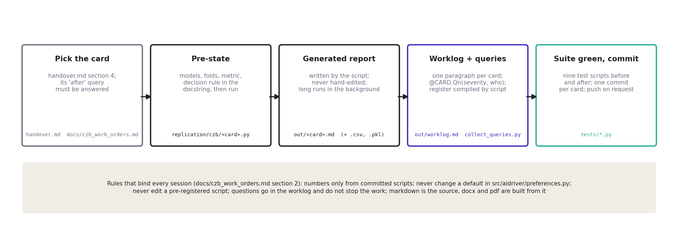
The rules that bind every session are listed in full in docs/czb_work_orders.md §2 and summarized in handover.md §2. The ones that bite most often: every quoted number comes from a committed script with a tracked output; never change a default in src/aidriver/preferences.py; never modify a script whose docstring says it is pre-registered; questions go into the worklog as queries and do not stop the work; a PermissionError on a build means the file is open in Word or PowerPoint, so write a -vN copy.

10 Jumping in
The entry sequence. Read handover.md in full (it says where the project stands, what is waiting on Jonas, and the queue in order), then docs/czb_work_orders.md §2, then the card or note for the task. Run the nine test scripts. Check git status. The performing-research skill sets the working mode.
Where to go for a question.
I want to … | open
understand the model in words | docs/handbook/00_reading_guide.md, then chapters 02, 03, 13
see the current comfort-zone results | replication/czb/out/stage1_looming.md, cutin2_gate.md, cutin2_looming.md, driver_levels.md
know what was decided and why | replication/czb/out/worklog.md (newest at the end), docs/r2_gate_decisions.md
know what is waiting on Jonas | replication/czb/out/query_register.md, handover.md §3
run the published model | replication/run_rear_end_single.py; expect hours, use --checkpoint-every
instrument the published model step by step | replication/causation/gz2_following_braking.py is the pattern
read the preference function | src/aidriver/preferences.py and docs/method_review.md §5
compute a surprise measure | src/surprise/__init__.py, the quick start in its docstring
add a scenario to the comfort-zone pipeline | docs/ltap_construction_note.md is the pattern; a construction note first, then a loader, tests, a card
build a document | pandoc docs/X.md -o docs/X.docx --from markdown --resource-path docs, then python docs/build_pdf.py docs/X.md
rebuild a deck | presentation/talk/README.md; never onto a file Jonas may have edited
work with the Volvo Cars data | transfer/README.md, docs/split_site_protocol.md; paused until Jonas says
Environment. Windows 11, Python 3.14, torch CPU-only, pandoc on PATH, no LaTeX, no GPU, no gh. The repository lives in OneDrive, so open Office files are locked. external/, papers/ (except their READMEs), OthersWork/ and the .pptx decks are untracked. Long runs go in the background with a log; a hierarchical fit takes 5 to 35 minutes; the closed loop takes 5 to 100 s per step depending on machine load.
Five first exercises for a first afternoon are in handbook chapter 12; each is under an hour and touches a different block.

11 What this document leaves out, on purpose
The science and its numbers, which live in the reports and the handbook; the authors’ code at the class level, which is handbook chapter 12; the history of decisions, which is the worklog and the dated handovers; and OthersWork/, a colleague’s parallel analysis that is not context for this project beyond handbook appendix 16.

