Scope map: what we use of active inference, what we do not, and what the method actually is
2026-08-29, written at Jonas’s request for an overview, after his rulings on queries R2.Q4–Q6. This document does not introduce new analysis. It collects what is already established across docs/active_inference_for_czb_assessment.md, docs/r2_gate_decisions.md, the handovers and the code, and states it in one place with diagrams. Every number quoted here comes from a committed script with a tracked output, and the source file is named at the point of quotation. Figures are generated by docs/make_ai_scope_figures.py; the two data figures read their numbers from those tracked outputs rather than from literals, so a re-run of an analysis moves the figure.

0 The overview in one paragraph
The project uses a thin, deliberately chosen slice of active inference: a calibrated preference distribution p(o) inherited from a published and behaviorally validated driver model, read through one member of the surprise family (residual information) to give a non-negative scalar with a true zero. Everything else in the framework — belief updating, policy search, expected-free-energy planning, epistemic value — is switched off in the deliverable, though the repository does contain a full closed-loop active-inference agent used in the crash-causation workstream. The distinctive claim was never “we use active inference”; it was that one scalar does two jobs — its level set defines the comfort-zone boundary, and its accumulation over time predicts when a driver acts. Both halves of that claim have now been tested on human data and both failed: the accumulator at review gate R.1, and the field’s kinematic ordering at review gate R.2, where it scored worse than chance on the design built to separate it from the simple alternatives. What is left, and what the project’s headline now is, is not an active-inference method at all: it is a psychometric, hierarchical-Bayesian measurement of a per-driver comfort-zone level, whose criticality axis is an open competition that the longitudinal gap currently leads. The active-inference contribution that survives is the framing, the calibration pipeline, and the falsification itself.

1 What we use
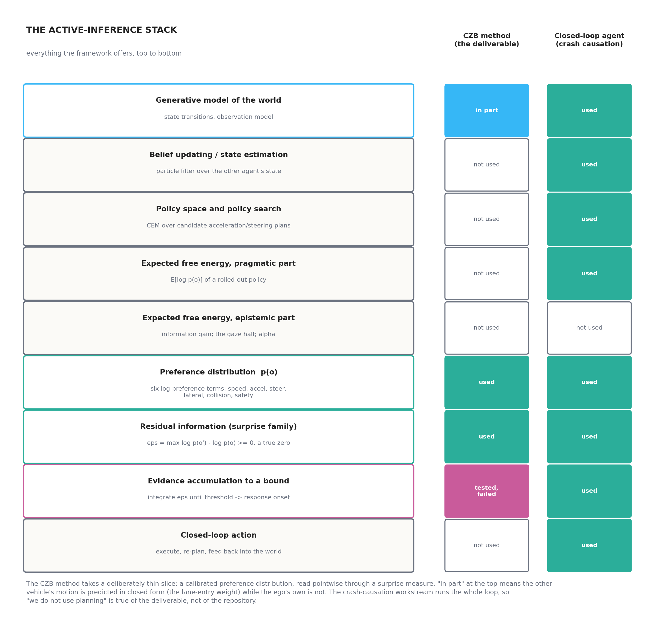
The active-inference stack, and the slice each workstream takes
Three components, and only three, carry the method.
The preference distribution p(o). Six additive log terms — speed, longitudinal acceleration, steering rate, lateral position, collision, safety — implemented in src/aidriver/preferences.py following the released code of Schumann et al. (2026). Not one of its parameters is refitted by us. This is the whole point of the inheritance: the functional form and its constants arrive pre-shaped by someone else’s behavioral validation, and are documented, rather than being invented by us as a hand-designed cost function. The two lower terms carry the conflict geometry: p_coll from the predicted overlap, and p_safe from the counterfactual in which the lead vehicle brakes as hard as it can.
Residual information. The surprise measure that converts a log-preference into a usable scalar:
ε(o) = maxo′ log p(o′) − log p(o) ≥ 0
The property that matters is the true zero: ε is exactly zero at the driver’s preferred observation, so “comfortable” is a value rather than a convention. That is what makes a level set interpretable as a boundary. src/surprise/ implements this alongside the rest of the Modirshanechi et al. (2022) taxonomy, and it is the one library component that is validated on its own terms and independent of everything else here.
Evidence accumulation — used, and now falsified as specified. Integrating ε to a bound gives a response onset. This is the link to timing, and it is what review gate R.1 tested and rejected in our formulation.
One qualification on “no prediction”. The lane-entry weight is a closed-form prediction of the other vehicle’s motion — that is why the figure marks the generative model “in part” rather than “not used”. What is absent is any rollout of the ego’s own policies (docs/czb_validation_roadmap.md §4b). For the study stimuli that omission is arguably correct rather than approximate: participants are asked when doing nothing stops being acceptable, which is exactly the pointwise deficit of the no-action trajectory.

2 What we do not use
Expected-free-energy planning and policy search. The field method is rollout-free by design; that is what makes it closed-form in observables and cheap enough to run in a vehicle. The full closed loop costs roughly 18 s of CPU per simulated step.
Epistemic value and the gaze half. α = 0 throughout. The authors’ own ablation found epistemic value inert in the longitudinal scenarios, so this matches their validated configuration rather than departing from it. Choosing glances by epistemic pricing — handbook ch. 08’s second proposal — remains the largest unexercised half of the machinery.
Belief updating and state estimation. The field is evaluated on observed kinematics directly, with no particle filter. This is what makes it applicable to naturalistic data without model roll-out.
A caveat about that list. All three are switched off in the deliverable. The repository’s crash-causation workstream (src/aidriver/agent.py, src/causation/) runs the entire loop — particle-filter beliefs, CEM policy search, expected free energy, closed-loop action — on all 5 000 QUADRIS seeds. So “we do not do planning” is a true statement about the CZB method and a false one about the repository, and the distinction matters whenever the project is described to someone else.

3 The claim that made the framework worth the trouble — and its two failures
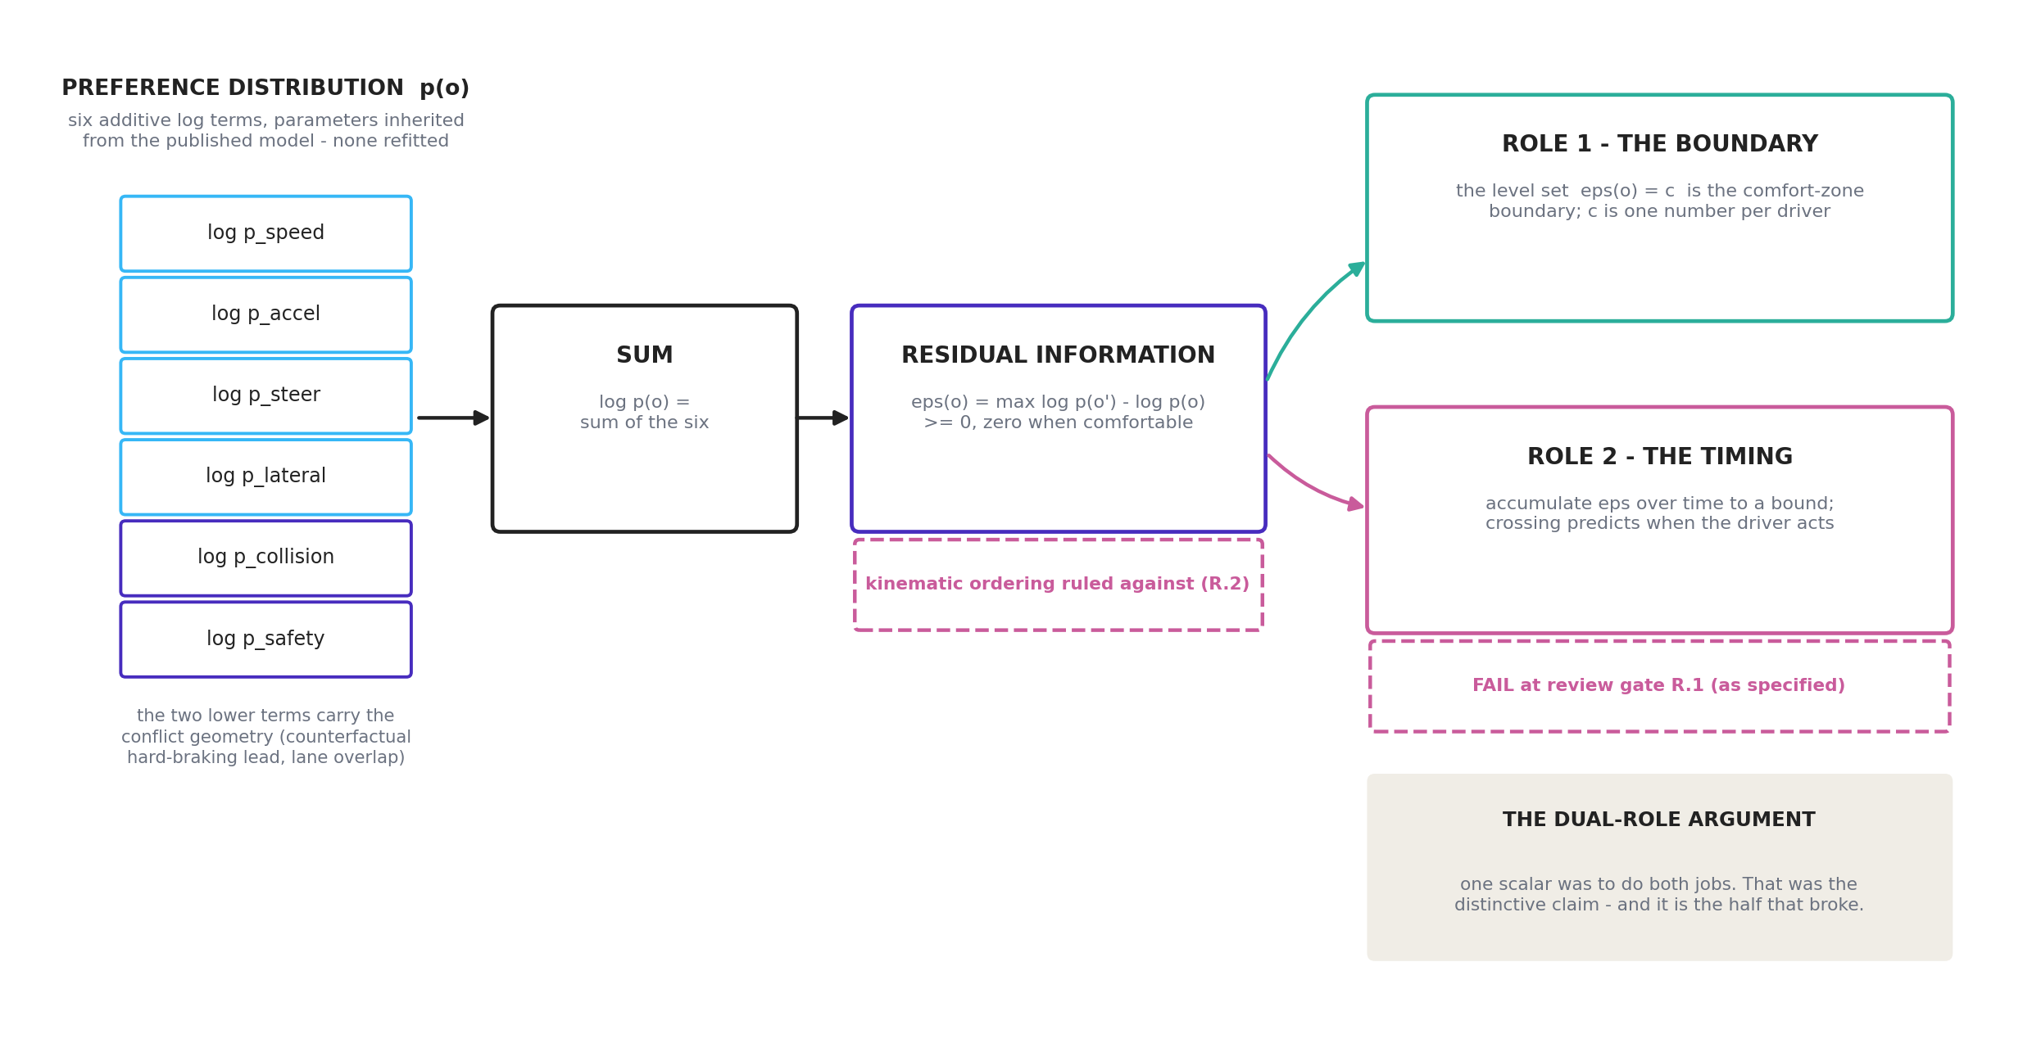
The preference field, and the two jobs one scalar was meant to do
The honest unique selling point was never the label. It was the dual role: the same scalar whose accumulation explains when drivers act is the scalar whose level set defines the boundary. No conventional indicator has that property, and — decisively — it is testable. Both tests have now been run.
Failure 1: the timing half (review gate R.1). Three structurally-argued accumulator variants all fit worse in sample than the stage-0 static two-parameter probit (the final v3 variant 0.169 against 0.125), and v3’s held-out RMSE of 0.255 failed the pre-registered rule fixed before fitting — ≤ 0.11 closes the gap, > 0.13 is failure (replication/czb/out/stage2_summary.md). The named reason: criticality-graded responding is already present at C1–C2, where at most 0.05–0.15 s of post-onset evidence exists under any plausible motor latency — anticipation from repeated exposure, which no evidence-gated integrator can express.
Discrepancy found while writing this document, not reconciled here. docs/active_inference_for_czb_assessment.md §3.3 records the same verdict as “best 0.178 vs 0.125” in sample and “held-out RMSE 0.267”. The tracked output replication/czb/out/stage2_summary.md (v3, the final iteration at R.1) gives 0.169 and 0.255. The repository beats the document, so the numbers above are the output’s; the assessment document appears to quote an earlier iteration and should be corrected in place. Raised as query SCOPE.Q1. The verdict itself — FAIL, by a wide margin against a rule of ≤ 0.11 — is unaffected either way.
Scope, narrowed at R.2 on Bontje et al. (2026): the FAIL is a verdict on the accumulator we specified — deficit-driven drift, non-leaky, fixed bound, on this repeated-exposure stimulus set. The standard traffic architectures (looming or TTC drift, leaky accumulation, collapsing bounds) were never tested, so the result licenses no claim about evidence accumulation as a family.
Failure 2: the boundary half’s axis (review gate R.2). This is the decisive one.
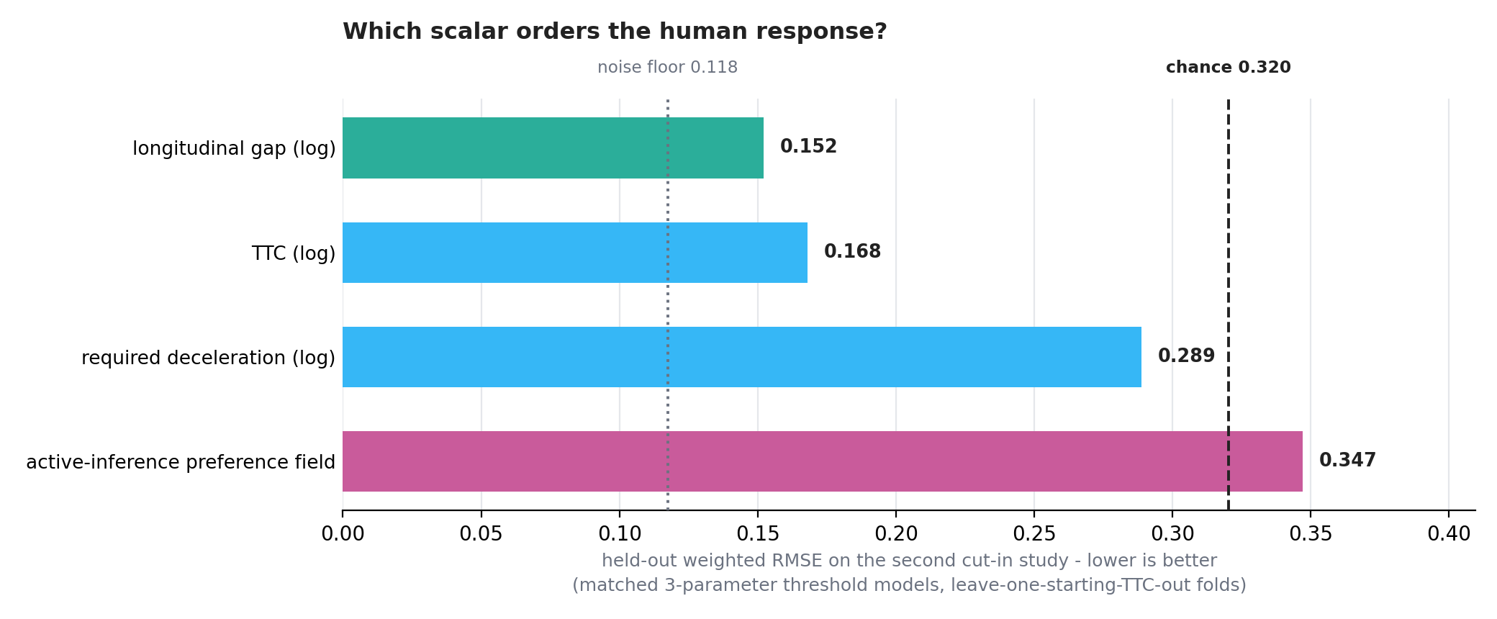
Which scalar orders the human response
On the second cut-in study’s 288 post-onset cells, with matched three-parameter threshold models (lapse + probit) on identical leave-one-starting-TTC-out folds, and with models, folds and decision rule committed before the run at commit e9203c6 (replication/czb/out/cutin2_field_vs_gap.md): the field scores held-out wRMSE 0.347 — worse than chance, 0.320 — against a log-gap threshold’s 0.152, with the sampling-noise floor at 0.118. The pre-registered rule fired at dRMSE = +0.195. The verdict is robust to excluding the 20 non-modal attention-check participants (+0.202) and to repairing a trace-noise handicap found after the registered run (0.356).
Why the earlier evidence did not catch this: in the first cut-in study relative speed is constant across all 18 cells, so correlation(gap, TTC) = 1.0000 — the longitudinal dimension has one degree of freedom, and the field’s encouraging 0.90 correlation was equally consistent with a driver simply thresholding the gap. The second study breaks that collinearity over a six-fold range of gap, and the field loses (replication/czb/out/cutin2_scope.md).
Consequence now in force: no document may describe the field as validated against human data on the longitudinal dimension.

4 What survived
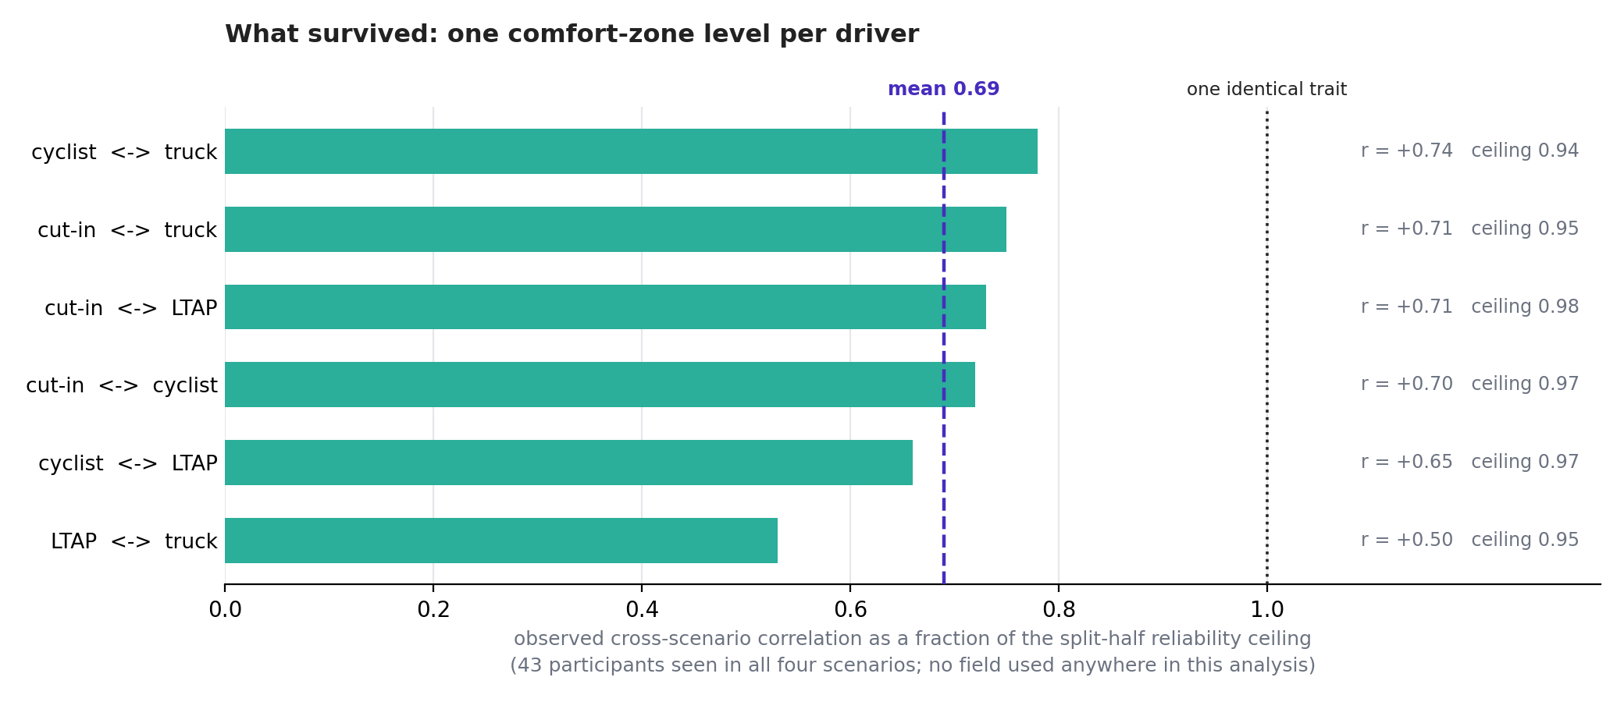
What survived: one comfort-zone level per driver
The gate’s own pre-commitment was that if the field lost, the project’s claim would be restated around what survives. Four things do.
- A driver carries one comfort-zone level across scenarios. Per-driver criticality-adjusted propensity correlates +0.50 to +0.74 across all six scenario pairs, which is 0.53–0.78 of the split-half reliability ceiling, mean 0.69 — and this is measured with no field at all (replication/czb/out/cross_scenario_consistency.md). About a third of reliable per-driver variance is scenario-specific, which caps every transfer test that will ever be run on this data.
- The boundary distribution is well estimated on its own scale, and stable. Under the current full specification the 50th/80th/95th percentiles moved by +0.9% / +0.2% / −0.5% when the covariate defect was fixed and k changed to 12 (replication/czb/out/stage1_summary.md).
- Transfer works once the per-scenario lapse is freed (0.136 against chance 0.158, refit ceiling 0.120; replication/czb/out/transfer_overtake_summary.md).
- The best within-scenario criticality axis is the longitudinal gap (log scale), with TTC close behind and required deceleration nowhere — a statement about any demand-based axis, not only ours.
The recommended wording, from the gate record: each driver carries a scalar comfort-zone threshold that is substantially shared across scenarios; the right criticality axis is an open empirical question on which simple scene scalars currently beat the active-inference preference field, whose kinematic content is ruled out as fitted.

5 What the method now actually consists of
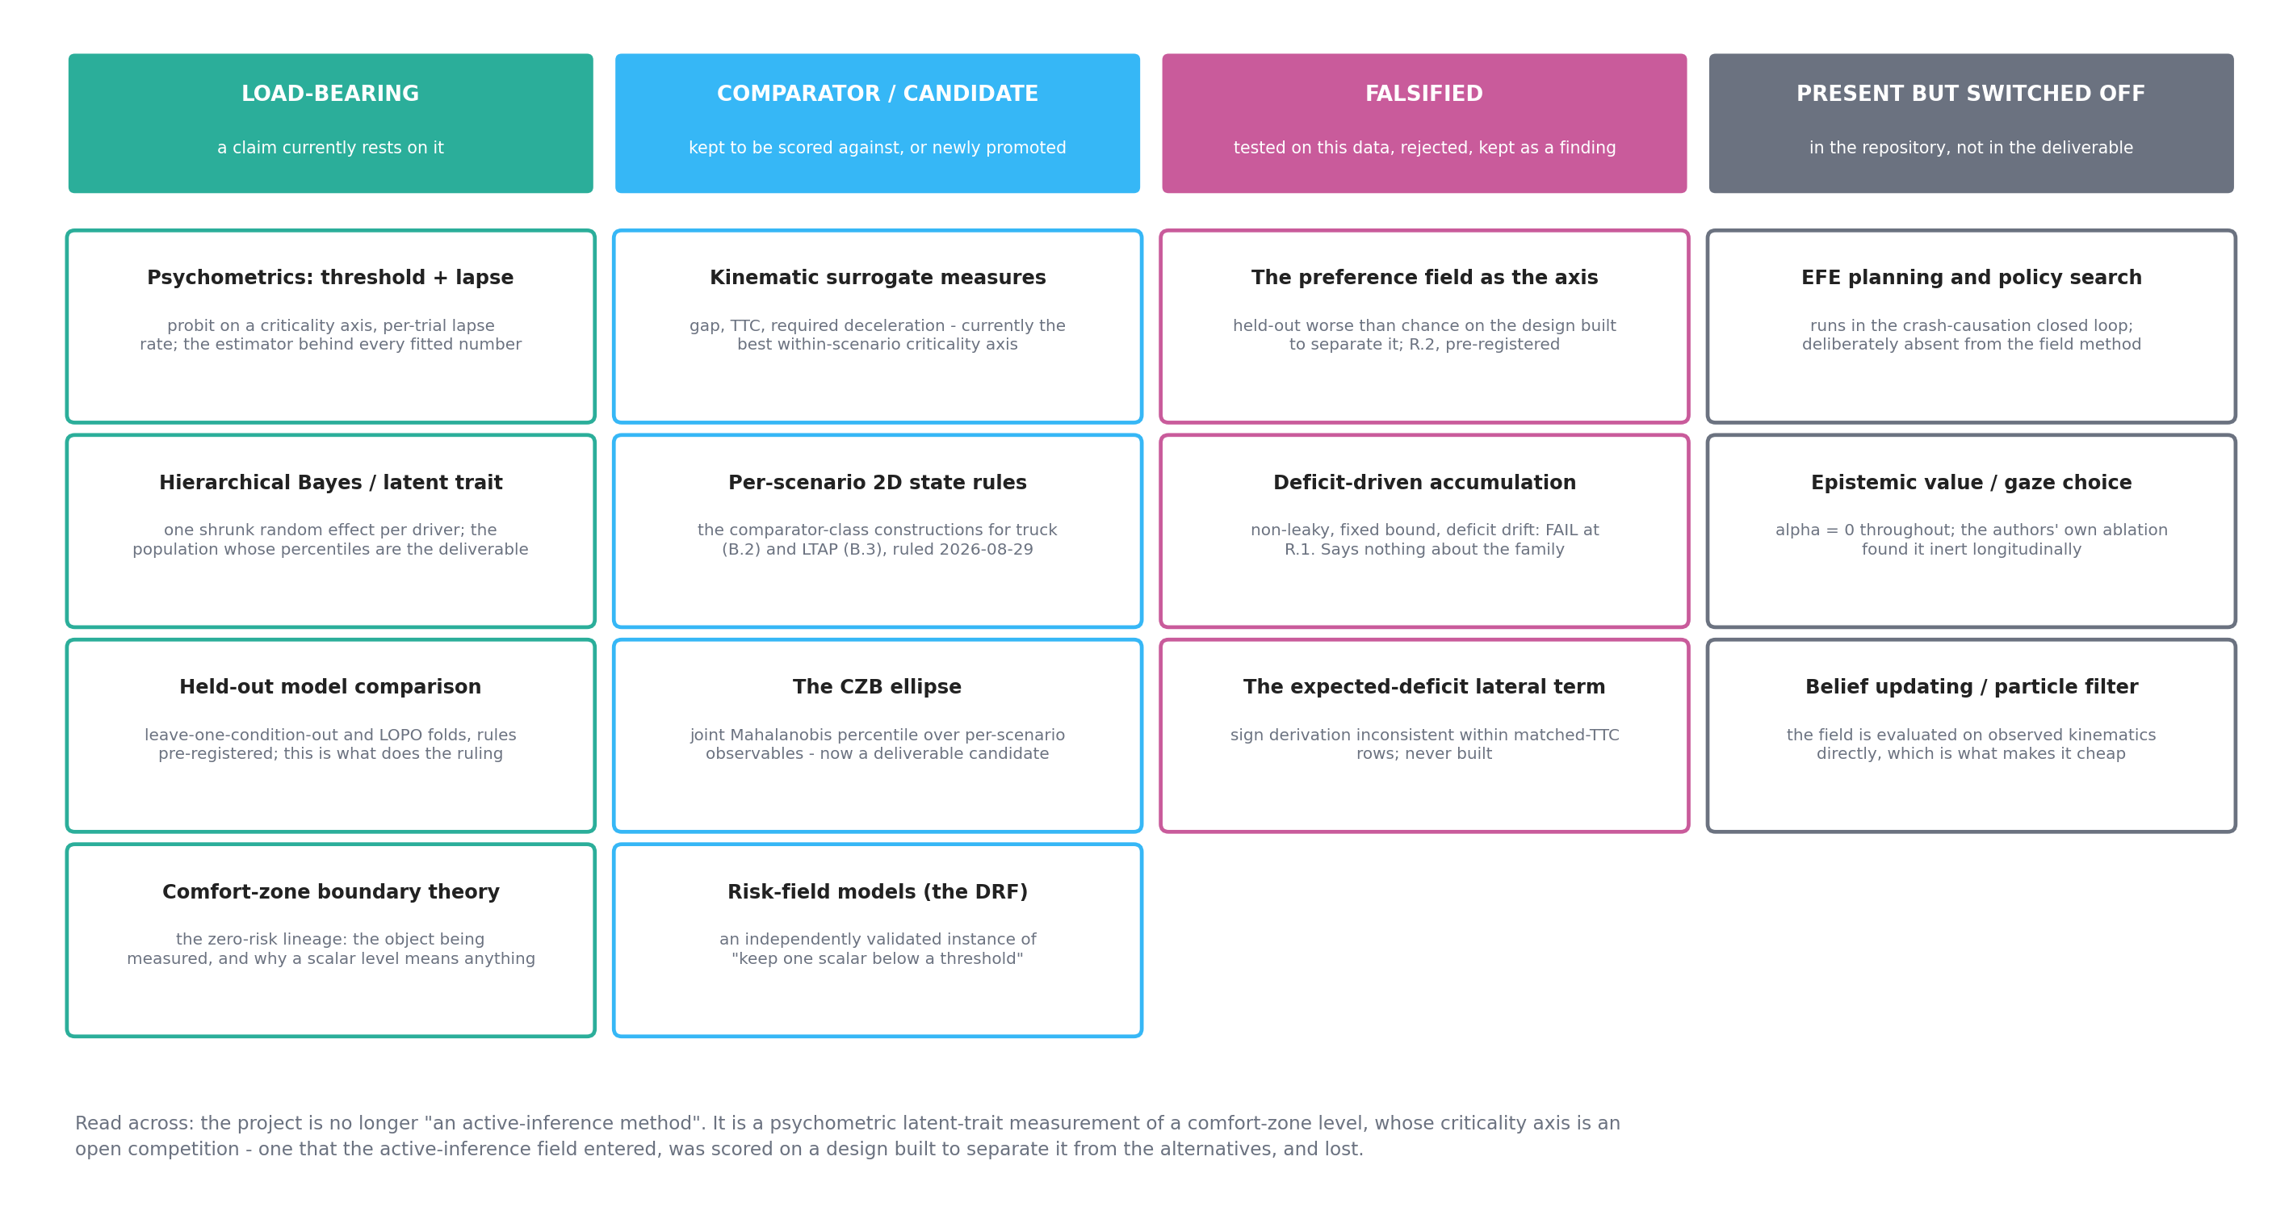
What the method is made of, by status
Read as a list of paradigms rather than as a narrative, the project is now this:
Paradigm | Role | Status
Psychophysics / signal detection — probit threshold plus a per-trial lapse rate | the estimator behind every fitted number in the project | load-bearing
Hierarchical Bayesian latent-trait modeling — one shrunk random effect per driver, marginal quadrature plus Laplace | produces the population whose percentiles are the deliverable | load-bearing
Held-out model comparison with pre-registered decision rules — leave-one-condition-out, LOPO | the machinery that does the ruling; it is what killed both halves of the dual-role claim | load-bearing
Comfort-zone boundary theory (the Näätänen & Summala zero-risk lineage) | defines the object being measured and why a scalar level is meaningful at all | load-bearing
Kinematic surrogate measures — gap, TTC, required deceleration | currently the best within-scenario criticality axis | comparator, currently winning
Per-scenario 2D state rules | how B.2 (truck) and B.3 (LTAP) are now built, per Jonas’s ruling of 2026-08-29 | comparator class, primary
The CZB ellipse — joint Mahalanobis percentile over per-scenario observables | promoted from comparator to deliverable candidate by the same ruling | candidate
Risk-field models (Kolekar et al.’s DRF) | an independently validated instance of “keep one scalar below a threshold” | comparator
Active inference: preference field as criticality axis | ruled against on its own scenario, pre-registered | falsified
Active inference: deficit-driven evidence accumulation | FAIL at R.1, as specified | falsified
Active inference: EFE planning, epistemic value, belief updating | present in the repository’s closed-loop agent; absent from the deliverable | switched off
Counterfactual crash-causation simulation (Bärgman et al. 2024 mechanisms, Wu et al. ROPE equivalence) | a separate, complete workstream that does run the full active-inference loop | complete, parallel
The one-line summary: the deliverable is a psychometric measurement instrument, not an active-inference model. Active inference supplied the candidate axis, a principled zero, and the vocabulary; the axis then entered a competition against simple scene scalars on a design built to separate them, and lost.
That is not a failed project. A pre-registered falsification of a plausible, theoretically-motivated construct — run on a design specifically built to discriminate, against matched-complexity alternatives, with the noise floor measured — is a publishable result in its own right, and the trait finding is a positive one that no field was needed to establish.

6 The open question, and why it is the right one to ask next
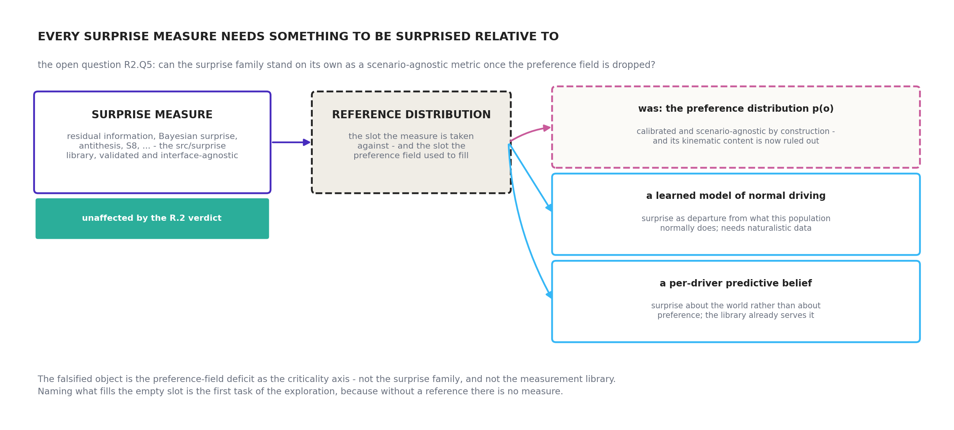
Every surprise measure needs a reference distribution
Jonas’s ruling on R2.Q5 left the positioning unsettled pending one exploration: can the surprise elements stand on their own as a scenario-agnostic metric, even with the preference field dropped?
The crux, and the first task of that exploration: every surprise measure needs a reference distribution to be surprised relative to. In this project the preference field was that reference. So “surprise without the field” is not yet a specification — it is a slot with nothing in it, and naming what fills the slot has to come before anything is measured. What is falsified is the preference-field deficit as the criticality axis, not the surprise family and not src/surprise, which is validated and interface-agnostic by construction and works unchanged on Gaussians, mixtures, particle sets and categoricals.
Two candidates worth taking seriously, both of which relocate the question from surprise about one’s own preferred state to surprise about the world: a learned predictive model of normal driving for this population (which is what naturalistic data would be for), and a per-driver predictive belief. Both are already served by the library’s other interfaces.
The three live threads, in the order the handover queues them: the B.3.v2 LTAP construction note written for the comparator class; a design note for the CZB ellipse; and this exploration.

7 Where I may be wrong
Stated as opinions, since this document interprets rather than measures.
- The R.2 verdict is about the longitudinal kinematic content of the field as fitted, with the lane gate engaged and k = 12. It does not test the lateral machinery (which failed separately on the overtake, B.1), and it does not rule out a differently constructed demand measure — though required deceleration’s showing makes that unpromising on this data.
- Calling the project “a psychometric instrument” is my framing, not a gate decision. A reasonable alternative framing is that it is a comparative study of criticality axes with a psychometric estimator, which puts the emphasis on the competition rather than on the measurement.
- The claim that active inference contributed “the framing, the pipeline and the falsification” is a positioning argument, and R2.Q5 is precisely the question of whether it holds. It should not be treated as settled here.
- Everything about percentiles rests on 43 crowdsourced participants watching clips in one paradigm. That supports method development and contrast; it does not support setting a fleet trigger.

References
Bontje, F., van Waveren, F., van Maanen, L., Nallapu, B., Markkula, G., & Zgonnikov, A. (2026). Knowing when to move: Evidence accumulation models of human behavior in traffic (arXiv:2606.00727). arXiv. https://arxiv.org/abs/2606.00727
Kolekar, S., de Winter, J., & Abbink, D. (2020). Human-like driving behaviour emerges from a risk-based driver model. Nature Communications, 11, Article 4850. https://doi.org/10.1038/s41467-020-18353-4
Modirshanechi, A., Brea, J., & Gerstner, W. (2022). A taxonomy of surprise definitions. Journal of Mathematical Psychology, 110, Article 102712. https://doi.org/10.1016/j.jmp.2022.102712
Schumann, J. F., Engström, J., Johnson, A., O’Kelly, M., Messias, J., Kober, J., & Zgonnikov, A. (2026). Active inference as a model of collision avoidance behavior in human drivers. Nature Communications, 17, Article 5009. https://doi.org/10.1038/s41467-026-73345-0
Näätänen and Summala’s zero-risk theory is referred to here as the comfort-zone lineage; per docs/data_requirements.md, the originals have not been consulted in this project and the attribution rests on secondary sources.

