After reviewing the aforementioned documents, do the following. Seek an ad or article which has a very good visual display of data; or, alternately one which has a very poor visual display. While either type of display may be shared, try to find an example of an excellent graphic presentation. Cite the display(s) you find and show it or them in your comments. Discuss whether or not the data have been fairly represented.
Drawing upon the readings and discussion, as well as your professional experience, please share something with the class about what you have learned this week.

In a 2015 US News article “The Heroin Epidemic, in 9 Graphs” Lindsey Cook illustrates several aspects of the epidemic using graphs. For instance, the growth of Heroin abuse and Heroin related deaths is presented in a good visual display in the following graph. Lindsey uses an overlay of a line graph over a bar graph to visually show the rise in Heroin deaths and abuse. She uses appropriate units for the vertical axis which provides an accurate statement on the rise of heroin addiction. The reader easily can see what is happening over the ten year period regarding the Heroin epidemic.
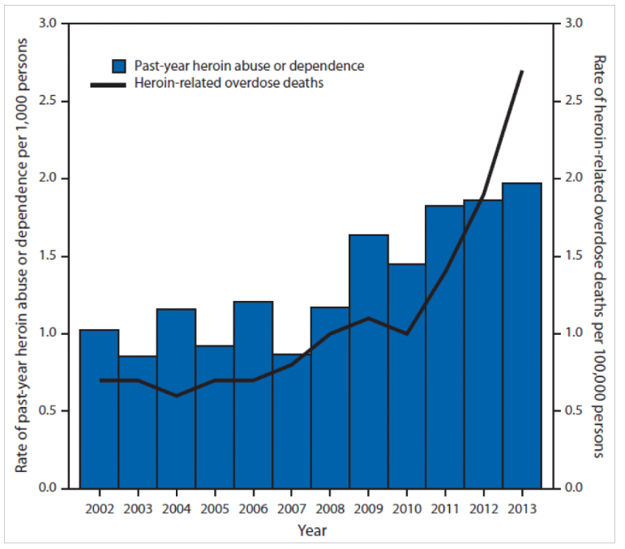

In another article by Lindsey Cook “What the Census Tells Us About America Today” from 2106 she describes how America is getting older, more diverse and more multiracial. In the graph below she uses color to show the reader the states and how multiracial they are. She is using squares to represent each state while piecing together a map of the United States. The color of each state represents the percentage of the population which is a minority in the state. She chooses the color to represent how brown the state is but I don’t think it does a very good job in terms of seeing how the population is dispersed. The middle three colors are too similar. This renders it difficult to decipher what is happening to the population. A general flow is shown, but it is there hard to tell which way the middle states are leaning.

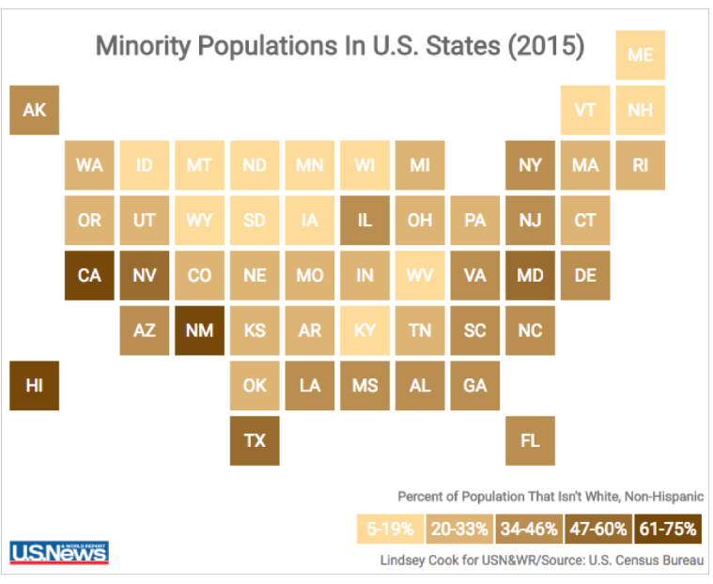

Form that same census article Lindsey Cook provides a graph to show the population by age and gender within age. This does a good job of showing how the population is aging. Ordinarily you would expect more tapering of the population as the age went up. But this table holds a rectangular shape until the population reaches 60. The colors are distinct and the comparisons are fair. Clearly the millennials are the largest group. You can also see how small gen x is in comparison to the surrounding generations.

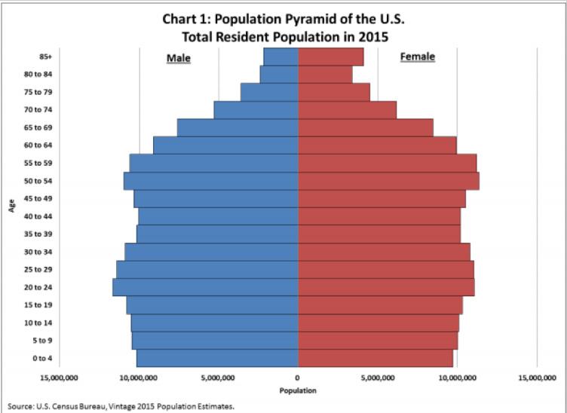

It is clear that properly used graphs can help prove a point. But if the graph is unclear it is just confusing and does not convey the point the author is trying to make.

https://canvas.northwestern.edu/courses/90283/discussion_topics/588334?module_item_id=1189369
https://www.usnews.com/news/articles/2016-06-23/what-the-census-tells-us-about-america-today

