John Barker, Programming with R Program Assignment 2
##### (1) R has probability functions available for use (Kabacoff, Section 5.2.3).
# Using one distribution to approximate another is not uncommon.
# (1)(a) (6 points) The Poisson distribution may be used to approximate the binomial distribution
# if n > 20 and np < 7. Estimate the following binomial probabilities using
# *dpois()* and *ppois()* with probability p = 0.05, and n = 100. Then, estimate
# the same probabilities using *dbinom()* and *pbinom()*.
# Show the numerical results of your calculations.

# (i) The probability of exactly 0 successes.

set.seed(1234)
dpois(0,5)
ppois(0,5)

dbinom(0,100,.05)
pbinom(0, 100,.05)

output
> set.seed(1234)
> dpois(0,5)
[1] 0.006737947
> ppois(0,5)
[1] 0.006737947
>
> dbinom(0,100,.05)
[1] 0.005920529
> pbinom(0, 100,.05)
[1] 0.005920529

#(ii) The probability of fewer than 6 successes.

set.seed(1234)
dpois(5,5)
ppois(5,5)-ppois(4,5)
dbinom(5,100,.05)
pbinom(5,100,.05)-pbinom(4,100,.05)

output
> set.seed(1234)
> dpois(5,5)
[1] 0.1754674
> ppois(5,5)-ppois(4,5)
[1] 0.1754674
> dbinom(5,100,.05)
[1] 0.1800178
> pbinom(5,100,.05)-pbinom(4,100,.05)
[1] 0.1800178

# (1)(b) (3 points) Generate side-by-side barplots using *par(mfrow = c(1,2))* or
# *grid.arrange()*. The left barplot will show Poisson probabilties for outcomes
# ranging from 0 to 10. The right barplot will show binomial probabilities for
# outcomes ranging from 0 to 10. Use p = 0.05 and n = 100. Title each plot,
# present in color and assign names to the bar; i.e. x-axis value labels.

n=100
p=.05
lambda<-n*p
trials <- c(0:10)
successes<-factor(trials)
pprobabilities <- dpois(trials,lambda = lambda)
bprobabilities <- dbinom(trials,size=n,prob=p)

par(mfrow=c(1,2))
barplot(pprobabilities, names.arg = successes, xlab = "successes", ylab = "Poisson probabilities",
main = "Poisson Probabilities trials = 10, n= 100 p= .05", col="red")
barplot(bprobabilities, names.arg = successes, xlab = "successes", ylab = "binomial probabilities",
main = "Binomial Probabilities trials = 10, n= 100 p= .05", col = "darkblue")
par(mfrow=c(1,1))

output
n=100
> p=.05
> lambda<-n*p
> trials <- c(0:10)
> successes<-factor(trials)
>
>
> pprobabilities <- dpois(trials,lambda = lambda)
> bprobabilities <- dbinom(trials,size=n,prob=p)
>
> par(mfrow=c(1,2))
> barplot(pprobabilities, names.arg = successes, xlab = "successes", ylab = "Poisson probabilities",
+ main = "Poisson Probabilities trials = 10, n= 100 p= .05", col="red")
> barplot(bprobabilities, names.arg = successes, xlab = "successes", ylab = "binomial probabilities",
+ main = "Binomial Probabilities trials = 10, n= 100 p= .05", col = "darkblue")
> par(mfrow=c(1,1))

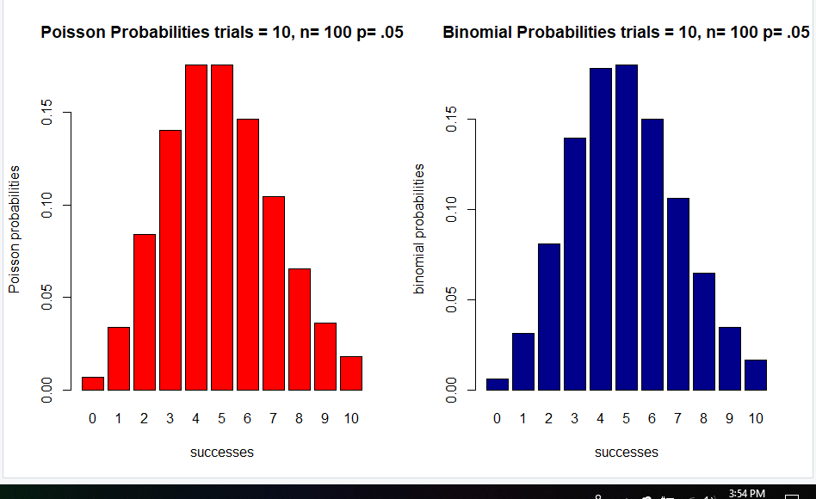

# (1)(c) For this problem, refer to Sections 5.2 of Business Statistics. A
# discrete random variable has outcomes: 0, 1, 2, 3, 4, 5, 6. The
# corresponding probabilities in sequence with the outcomes are:
# 0.215, 0.230, 0.240, 0.182, 0.130, 0.003, 0.001. In other words,
# the probabilty of obtaining "0" is 0.215.

# (i) (3 points) Calculate the expected value and variance for this distribution
# using the general formula for mean and variance of a discrete distribution. To do this,
# you will need to use integer values from 0 to 6 as outcomes along with the
# corresponding probabilities. Round your answer to 2 decimal places.

discretes<-c(0,1,2,3,4,5,6)
discprobs<-c(0.215, 0.230, 0.240, 0.182, 0.130, 0.003, 0.001)
discmean<-round(sum(discretes*discprobs),digits=2)
discmean
discvar<-round(sum(((discretes-discmean)**2)*discprobs),digits=2)
discvar

output
> discretes<-c(0,1,2,3,4,5,6)
> discprobs<-c(0.215, 0.230, 0.240, 0.182, 0.130, 0.003, 0.001)
> discmean<-round(sum(discretes*discprobs),digits=2)
> discmean
[1] 1.8
> discvar<-round(sum(((discretes-discmean)**2)*discprobs),digits=2)
> discvar
[1] 1.79

# (ii) (3 points) Use the *cumsum()* function and plot the cumulative
# probabilties versus the corresponding outcomes. Detemine the value
# of the median for this distribution and show on this plot.

disccum<-c(cumsum(discprobs))
disccum
index<-0
median<-0
median
plot(discretes, disccum,
main="Cumulative Probability",
xlab="Discrete Values",
ylab="Cumulative Probability")
lines(discretes, disccum)
abline(v=2)
abline(h=.5)
disccum

output
> disccum<-c(cumsum(discprobs))
> disccum
[1] 0.215 0.445 0.685 0.867 0.997 1.000 1.001
> index<-0
> median<-0
> median
[1] 0
> plot(discretes, disccum,
+ main="Cumulative Probability",
+ xlab="Discrete Values",
+ ylab="Cumulative Probability")
> lines(discretes, disccum)
> abline(v=2)
> abline(h=.5)
> disccum
[1] 0.215 0.445 0.685 0.867 0.997 1.000 1.001

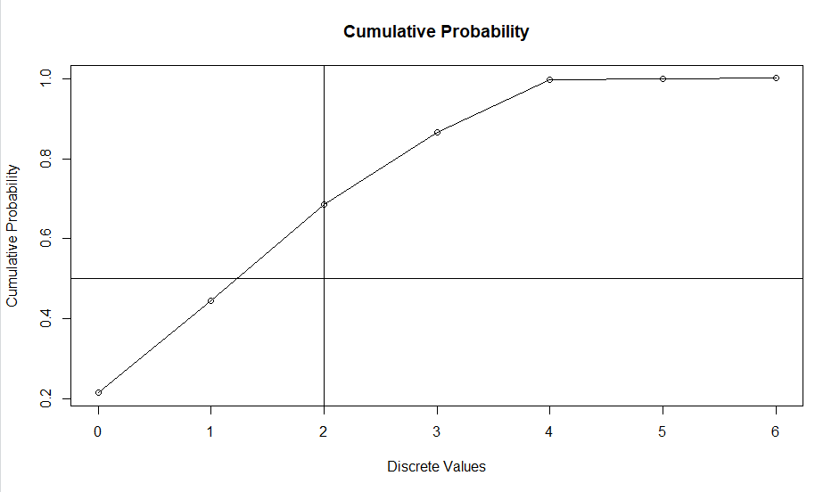
##### Section 2: (15 points) ##################################

##### (2) Conditional probabilities appear in many contexts and, in particular,
# are used by Bayes' Theorem. Correlations are another means for evaluating dependency
# between variables. The dataset "faithful"" is part of the "datasets" package
# and may be loaded with the statement *data(faithful)*. It contains 272 observations
# of 2 variables; waiting time between eruptions (in minutes) and the duration of the
# eruption (in minutes) for the Old Faithful geyser in Yellowstone National Park.

#(2)(a) (3 points) Load the "faithful" dataset and present summary statistics and a histogram
# of waiting times. Additionally, compute the empirical conditional probability of an
# eruption less than 3.0 minutes, if the waiting time exceeds 70 minutes.

data(faithful)
x<-faithful
summary(x)
a<-hist(x$waiting)
pa<-sum(x$waiting>70)/nrow(x)
pa
(Nab <- nrow(x[which(x$waiting>70 & x$eruptions<3),]))
(Nb <- sum(hist(x$eruptions,plot=F)$counts[hist(x$eruptions,plot=F)$mids<3]))
(Pab <- Nab / Nb)
Output
> data(faithful)
> x<-faithful
>
> summary(x)
eruptions waiting
Min. :1.600 Min. :43.0
1st Qu.:2.163 1st Qu.:58.0
Median :4.000 Median :76.0
Mean :3.488 Mean :70.9
3rd Qu.:4.454 3rd Qu.:82.0
Max. :5.100 Max. :96.0
>
> a<-hist(x$waiting)
> pa<-sum(x$waiting>70)/nrow(x)
> pa
[1] 0.6066176
> (Nab <- nrow(x[which(x$waiting>70 & x$eruptions<3),]))
[1] 1
> (Nb <- sum(hist(x$eruptions,plot=F)$counts[hist(x$eruptions,plot=F)$mids<3]))
[1] 97
>
> (Pab <- Nab / Nb)
[1] 0.01030928

#(i) (3 points) Identify any observations in "faithful" for which the waiting time
# exceeds 70 minutes and the eruptions are less than 3.0 minutes. List and show any
# such observations in a distinct color on a scatterplot of all eruption (vertical axis)
# and waiting times (horizontal axis). Include a horizontal line at eruption = 3.0,
# and a vertical line at waiting time = 70. Add a title and appropriate text.

pabt<-subset(x, subset = waiting>=70 & eruptions <= 3)
pabt
summary(pabt)
str(pabt)
color = rep(NA, length=length(x))
color[which(x$eruptions<3 & x$waiting > 70)] = "red"
color[which(!(x$eruptions<3 & x$waiting > 70))] = "blue"
color
plot(x$waiting,x$eruptions, col = color, pch=16, xlab = "Wait time for eruption",
ylab = "Eruption Time", main = "Scatterplot of Wait Times versus Eruption Times")
output
> pabt<-subset(x, subset = waiting>=70 & eruptions <= 3)
> pabt
eruptions waiting
211 2.383 71
> summary(pabt)
eruptions waiting
Min. :2.383 Min. :71
1st Qu.:2.383 1st Qu.:71
Median :2.383 Median :71
Mean :2.383 Mean :71
3rd Qu.:2.383 3rd Qu.:71
Max. :2.383 Max. :71
> str(pabt)
'data.frame': 1 obs. of 2 variables:
$ eruptions: num 2.38
$ waiting : num 71
>
> color = rep(NA, length=length(x))
> color[which(x$eruptions<3 & x$waiting > 70)] = "red"
> color[which(!(x$eruptions<3 & x$waiting > 70))] = "blue"
> color
[1] "blue" "blue" "blue" "blue" "blue" "blue" "blue" "blue" "blue" "blue" "blue" "blue" "blue" "blue" "blue"
[16] "blue" "blue" "blue" "blue" "blue" "blue" "blue" "blue" "blue" "blue" "blue" "blue" "blue" "blue" "blue"
[31] "blue" "blue" "blue" "blue" "blue" "blue" "blue" "blue" "blue" "blue" "blue" "blue" "blue" "blue" "blue"
[46] "blue" "blue" "blue" "blue" "blue" "blue" "blue" "blue" "blue" "blue" "blue" "blue" "blue" "blue" "blue"
[61] "blue" "blue" "blue" "blue" "blue" "blue" "blue" "blue" "blue" "blue" "blue" "blue" "blue" "blue" "blue"
[76] "blue" "blue" "blue" "blue" "blue" "blue" "blue" "blue" "blue" "blue" "blue" "blue" "blue" "blue" "blue"
[91] "blue" "blue" "blue" "blue" "blue" "blue" "blue" "blue" "blue" "blue" "blue" "blue" "blue" "blue" "blue"
[106] "blue" "blue" "blue" "blue" "blue" "blue" "blue" "blue" "blue" "blue" "blue" "blue" "blue" "blue" "blue"
[121] "blue" "blue" "blue" "blue" "blue" "blue" "blue" "blue" "blue" "blue" "blue" "blue" "blue" "blue" "blue"
[136] "blue" "blue" "blue" "blue" "blue" "blue" "blue" "blue" "blue" "blue" "blue" "blue" "blue" "blue" "blue"
[151] "blue" "blue" "blue" "blue" "blue" "blue" "blue" "blue" "blue" "blue" "blue" "blue" "blue" "blue" "blue"
[166] "blue" "blue" "blue" "blue" "blue" "blue" "blue" "blue" "blue" "blue" "blue" "blue" "blue" "blue" "blue"
[181] "blue" "blue" "blue" "blue" "blue" "blue" "blue" "blue" "blue" "blue" "blue" "blue" "blue" "blue" "blue"
[196] "blue" "blue" "blue" "blue" "blue" "blue" "blue" "blue" "blue" "blue" "blue" "blue" "blue" "blue" "blue"
[211] "red" "blue" "blue" "blue" "blue" "blue" "blue" "blue" "blue" "blue" "blue" "blue" "blue" "blue" "blue"
[226] "blue" "blue" "blue" "blue" "blue" "blue" "blue" "blue" "blue" "blue" "blue" "blue" "blue" "blue" "blue"
[241] "blue" "blue" "blue" "blue" "blue" "blue" "blue" "blue" "blue" "blue" "blue" "blue" "blue" "blue" "blue"
[256] "blue" "blue" "blue" "blue" "blue" "blue" "blue" "blue" "blue" "blue" "blue" "blue" "blue" "blue" "blue"
[271] "blue" "blue"

> plot(x$waiting,x$eruptions, col = color, pch=16, xlab = "Wait time for eruption",
+ ylab = "Eruption Time", main = "Scatterplot of Wait Times versus Eruption Times")

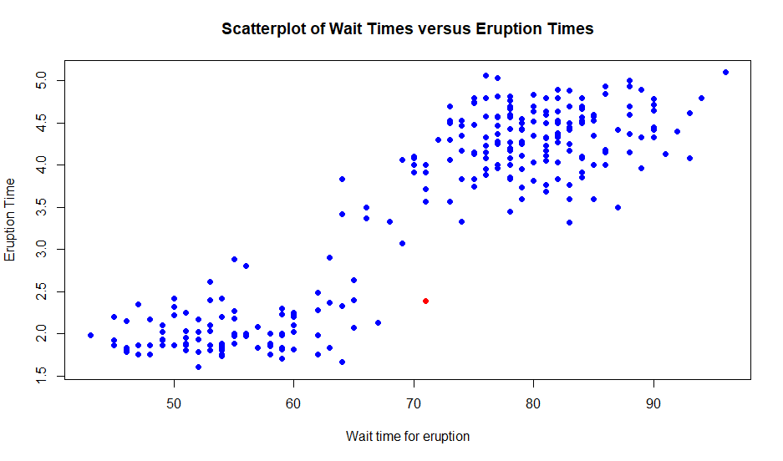
#(ii) (1.5 point) What does the plot suggest about the relationship between eruption time and waiting time?
#***Answer: (Enter your answer here.) ***
#The plot suggests the longer the wait time for Faithful to erupt the longer the eruption lasts.
#In particular there is only one eruption less than three minutes where the wait time for
#eruption exceeds 70.
#-----
#(2)(b) (4.5 points) Past research indicates that the waiting times between consecutive
# eruptions are not independent. This problem will check to see if there is evidence
# of this. Form consecutive pairs of waiting times. In other words, pair the first
# and second waiting times, pair the third and fourth waiting times, and so forth.
# There are 136 resulting consecutive pairs of waiting times. Form a data frame with
# the first column containing the first waiting time in a pair and the second column
# with the second waiting time in a pair. Plot the pairs with the second member of
# a pair on the vertical axis and the first member on the horizontal axis.

# One way to do this is to pass the vector of waiting times - faithful$waiting -
# to *matrix()*, specifying 2 columns for our matrix, with values organized by row;
# i.e. byrow = TRUE.

vwaiting<-matrix(x$waiting, ncol = 2, byrow = TRUE)
vwaiting
plot(vwaiting, col="orange", xlab = "Waiting time of First Paired Eruption",
ylab = "Waiting time of Second Paired Eruption", pch=16,
main = "Scatter Plot of Eruption Wait Times\nfor Consecutive Pairs of Eruptions ")
output
> vwaiting<-matrix(x$waiting, ncol = 2, byrow = TRUE)
> vwaiting
[,1] [,2]
[1,] 79 54
[2,] 74 62
[3,] 85 55
[4,] 88 85
[5,] 51 85
[6,] 54 84
[7,] 78 47
[8,] 83 52
[9,] 62 84
[10,] 52 79
[11,] 51 47
[12,] 78 69
[13,] 74 83
[14,] 55 76
[15,] 78 79
[16,] 73 77
[17,] 66 80
[18,] 74 52
[19,] 48 80
[20,] 59 90
[21,] 80 58
[22,] 84 58
[23,] 73 83
[24,] 64 53
[25,] 82 59
[26,] 75 90
[27,] 54 80
[28,] 54 83
[29,] 71 64
[30,] 77 81
[31,] 59 84
[32,] 48 82
[33,] 60 92
[34,] 78 78
[35,] 65 73
[36,] 82 56
[37,] 79 71
[38,] 62 76
[39,] 60 78
[40,] 76 83
[41,] 75 82
[42,] 70 65
[43,] 73 88
[44,] 76 80
[45,] 48 86
[46,] 60 90
[47,] 50 78
[48,] 63 72
[49,] 84 75
[50,] 51 82
[51,] 62 88
[52,] 49 83
[53,] 81 47
[54,] 84 52
[55,] 86 81
[56,] 75 59
[57,] 89 79
[58,] 59 81
[59,] 50 85
[60,] 59 87
[61,] 53 69
[62,] 77 56
[63,] 88 81
[64,] 45 82
[65,] 55 90
[66,] 45 83
[67,] 56 89
[68,] 46 82
[69,] 51 86
[70,] 53 79
[71,] 81 60
[72,] 82 77
[73,] 76 59
[74,] 80 49
[75,] 96 53
[76,] 77 77
[77,] 65 81
[78,] 71 70
[79,] 81 93
[80,] 53 89
[81,] 45 86
[82,] 58 78
[83,] 66 76
[84,] 63 88
[85,] 52 93
[86,] 49 57
[87,] 77 68
[88,] 81 81
[89,] 73 50
[90,] 85 74
[91,] 55 77
[92,] 83 83
[93,] 51 78
[94,] 84 46
[95,] 83 55
[96,] 81 57
[97,] 76 84
[98,] 77 81
[99,] 87 77
[100,] 51 78
[101,] 60 82
[102,] 91 53
[103,] 78 46
[104,] 77 84
[105,] 49 83
[106,] 71 80
[107,] 49 75
[108,] 64 76
[109,] 53 94
[110,] 55 76
[111,] 50 82
[112,] 54 75
[113,] 78 79
[114,] 78 78
[115,] 70 79
[116,] 70 54
[117,] 86 50
[118,] 90 54
[119,] 54 77
[120,] 79 64
[121,] 75 47
[122,] 86 63
[123,] 85 82
[124,] 57 82
[125,] 67 74
[126,] 54 83
[127,] 73 73
[128,] 88 80
[129,] 71 83
[130,] 56 79
[131,] 78 84
[132,] 58 83
[133,] 43 60
[134,] 75 81
[135,] 46 90
[136,] 46 74
> plot(vwaiting, col="orange", xlab = "Waiting time of First Paired Eruption",
+ ylab = "Waiting time of Second Paired Eruption", pch=16,
+ main = "Scatter Plot of Eruption Wait Times\nfor Consecutive Pairs of Eruptions ")

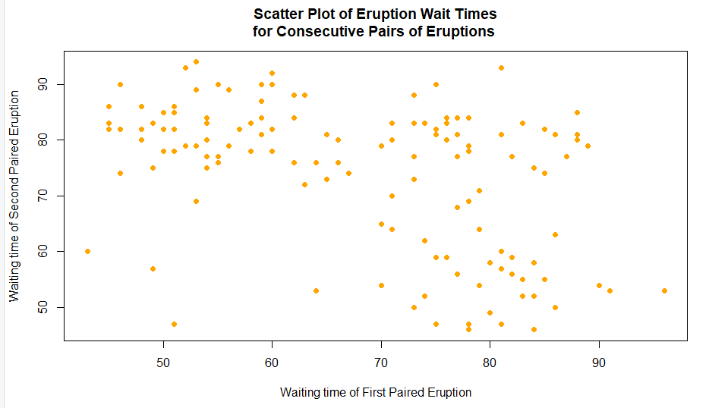

#(2)(c) (2) Test the hypothesis of independence with a two-sided test at the 5% level
# using the Kendall correlation coefficient.

#```{r test2c}
cor(vwaiting, method="kendall", use = "pairwise")
output
> cor(vwaiting, method="kendall", use = "pairwise")
[,1] [,2]
[1,] 1.0000000 -0.2935579
[2,] -0.2935579 1.0000000

##### Section 3: (15 points) ##################################

##### (3) Performing hypothesis tests using random samples is fundamental to
# statistical inference. The first part of this problem involves comparing two
# different diets. Using "ChickWeight" data available in the base R, "datasets"
# package, execute the following code to prepare a data frame for analysis.

#```{r test3}

# load "ChickWeight" dataset
data(ChickWeight)
# Create T | F vector indicating observations with Time == 21 and Diet == "1" OR "3"
index <- ChickWeight$Time == 21 & (ChickWeight$Diet == "1" | ChickWeight$Diet == "3")
# Create data frame, "result," with the weight and Diet of those observations with "TRUE" "index"" values
result <- subset(ChickWeight[index, ], select = c(weight, Diet))
# Encode "Diet" as a factor
result$Diet <- factor(result$Diet)
str(result)

##### The data frame, "result", has chick weights for two diets, identified as
# diet "1" and "3". Use the data frame, "result," to complete the following item.

#(3)(a) (3 points) Display two side-by-side vertical boxplots using par(mfrow = c(1,2)).
# One boxplot would display diet "1" and the other diet "3".
par(mfrow=c(1,2))
Diet1<-result[which(result$Diet==1),]
Diet3<-result[which(result$Diet==3),]
boxplot(Diet1$weight, main = "Chick Weights Diet 1", col = "red")
boxplot(Diet3$weight, main = "Chick Weights Diet 2", col = "yellow")
par(mfrow=c(1,1))
output
> data(ChickWeight)
>
> # Create T | F vector indicating observations with Time == 21 and Diet == "1" OR "3"
> index <- ChickWeight$Time == 21 & (ChickWeight$Diet == "1" | ChickWeight$Diet == "3")
>
> # Create data frame, "result," with the weight and Diet of those observations with "TRUE" "index"" values
> result <- subset(ChickWeight[index, ], select = c(weight, Diet))
>
> # Encode "Diet" as a factor
> result$Diet <- factor(result$Diet)
> str(result)
Classes ‘nfnGroupedData’, ‘nfGroupedData’, ‘groupedData’ and 'data.frame': 26 obs. of 2 variables:
$ weight: num 205 215 202 157 223 157 305 98 124 175 ...
$ Diet : Factor w/ 2 levels "1","3": 1 1 1 1 1 1 1 1 1 1 ...
> par(mfrow=c(1,2))
> Diet1<-result[which(result$Diet==1),]
> Diet3<-result[which(result$Diet==3),]
> boxplot(Diet1$weight, main = "Chick Weights Diet 1", col = "red")
> boxplot(Diet3$weight, main = "Chick Weights Diet 2", col = "yellow")
> par(mfrow=c(1,1))
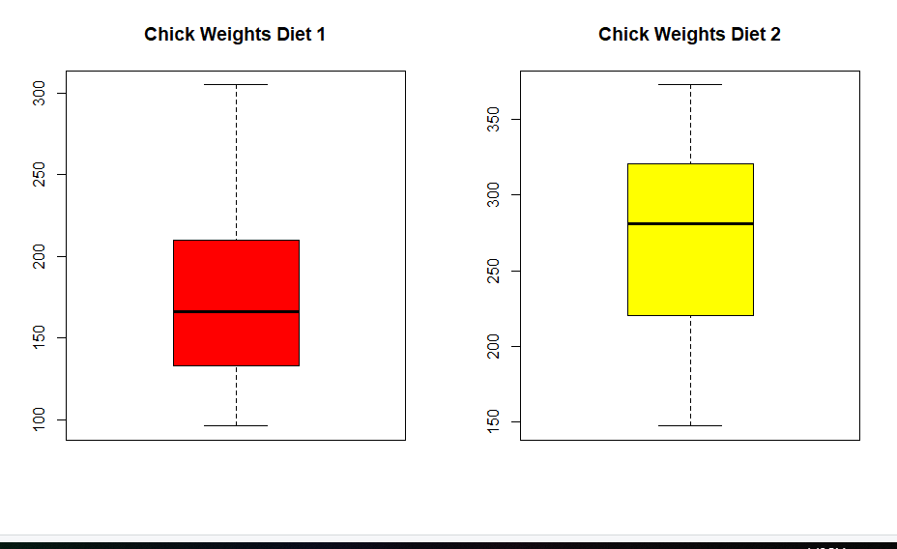
#(3)(b) (3 points) Use the "weight" data for the two diets to test the
# null hypothesis of equal population mean weights for the two diets. Test at
# the 95% confidence level with a two-sided t-test. This can be done using
# *t.test()* in R. Assume equal variances. Display the results of t.test().

t.test(Diet1$weight, Diet3$weight)

output
> t.test(Diet1$weight, Diet3$weight)

Welch Two Sample t-test

data: Diet1$weight and Diet3$weight
t = -3.4293, df = 16.408, p-value = 0.003337
alternative hypothesis: true difference in means is not equal to 0
95 percent confidence interval:
-149.64644 -35.45356
sample estimates:
mean of x mean of y
177.75 270.30

##### Working with paired data is another common statistical activity.
# The "ChickWeight" data will be used to illustrate how the weight gain
# from day 20 to 21 may be analyzed. Use the following code to prepare
# pre- and post-data from Diet == "3" for analysis.

#```{r test3paired}

# load "ChickWeight" dataset
data(ChickWeight)

# Create T | F vector indicating observations with Diet == "3"
index <- ChickWeight$Diet == "3"
# Create vector of "weight" for observations where Diet == "3" and Time == 20
pre <- subset(ChickWeight[index, ], Time == 20, select = weight)$weight
# Create vector of "weight" for observations where Diet == "3" and Time == 21
post <- subset(ChickWeight[index, ], Time == 21, select = weight)$weight
# The pre and post values are paired, each pair corresponding to an individual chick.
cbind(pre, post)
#(3)(c) (3 points) Present a scatterplot of the variable "post" as a function of the
# variable "pre". Include a diagonal line with zero intercept and slope equal to one.
# Title and label the variables in this scatterplot.
plot(pre, post, xlab="Day 20 Chick Weight",
ylab="Day 21 Chick Weight",
main = "Chick Weight Change From Day 20 to Day 21",
pch=16, col="red")
abline(a=0,b=1)
output
> plot(pre, post, xlab="Day 20 Chick Weight",
+ ylab="Day 21 Chick Weight",
+ main = "Chick Weight Change From Day 20 to Day 21",
+ pch=16, col="red")
> abline(a=0,b=1)

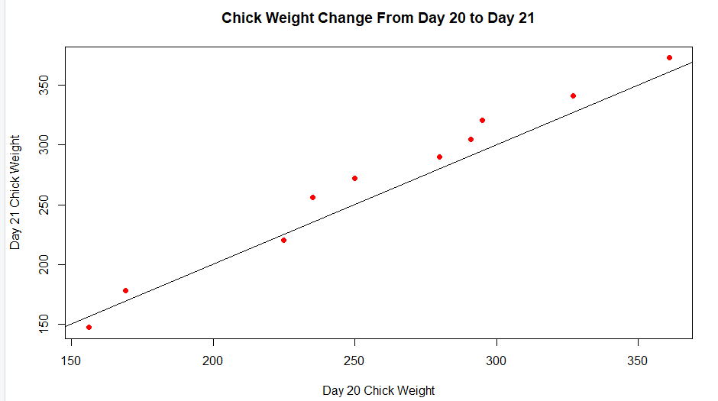

#(3)(d) (6 points) Calculate and present a one-sided, 95% confidence interval for the
# average weight gain from day 20 to day 21. Write the code for the paired t-test and
# for determination of the confidence interval endpoints. **Do not use *t.test()**,
# although you may check your answers using this function. Present the resulting
# test statistic value, critical value, p-value and confidence interval.
#```{r test3d}
mu<-mean(pre - post)
n<-length(pre)
crit_t<-qt(p=.950,df=n-1)
se<-sd(pre-post)/sqrt(n)
t<-mu/se
list(t.statistic = t, critical.t = crit_t,
p.value = 2 * pt(q = t, df = n - 1, lower.tail = FALSE),
conf.interval = c(mu - crit_t * se, mu + crit_t * se))
t.test(x = pre, y = post, paired = TRUE)
output
> mu<-mean(pre - post)
> n<-length(pre)
> crit_t<-qt(p=.950,df=n-1)
> se<-sd(pre-post)/sqrt(n)
> t<-mu/se
>
> list(t.statistic = t, critical.t = crit_t,
+ p.value = 2 * pt(q = t, df = n - 1, lower.tail = FALSE),
+ conf.interval = c(mu - crit_t * se, mu + crit_t * se))
$t.statistic
[1] -3.225267

$critical.t
[1] 1.833113

$p.value
[1] 1.989599

$conf.interval
[1] -17.879304 -4.920696

>
> t.test(x = pre, y = post, paired = TRUE)

Paired t-test

data: pre and post
t = -3.2253, df = 9, p-value = 0.0104
alternative hypothesis: true difference in means is not equal to 0
95 percent confidence interval:
-19.3958 -3.4042
sample estimates:
mean of the differences
-11.4

#(4)(a) (3 points) Using Nile River flow data and the "moments" package, calculate
# skewness and kurtosis. Present a QQ plot and boxplot of the flow data side-by-side
# using *qqnorm()*, *qqline()* and *boxplot()*; *par(mfrow = c(1, 2))* may be used
# to locate the plots side-by-side. Add features to these displays as you choose.

#```{r test4a}
library(moments)
str(Nile)
summary(Nile)
skewness(Nile)
kurtosis(Nile)
par(mfrow=c(1,2))
boxplot(Nile, col = 'red', main = 'Nile River Flows 1871 to 1970' )
qqnorm(Nile, col = 'red', pch=16, main = 'Nile River Flows 1871 to 1970' )
qqline(Nile)
par(mfrow=c(1,1))

output
> library(moments)
> str(Nile)
Time-Series [1:100] from 1871 to 1970: 1120 1160 963 1210 1160 1160 813 1230 1370 1140 ...
> summary(Nile)
Min. 1st Qu. Median Mean 3rd Qu. Max.
456.0 798.5 893.5 919.4 1032.5 1370.0
> skewness(Nile)
[1] 0.3223697
> kurtosis(Nile)
[1] 2.695093
> par(mfrow=c(1,2))
> boxplot(Nile, col = 'red', main = 'Nile River Flows 1871 to 1970' )
> qqnorm(Nile, col = 'red', pch=16, main = 'Nile River Flows 1871 to 1970' )
> qqline(Nile)
> par(mfrow=c(1,1))
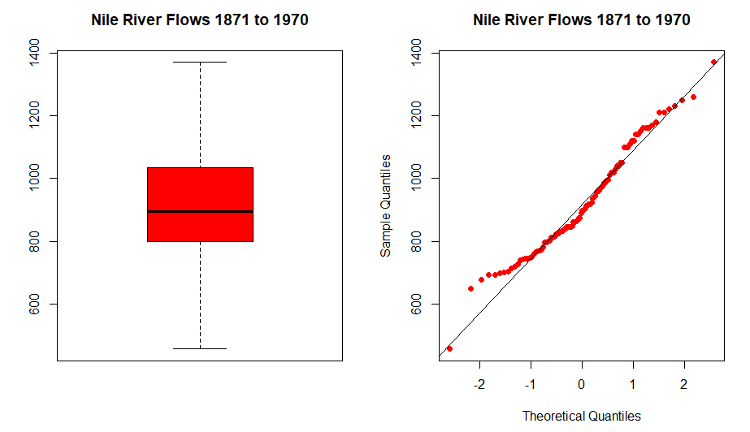
#(4)(b) (6 points) Using *set.seed(124)* and the Nile data, generate 1000 random
# samples of size n = 16, with replacement. For each sample drawn, calculate and
# store the sample mean. This can be done with a for-loop and use of the *sample()*
# function. Label the resulting 1000 mean values as "sample1". **Repeat these steps
# using *set.seed(127)* - a different "seed" - and samples of size n = 64.** Label
# these 1000 mean values as "sample2". Compute and present the means, sample standard
# deviations and sample variances for "sample1" and "sample2" in a table with the first
# row for "sample1", the second row for "sample2" and the columns labled for each statistic.

#```{r test4b}

set.seed(124)
sample1<-numeric(1000)
for (i in 1:1000) {
a<-sample(y, 16, replace = T)
sample1[i]<- mean(a)
}
set.seed(127)
sample2<-matrix(, nrow = 1000, ncol=3)
sample2<-numeric(1000)
for (i in 1:1000) {
a<-sample(y, 64, replace = T)
sample2[i]<- mean(a)
}
(samp <- cbind(mean(sample1),sd(sample1),var(sample1)))
(samp <- rbind(samp,cbind(mean(sample2),sd(sample2), var(sample2))))
rownames(samp) <- c("sample1","sample2")
colnames(samp) <- c("Mean", "Std", "Variance")
samp
OUTPUT
> set.seed(124)
> sample1<-numeric(1000)
> for (i in 1:1000) {
+ a<-sample(y, 16, replace = T)
+ sample1[i]<- mean(a)
+ }
>
> set.seed(127)
> sample2<-matrix(, nrow = 1000, ncol=3)
> sample2<-numeric(1000)
> for (i in 1:1000) {
+ a<-sample(y, 64, replace = T)
+ sample2[i]<- mean(a)
+ }
>
> (samp <- cbind(mean(sample1),sd(sample1),var(sample1)))
[,1] [,2] [,3]
[1,] 0.1878658 0.0469961 0.002208633
> (samp <- rbind(samp,cbind(mean(sample2),sd(sample2), var(sample2))))
[,1] [,2] [,3]
[1,] 0.1878658 0.04699610 0.002208633
[2,] 0.1889880 0.02346896 0.000550792
> rownames(samp) <- c("sample1","sample2")
> colnames(samp) <- c("Mean", "Std", "Variance")
>
> samp
Mean Std Variance
sample1 0.1878658 0.04699610 0.002208633
sample2 0.1889880 0.02346896 0.000550792

#(4)(c) (6 points) Present side-by-side histograms of "sample1" and "sample2" with the
# normal density curve superimposed. To prepare comparable histograms, it will be
# necessary to use "freq = FALSE" and to maintain the same x-axis with
# "xlim = c(750, 1050)", and the same y-axis with "ylim = c(0, 0.025)."
# **To superimpose separate density functions, you will need to use the mean and
# standard deviation for each "sample" - each histogram - separately.**
#```{r test4c}
par(mfrow=c(1,2))
x<-seq(from = 700, to = 1100, by = 1)
hist(sample1, freq = FALSE, col = "darkred", xlab = "Flow",
main = "Histogram of Nile River\nSample 1 Flows 1871 to 1970"
, ylim = c(0, 15),
xlim = c(0, 0.25), plot = TRUE)
curve(dnorm(x, mean = samp[1,1], sd = samp[1,2]), col = "green", lwd = 2, add = TRUE)
hist(sample2, freq = FALSE, col = "darkred", xlab = "Flow",
main = "Histogram of Nile River\nSample 2 Flows 1871 to 1970"
, ylim = c(0, 15),
xlim = c(0, 0.25), plot = TRUE)
curve(dnorm(x, mean = samp[2,1], sd = samp[2,2]), col = "green", lwd = 2, add = TRUE)
par(mfrow=c(1,1))
output
> par(mfrow=c(1,2))
> x<-seq(from = 700, to = 1100, by = 1)
> hist(sample1, freq = FALSE, col = "darkred", xlab = "Flow",
+ main = "Histogram of Nile River\nSample 1 Flows 1871 to 1970"
+ , ylim = c(0, 15),
+ xlim = c(0, 0.25), plot = TRUE)
> curve(dnorm(x, mean = samp[1,1], sd = samp[1,2]), col = "green", lwd = 2, add = TRUE)
> hist(sample2, freq = FALSE, col = "darkred", xlab = "Flow",
+ main = "Histogram of Nile River\nSample 2 Flows 1871 to 1970"
+ , ylim = c(0, 15),
+ xlim = c(0, 0.25), plot = TRUE)
> curve(dnorm(x, mean = samp[2,1], sd = samp[2,2]), col = "green", lwd = 2, add = TRUE)
> par(mfrow=c(1,1))

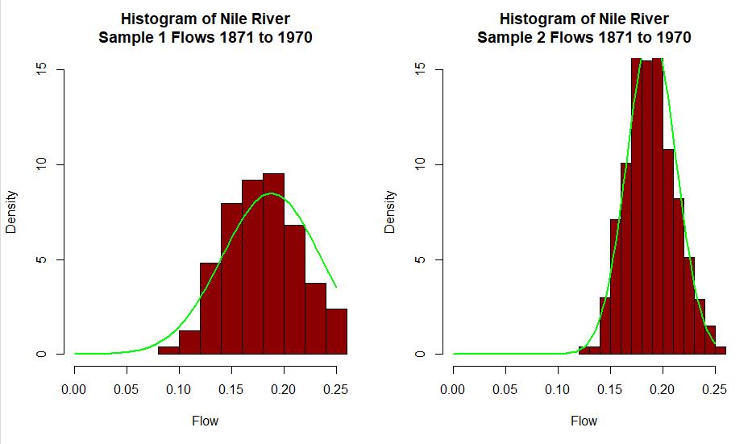

##### Section 5: (15 points) ##################################

##### (5) This problem deals with contingency table analysis. This is an example
# of categorical data analysis (see Kabacoff, pp. 145-151). The "warpbreaks" dataset
# gives the number of warp breaks per loom, where a loom corresponds to a fixed length
# of yarn. There are 54 observations on 3 variables: breaks (numeric, the number of breaks),
# wool (factor, type of wool: A or B), and tension (factor, low L, medium M and high H).
# These data have been studied and used for example elsewhere. For the purposes of this problem,
# we will focus on the relationship between breaks and tension using contingency table analysis.

# (5)(a)(4.5 points) warpbreaks is part of the "datasets" package and may be loaded via
# *data(warpbreaks)*. Load "warpbreaks" and present the structure using *str()*.
# Calculate the median number of breaks for the entire dataset, disregarding "tension" and
# "wool". Define this median value as "median_breaks". Present a histogram of the number of
# breaks with the location of the median indicated.

# Create a new variable "number" as follows: for each value of "breaks", classify the number
# of breaks as either strictly below "median_breaks", or the alternative. Convert the
# "above"|"below" classifications to a factor, and combine with the dataset warpbreaks.
# Present a summary of the augmented dataset using *summary()*. Present a contingency
# table of the frequency of breaks using the two variables "tension" and "number".
# There should be six cells in this table.

#```{r test5a}

data(warpbreaks)
warp<-warpbreaks
str(med)

(median_breaks <- median(warp$breaks))

hist(warp$breaks, main = paste("Histogram of Breaks with Median Value\n Blue vertical line at ",
median_breaks, "Breaks"))
abline(v= median_breaks, col="blue")

warp$P50.loc <- factor(warp)
warp$P50.loc <- factor(warp$breaks>median_breaks)
levels(warp$P50.loc <- c("below", "above"))
summary(warp)

(warptab <- table(warp$tension,warp$P50.loc))

#```
data(warpbreaks)
warp<-warpbreaks
str(med)
(median_breaks <- median(warp$breaks))
hist(warp$breaks, main = paste("Histogram of Breaks with Median Value\n Blue vertical line at ",
median_breaks, "Breaks"))
abline(v= median_breaks, col="blue")
warp$P50.loc <- factor(warp)
warp$P50.loc <- factor(warp$breaks>median_breaks)
levels(warp$P50.loc <- c("below", "above"))
summary(warp)
(warptab <- table(warp$tension,warp$P50.loc))
Output
> data(warpbreaks)
> warp<-warpbreaks
> str(med)
'data.frame': 54 obs. of 4 variables:
$ breaks : num 26 30 54 25 70 52 51 26 67 18 ...
$ wool : Factor w/ 2 levels "A","B": 1 1 1 1 1 1 1 1 1 1 ...
$ tension: Factor w/ 3 levels "L","M","H": 1 1 1 1 1 1 1 1 1 2 ...
$ P50.loc: chr "below" "above" "below" "above" ...
>
> (median_breaks <- median(warp$breaks))
[1] 26
>
> hist(warp$breaks, main = paste("Histogram of Breaks with Median Value\n Blue vertical line at ",
+ median_breaks, "Breaks"))
> abline(v= median_breaks, col="blue")
>
> warp$P50.loc <- factor(warp)
> warp$P50.loc <- factor(warp$breaks>median_breaks)
> levels(warp$P50.loc <- c("below", "above"))
NULL
> summary(warp)
breaks wool tension P50.loc
Min. :10.00 A:27 L:18 Length:54
1st Qu.:18.25 B:27 M:18 Class :character
Median :26.00 H:18 Mode :character
Mean :28.15
3rd Qu.:34.00
Max. :70.00
>
> (warptab <- table(warp$tension,warp$P50.loc))

above below
L 9 9
M 9 9
H 9 9

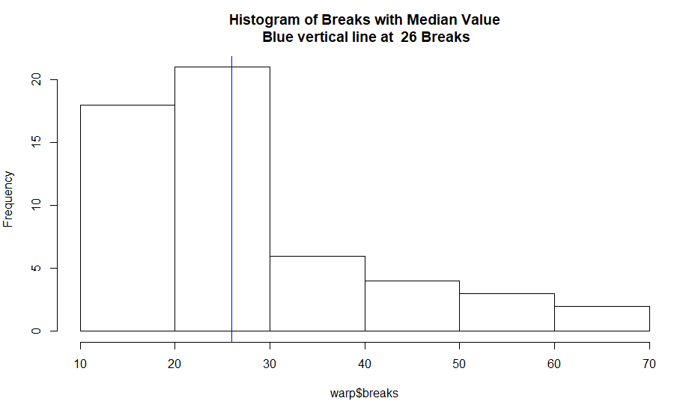

#(5)(b)(3 points) Using the table constructed in (5)(a), test at the 5% level
# the null hypothesis of independence using the uncorrected *chisq.test()*
# (Black, Business Statistics, Section 16.2). Show the results of this test and state your conclusions.

#```{r test5b}
chisq.test(warptab, correct = FALSE)
output
> chisq.test(warptab, correct = FALSE)

Pearson's Chi-squared test

data: warptab
X-squared = 0, df = 2, p-value = 1

The observed value of chi squared 0 is less than the critical value 5.9915 so the null hypothesis tension is independent of number is accepted.

#(5)(c) (7.5 points) Write a function that computes the uncorrected
# Pearson Chi-squared statistic. Apply your function to the table from (5)(a).
# You should be able to duplicate the X-squared value (chi-squared) and *p*-value. Present both.

# Shown below are examples of the type of function required. These examples will have
# to be modified to accomodate the table generated in (5)(a).

#```{r test5c}
chi <- function(x) {
# To be used with 2x2 contingency tables that have margins added.
# Expected values are calculated.
e11 <- x[4,1]*x[1,3]/x[4,3]
e12 <- x[4,2]*x[1,3]/x[4,3]
e21 <- x[4,1]*x[2,3]/x[4,3]
e22 <- x[4,2]*x[2,3]/x[4,3]
e31 <- x[4,1]*x[3,3]/x[4,3]
e32 <- x[4,2]*x[3,3]/x[4,3]
# Value of chi square statistic is calculated.
chisqStat <- (x[1,1] - e11)^2/e11 + (x[1,2] - e12)^2/e12 +
(x[2,1] - e21)^2/e21 + (x[2,2] - e22)^2/e22 +
(x[3,1] - e31)^2/e31 + (x[3,2] - e32)^2/e32
return(list("chi-squared" = chisqStat,
"p-value" = pchisq(chisqStat, 1, lower.tail = F)))
}

chisqfun <- function(t) {
x <- addmargins(t)
e <- matrix(0, nrow = nrow(t), ncol = ncol(t), byrow = T)
r <- matrix(0, nrow = nrow(t), ncol = ncol(t), byrow = T)
for (i in 1:2) {
for (j in 1:2) {
e[i,j] = x[nrow(x),j] * x[i,ncol(x)]/x[nrow(x), ncol(x)]
r[i,j] = ((x[i,j] - e[i,j])^2)/e[i,j]
}
}
chi <- sum(r)
xdf <- nrow(t) - 2
pv <- pchisq(chi, df = xdf, lower.tail = FALSE)
return(cat("Pearson's Chi-squared test \n","Chi sq: ", chi, ";
Degree of Freedom :",xdf," ; P-value :",pv))
}

(Y <- matrix(warptab, nrow = 3, byrow = F))
(A <- cbind(Y, apply(Y,1,sum)))
(B <- rbind(A, apply(A, 2, sum)))

chi(B)
chisqfun(B)

output
> chi <- function(x) {
+ # To be used with 2x2 contingency tables that have margins added.
+ # Expected values are calculated.
+ e11 <- x[4,1]*x[1,3]/x[4,3]
+ e12 <- x[4,2]*x[1,3]/x[4,3]
+ e21 <- x[4,1]*x[2,3]/x[4,3]
+ e22 <- x[4,2]*x[2,3]/x[4,3]
+ e31 <- x[4,1]*x[3,3]/x[4,3]
+ e32 <- x[4,2]*x[3,3]/x[4,3]
+ # Value of chi square statistic is calculated.
+ chisqStat <- (x[1,1] - e11)^2/e11 + (x[1,2] - e12)^2/e12 +
+ (x[2,1] - e21)^2/e21 + (x[2,2] - e22)^2/e22 +
+ (x[3,1] - e31)^2/e31 + (x[3,2] - e32)^2/e32
+ return(list("chi-squared" = chisqStat,
+ "p-value" = pchisq(chisqStat, 1, lower.tail = F)))
+ }
>
> chisqfun <- function(t) {
+ x <- addmargins(t)
+ e <- matrix(0, nrow = nrow(t), ncol = ncol(t), byrow = T)
+ r <- matrix(0, nrow = nrow(t), ncol = ncol(t), byrow = T)
+ for (i in 1:2) {
+ for (j in 1:2) {
+ e[i,j] = x[nrow(x),j] * x[i,ncol(x)]/x[nrow(x), ncol(x)]
+ r[i,j] = ((x[i,j] - e[i,j])^2)/e[i,j]
+ }
+ }
+ chi <- sum(r)
+ xdf <- nrow(t) - 2
+ pv <- pchisq(chi, df = xdf, lower.tail = FALSE)
+ return(cat("Pearson's Chi-squared test \n","Chi sq: ", chi, ";
+ Degree of Freedom :",xdf," ; P-value :",pv))
+ }
>
> (Y <- matrix(warptab, nrow = 3, byrow = F))
[,1] [,2]
[1,] 9 9
[2,] 9 9
[3,] 9 9
> (A <- cbind(Y, apply(Y,1,sum)))
[,1] [,2] [,3]
[1,] 9 9 18
[2,] 9 9 18
[3,] 9 9 18
> (B <- rbind(A, apply(A, 2, sum)))
[,1] [,2] [,3]
[1,] 9 9 18
[2,] 9 9 18
[3,] 9 9 18
[4,] 27 27 54
>
> chi(B)
$`chi-squared`
[1] 0

$`p-value`
[1] 1

> chisqfun(B)
Pearson's Chi-squared test
Chi sq: 0 ;
Degree of Freedom : 2 ; P-value : 1

