The two articles I chose to compare Online Term Extraction Engines are Wikipedia articles about Black Holes. I chose Black Holes and Binary Black Holes as my documents for term extraction. The first thing I did was to cut and paste the text from the two html pages and store them in local text files. I used the following Python code to count the occurrences of each word in my text files.
# Open the file in read mode
text = open("Black_Hole.txt", "r")

# Create an empty dictionary
d = dict()
# Loop through each line of the file
for line in text:
# Remove the leading spaces and newline character
line = line.strip()
# Convert the characters in line to
# lowercase to avoid case mismatch
line = line.lower()

# Split the line into words
words = line.split(" ")

# Iterate over each word in line
for word in words:
# Check if the word is already in dictionary
if word in d:
# Increment count of word by 1
d[word] = d[word] + 1
else:
# Add the word to dictionary with count 1
d[word] = 1

# Print the contents of dictionary
for key in list(d.keys()):
print(key, ":", d[key])

After doing this I inspected the code and created a list of terms using human power to determine the best terms for searching similar documents. One problem with my method is that all my terms were one word terms so Black Hole is considered two different occurrences. Below is the table I created with my scripts, Termine and FiveFilters.
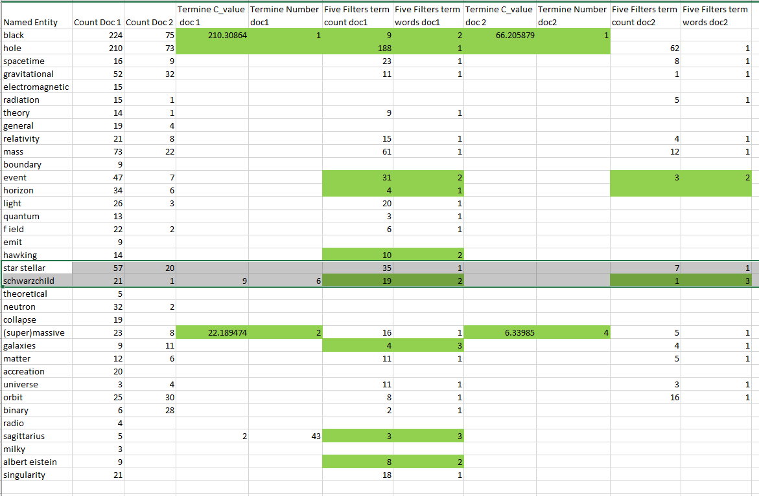

The highlighted green text represents terms where I had singular words and the extraction engine had 2-grams and 3-grams or more. My method would have to be refined to limit the retrieved corpus to articles pertaining to black holes and not retrieve an article about the Black Knight for instance. I didn’t have many intersections with the Termine extraction engine. Termine extracted terms like black hole, supermassive black hole and Schwarzschild black hole where my terms were black, hole, supermassive and Schwarzschild. While Schwardzschild would select documents pertaining to black holes the other terms would retrieve documents from many subjects. FiveFilters suffers from these issues as well. There were two terms which were a 2-gram, black hole and event horizon. For the most part it consisted of extracting terms which were single words. If I want to create a set of tokens to search the internet for webpages about black holes, I would use TerMine to extract terms for search.

