What is an ontology? How can we create an ontology?
And if we had an ontology, how could we use it?

Do background reading on ontologies, including materials in the course site under Week 8 NLP applications and the Neo4j graph database. Learn about the RDF triple-store, semantic networks, and knowledge graphs. This is a big area that involves NLP as well as graph databases.

Graph databases provide an alternative structure to traditional relational databases. While typically classified in the catch-all group of "NoSQL" databases, they are very different other NoSQL databases, such as key-value stores, columnar, and document databases.

An ontology is a structure and system of dividing a topic into subclasses which get more granular as division continues. For instance, from our reading the authors used wine as their root super class which can be divided into three subclasses red wine, white wine and Burgundy wine. Red wine can be divided into smaller subclasses such as Merlot, Pinot Noir, Cabernet Sauvignon etc. As you go down in level each subclass provides more specific information which may not be an attribute of its superclass. Here are two examples of ontologies represented as graphs.
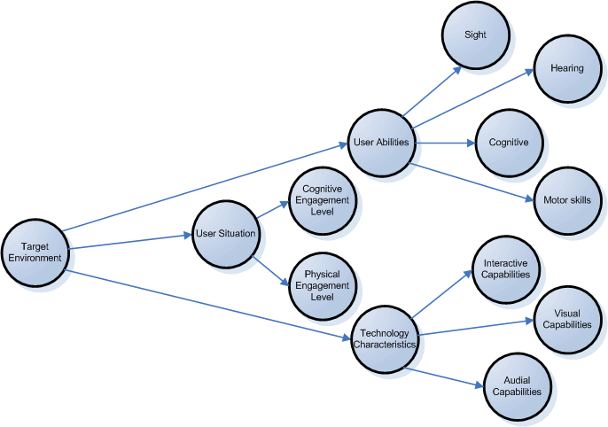
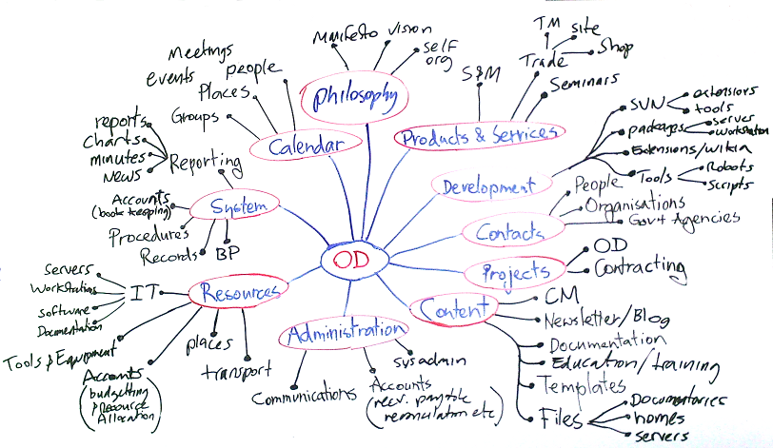

Ontologies when used in graph databases can prove to be very useful. In the Neo4j video William Lyon demonstrated how storing his data in a graph database called Neo4j could be used to find similar data for additional study. He has stored articles he has read or shared in the graph database. As part of the ontology keywords from the articles are stored in the graph of each article. Using the graph structure, he was able to get meaning from the data and use it to search for similar articles on the internet. This sort of technology can be used to find articles other people have read who share the same interests. It is one of the ways Amazon or Netflix can find things which may have your interest.

