Conversational agents or chatbots are among the most widely used applications of natural language processing. This is a three-part discussion question.

- Consider what it takes to implement Amazon Alexa, Apple Siri, and Google Assistant. Describe the software components involved in developing such applications. How do these components relate to natural language processing discussed in this course?

Below is the basic architecture of a chatbot for the major vendors Amazon, Apple and Google as well as Microsoft and IBM. This one is modeled after Alexa.
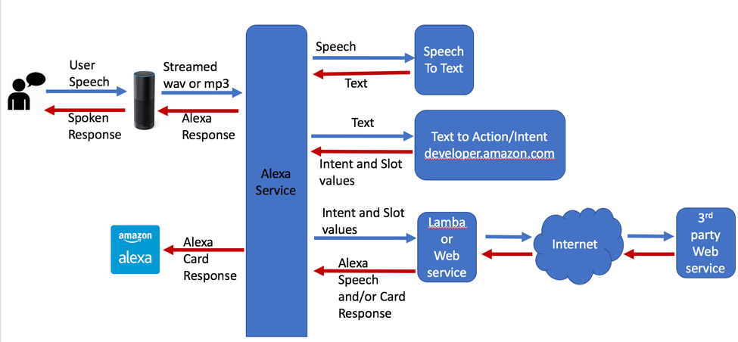

The user supplies an utterance as is classified by Amazon which is heard by one of the vendors devices. From here a speech to text converter is used to convert the sounds into text. Then the text is piped to a component that translates intent, “I want to rent a projector” becomes Rent a Projector. A lambda or web service is used to create a response to the utterance. The response is synthesized as speech and the user is engaged for the next exchange. This process continues until the user no longer speaks an utterance.

- Suppose you were asked to lead a team in developing a service agent chatbot for your current or former employer. What kinds of skills would be needed in the development team?

The team would require domain expertise in the area a human is replaced with a chatbot. Data science skills are required to build the AI components for the chatbot. There are many components in this system so software engineering skills are required to piece the whole system together and provide an interface for human machine interaction. If the chatbot includes a device then hardware skills such as electrical engineering and possibly mechanical engineering depending on the functionality of the chatbot are required. Finally, a good test team is required to verify the functionality and usability of the chatbot. The developers may be to close to the system to try something Aunt Martha might try. But a good tester will ensure these types of paths are tested.

(3) Consider alternative development platforms, including AWS Lex, Google Dialogflow, IBM Watson, and Rasa, as compared at

https://www.globalme.net/blog/lex-vs-dialogflow-vs-watson-vs-rasa (Links to an external site.)

Given your reading of reviews of various speech recognition and chatbot facilities, which platform would you recommend for to your employer for the chatbot development project?

Explain your reasoning, providing links to literature that has influenced your recommendation for chatbot development.
Google’s dialogflow provides the best documentation and is easy to use but does not provide example. All of the Intents have to be written by the developer. Google’s interface graphics are the best.
Amzon’s Lex documentation is more difficult to work with but they provide example chatbots which can be modified to meet developer needs. So the developer can use the examples and predefined intents and slots to build a chatbot. Although the look isn’t as good the chatbot can be enabled on Facebook, Kik, Slack and Twilo
IBM’s Watson has great documentation. Tutorials that are easy to follow and the most examples make Watson the easiest chatbot development platform to get a chatbot functioning. Many of the intents and entities are already done allowing the developer to expand the chatbot.

