Identify a recent work in the NLP area that uses a deep learning approach. Describe how this approach improves the NLP process.

General Approach:
Find a recent article (within the last year/month/week) on this topic.
Briefly summarize/discuss this article - especially why you think it's important.
Identify key terms/concepts mentioned in this article that you would like to understand by the end of this quarter; assess and evaluate the impact.

There are many new areas of research pursued regarding deep learning and NLP such as BERT, GPT-2 which use the new transformer architecture combined with pre-trained models and fine tuning. Chatbots will benefit from these new techniques.
https://blog.floydhub.com/ten-trends-in-deep-learning-nlp/
Another technology that is generating interest is N-shot Learning which consists of zero shot learning, one-shot learning and few-shot learning. A shot is an example of data so these techniques involve training with limited data. In his article on FloydHub “N-Shot Learning: Learning More with less Data”, Andrew Ng outlines the various types of n-shot learning and provides an example of few-shot learning in prototypical networks which meta-learning and reinforcement-learning algorithms are combined with standard deep learning algorithms producing great results with only two to five images. Images are mapped into a metric space called an Image2Vector model.
https://blog.floydhub.com/n-shot-learning/#zero-shot-learning

In terms of NLP Mikel Artetxe and Holger Schwenk published an article in September 2019 on the use of Zero-Shot architecture to produce massive multilingual sentence embeddings for Zero-shot cross-lingual transfer and beyond. Their architecture learned fixed-length sentence embeddings for 93 languages. They used a single language bi-directional LSTM which they trained on publicly available corpora. To the best of their knowledge this was the first successful research of this type. Here is the link for this article.
https://arxiv.org/abs/1812.10464
Here is the pipeline flow comparison between standard models and the zero-shot model.

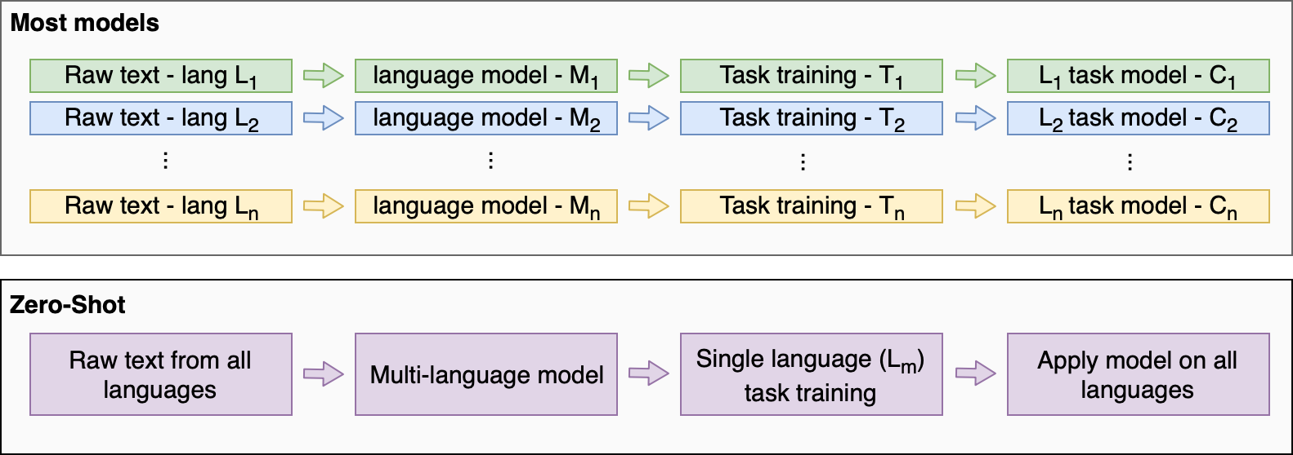

I would like to understand BERT, prototypical networks, zero-shot and multilingual sentence embeddings.

