Jude Barlow

David Hanlon

COSC 436

5/6/19

**Assignment 5**

**Introduction**

In this assignment, we used the structural design pattern known as decorator. While using this design pattern, we were eligible to modify the functionality of an object at the program runtime, where individual/specific objects attain the modified behavior. For this assignment, we had a receipt which holds taxes, rebates, and coupons. The taxes are matched according to the store’s state which can be edited in the “storeInfo.txt” file, and the rebates are on specific objects in the inventory. The best buy store is also stored with an inventory of things to buy and add to the receipt.

**Screenshots with Description**

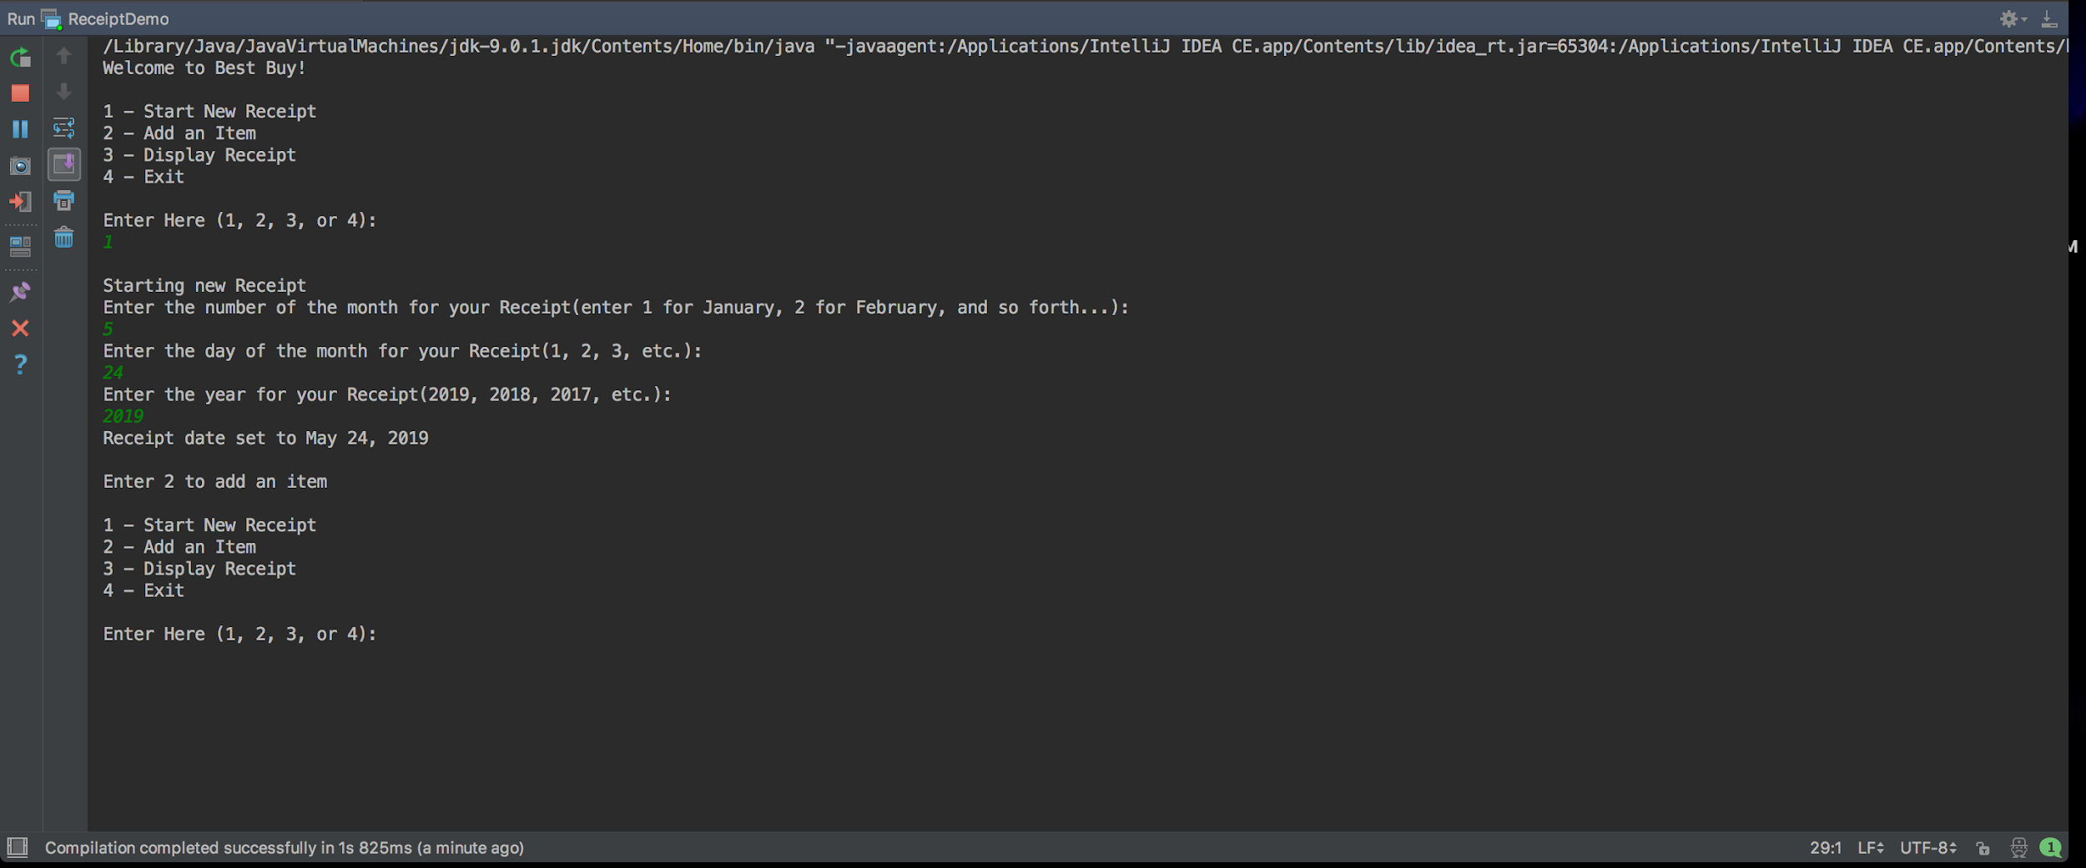

In this screenshot, I inputed “1” which led to starting a new receipt where the user can input the specific date they desire to be on the receipt. *** If the user skips the start a new receipt step, the receipt displayed after adding items will have the current date the user is running this on.***

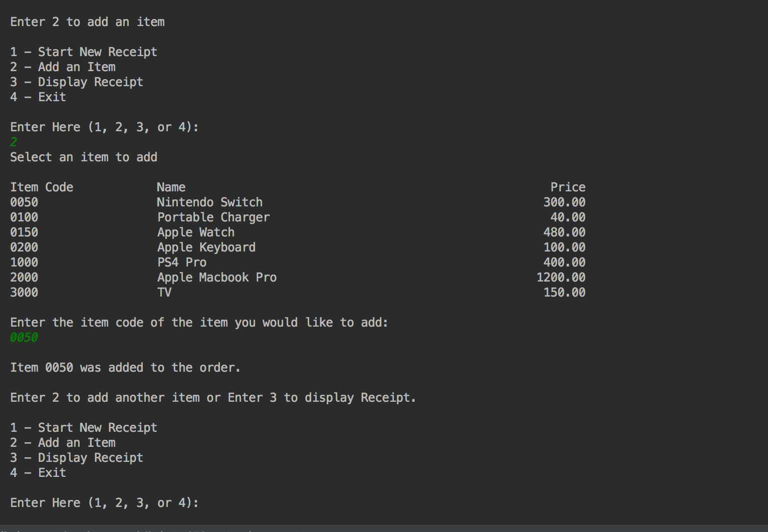

In this screenshot, I am adding an item to the receipt via inputting its item code. For this example, I used the 0050, which was for the nintendo switch.

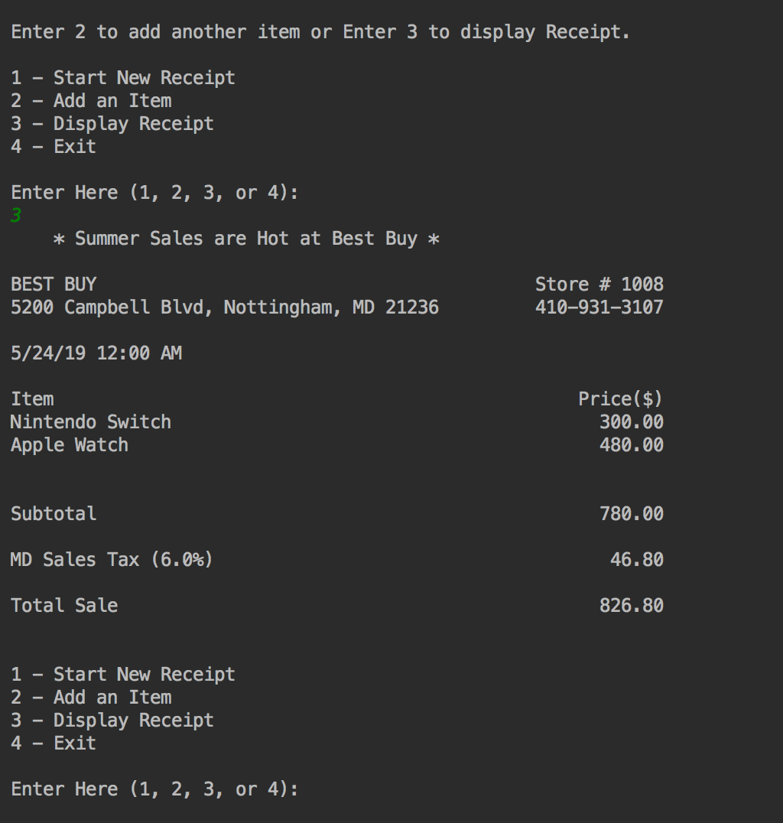

In this screenshot, I selected the display receipt option after making some item additions and it printed out the receipt of what I added and included the sales tax of 6% according to the store info I was using. The state tax applies to MD, CA, MA, and DE.

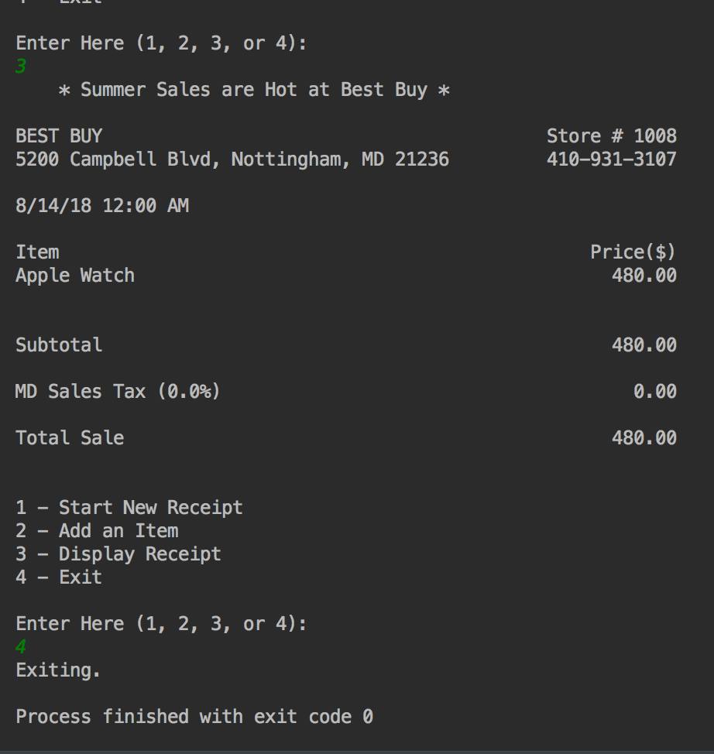

In this screenshot, this is the displayed receipt option result during the tax holiday in August. In this picture, I added the apple watch to the receipt and notice that there is no sales tax as a result of it being ordered during the tax holiday period.

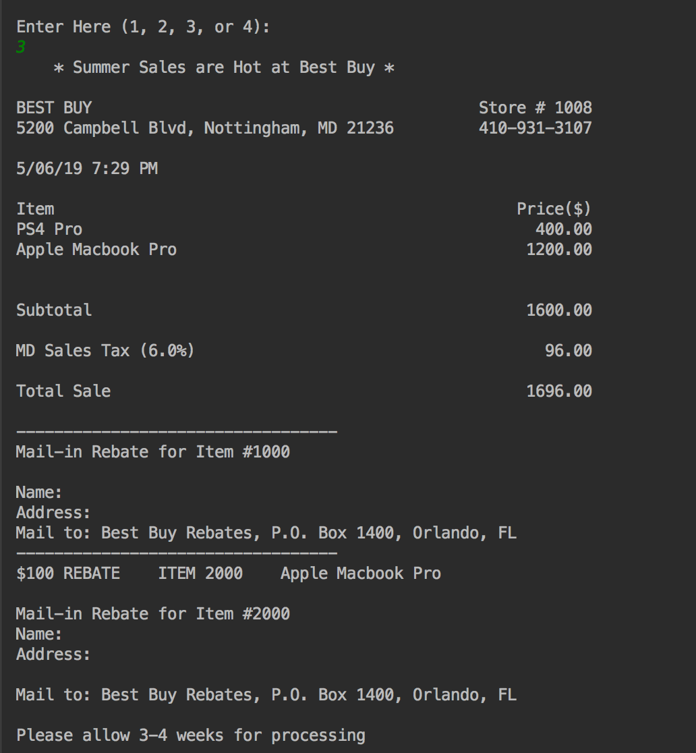

In this screenshot, I added the items to the receipt in which have rebates. In this case, the items that have rebates in the program are the ps4 and the macbook pro. It labels the item code number as well as the name, address and mail to address template.

**\*\*\*REMINDER: To try different state locations of best buy for this program, simply change the info in the “storeInfo.txt” file.\*\*\***