Jonny Armstrong

Dr. Simari

Computer Graphics

December 10, 2018

Final Project Documentation

Implementation Decisions

The bowling ball was modeled with a primitive sphere, and was given coordinate velocities to roll towards the pins. The pins were modeled with primitive cylinders, and remain motionless until the bowling ball intersects with the front pin. Once that happens the pins fly backward and rotate until hitting the back wall and falling downward.

It was decided that the back wall of the modeled bowling alley and the three bowling lanes were the most sensible candidates for texture mapping. A png of a bowling lane and a png of a purple square pattern were used and are shown below.

Purple Square Pattern

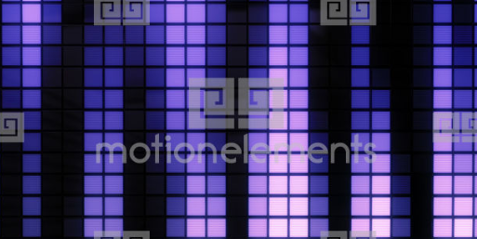

Bowling lane Design



Both textures in the model (the lane texture was made slightly darker)

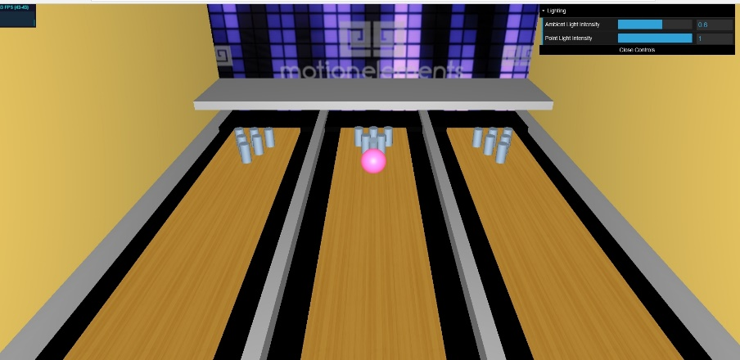

As for implementing sound into the model, the bowling ball intersecting the first pin was the best place to put a strike sound effect. It is loaded slightly before the bowling ball actually hits due to the delay and as a result times up with the animated ball and pins.

This sample video was used to get a feel for how a bowling ball hitting pins looks. It served as an inspiration for the choice of speed and rotation put on the pins as a result of the bowling ball hitting them as well as other pins.

<https://www.youtube.com/watch?v=Fp7aTFsrr50>

Technical issues and solutions

The lone standout technical issue was Google Chrome prohibiting the use of local files in javascript and html. A cross origin error would be thrown. Switching from Google Chrome to Mozilla Firefox solved the issue for images but it was still present for sounds.

By entering about:config into forefox’s url bar and searching “security.fileuri.strict_origin_policy” and setting it to false, the sound file loaded correctly.

Screenshot

