FNMA HAMP REPORTING

Place report in Servicing App, Management, Reports, and create another folder and name it called EOM Investor Reporting.

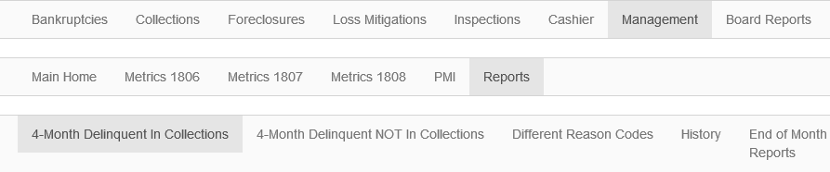

Crystal Report: Go to Servicing, Foreclosure Reports, Conventional Delinquency Rpt. Click on report, Pick FNMA-HAMP Modification option and move to other side with using arrow and hit OK to get report.
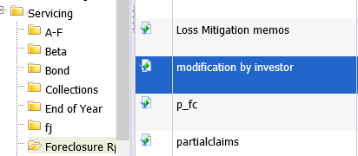

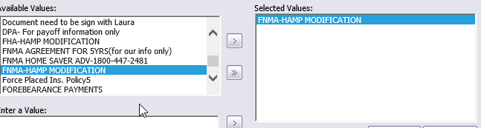
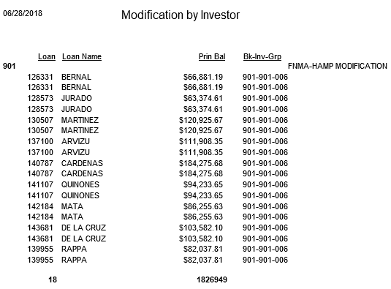

By the 3rd of every month, we must report all FNMA-HAMP as of the last day of the previous month. We just need a listing of those loans.

Information requested on the report:
Loan #, HAMP Servicer Number (909389186-the same for all loans) Last Name, Last Paid Installment Due Date, Unpaid Principal Balance, Principal Payment Amount of last payment made, Interest Payment Amount of last payment made

FNMA Modifications can be identified with Loan Stop &
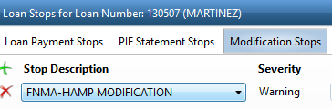
Investor Information &
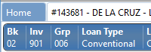

Loan Modification alert at bottom of Loan Details screen.
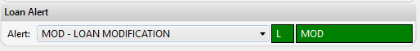

Data for principal balance, principal payment and interest payment amount can be found on MS, Histories, View History Screen as shown below. In this example: Last Paid Installment Date is 6/1/18, Unpaid Principal Balance is $120, 925.67, Last Principal payment made is $527.82, and Interest Payment is $404.84.
