FANNIE MAE DELINQUENCY REPORT

Place report in Servicing App, Management, Reports, and create another folder and name it called EOM Investor Reporting.

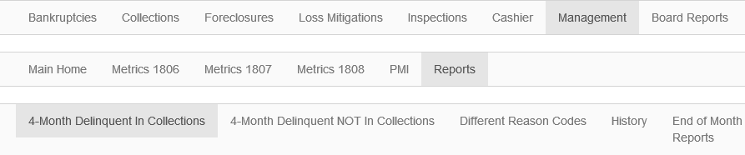

Crystal Report: Go to Servicing, Foreclosure Reports, Conventional Delinquency Rpt. Enter value as last day of previous month and change time on calendar to 00:00:00 and ok to get report
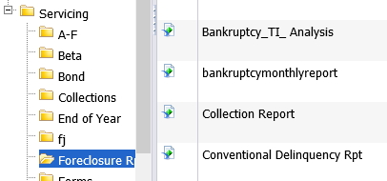

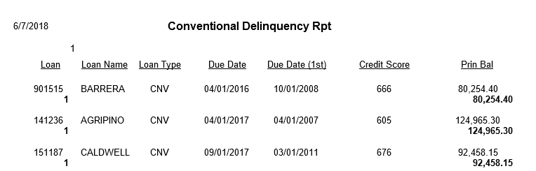

By the second of every month, we must report all Fannie Mae delinquency as of the last day of the previous month. We just need a listing of those loans.

Information requested on the report:
Loan #, Investor Loan # (Investor/Service Fee screen, Investor tab), Last Name, Due Date, Mortgage Status Code/Description, Default Reason Code/Description

