NO CONTACT LISTING

Place report in Collection Reports tab.

We need to identify all loans that we have had no contact within the current month. So at any given time, we want to identify these loans so that we can begin skip-tracing these mortgagors.
We will generally start using this report around the 25th, or towards the end of the month.
We need to identify all delinquent loans (30, 60, 90+ ) in which we have had no contact within the current month. I don’t know if using these specific lists would be helpful to you (except Promised to pay)?
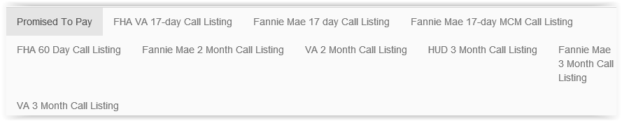

We can identify these loans by using:
Subject: BC
Memo type: BC-No Contact and/or
Category: 031 Unable to contact.

Look at all memos for the month of January (or current month we are in only)with the subject type BC and if all the memos have No Contact and 31 Unable to Contact, then it needs to be on the listing.

For example: 132621 Rodriguez : Subject is BC, Type is No Contact, Cat is 31 Unable to Contact

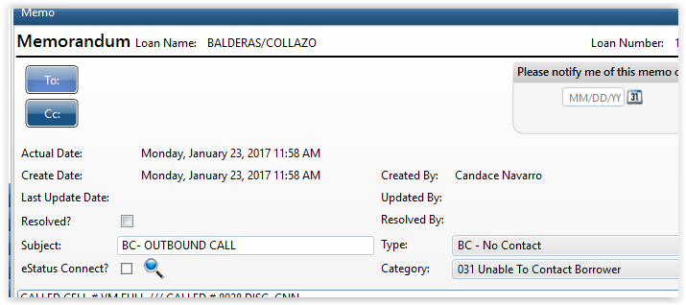

Now if you look at the BC calls for the month of January, the memos are all BC, BC, and 31s (1/18 and 1/23).
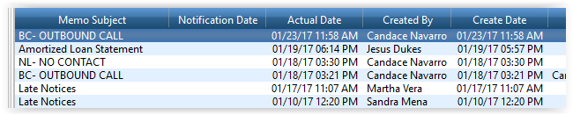

In order to come off of the listing, a subsequent memo with the Subject: BC… and Type: (any other than BC-No Contact) and/or Category (any other than 031 Unable to contact). As shown in example below.
