QUARTER REPORTS
Name: MODS DELINQUENT

Purpose: These numbers are used at the end of each quarter in order to create a report for the Accounting department. Robert reports this information certain agencies. We must identify all modifications, current and delinquent and must be reported in separate stages of delinquency.

- Identify modification loans that were modified effective date of 12 months or less. This would be the first Due Date of the modification.
Need number of current loans, 30 days delinquents, 60 day delinquents, and 90+ delinquents.
- Identify modification loans that were modified 13 months ago or later. This would be the first due date of the modification.
Need number of current loans, 30 days delinquents, 60 day delinquents, and 90+ delinquents.

Information on Report:
Loan #, Name, Loan Type, Mod Plan, Mod Date, Mod Effective Date, Due Date , UPB
Provide Total # of Loans and UPB at bottom of each category.

Where to find some of this info:
Mod Plan and Mod Effective Date - General, Collections, Modification Information Summary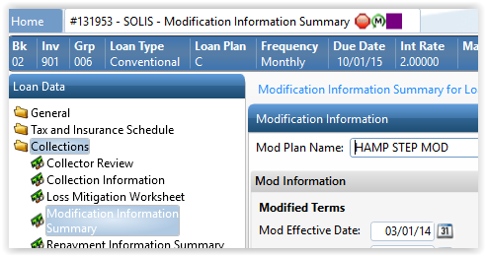

Modification Date – General, Loan Status – Modified Date (right hand side of screen)
