# of MONTHS
SPREAD DEFICIENCY/SHORTAGE REPORT

We need a report to identify all loans that have their shortage and/or deficiency spread over a 12 to 60 month period.
Name of Report: # of Months Spread
Place report in Collections, Reports, End of Month Reports, after Modification Analysis Report.

The MS screen used to locate this information is as follows:
Go to General, Tax & Insurance Details, then click on the third tab name Tax & Insurance Disclosure as shown in example below (LN # 208000).
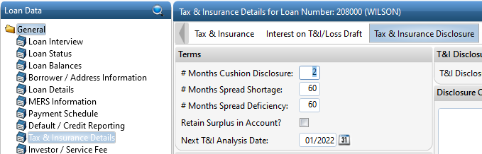

The loans that need to be identified will have the # Months Spread Shortage populated, or the # Months Spread Deficiency populated, and/or both populated.
The fields are usually populated with the following numbers: 60, 48, 36, 24, or 12. Loans with both fields blank should NOT be on report.

Columns needed on report:
Loan #, Last Name, Alert Description (Loan Details screen on bottom of page), # of Months Spread Shortage, # of Months Spread Deficiency, Next T&I Analysis Date (info on latter three on Tax & Insurance Disclosure). See screen shot/info above.

