Kilosort Automation
Binary file creation:

- Our Cambridge Neurotech probe recordings will output one .ncs file for each channel, but Kilosort needs a single file with all the channel information called a binary file
- Create an .xlsx feeder sheet with the paths to each recording session you want to create a binary file for. This feeder sheet will need to have two filler columns in rows 1 & 2 and one filler column in the A column
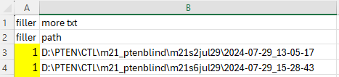
- Run the create_kilosort_binary() function in MATLAB with the file directory, feeder sheet .xlsx file name, and probe name (probe name should be ‘CSC’ by default)
- This should do two things:
  - Create a binary file for each recording session which does not have a directory named “binary”
  - Create a new feeder sheet to be used for the Kilosort automation named feeder_for_kilosort.xlsx

Kilosort automation:

- I know there has to be a better way to do this, but for now, I used Spyder to run the Kilosort automation. For this to work, the python interpreter must be set to the Kilosort environment
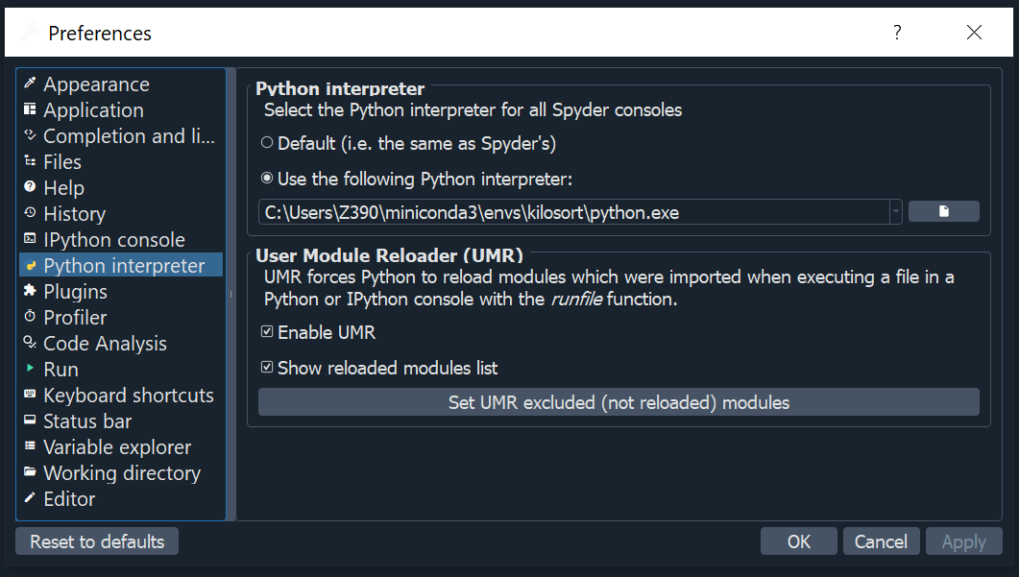
  - Tools -> preferences -> Python interpreter
  - Set “Use the following Python interpreter:” to the Kilosort environment
- From here, the kilosort_automation_test.py file can be run, adjusting the file path as needed
- For different settings to be used:
  - Open Kilosort
  - Set the parameters as desired
  - Export parameters as a .json file to the directory containing the Kilosort automation script
- If a binary file has not been run though Kilosort with the selected Th_learned and Th_universal, the following will occur for each file you ran your binary file automation on:
  - A new directory will be created
  - Kilosort will run and place the outputs in the new directory, leaving the old binary file intact

