# 3D Printing Brains from Anatomical MRI James Bartolotti Updated 10/13/2023

# Anatomical to Printable

The Synapse command make3dBrain converts anatomical files to 3d-printable .stl files using freesurfer. It accepts a single participant at a time, and you can provide any one of the following:

* A directory containing DICOM files from a T2 anatomical scan
* A single NIFTI file containing the anatomical image
* A freesurfer output directory containing lh.pial and rh.pial files.

Specify an output directory and filename, and the script will create a folder called FILENAME containing the two files FILENAME_lh.stl and FILENAME_rh.stl.

Note: If you supply DICOM or NIFTI files, processing will be a multi-hour job. You may optionally supply a KUMC email address and you will be notified when complete, along with instructions for further processing and printing. If you supply a non-KUMC address, your email will be sent to an admin who will attempt to forward it to you.

Usage:

make3dBrain /myproject/SCANS/1/DICOM /path/to/3dPrints MyBrain myemail@kumc.edu

for additional help, run make3dBrain -h

# Refining the Printable .STL

The command make3dBrain outputs two printable .stl files, for the left and right hemispheres. Before printing, we need to simplify the model and combine the two hemispheres into a single print. See <https://www.instructables.com/3D-print-your-own-brain/> for additional details.

These instructions are written for MeshLab, which you can download at https://www.meshlab.net/#download

* Start MeshLab and import MyBrain_lh.stl and My_Brain_rh.stl via ‘File’ -> ‘import mesh’.
* Click on 'Filters' -> 'Mesh Layer' -> 'Flatten Visible Layers' and apply. Now your brain mesh is RH_LH combined.
* Simplify vertices before printing with 'Filters' -> 'Remeshing, Simplification, Reconstruction' -> 'Simplification: Quadratic Edge Collapse Decimation'". Enter the number of faces to use for simplification; try 100,000. Click apply.
* Next, apply smoothing. Use ‘Filters’ -> ‘Smoothing, Fairing and Deformation’ -> ‘Laplacian Smooth’ with 3 steps. Click the apply button once. Adjust these settings for different amounts of smoothing. HC Laplacian Smooth also gives good results.
* When done, use ‘File’ -> ‘Export Mesh As’ and save as an .stl file for printing.

# Printing

Print the finished .stl brain using your 3D Printer of choice. To begin, you will take the finished .stl file and use it to create a .gcode file, which is the set of instructions that the printer will use to actually create the print. This is done in 3D printing software on a separate computer, not on the printer itself. The general procedure is to load the model, scale its size, adjust its orientation, and adjust infill and scaffolding to ensure a successful print.

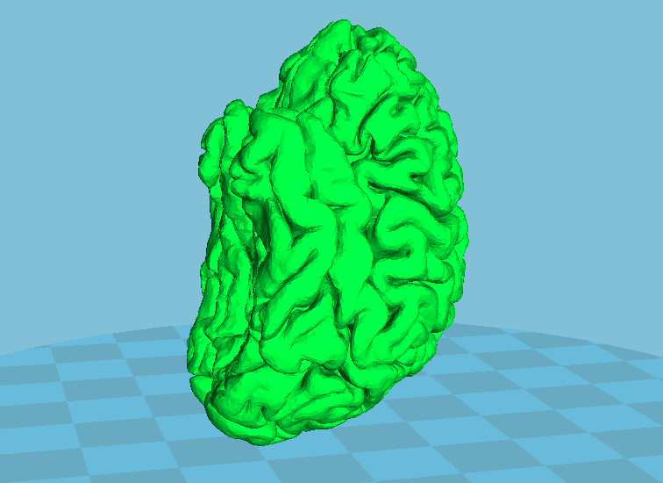Print at **30% scale** for a good tradeoff of time and materials (and printer space limitations). The support box is sized to hold a 30% scale adult brain.

Because models are printed from the ground up one layer at a time, anything that is hanging out in the air must be supported with scaffolding that will be removed later. To minimize support, rotate the brain with the occipital lobe on the build plate, tilted slightly back so that the anterior temporal lobes point straight up instead of angled. Set the support type to Touching Buildplate, and for plate adhesion, select Brim or None.

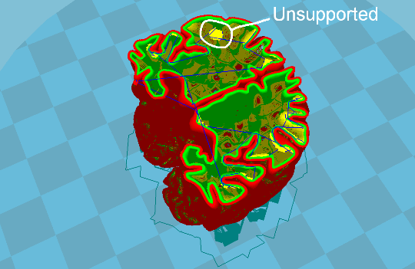If you are printing with a solid color filament (i.e., no transparency), you can use higher levels of infill to make the print sturdier. Infill is a grid of filament printed inside the structure to provide additional support. If you are printing with transparent filament, high infill compromises the look of the print when illuminated with a light source. If you attempt to print with 0% infill, ensure that there will be no unsupported structures inside the brain. Use the slice view to slide between slices in the preview, and check that there are no interior cortical folds that start printing on a layer not touching other parts of the print, as the printer will attempt to print those and the filament will simply fall to the bottom of the brain. Depending on the specific brain’s folds, you may need to provide a small amount of infill (5-10%) to ensure interior support.

When you are finished with the settings, save the .gcode, and save to an SD card or USB drive as applicable in order to transfer the file to the printer. Load the desired filament and begin the print; this may take 4-6 hours depending on the printer and the model’s size/complexity. When the print is finished, remove it from the build plate and snap off all support structures.

## Additional Materials

To display translucent brains, it is recommended to print a support box with a recessed space to hold a high-brightness LED tealight. These lamps have a simple twist to turn on mechanism. If adjusted correctly, the lamp will turn on when gently pressed on. With a small platform resting on the lamp and the brain on the platform, gently pressing the brain will cause it to light up. The tealights were purchased on Amazon, Super Bright LED Tea Light <https://www.amazon.com/JYtrend-Bright-Floral-Submersible-Wedding/dp/B00IT9QIGE> . The brain box display is designed to hold a round LED lamp that is 1.2 inches diameter, and 1 inch tall.

The files to print are BrainBox.stl and BrainBox_platform.stl. Print the brain box with 10% infill. The platform is thin enough that you don’t need to worry about infill.

For wordmarked brain boxes, You will need to print a contrast plate to put behind the lettering cutouts. This file is called BrainBox_facade.stl, and is sized to slot into the opening in the brain box. Depending on fit, a small amount of glue may be required to secure it.

The print should be already designed with support structures in place for the lettering cutouts on the front. You may need to remove some of these supports afterwards. For the included HBIC wordmark, remove the post supporting the top of the H, and the post supporting the C. Do not remove the post in the B, this support is the only thing holding up the inner circles of the B.

# Cost

Material costs assume filament cost of $25/kg.

Brains printed at 30% scale consume about 16-20g of filament, depending on support and infill, yielding a material cost per brain of 40-50 cents.

The brain box consumes 13g of filament with 15% infill (33 cents).

The platform consumes 2g of filament (5 cents).

The contrast façade consumes 1g of filament (2 cents).

LED tealights were purchased at 20 lamps for $17, or 85 cents each. (Super Bright LED Tea Light, <https://www.amazon.com/JYtrend-Bright-Floral-Submersible-Wedding/dp/B00IT9QIGE>)

**Total material cost: $1.75**

## Guide for Recipients

The following page contains a printable template to give to the recipient along with their brain model and display box with setup instructions.

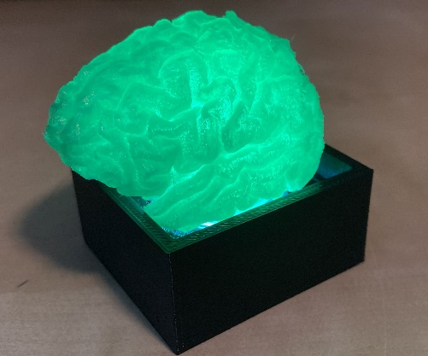

Thank you for participating in research! We are providing you with a keepsake miniature 3D model of your brain.

To assemble the display, first prepare the LED lamp.

* Unscrew the bottom piece, keeping care not to lose the two CR2032 batteries inside. If they fall out, re-insert them positive side down.
* Remove the paper insulator and lightly screw the top back on just until the light comes on.
* Unscrew the top just until the light turns back off. Lightly press on the middle of the lamp and make sure that the light comes on when you press it and goes off when you release. Adjust the screw as needed.

Assemble the display box.

* Place the prepared LED lamp inside the hole in the display box.
* Put the support platform (square with a hole in the middle) on top of the lamp so that it lies flat. The square only fits in one orientation, so rotate it 90 degrees if it’s not lying flat.
* Place the brain model on top of the support platform.
* Lightly press on the brain, and the LED will illuminate your brain from below.

If you have any questions or comments about your model, please contact EMAIL, PHONE.