- Create Groq API
- https://console.groq.com/keys
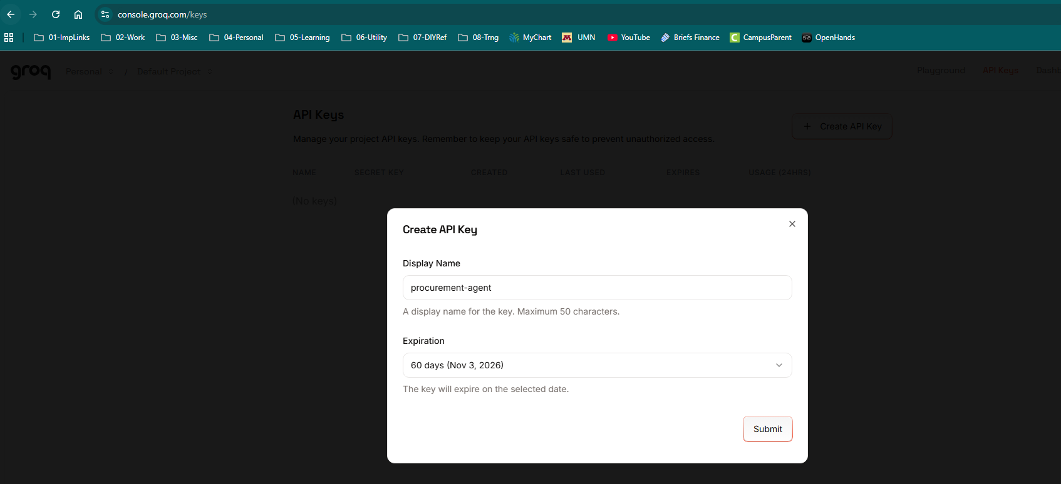
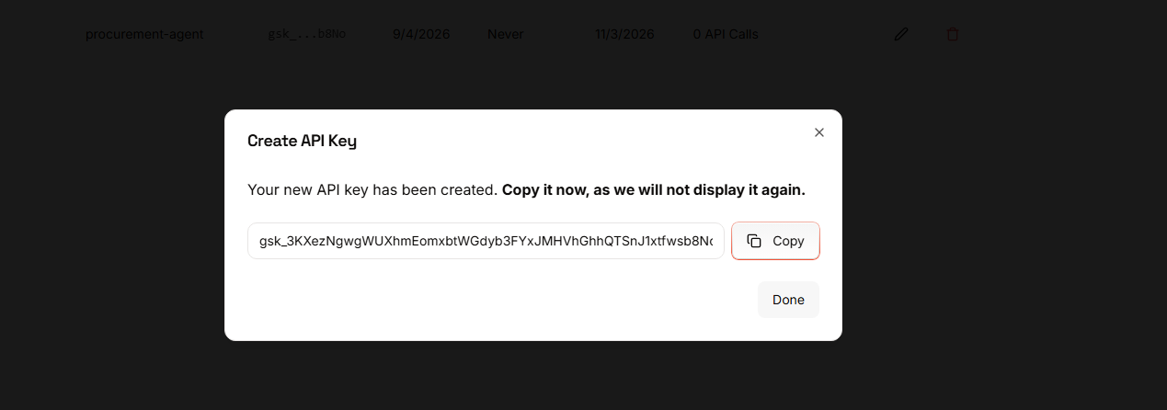
- Save Groq API Key
- Key: 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
- Alternate Key: 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
- Build the project and checkin to Github public repo:
- https://github.com/jbasak/edureka_capstone_b12_jkbasak.git

- Create and activate a virtual environment:
- py -3.12 -m venv .venv
- .\.venv\Scripts\Activate.ps1
- python -m pip install --upgrade pip
- pip install -r requirements.txt
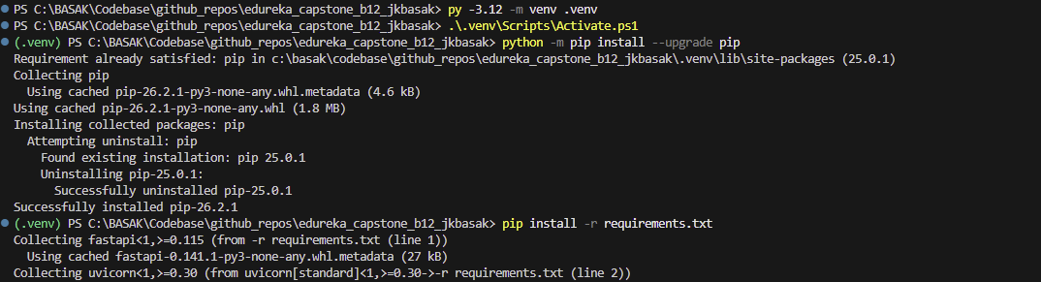
- Create the environment file and update the local ChromaDB settings:
- copy-Item .env.example .env
- Start ChromaDB in terminal 1. The `--path` directory stores vectors locally and is created automatically:
- cd C:\BASAK\Codebase\github_repos\edureka_capstone_b12_jkbasak
- .\.venv\Scripts\Activate.ps1
- chroma run --path .\chroma_data --host localhost --port 8001
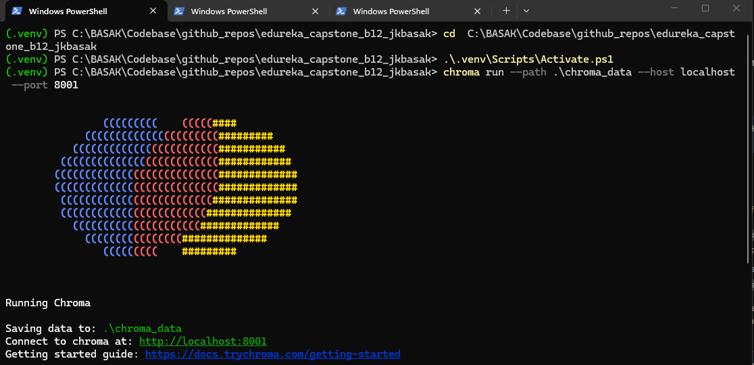
- Start the FastAPI backend in terminal 2:
- cd C:\BASAK\Codebase\github_repos\edureka_capstone_b12_jkbasak
- .\.venv\Scripts\Activate.ps1
- uvicorn src.api.main:app --reload --host 127.0.0.1 --port 8000
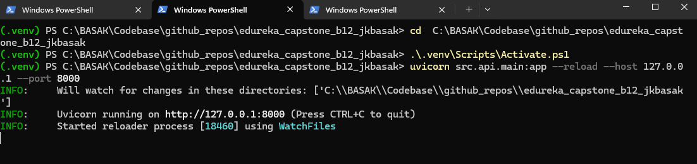
- Start the Streamlit UI in terminal 3:
- cd C:\BASAK\Codebase\github_repos\edureka_capstone_b12_jkbasak
- .\.venv\Scripts\Activate.ps1
- streamlit run src/ui/app.py --server.port 8501
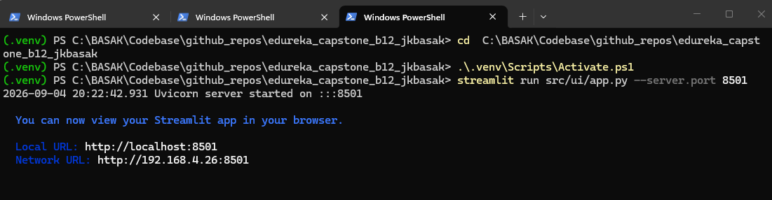
- Open the UI at `http://localhost:8501
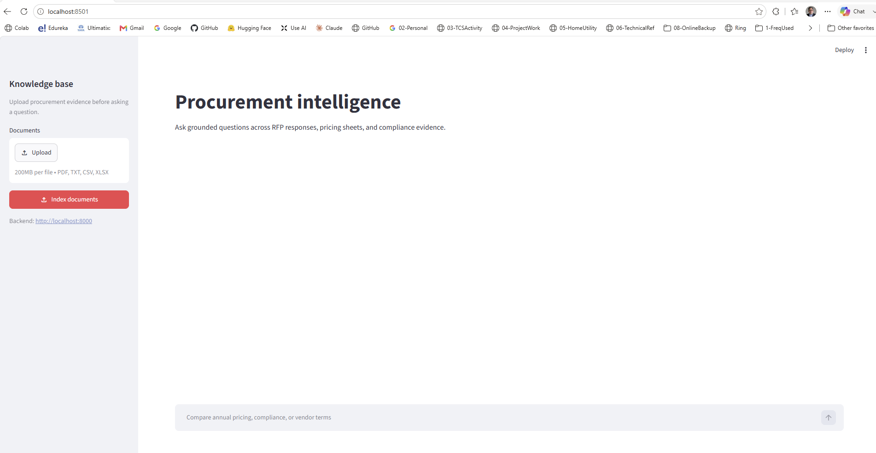

- Upload PDF, XLS and CSV Files
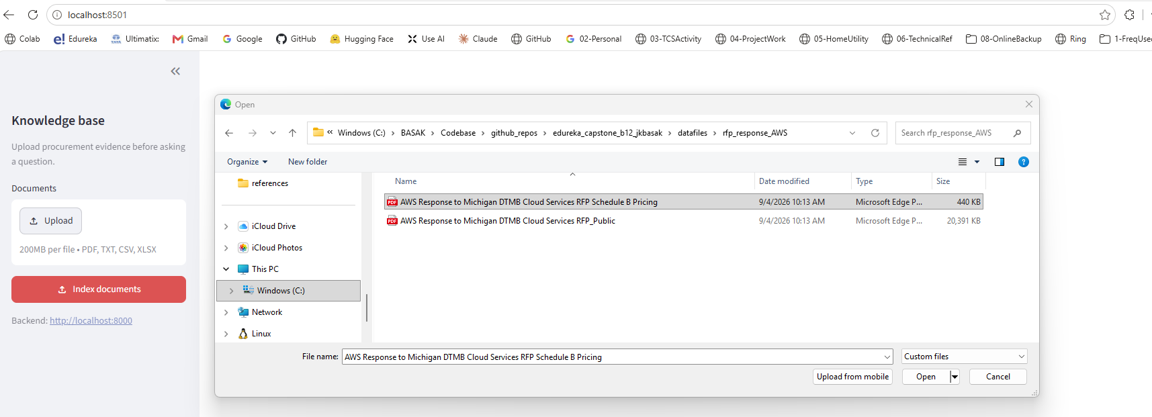
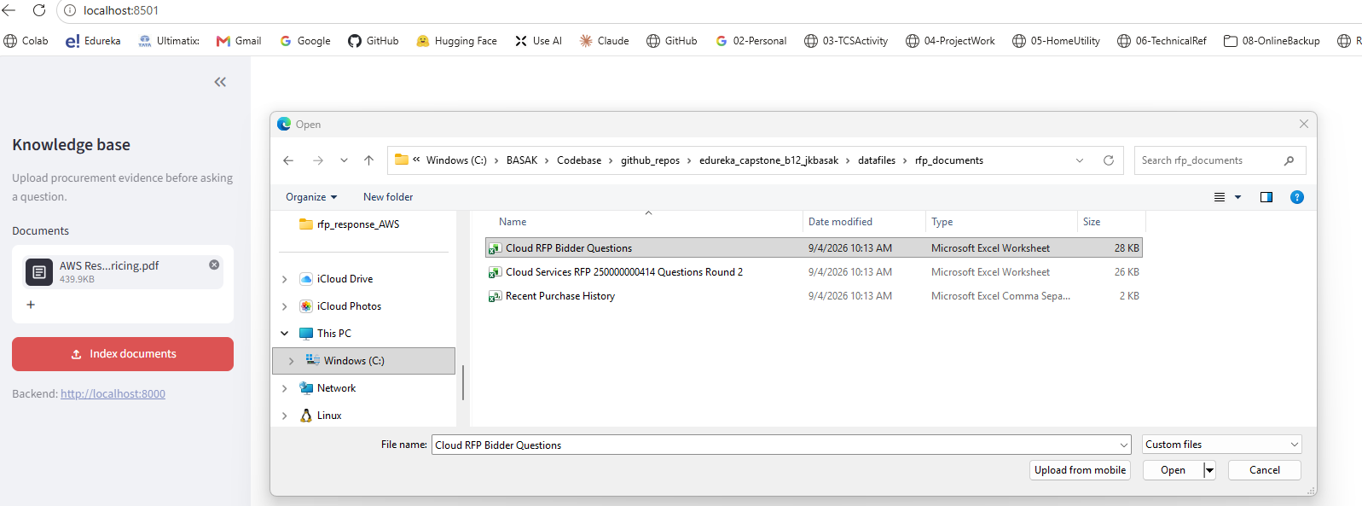
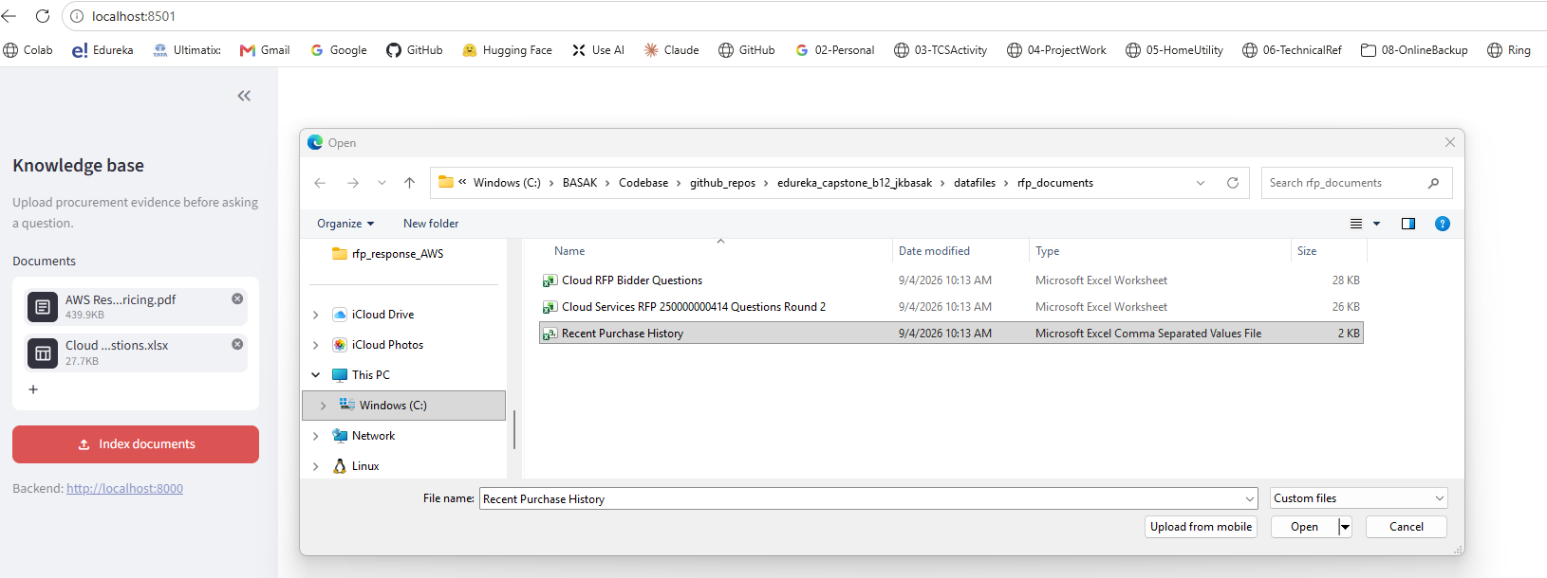

- Click on Index documents to upload and chunking

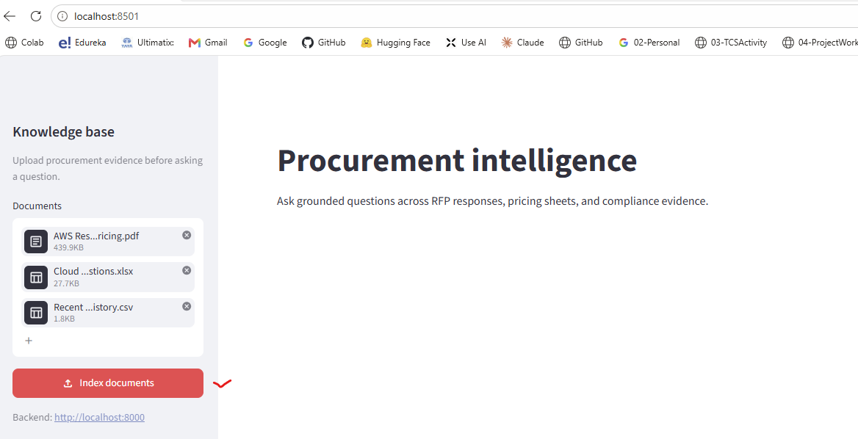
- Documents will upload, checks and indexed
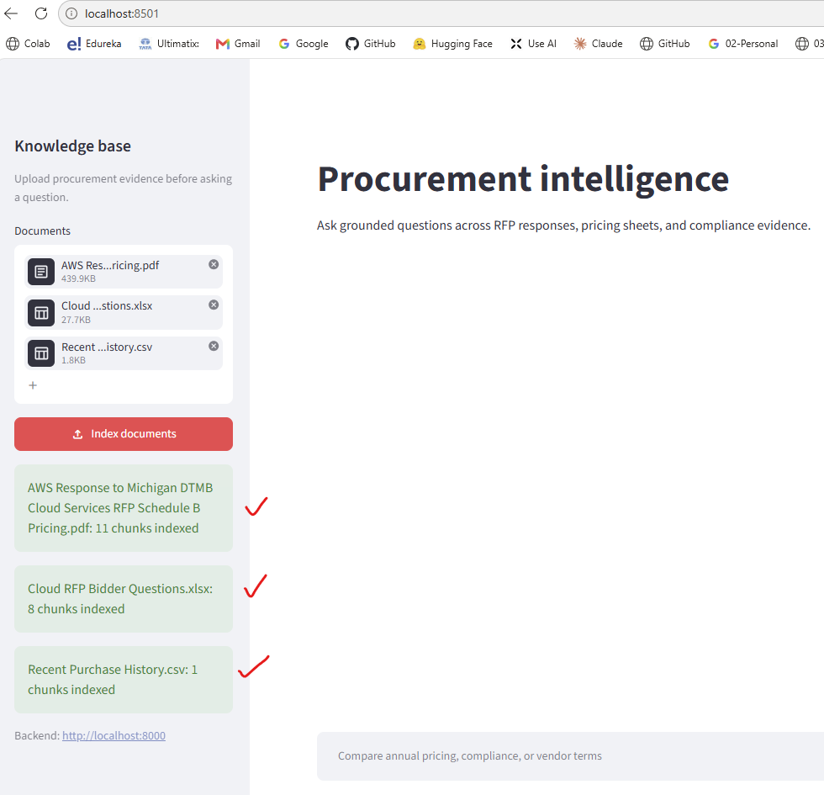

- Chat with LLM to validate the results
  - Query to retrieve data from pdf knowledgebase: what is the year1 price quoted by AWS
  - Query to retrieve value from Excel knowledgebase: what is the price paid for MS Visio Pro for O365 ?
  - Query to test reasoning: what is the year1 price quoted by Google(Google submiited quote was not uploaded)
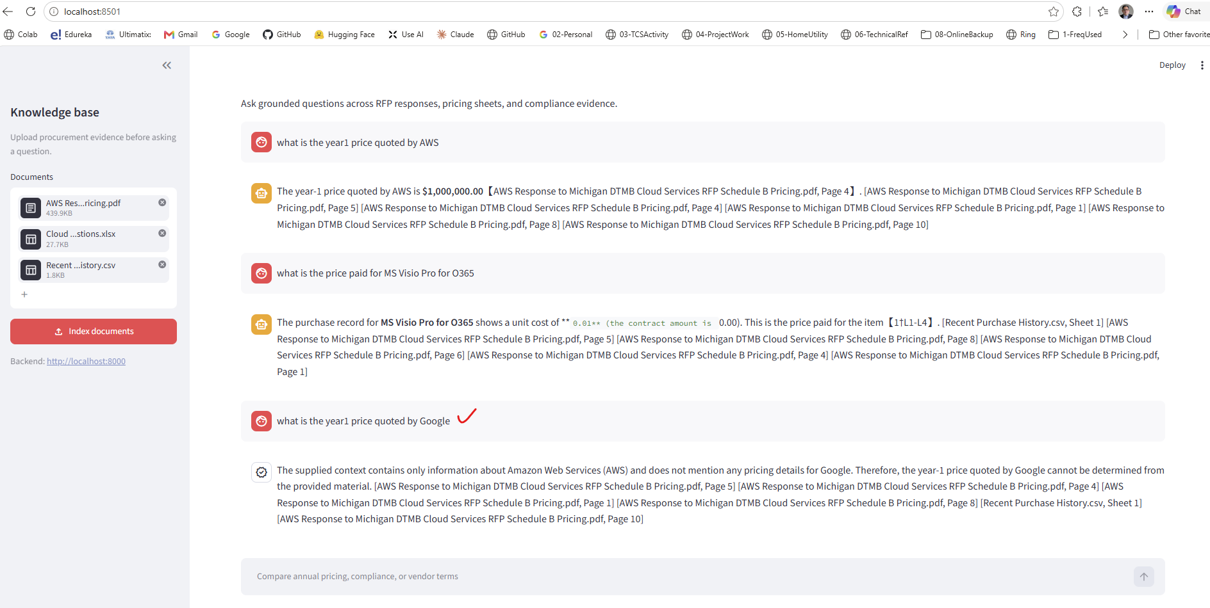
- Enhanced to add a logo and ask another question
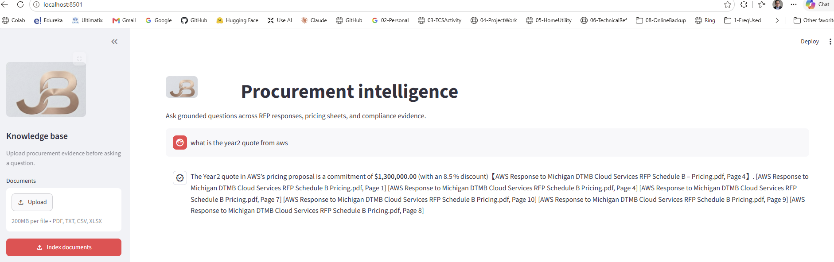

- Add additional Quote from Oracle and compare
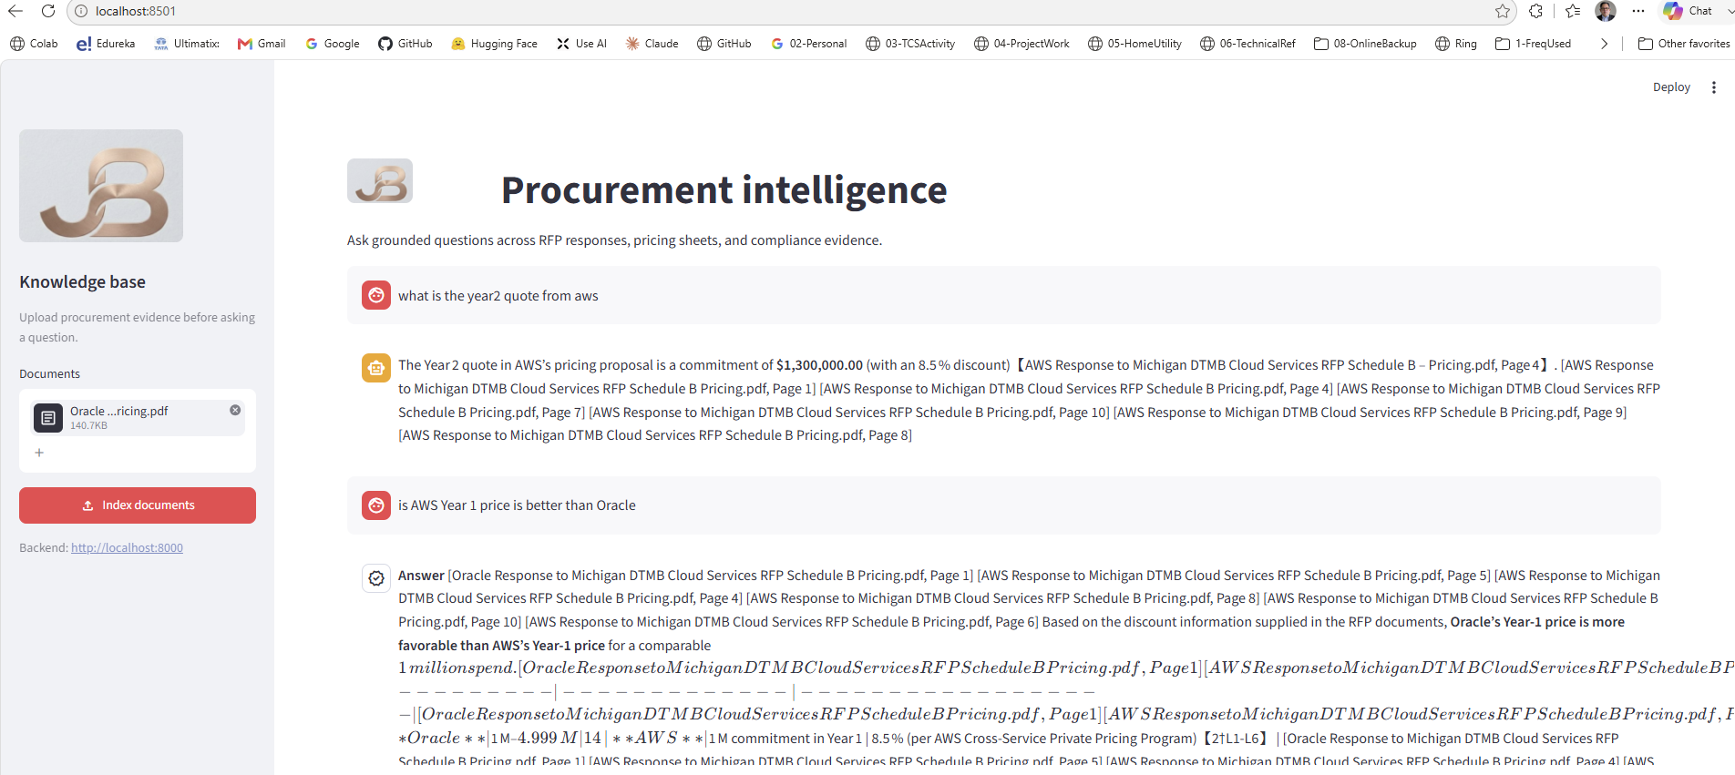

- All Data used here are available publicly on Michigan Govt Site:
https://www.michigan.gov/dtmb/procurement/contractconnect/bid-proposals
- Submission Screenshot:
