- Create Groq API
- https://console.groq.com/keys
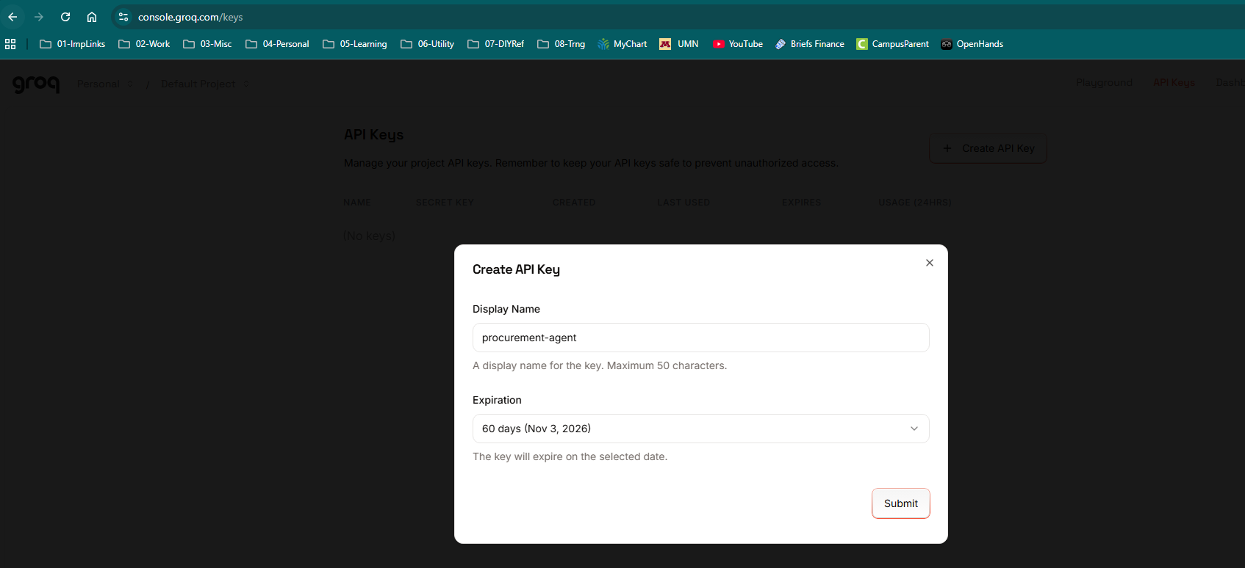
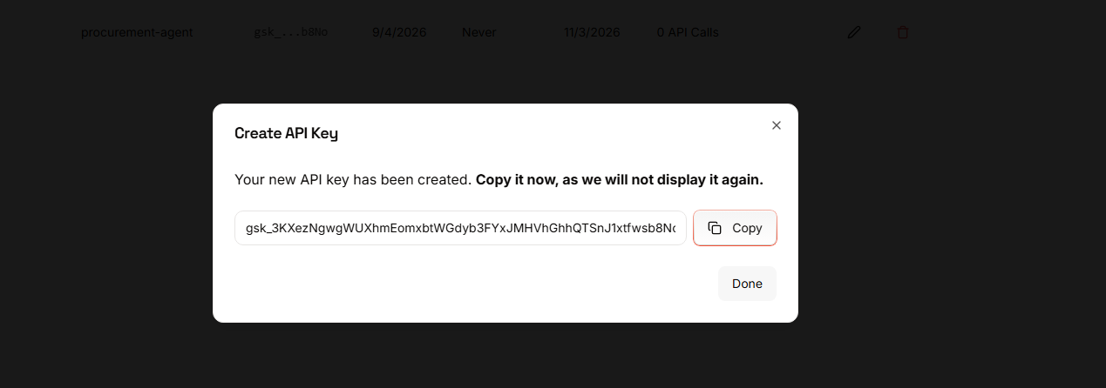
- Save Groq API Key
- procurement-agent
- 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

- Create and activate a virtual environment:
- py -3.12 -m venv .venv
- .\.venv\Scripts\Activate.ps1
- python -m pip install --upgrade pip
- pip install -r requirements.txt
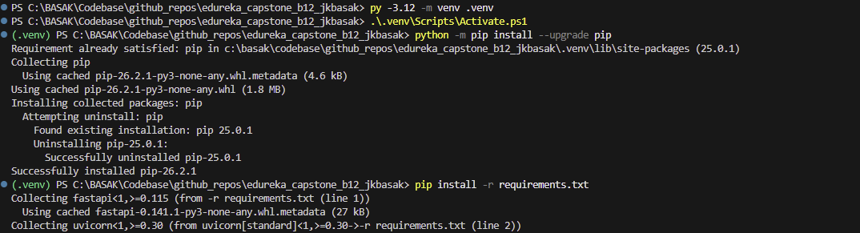
- Create the environment file and update the local ChromaDB settings:
- copy-Item .env.example .env
- Start ChromaDB in terminal 1. The `--path` directory stores vectors locally and is created automatically:
- cd C:\BASAK\Codebase\github_repos\edureka_capstone_b12_jkbasak
- .\.venv\Scripts\Activate.ps1
- chroma run --path .\chroma_data --host localhost --port 8001
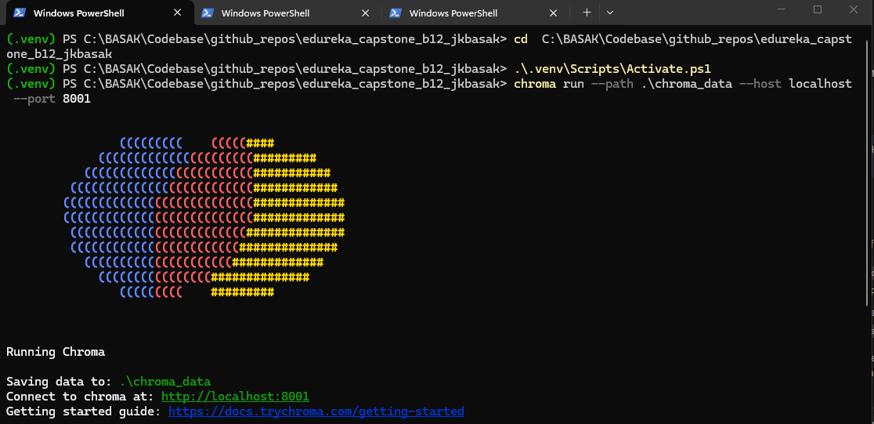
- Start the FastAPI backend in terminal 2:
- cd C:\BASAK\Codebase\github_repos\edureka_capstone_b12_jkbasak
- .\.venv\Scripts\Activate.ps1
- uvicorn src.api.main:app --reload --host 127.0.0.1 --port 8000
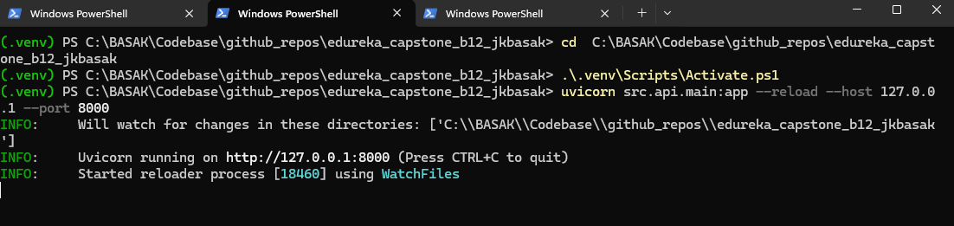

- Start the Streamlit UI in terminal 3:
- cd C:\BASAK\Codebase\github_repos\edureka_capstone_b12_jkbasak
- .\.venv\Scripts\Activate.ps1
- streamlit run src/ui/app.py --server.port 8501
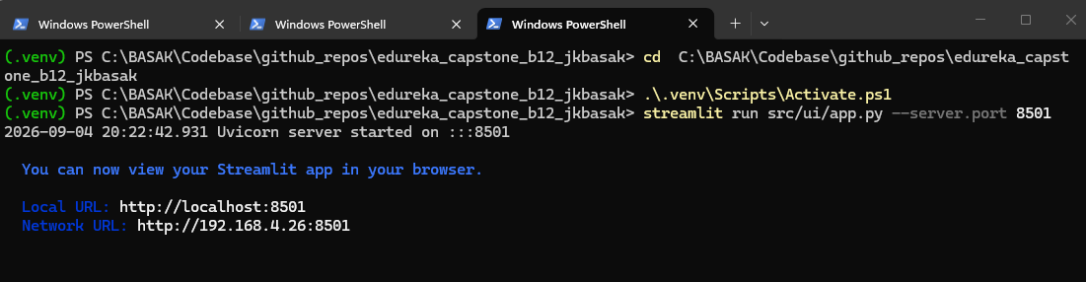
- Open the UI at `http://localhost:8501
