05_CARDS_EXTRA
Objektu-Array bi ditugu: smallDogs eta bigDogs.

const bigDogs = [
{
breed: "Golden Retriever",
image: "https://images.unsplash.com/photo-1552053831-71594a27632d",
weight: "25 - 34 kg",
height: "55 - 61 cm",
characteristics: "Intelligent, friendly, affectionate and very sociable.",
suitableOwners: "Ideal for families with children and active people."
},
{
breed: "German Shepherd",
image: "https://images.unsplash.com/photo-1589941013453-ec89f33b5e95",
weight: "22 - 40 kg",
height: "55 - 65 cm",
characteristics: "Protective, loyal, brave and highly intelligent.",
suitableOwners: "Perfect for sporty people or security-related work."
},
{
breed: "Siberian Husky",
image: "https://images.unsplash.com/photo-1605568427561-40dd23c2acea",
weight: "20 - 27 kg",
height: "50 - 60 cm",
characteristics: "Energetic, independent and resilient.",
suitableOwners: "Perfect for very active people and sports lovers."
}];

const smallDogs =[
{
breed: "French Bulldog",
image: "https://images.unsplash.com/photo-1541599540903-216a46ca1dc0",
weight: "8 - 14 kg",
height: "28 - 33 cm",
characteristics: "Calm, playful and an excellent companion.",
suitableOwners: "Ideal for apartment living and calm people."
}

Array horietatik datuak eskuratu eta pantailan bistaratzen ditugu, irudian erakusten den moduan.

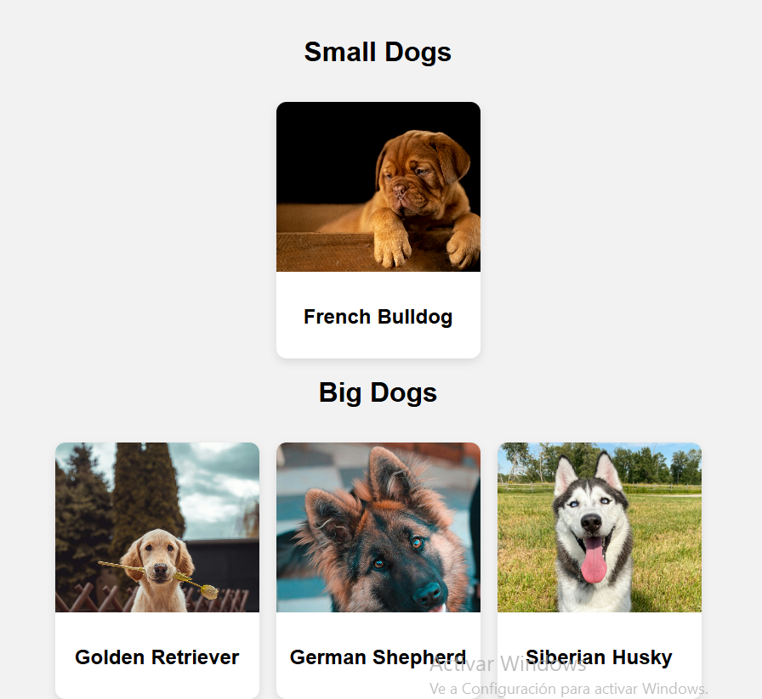
Irudietako edozeinetan klik egitean, details.html fitxategia deitzen dugu; hori leiho berri batean irekitzen da.

