TEST ADD
Test add 2
Draft of Stories for Portfolio Health Assessment Tool
As a Technical Architect, I want to be able to add systems to PenFed’s Portfolio so that an accurate list of systems used by PenFed is maintained
- User most fill in all required data before system can be added
- Information is stored in application database
- Following data is required:
  - name, short name, description , TIME rating, deployment model (on premise, cloud, etc.) , software type (open source, vendor, custom built, etc.), if software type is vendor include vendor name
- Following data is optional
  - Computing type ( distributed, mainframe), database/storage (SQL Server, Oracle , UDB ,etc. ),language (Java, Cobol, .NET, etc.) , operational owner, technical architect assigned, business owner, notes
As a Technical Architect, I want to be able create domains so that I can group systems together based on business capabilities
- User most fill in all required data before system can be added
- Information is stored in application database
- Following data is required:
  - name, short name, description
As a Technical Architect, I want to be able to create business areas so that I can group like domains together
- User most fill in all required data before business are can be added
- Information is stored in application database
- Following data is required:
  - name, short name, description

As a Technical Architect, I want to be able to create organizations so that I can group business areas under the organization they support
- User most fill in all required data before organization can be added
- Information is stored in application database
- Following data is required:
  - name, short name, description
As a Technical Architect, I want to be able to assign domains to business areas so that I document which domains support a business areas
- User most fill in all required data before assignment can occur
- Information is stored in application database
- Following data is required:
  - Business area, Domain, weight (%)
As a Technical Architect, I want to be able to assign business areas to organizations so that I document which business areas support an organization
- User most fill in all required data before assignment can occur
- Information is stored in application database
- Following data is required:
  - Organizations, Business area, weight (%)
As a Technical Architect, I want to be able to assign systems to domains so that I document which systems support a domain
- User most fill in all required data before assignment can occur
- Information is stored in application database
- Following data is required:
  - Domain, system weight (%)

As a Business Architect, I want to be able create business capabilities so that I can document the business capabilities needed to support PenFed’ Business vision
- User most fill in all required data before business capability can be added
- Information is stored in application database
- Following data is required:
  - Enterprise group (drop down) , name, short name, description

As a Business Architect, I want to be able create business capabilities so that I can document the business capabilities needed to support PenFed’ Business vision
- User most fill in all required data before assignment can occur
- Information is stored in application database
- Following data is required:
  - Business capability , system , comment

As a Business Architect, I want to be able assign business capabilities to systems so that I can document which business capabilities each system provides
- User most fill in all required data before assessment can occur
- Information is stored in application database
- Following data is required:
  - Resue, architecture alignment, life stage, security

As a Technical Architect, I want to be able to create an assessment of systems in PenFed’s Portfolio so that I can assess the health of each system
- User most fill in all required data before assessment can occur
- Information is stored in application database
- Following data is required:
  - Reuse, architecture alignment, life stage, security

As an application owner, I want to be able to create an assessment of systems in PenFed Portfolio so that I can assess the operation of each system
- User most fill in all required data before assessment can occur
- Information is stored in application database
- Following data is required:
  - Availability , Scalability , Supportability , Agility

As a Business Architect, I want to be able to create an assessment of systems in PenFed Portfolio so that I can assess the business capabilities of each system
- User most fill in all required data before assessment can occur
- Information is stored in application database
- Following data is required:
  - Functionality , Usability

As a Technical Architect, I want to be able to assign a TIME (Tolerate, Invest, Migrate, Eliminate) rating to systems in PenFed’s Application Portfolio so that I can communicate the value and high level direction of each system
As a Technical Architect, I want to be able to create a system recommendation so that I can document ways to improve the health of a given system
- User most fill in all required data before assessment can occur
- Information is stored in application database
- Following data is required:
  - Name , Description , ranking/order

As a Technical Architect, I want to be able to create a domain recommendation so that I can document ways to improve the health of a given domain
- User most fill in all required data before assessment can occur
- Information is stored in application database
- Following data is required:
  - Name , Description , ranking/order

As a Technical Architect, I want to be able to create a business area recommendation so that I can document ways to improve the health of a given business area
- User most fill in all required data before assessment can occur
- Information is stored in application database
- Following data is required:
  - Name , Description , ranking/order
As a user, I want to be able create investments so I can document efforts have funding vehicles are
- User most fill in all required data before investment can be created
- Information is stored in application database
- Following data is required:
  - Name , Description , size (small , med, large, XL),
- Following data is optional
  - Year and quarter of start, year and quarter of end of investment

As a user, I want to be able assign investments to recommendation (business area, domain or systems) so that I can document which recommendations have funding vehicles
- User most fill in all required data before investment assigned
- Information is stored in application database
- Following data is required:
  - Investment , recommendation

As a user, I want to be able to view the assessment for all systems that belong to a selected organization so that I can assess the health of an organization
- User is able to filter by org
- User is able select output data:
  - View by systems
  - View by domains
  - View by business area

As a user, I want to be able to view the assessment for all systems that belong to selected business area so that I can assess the health of a business area
- User is able to filter by business area
- User is able select output data:
  - View by systems
  - View by domains

As a user, I want to be able to view the assessment for all systems that belong to selected domain area so that I can assess the health of a domain area
- User is able to filter by domain area
- User is able select output data:
  - View by systems

Scoring Model
Agility 1-5
- Asset takes a very long time to respond to requirement changes
- Asset takes a significant amount of time to respond to requirement changes
- Asset takes a moderate amount of time to respond to requirement changes
- Asset is fairly simple to maintain and tailor to meet business needs
- Asset is easy to maintain and tailor to meet business needs; it is highly responsive to requirement changes
Functionality 1-5
- Provides no features needed by the users
- Provides limited features needed by users
- Provides some features needed by users
- Provides most features needed by users
- Provides all features needed by users
Usability 1-5
- The asset is difficult and/or cumbersome to use , negatively affecting productivity
- The asset is not user friendly, potentially making a user’s job more challenging at times
- The usability of the asset is average
- The usability of the asset is strong – making the user’s job less difficult
- The usability of the asset greatly enhances a user’s productivity

Cost - ??? Need to figure out what cost we are capturing??
- 0 - $1M
- $1M - $3M
- $3M - $5M
- $5M - $10M
- $10M+

Reuse 1-5
- Asset is not used across business areas or business domains
- Asset has the ability to support two business domains
- Asset has the ability to support multiple business domains
- Asset has the ability to support multiple business areas
- Asset has the ability to support the enterprise

Architecture Alignment 1-5
- Asset does not align with architecture standards (waiver does not exist)
- Asset does not align with architectural standards (waiver exists)
- Asset aligns with all architecture principles and standards but is not a target state platform
- Asset aligns with all architecture principles and standards and is a target state platform
- Asset aligns with all architecture principles and standards and is a target state platform from a strategic partner

Life Stage 1-5
- Asset is new in all three areas : new to PenFed, new to Supplier, new to industry --(bleeding edge)
- Asset is new in two of three areas: new PenFed, new to Supplier, new to industry -- (cutting edge)
- Asset is new in one of three areas: new PenFed, new to Supplier and a new industry offering
- Asset is an established product , from an established supplier that PenFed has experience
- Asset is an established product , from an strategic supplier that PenFed has experience

Availability
- Asset cannot support PenFed’s availability requirements and there is no plan in place to address gap
- Asset cannot support PenFed’s availability requirements and there is a plan in place to address gap
- Asset can support PenFed’s availability requirements

Scalability
- Asset cannot scale to be meet expected volumes
- Asset can scale to meet expected volumes but requires significate investment
- Asset can scale to meet expected volumes but requires moderate investment
- Asset can scale to meet expected volumes but requires minor investment
- Asset can scale to meet expected volumes with no investment
Security
- Asset does not comply with security standards and no plan is in place to address gap
- Asset does not comply with security standards but a plan to address gap is in place
- Asset complies with security standards

Supportability
- Asset is highly unstable and requires major maintenance effort
- Asset is fairly unstable and requires significant maintenance effort
- Asset is moderately stable and requires moderate maintenance effort
- Asset is somewhat unstable but required maintenance is minor
- Asset is stable and has few or no issues at all to keep it running

Examples Reports/Dashboards
Bubble Chart (could use IT value and Business Value as X/Y axis for systems, domain or business area)
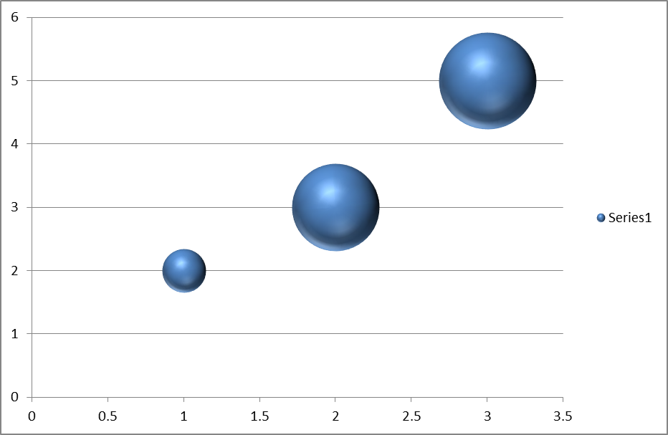

Example Summary Reports/Dashboard
Org Report
Organization | Business Area | Rating
PenFed | -------------------- | 2.5
 | Product | 2.6
 | Sales & Servicing | 1.5
 | Risk Compliance | 1.8
 | Business Support | 4.0

Business Area Report

Business Area | Domain | Rating
Product | -------------------- | 2.6
 | Home Loan | 2.6
 | Credit Card | 1.5
 | Auto Loan | 3.3
 | Deposits | 3.1
Domain Report
Domain | System | Rating
Home Loans | -------------------- | 2.6
 | UniFi | 2.6
 | Fannie Mae | 1.5
 | MortgageBot | 3.3
 | Elynx | 3.1

