CYCLISTIC BIKE-SHARE
Member vs. Casual Rider Analysis

Q1 2019 & Q1 2020 Trip Data
Prepared for: Lily Moreno, Director of Marketing
Data Source: Divvy / Motivate International Inc.
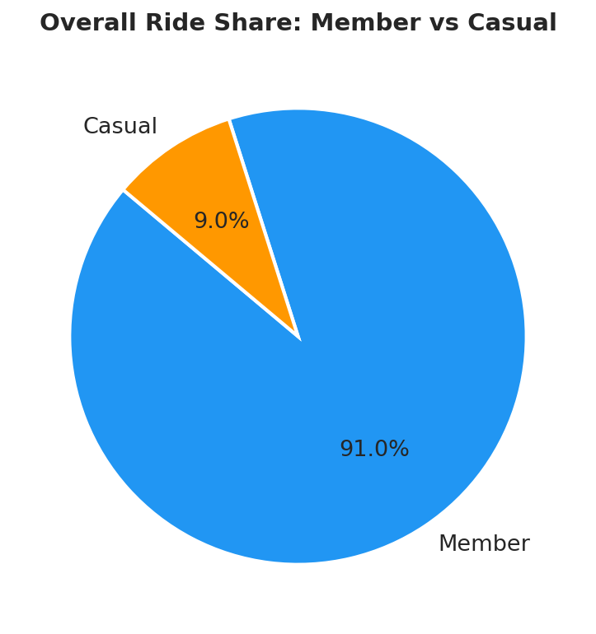

1. Business Task
Cyclistic's finance analysts have confirmed that annual members are significantly more profitable than casual riders. The director of marketing, Lily Moreno, has identified converting existing casual riders into annual members as the highest-leverage growth opportunity.

Business question assigned to this analysis:
How do annual members and casual riders use Cyclistic bikes differently?
Insights from this analysis will inform a targeted marketing strategy to maximize annual membership conversion. Recommendations must be backed by compelling data and professional visualizations for executive approval.

2. Data Sources
Two datasets were used, covering Q1 of consecutive years:

Dataset | Period | Rows | Key Fields
Divvy_Trips_2019_Q1 | Jan – Mar 2019 | 365,069 | trip_id, start_time, end_time, usertype
Divvy_Trips_2020_Q1 | Jan – Mar 2020 | 426,886 | ride_id, started_at, ended_at, member_casual

Data is made publicly available by Motivate International Inc. under their data license agreement. No personally identifiable information (PII) is included; riders cannot be linked to credit card numbers or home addresses.

3. Data Cleaning & Processing

Column Standardisation
The 2019 dataset used different column names than the 2020 dataset. The following renames were applied to make schemas consistent:

- trip_id → ride_id
- start_time / end_time → started_at / ended_at
- from_station_name / to_station_name → start_station_name / end_station_name
- usertype (Subscriber/Customer) → member_casual (member/casual)

Feature Engineering
- ride_length_min: ride duration in minutes = (ended_at - started_at) / 60
- day_of_week: day name extracted from started_at
- hour: hour of day (0–23) extracted from started_at
- month: year-month period extracted from started_at

Data Quality
- Rows with ride_length_min ≤ 0 (negative or zero durations) removed
- Rows with ride_length_min ≥ 1,440 min (24 hrs+) removed as likely maintenance trips
- Total rows removed: 692 out of 791,956 (<0.1%)
- Final clean dataset: 791,264 rides

4. Analysis Summary

Key Statistics at a Glance
Metric | Member | Casual
Total Rides | 720,126 (91%) | 71,138 (9%)
Avg Ride Duration | 11.4 min | 36.5 min
Median Ride Duration | 8.5 min | 22.0 min
Peak Days | Tue – Thu | Sat – Sun
Peak Hours | 7–9 AM, 5–6 PM | 10 AM – 4 PM
Riding Pattern | Commute-oriented | Leisure-oriented

Finding 1: Members Dominate Volume, Casuals Ride Longer
Members account for 91% of all Q1 rides (720,126) while casual riders represent just 9% (71,138). However, casual riders take rides that are on average 3.2x longer — 36.5 minutes versus 11.4 minutes for members. This pattern strongly suggests members use bikes for short, routine commutes while casual riders use them for extended leisure trips.
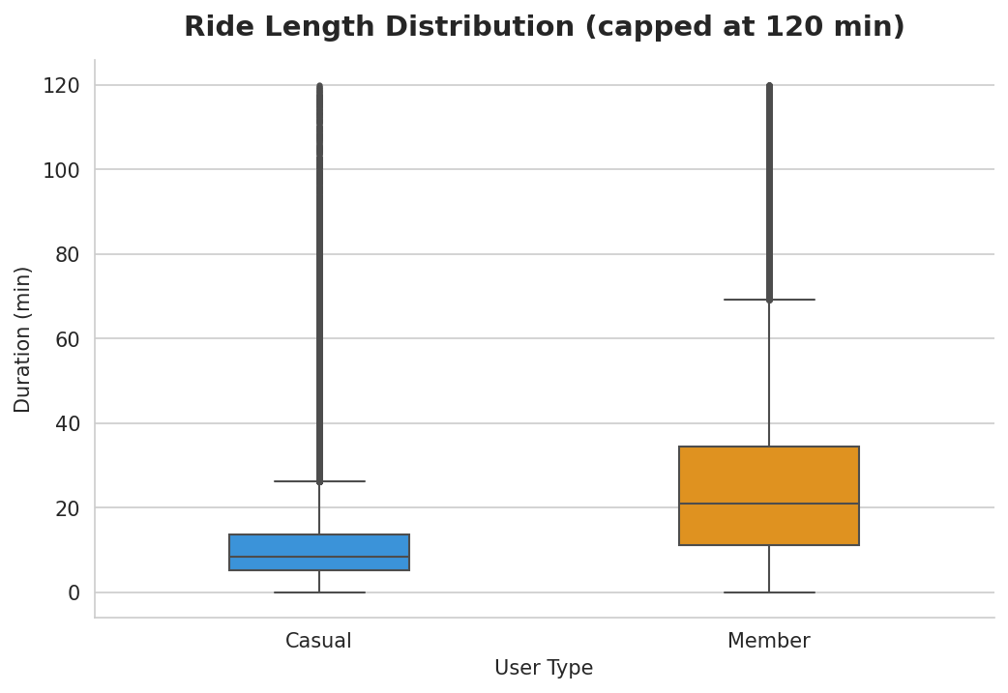

Finding 2: Members Ride on Weekdays, Casuals Ride on Weekends
Member ridership peaks mid-week (Tuesday through Thursday) and drops sharply on weekends, consistent with commuting behaviour. Casual ridership follows the opposite pattern, peaking Saturday and Sunday. This is a critical differentiator: casual riders are weekend leisure riders, not daily commuters.
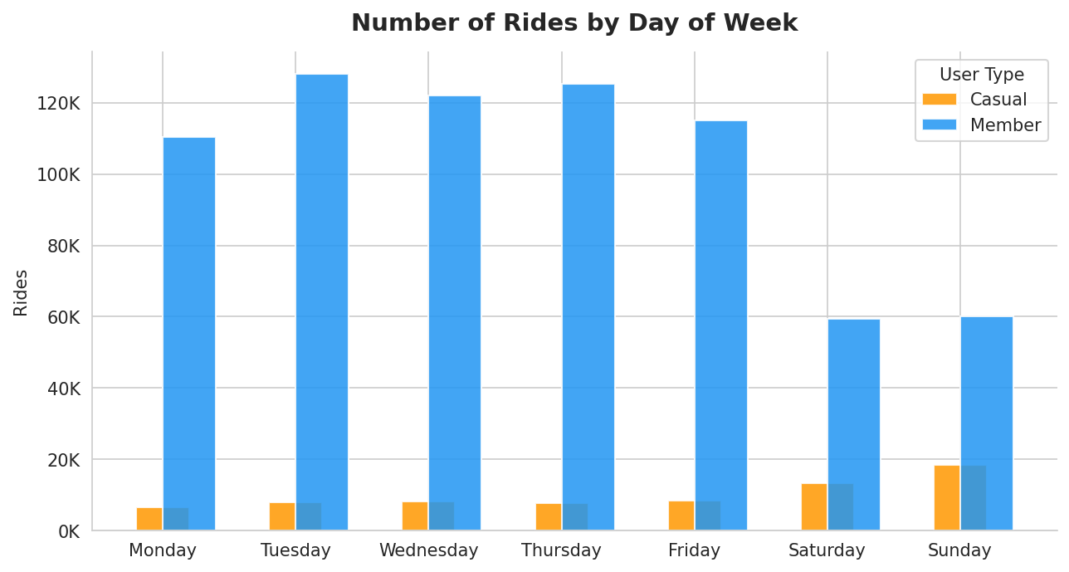
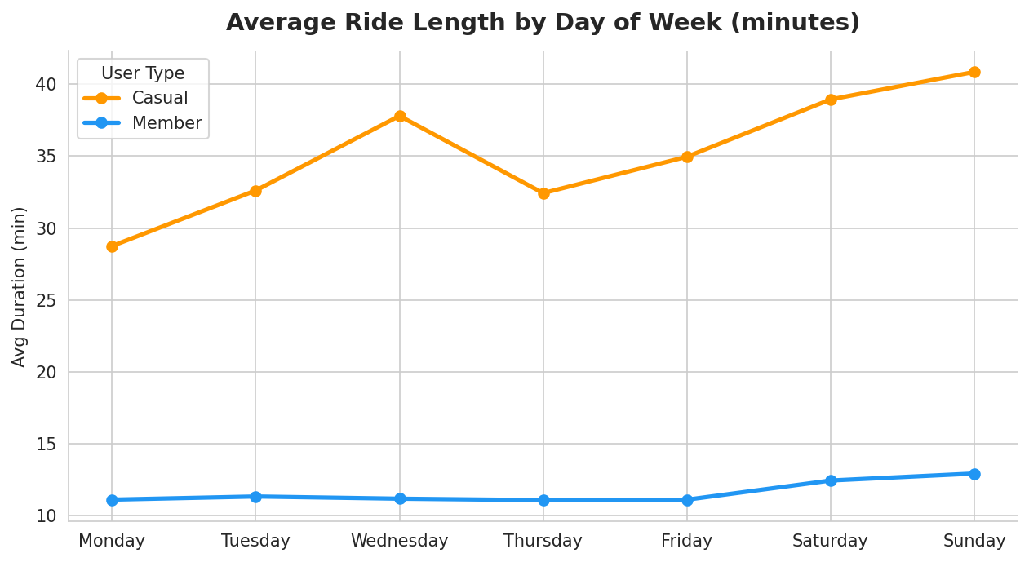

Finding 3: Members Follow Classic Commute Hour Peaks
The hourly ride pattern reveals a textbook dual-peak commute shape for members — strong spikes at 7–9 AM and 5–6 PM. Casual riders show a single broad peak from mid-morning through the afternoon (10 AM–4 PM), with no morning rush spike. This reinforces the commuter vs. leisure distinction.
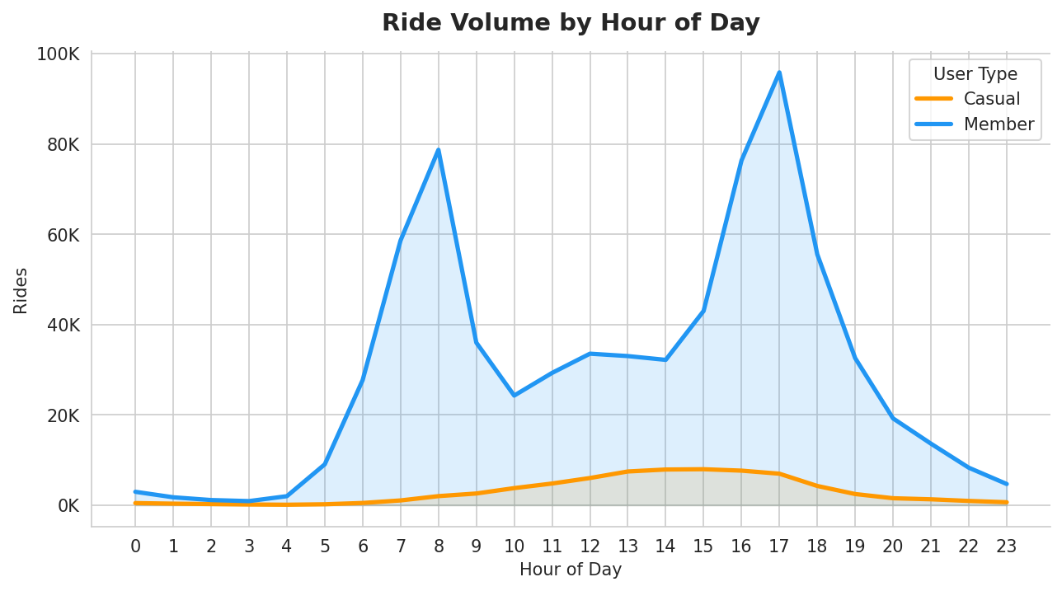

Finding 4: Casual Ridership is More Seasonal
Monthly volume shows that casual ridership grows more steeply into warmer months. Members maintain more consistent ridership through Q1. This suggests casual riders are highly weather-sensitive and more likely to be tourists or fair-weather leisure cyclists.
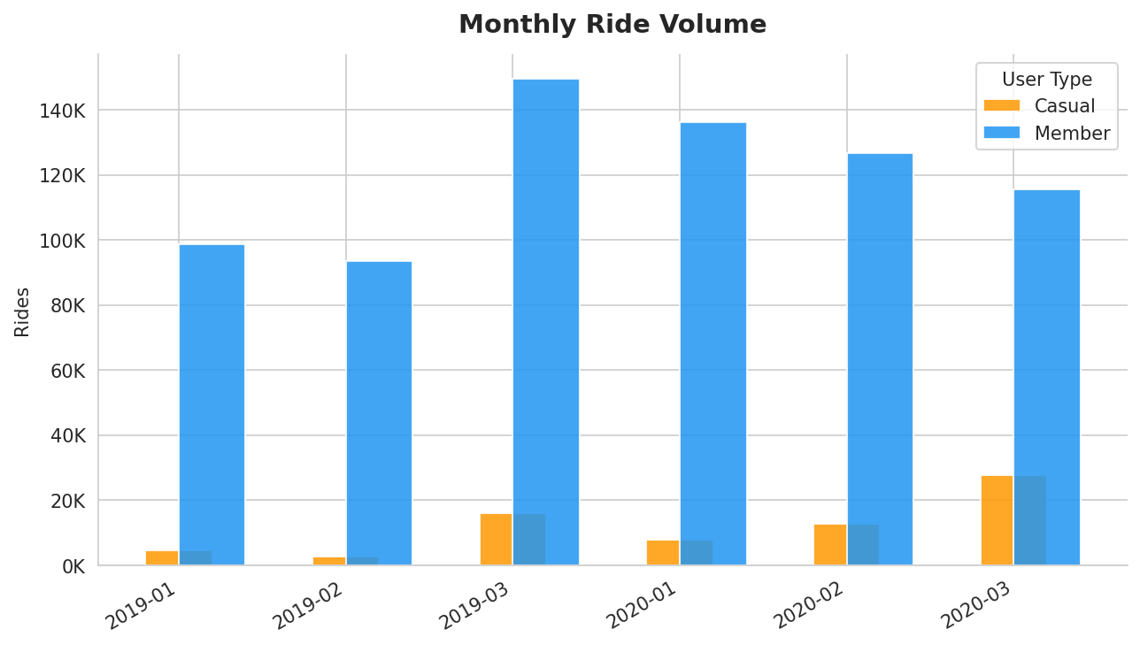

5. Top 3 Recommendations

1 | Launch Weekend-to-Membership Conversion Campaigns  Target casual riders at docking stations and via the app on Saturday and Sunday — their peak usage days. Offer a time-limited discount for converting to an annual membership during or after a weekend ride. Highlight the cost savings: at casual single-ride rates, frequent weekend riders often pay more annually than a member would.

2 | Introduce a Leisure or Weekend Membership Tier  Casual riders' weekend and midday pattern suggests they don't need the commuter value proposition. Create a "Weekend Membership" or "Leisure Pass" priced between casual rates and full annual membership. This lower-commitment tier reduces the barrier to converting, and members in this tier can later be upsold to full annual membership.

3 | Use Digital Media to Showcase the Value of Membership During Peak Leisure Hours  Run targeted social media and in-app ads between 10 AM–4 PM on weekends — exactly when casual riders are most active. Messaging should focus on leisure benefits (explore Chicago, save on longer rides, no per-minute charges) rather than commuting efficiency. Partner with local tourism and event platforms to reach casual riders planning weekend activities.

Appendix: Limitations & Next Steps
- This analysis covers Q1 only (January–March). Full-year data would strengthen seasonal findings, particularly regarding summer leisure riding peaks.
- Data privacy prevents linking rides to individual users; lifetime value comparisons and conversion funnel tracking are not possible with this dataset.
- Future analysis could incorporate weather data, station-level geography, and ride-type breakdowns (electric vs. classic) to further refine targeting.
- A/B testing the proposed weekend campaign against a control group is recommended before a full rollout.

