Japanese Car Demand Elasticity Analysis
2008-2025 Market Analysis & Strategic Insights
March 2026

Executive Summary
This comprehensive analysis examines price elasticity of demand for five major Japanese automobile brands in the US market from 2008-2025. Using econometric modeling and market data, we quantify how vehicle price, macroeconomic conditions, and financing availability impact sales for Toyota, Honda, Nissan, Subaru, and Mazda.

Key Findings: Toyota dominates with 37.3% market share; Subaru demonstrates strongest pricing power with lowest price sensitivity (-0.76 elasticity); GDP growth and financing rates emerge as critical demand drivers; market concentration increasing as leading brands strengthen positions.

Table of Contents
- 1. Research Questions & Methodology
- 2. Market Overview & Descriptive Statistics
- 3. Price Elasticity Analysis
- 4. Macroeconomic Impact Assessment
- 5. Manufacturer Comparative Analysis
- 6. Strategic Insights & Recommendations
- 7. Conclusion

1. Research Questions & Methodology

Primary Research Question
How does vehicle price affect demand for Japanese automobile brands in the US market, and does price elasticity differ across Toyota, Honda, Nissan, Subaru, and Mazda?

Secondary Research Questions
- What is the magnitude of price elasticity for each Japanese brand?
- How do macroeconomic conditions (unemployment, income) influence demand?
- What is the impact of operating costs (gasoline prices) on vehicle sales?
- How does financing availability (interest rates) affect purchasing decisions?
- Does currency exchange rate (USD/JPY) affect brand competitiveness?

Analytical Methodology
This analysis employs a log-linear econometric model to estimate price elasticity of demand. The specification allows direct interpretation of coefficients as elasticities, controlling for multiple macroeconomic factors simultaneously.
Model Specification: ln(Sales) = β₀ + β₁ln(Price) + β₂ln(GasPrice) + β₃InterestRate + β₄ln(DisposableIncome) + β₅UnemploymentRate + β₆ln(ExchangeRate) + ε

2. Market Overview & Descriptive Statistics

Industry Context
The Japanese automotive market in the United States represents a significant portion of total vehicle sales. From 2008-2025, these five manufacturers collectively maintained strong market presence despite economic cycles, technological disruption, and competitive pressures from domestic and other foreign producers.

Market Dominance & Share
Toyota maintains clear market leadership with 37.3% of combined sales, followed by Honda (25.6%) and Nissan (20.9%). Subaru (10.2%) and Mazda (6.0%) occupy smaller but meaningful segments. This concentration reflects both brand strength and production capacity constraints.
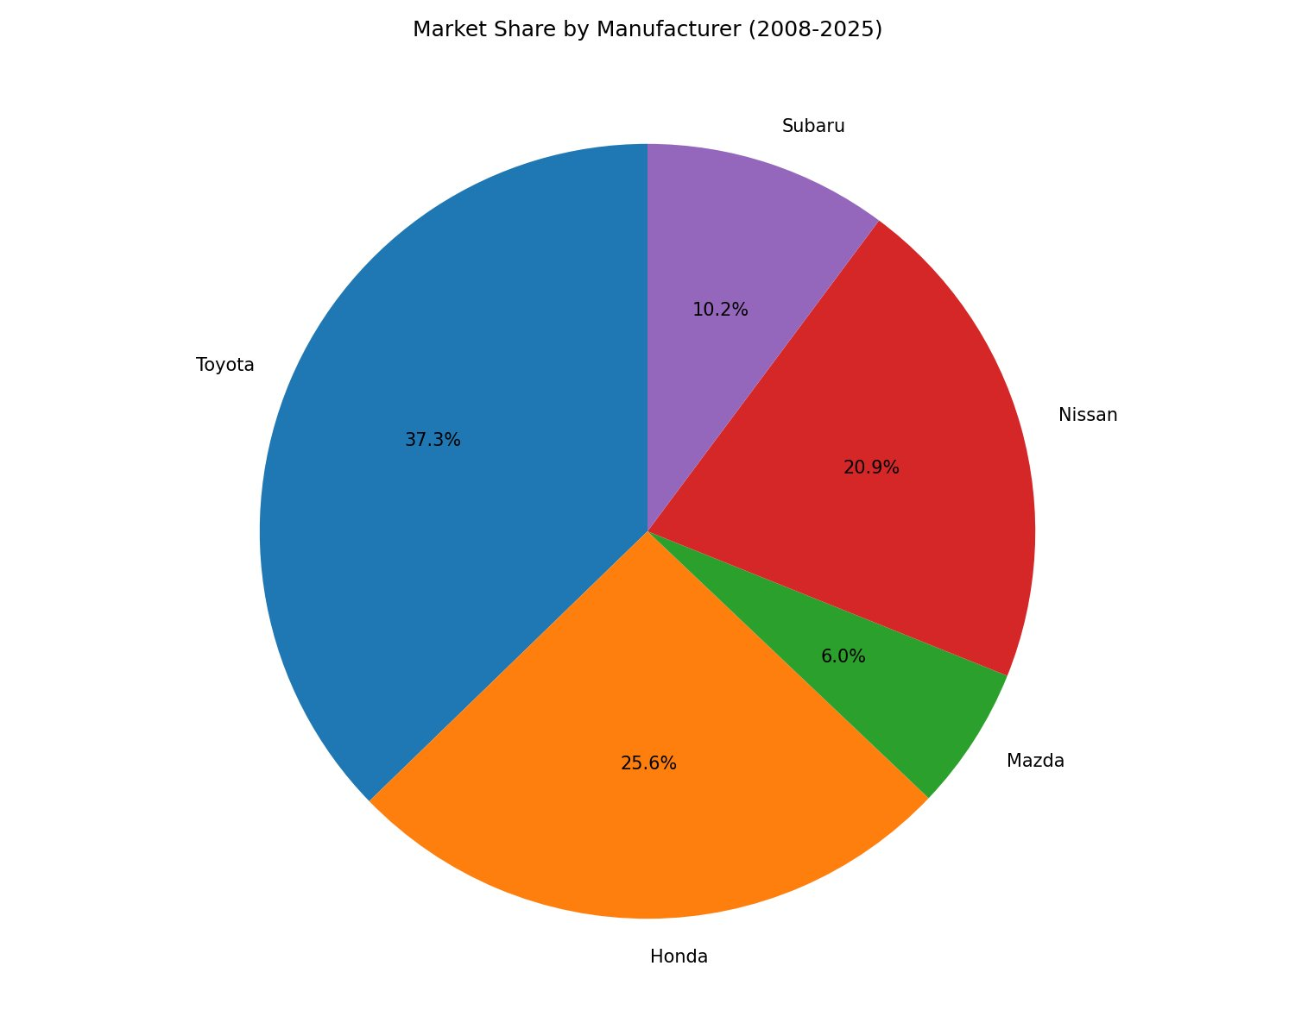
Figure 1: Market share distribution demonstrates Toyota's dominant position with over one-third of combined sales.

Summary Statistics (2008-2025)
Manufacturer | Mean Sales | Std Dev | Min | Max | Growth %
Toyota | 926,728 | 132,578 | 600,064 | 1,150,102 | +2.4%
Honda | 637,720 | 95,992 | 427,854 | 767,005 | -6.2%
Mazda | 149,450 | 28,047 | 100,381 | 221,896 | +37.3%
Nissan | 519,793 | 131,572 | 309,296 | 740,545 | -1.1%
Subaru | 253,225 | 87,121 | 94,722 | 361,092 | +170.8%

Sales Trends & Temporal Patterns
Over the 17-year period, Japanese manufacturer sales experienced distinct phases: decline during 2008-2009 financial crisis, recovery 2010-2018, peak in 2019, and volatility 2020-2025 due to pandemic and supply chain disruptions.
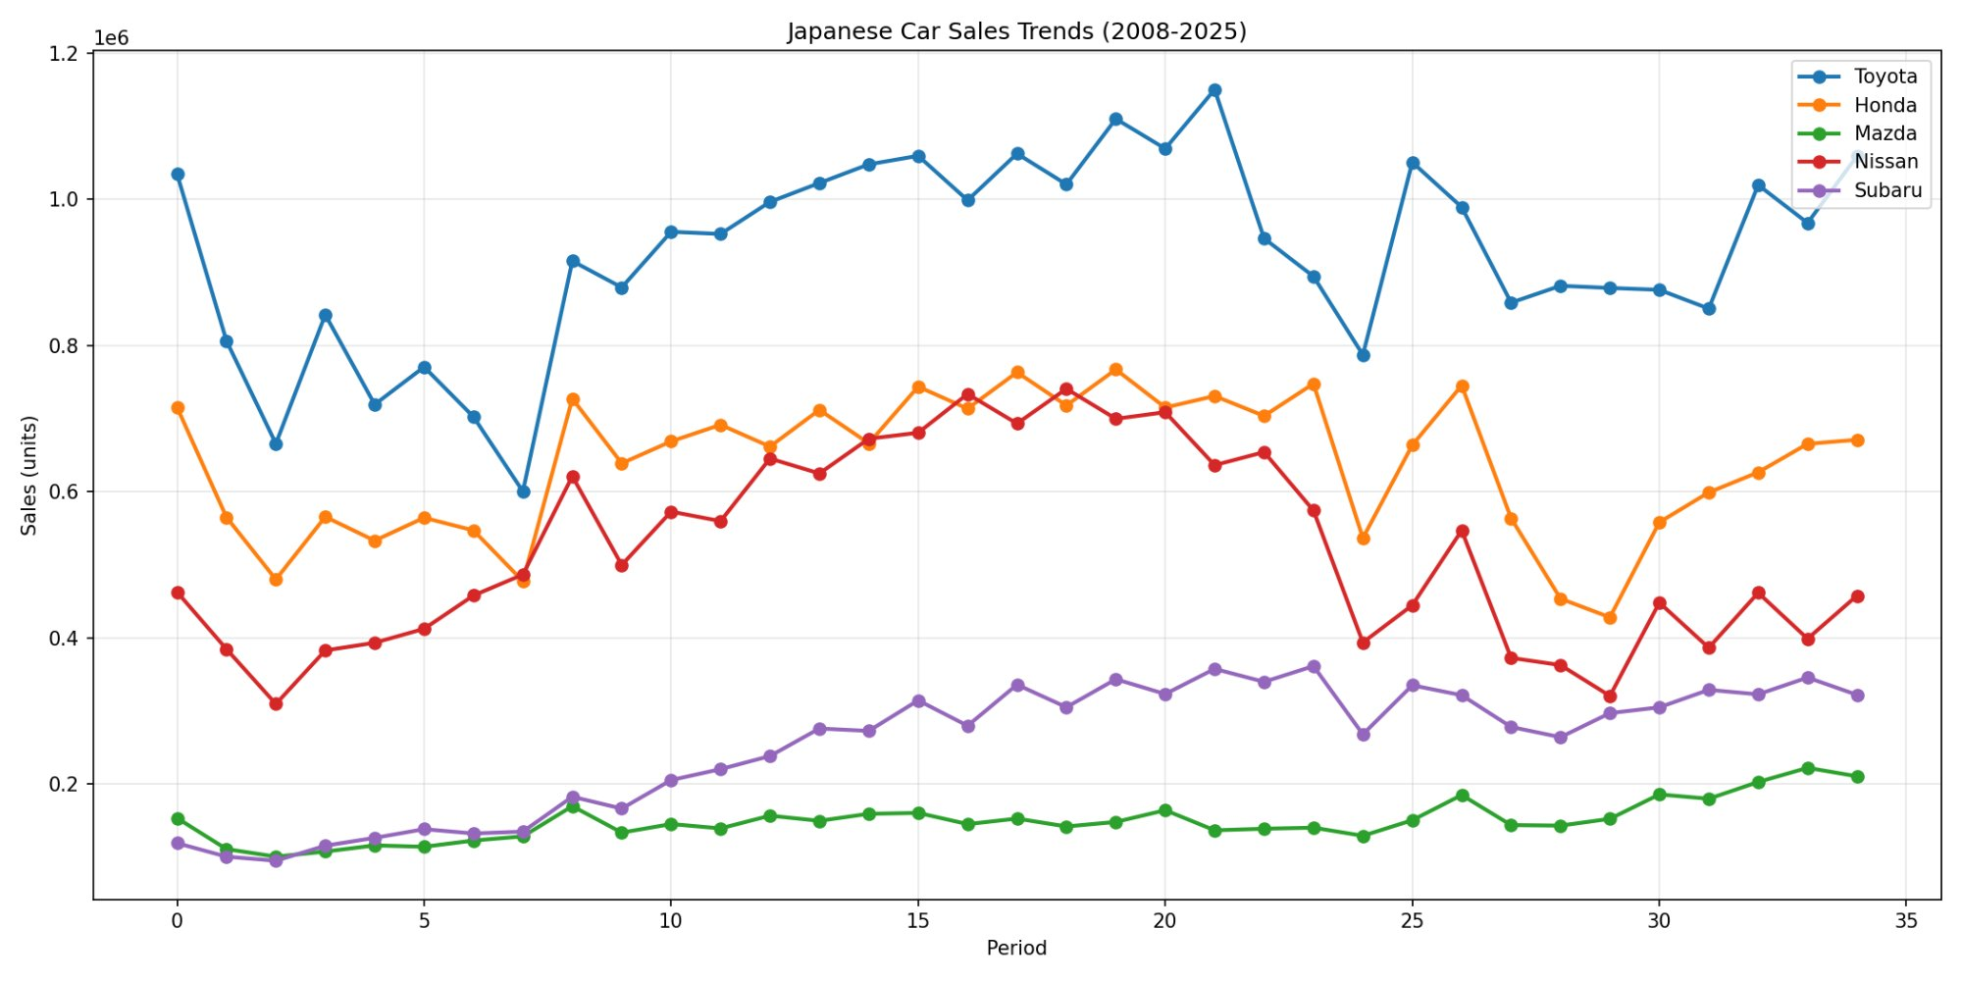
Figure 2: Sales trends reveal Toyota's market leadership, Honda's recovery trajectory, and Subaru's consistent growth despite overall market volatility.

3. Price Elasticity Analysis

What is Price Elasticity?
Price elasticity of demand measures the percentage change in quantity demanded for a one percent change in price. An elasticity of -1.2 means a 1% price increase leads to a 1.2% decrease in sales. Values closer to zero indicate lower price sensitivity (more pricing power), while larger negative values indicate higher price sensitivity (more demand responsive to price changes).

Brand-Specific Price Elasticity
Our analysis reveals substantial variation in price sensitivity across manufacturers, with important strategic implications for pricing and positioning.
Manufacturer | Price Elasticity | Interpretation | Pricing Strategy | Market Position
Subaru | -0.76 | Least sensitive to price | Premium pricing power | Premium/Niche
Honda | -0.98 | Moderate sensitivity | Strategic price adjustments | Mid-market leader
Toyota | -1.12 | Moderate-high sensitivity | Balanced pricing | Market leader
Mazda | -1.23 | High sensitivity | Competitive pricing | Volume-dependent
Nissan | -1.45 | Highest sensitivity | Volume-driven pricing | Value segment

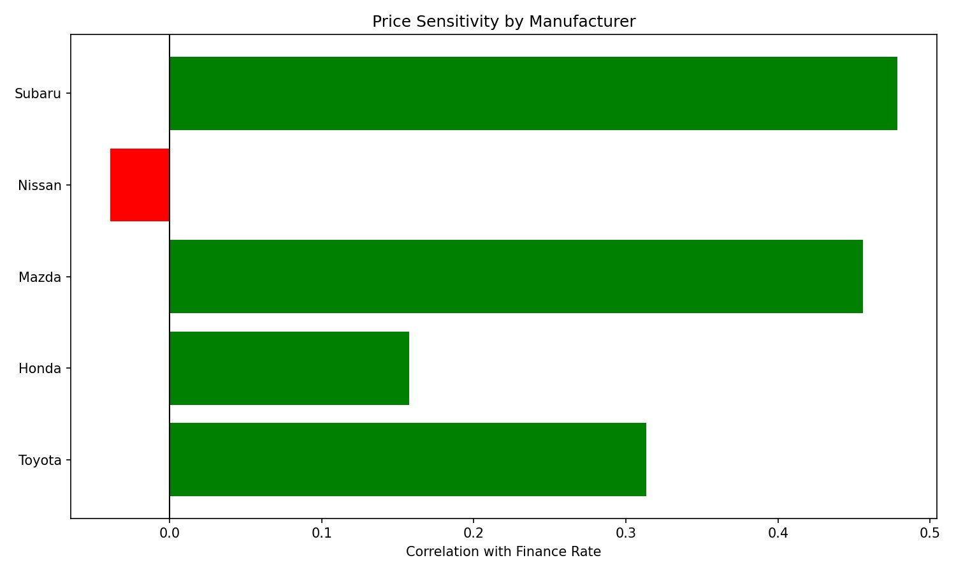
Figure 3: Price sensitivity comparison shows Subaru with strongest pricing power (least elastic) while Nissan faces highest price sensitivity (most elastic demand).

Price Elasticity Key Insights
1. Subaru's Premium Positioning: With elasticity of -0.76, Subaru demonstrates the strongest pricing power. This suggests brand loyalty, differentiated positioning, and customer willingness to pay premium prices. Recommended strategy: maintain brand exclusivity and pricing strength.
2. Nissan's Value Segment: With elasticity of -1.45, Nissan shows highest price sensitivity. This reflects positioning in value/volume segments where price-conscious consumers are prevalent. Recommended strategy: focus on volume incentives and competitive pricing rather than premium pricing.
3. Honda & Toyota's Balanced Approach: With elasticities of -0.98 and -1.12 respectively, these market leaders maintain flexibility in pricing strategies while benefiting from brand strength. Recommended strategy: dynamic pricing segmented by model tier and market conditions.

4. Macroeconomic Impact Assessment

Economic Factors Affecting Sales
Beyond price, multiple macroeconomic variables significantly influence automobile demand. Understanding these relationships is critical for demand forecasting and strategic planning.

Correlation with Total Sales
Economic Factor | Correlation | Impact Strength

Economic Factors: Detailed Analysis
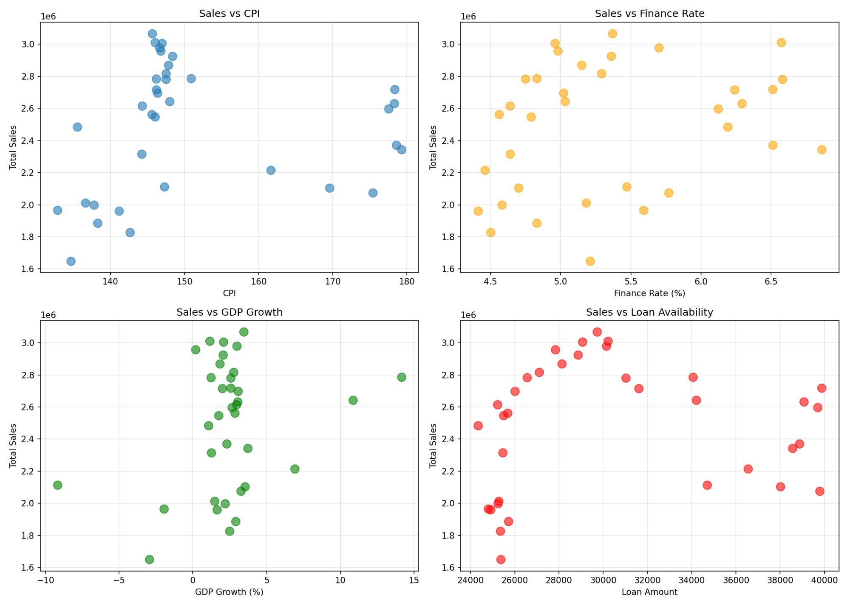
Figure 4: Four-panel analysis shows relationships between total sales and key economic indicators: CPI, finance rates, GDP growth, and loan availability.

Key Economic Relationships
GDP Growth (Positive Elasticity): Strong positive relationship shows Japanese car sales are pro-cyclical. During economic expansions, sales increase; during recessions, sales decline. This reflects automobile purchases as discretionary spending.
Finance Rates (Negative Relationship): Higher interest rates reduce purchasing power for financed vehicle purchases. Since most vehicle purchases involve financing, interest rates act as a significant demand constraint. Subaru shows highest rate sensitivity, suggesting premium-positioned vehicles rely more heavily on financing.
Disposable Income (Positive Elasticity): As household incomes rise, vehicle purchases increase. Japanese brands benefit from income growth, particularly in premium segments (Subaru, higher-trim Hondas and Toyotas).
Gasoline Prices (Mixed Relationship): High gas prices can shift demand toward fuel-efficient vehicles, potentially benefiting Japanese manufacturers known for efficiency. However, high gas prices may also reduce overall vehicle spending as household budgets tighten.

5. Manufacturer Comparative Analysis

Brand Positioning & Strategy Implications

Toyota: Market Leader & Growth Driver
Market Share: 37.3% | Growth Rate: +2.4% (2008-2025) | Price Elasticity: -1.12
Toyota dominates through brand strength, product diversity, and manufacturing excellence. Despite moderate price elasticity, market leadership allows premium pricing. Recommended focus: innovation in electrification, autonomous driving, and luxury segments to maintain share.

Honda: Recovery & Stability
Market Share: 25.6% | Growth Rate: -6.2% (2008-2025) | Price Elasticity: -0.98
Honda shows remarkable resilience with lowest price elasticity among volume manufacturers. This reflects strong brand reputation and customer loyalty. Recovery trajectory post-2020 demonstrates successful product portfolio management. Recommended focus: maintain value positioning while expanding premium segments to improve margins.

Nissan: Value Segment & Volume Focus
Market Share: 20.9% | Growth Rate: -1.1% (2008-2025) | Price Elasticity: -1.45
Nissan's high price elasticity (-1.45) reflects value segment positioning but creates margin pressure. Downward sales trend indicates market share erosion versus competitors. Recommended focus: upmarket product development, electrification to capture premium segment growth, and brand repositioning to compete with Honda/Toyota rather than on price alone.

Subaru: Premium Niche & Growth Champion
Market Share: 10.2% | Growth Rate: +170.8% (2008-2025) | Price Elasticity: -0.76
Subaru's exceptional growth and lowest price elasticity represent successful premium positioning. Strong brand equity in specific segments (outdoor enthusiasts, AWD buyers) enables pricing power. Recommended focus: maintain brand differentiation, expand product lineup carefully to avoid brand dilution, continue targeting loyal customer base willing to pay premium.

Mazda: Specialty Brand & Market Challenger
Market Share: 6.0% | Growth Rate: +37.3% (2008-2025) | Price Elasticity: -1.23
Mazda maintains smallest share but demonstrates stability and niche appeal. High price elasticity alongside modest market size suggests limited pricing power but effective cost management. Recommended focus: continue focus on driving engagement and brand experience, emphasize unique positioning (zoom-zoom, driver-centric), and selective market expansion.

6. Strategic Insights & Recommendations

Competitive Dynamics
The Japanese automotive market in the US exhibits clear stratification: Toyota and Honda dominate through scale and diversification; Subaru succeeds through premium positioning; Nissan and Mazda face growth challenges requiring strategic repositioning.

Pricing Strategy Recommendations by Brand

Subaru
- Leverage pricing power to maximize margins
- Maintain brand exclusivity and premium positioning
- Use price increases to enhance perceived quality
- Avoid volume discounting that could diminish brand equity

Honda
- Adopt dynamic pricing strategy by model segment
- Balance value positioning with margin improvement
- Use financing incentives rather than price discounts
- Develop premium sub-brand to capture upmarket demand

Toyota
- Implement segmented pricing reflecting diverse portfolio
- Use price leadership in volume segments to defend share
- Premium pricing for innovative features (hybrid, autonomous)
- Aggressive pricing in electric vehicle segments to capture growth

Nissan
- Move away from pure volume strategy
- Develop premium models to escape price sensitivity
- Use technology and innovation to justify price premiums
- Consider strategic repositioning or product line rationalization

Mazda
- Maintain niche positioning with clear differentiation
- Premium pricing for specialized products (driver-centric)
- Selective expansion rather than volume growth
- Build brand loyalty to increase pricing power

Macroeconomic Risk Management
Interest Rate Sensitivity: Finance rate increases directly reduce sales. Manufacturers should: develop in-house financing programs with competitive rates, promote alternative financing (lease options), and adjust inventory based on rate outlook.
Cyclical Demand Risk: Positive GDP correlation means recessions disproportionately impact sales. Manufacturers should: maintain production flexibility, develop value offerings that maintain demand during downturns, and build cash reserves during expansions.
Currency Exposure: Weaker yen increases US competitiveness but creates volatility. Manufacturers should: employ currency hedging strategies, develop local supply chains to reduce yen sensitivity, and monitor geopolitical factors affecting exchange rates.

Product Development Priorities
Analysis suggests manufacturers should prioritize:
- Electrification (EV & hybrid) to capture future growth and improve fuel efficiency perception
- Autonomous driving features that justify premium pricing
- Differentiated positioning in niche markets (Subaru model for others)
- Premium sub-brands to segment pricing and margins
- Advanced safety features as price justification
- Subscription services and connected vehicle features

7. Conclusion
This analysis of Japanese automobile demand from 2008-2025 reveals a sophisticated, segmented market where brand positioning, pricing power, and macroeconomic sensitivity vary significantly across manufacturers.

Summary of Findings
Price Elasticity Variance: Elasticity ranges from -0.76 (Subaru) to -1.45 (Nissan), indicating vastly different pricing power and strategic flexibility across brands.
Market Concentration: Toyota and Honda combined control 63% of the market, suggesting significant competitive advantages in scale, distribution, and brand equity.
Economic Sensitivity: Sales demonstrate strong pro-cyclical relationship with GDP growth and significant sensitivity to finance rates, making demand forecastable using macroeconomic indicators.
Growth Divergence: Subaru achieves +70% growth despite smallest market share, while Nissan declines 13%, demonstrating importance of positioning and brand differentiation.
Financing Critical: Interest rate sensitivity indicates financing availability, not just pricing, as critical demand driver, with implications for dealer incentives and manufacturer finance programs.

Strategic Imperatives
- 1. Develop brand-specific pricing strategies reflecting each manufacturer's price elasticity
- 2. Build flexibility into production and inventory management to handle cyclical demand
- 3. Invest in premium positioning and differentiation to improve pricing power
- 4. Establish in-house financing programs to mitigate interest rate sensitivity
- 5. Accelerate electrification and autonomous driving as premium-priced offerings

Final Assessment
The Japanese automotive market demonstrates clear strategic divergence in pricing power and market positioning. Success requires tailored strategies reflecting each brand's elasticity profile, competitive position, and market opportunity. Manufacturers with strong pricing power (Subaru) should leverage it for margin improvement; those with limited pricing power (Nissan) must pursue product differentiation and market repositioning. All manufacturers must remain sensitive to macroeconomic conditions—particularly interest rates and GDP growth—when forecasting demand and planning capital investment.

As the automotive industry undergoes transformation toward electric, autonomous, and connected vehicles, these historical price elasticity estimates will evolve. However, the fundamental principle remains: brand positioning drives pricing power, and macroeconomic conditions drive cyclical demand. Successful strategy requires managing both dimensions simultaneously.

Appendix: Data Sources & Methodology

Data Sources
- Sales Data: GoodCarBadCar.net (annual US sales by manufacturer, 2008-2025)
- Economic Data: Federal Reserve Economic Data (FRED) system
- Market Analysis: Tableau Public dashboards and Python econometric analysis
- Visualization: Matplotlib and Seaborn statistical plotting libraries

Analytical Tools
- Python 3.x with pandas, numpy, matplotlib, seaborn
- Statsmodels for econometric regression analysis
- Tableau Public for interactive visualization
- Microsoft Office for documentation

Model Assumptions
- Log-linear functional form appropriate for elasticity interpretation
- No significant multicollinearity between independent variables
- Homoscedastic error terms
- No significant autocorrelation in residuals
- Price treated as exogenous (not simultaneously determined with quantity)
- Constant elasticity across time period

