FINAL PROJECT

Create a directory for this project (final_project). Create an index.html file in the root directory (final_project), create a css directory in the root directory with a file named style.css inside of that directory, and create a js subdirectory in the root directory with a file named script.js inside of that directory.

Link the stylesheet and the JavaScript file in the index.html file.

You may use JavaScript or JQuery or a combination of both for this project. Do not copy whole chunks of code from the internet. You may use the internet as a resource.

There are three buttons. Two are planets and one is the sun. They should be placed on the page as shown in the image below, with one paragraph shown under the sun button. The buttons should look as closely as possible to the buttons below. (15)

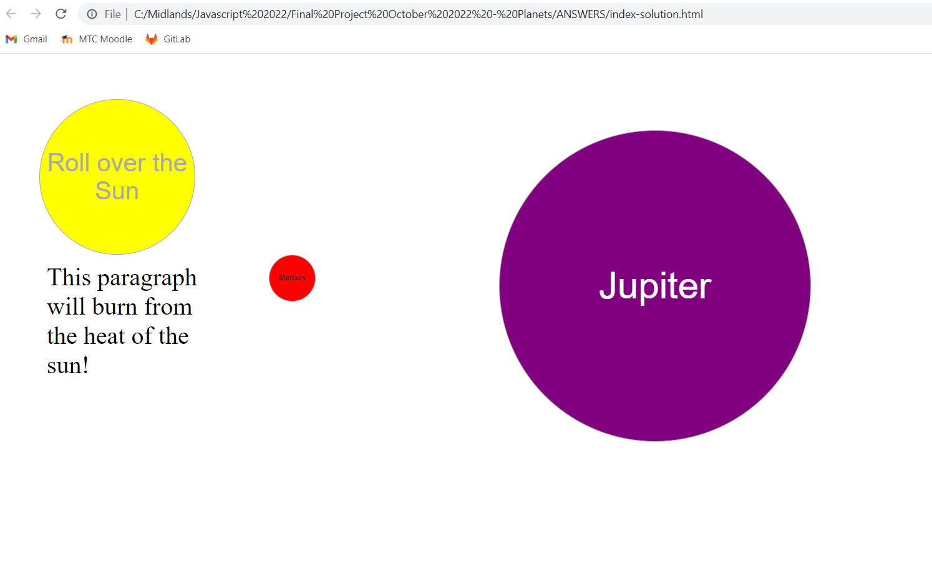

When the user rolls over the sun, the paragraph will no longer be visible, as shown below. It will come back as soon as the user’s mouse leaves the sun. (15)

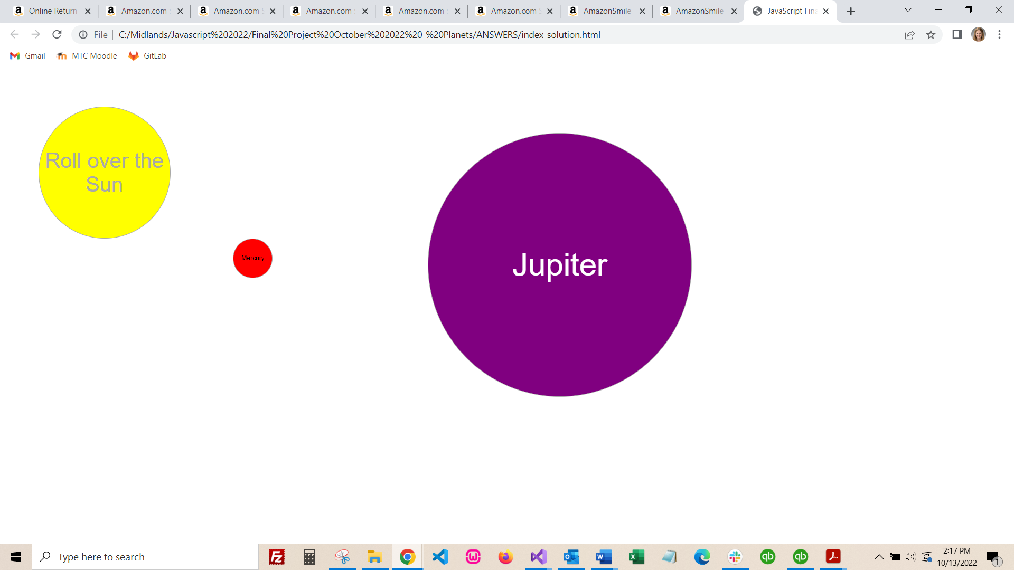

When the user clicks Mercury, a pop up with four facts about Mercury should appear, and should be formatted as closely to the pop up shown below. The facts about Mercury must be in a simple array, and the function that creates the pop up must use a loop. That loop must use the number of items in the array (using JQuery or JS), and must not be coded for 4 items, as in the “real world” the number of items in an array can change. (25)

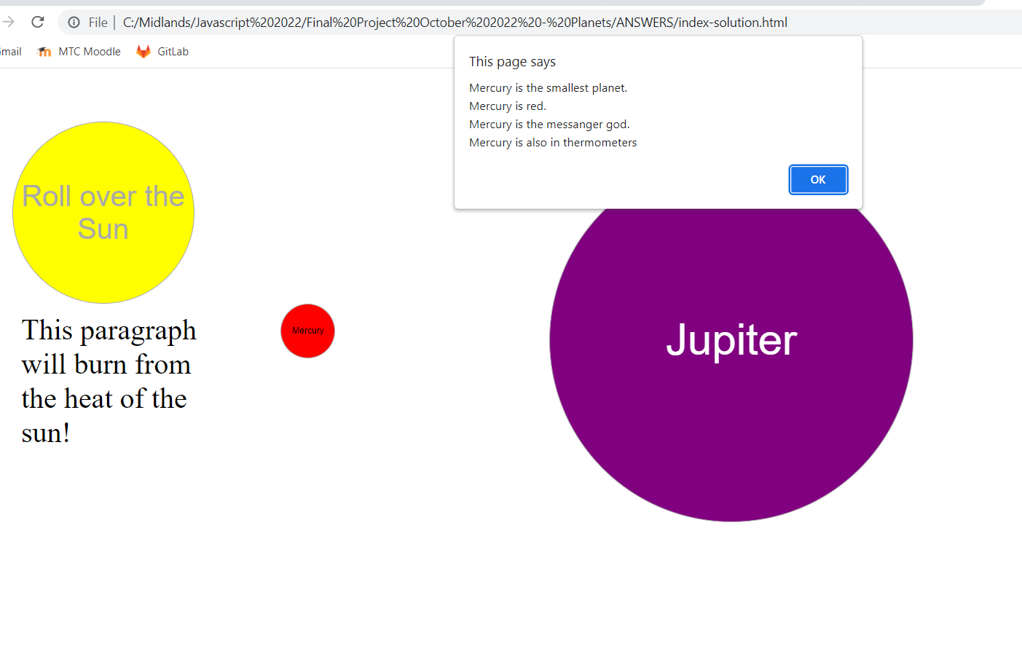

When the user clicks Jupiter, Jupiter moves down (or is moved down by the words), and five items appear above Jupiter. The five items must be strings contained in a well-formed JSON object that is included in the JavaScript file. Please do not try to create a .json file unless you can make the items show up. Defining the JSON inside of the file is acceptable at this point!

Figure out how many items are in the JSON. The JSON should be an object that can contain an array in it – so that a loop can be used to show the words above Jupiter. You do not have to use an array. You may use any type of loop. As long as there is a loop, the JSON format is up to you. There should be an if statement – that if the word “storm” is in the item, then style that particular item red. You may use inline styling. Do not use the position in the JSON – meaning, do not use logic that if the item is the second item, make it red. Use the logic that if the word storm is in the JSON, then color the item red. (35)

Use the statements shown below in the JSON.

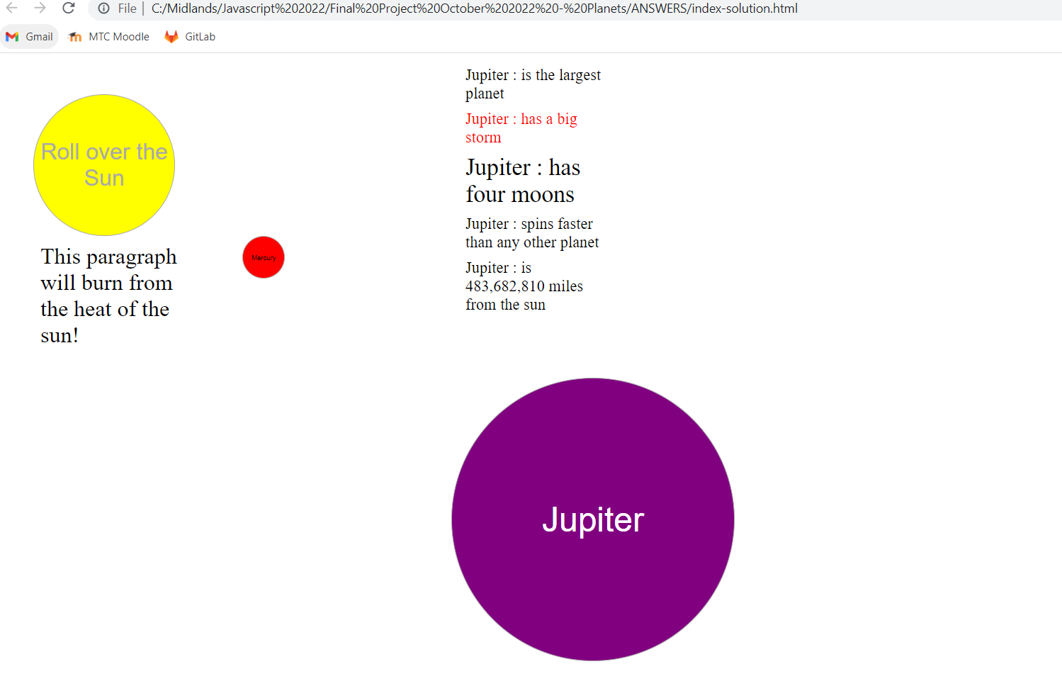

When the user rolls over the sun, it should rotate so that the words end up fully upside down. The next two images show the sun in rotation, and when the rotation ends. This may be done with CSS or with JavaScript/JQuery. The rotation does not have to perform in reverse when the user stops hovering over the sun; the sun can just return to its original state when the mouse is removed from the sun button. (5)

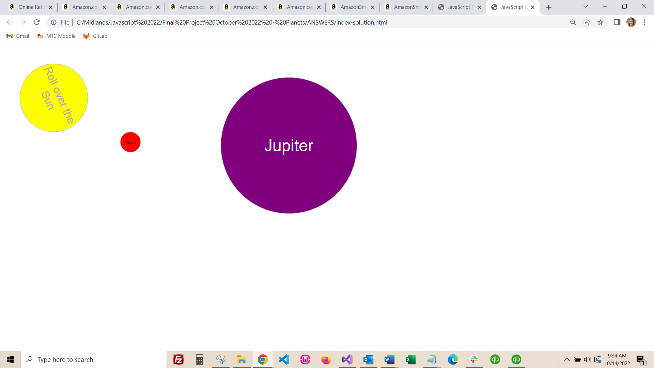

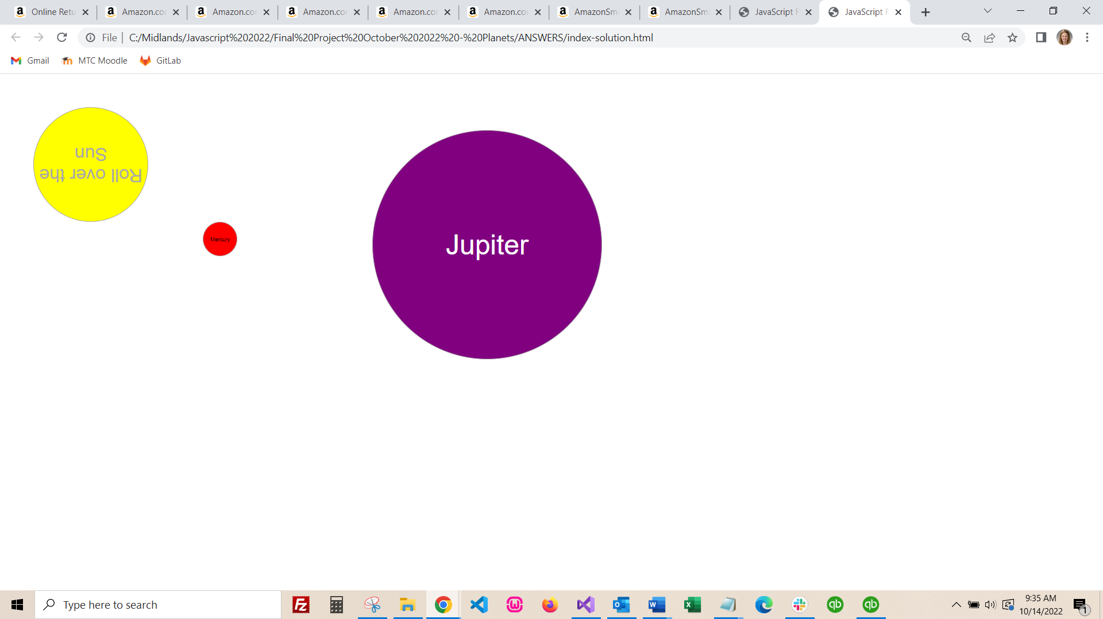

When the user rolls over Jupiter (different from the click event), Jupiter should rotate on its axis as shown in the images below. The next two images show Jupiter in rotation, and when the rotation ends. This may be done with CSS or with JavaScript/JQuery. The rotation does not have to perform in reverse when the user stops hovering over Jupiter; Jupiter can just return to its original state when the mouse is removed from the Jupiter button. (5)

