PLANETS PROJECT

Create a directory for this project (planets_project). Create an index.html file in the root directory (planets_project), create a css directory in the root directory with a file named style.css inside of that directory, and create a js subdirectory in the root directory with a file named script.js inside of that directory.

Link the stylesheet and the JavaScript file in the index.html file.

Do not copy whole chunks of code from the internet. You may use the internet as a resource.

There are three buttons. Two are planets and one is the sun. They should be placed on the page as shown in the image below, with one paragraph shown under the sun button. The buttons should look as closely as possible to the buttons below. (15)

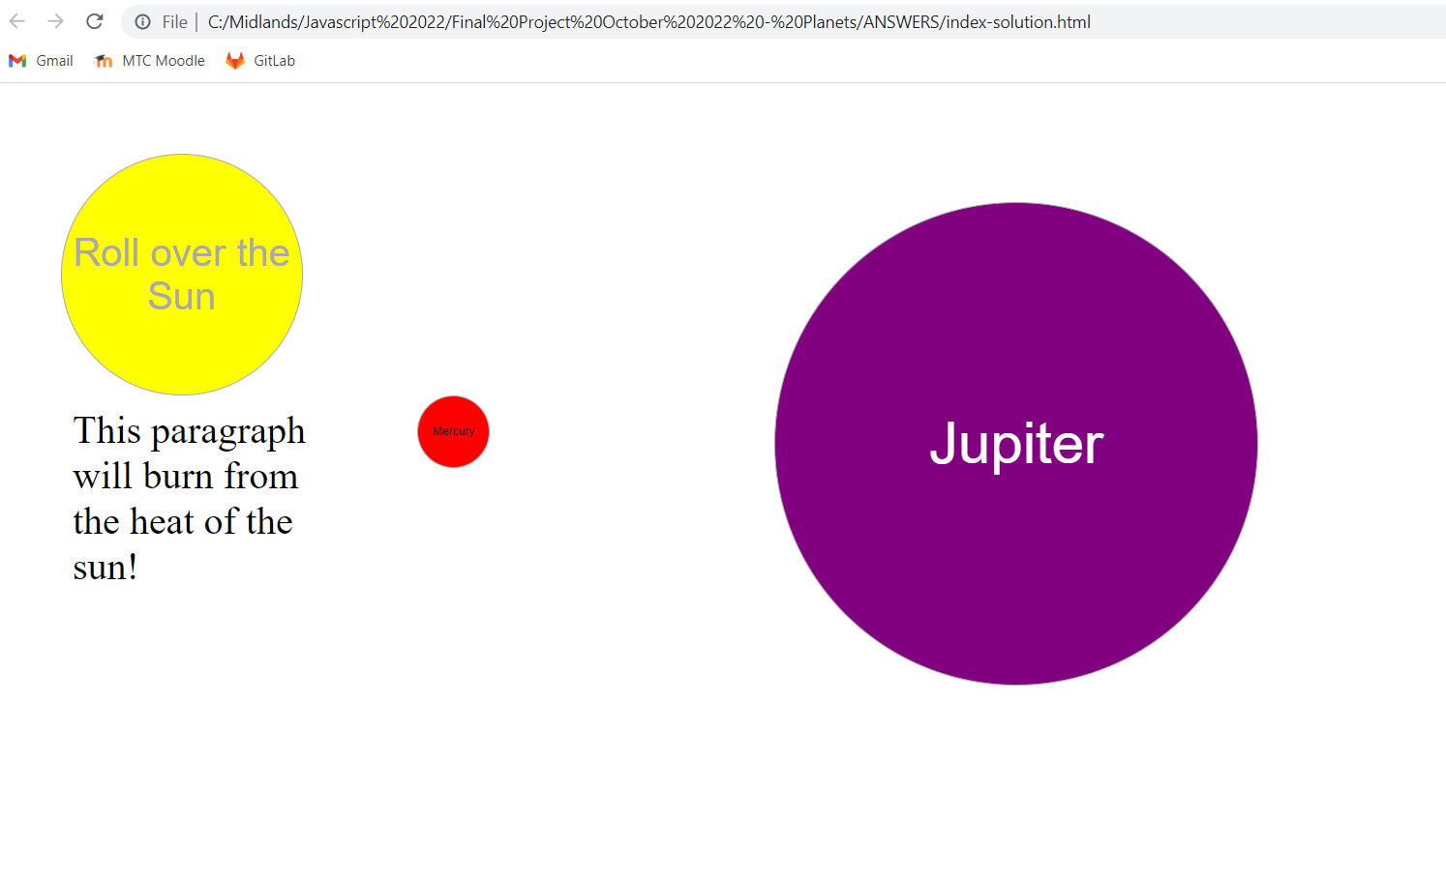

When the user rolls over the sun, the paragraph will no longer be visible, as shown below. It will come back as soon as the user’s mouse leaves the sun. (15)

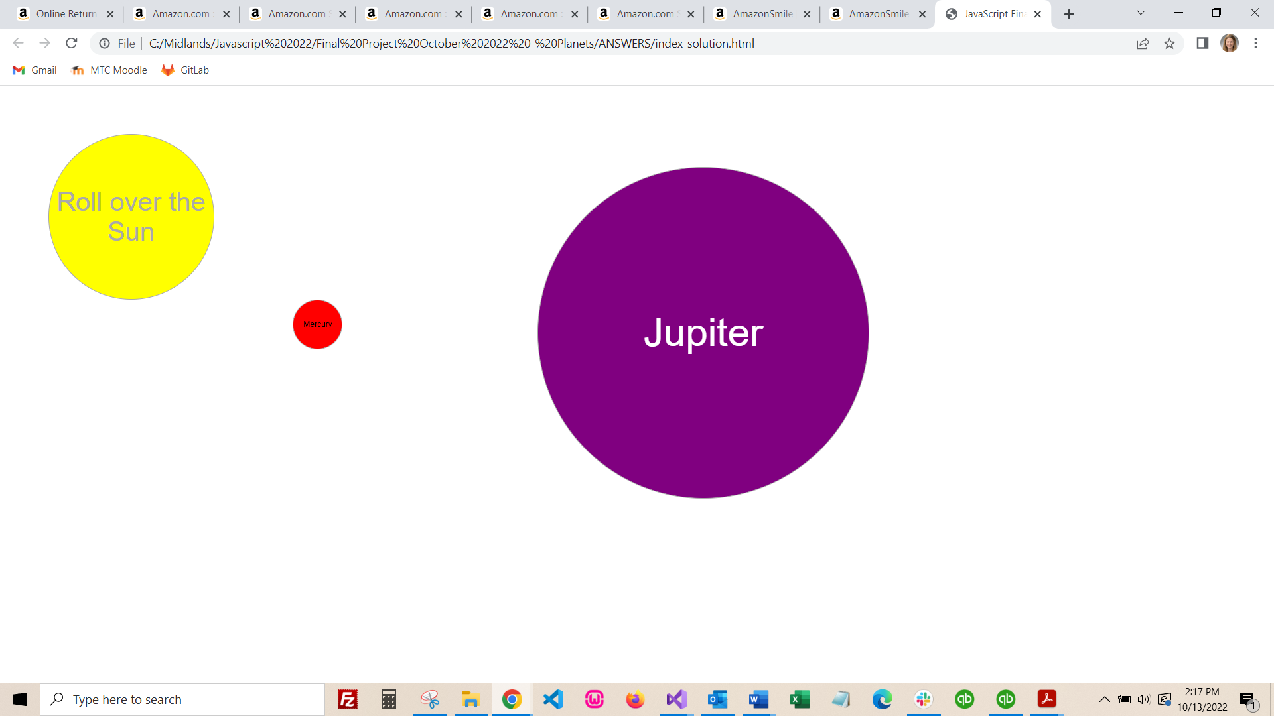

When the user clicks Mercury, a pop up with four facts about Mercury should appear, and should be formatted as closely to the pop up shown below. The facts about Mercury must be in a simple array, and the function that creates the pop up must use a loop. That loop must use the number of items in the array and must not be coded for 4 items, as in the “real world” the number of items in an array can change. (25)

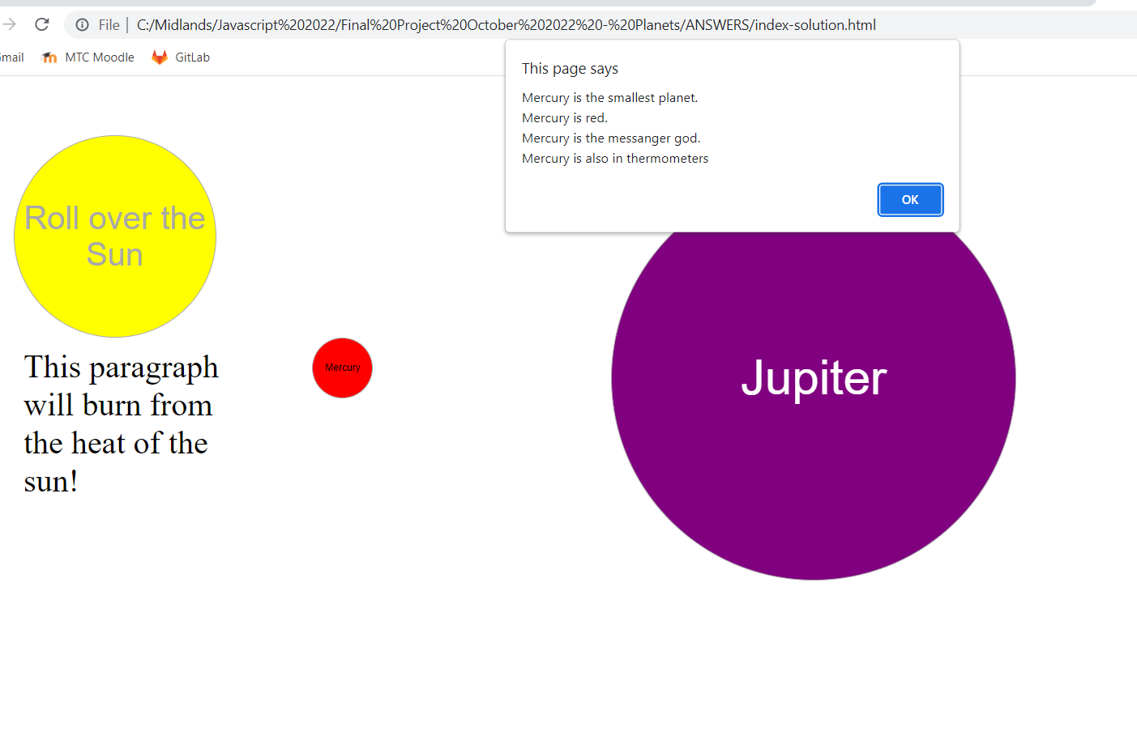

When the user rolls over the sun, it should rotate so that the words end up fully upside down. The next two images show the sun in rotation, and when the rotation ends. This may be done with CSS or with JavaScript. The rotation does not have to perform in reverse when the user stops hovering over the sun; the sun can just return to its original state when the mouse is removed from the sun button. (5)

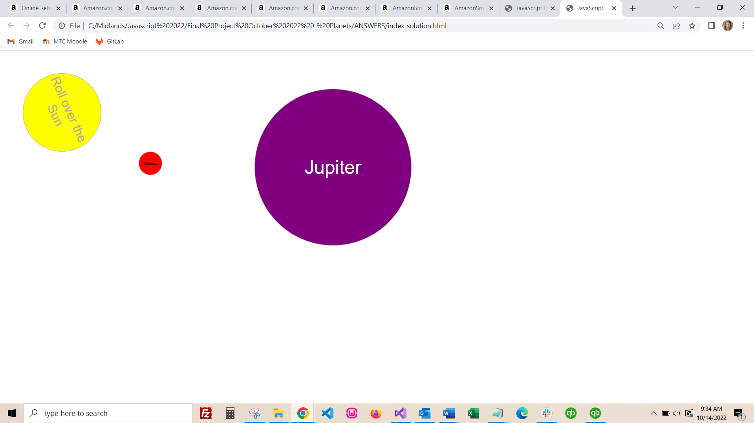

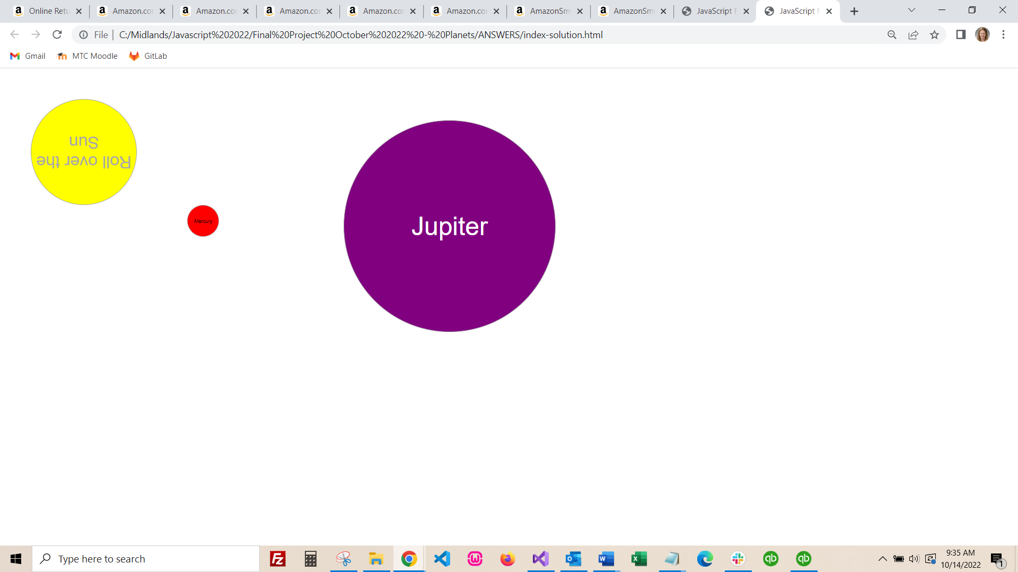

When the user rolls over Jupiter (different from the click event), Jupiter should rotate on its axis as shown in the images below. The next two images show Jupiter in rotation, and when the rotation ends. This may be done with CSS or with JavaScript. The rotation does not have to perform in reverse when the user stops hovering over Jupiter; Jupiter can just return to its original state when the mouse is removed from the Jupiter button. (5)

