Introduction

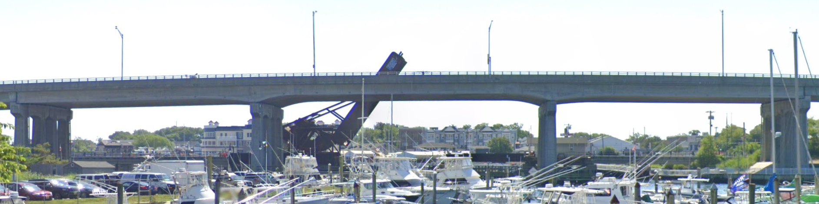

[1311150](http://bridgereports.com/1366791) is a 3 span continuous bridge with prestressed girders (haunched). [1311151](http://bridgereports.com/1366792) is a 3 span continuous with prestressed girders immediately south of the 1311150 (approach spans).

### Driving Questions:

How the bridge design is affected by the continuity for dead load and live load.

Investigation into the uplift caused by staged construction

Computation of losses at different stages of construction

Outline a procedure for construction sequencing that can be used for other bridges similar to this one.

NJDOT is interested in looking into the capabilities of AASHTOWARE BrR and how to use this software for live load continuous bridges.

### Methods and Effort:

Taking the structure 1311150 as an example, perform parametric studies to determine different critical situations. The reasons for this study:

* Contract documents always do not include shop or as-built drawings, requiring several assumptions to be made for load rating. The parametric study would identify the critical conditions/assumptions for different configurations.
* What span arrangement, construction sequence, etc. might cause uplift?
* Confusion exists about DL continuity (although I explained that DL continuity for the subject bridge structural arrangement is very unlikely, and 1311150 was continuous for SDL and LL only). What happens if DL continuity was implemented?

Approach spans (structure 1311151) was load rated using LARS that required some assumptions.

* Load rate one of the approach span units using BrR and find out the challenges.
* Consider construction stages

### Deliverables:

* Prepare two reports: One for three span structure; One for approach span
* Goal is to develop methodology for assets that do not have plans. What assumptions should be made?
* Deliver a webinar upon completion of the work.

### Information Required:

Any previous load rating reports for approach spans (1311151). (As-builts for 1311151 included in 1311150 plans).

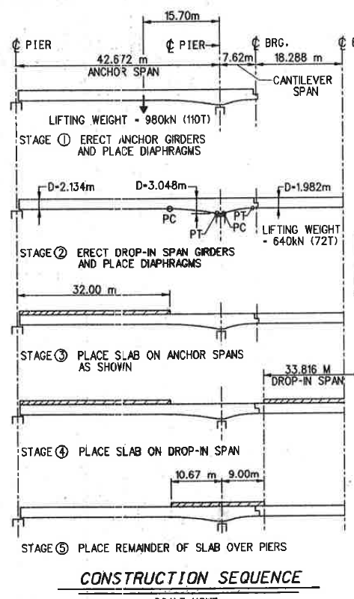Tasks:  
**Parametric studies of 1311150**

Compile all required documentation to construct 3D FE model (load rating report and as-built already obtained)

Determine which assumptions/conditions should be considered in parametric studies

Live Load

* Sequence of construction, continuity
* Ratio of length of end spans to center span
* Effect of diaphragms on load distribution (compare to DFs)
* Bearing fixity

Determine effect of assumptions on capacity calculations

* Strand numbers and location (capacity)
* Prestressing losses at different stages of construction (identify influential parameters or assumptions).
* Compression side reinforcement

**Load Rating of PSC LL Cont. (1311151)**

Lit Review of industry/agency LR practice?

Complete load rating using BrR (WSP?)

Determine any challenges or assumptions

Effect of skew?

Examine means of integrating construction stages within BrR, other challenges.

## Parametric studies

### Length of spans (ratio of end spans to middle span)

Full-factorial sampling of space.

Examine ratios of middle to end span of 0.8 to 2.5 (increments of 0.1).

Examine mid-span lengths of 50 feet to 250 feet.

Examine cantilever distance of 10% ,15%, and 20% of anchor span length.

Must design likely sections (Limit to aashto and BT). Design for section and number of strands. Assume cantilever designed appropriately.

Effect of span length and span length ratios on the following

* Midspan rating of side spans (Strength I, Svc III)
* Tension stresses at midspan of side spans
* Uplift forces at bearings of end spans (inclusive of dead-weight)

### Sequence of deck pour on demands

If the deck were to be poured in a different sequence, what would the effect be on midspan (anchor span) demands (and stresses) and uplift forces. The following sequences will be examined.

* Poured from one side to the other
* Poured center, then end spans, (then neg. moment region)
* Poured center (including cont. joint), allowed to set, then pour end spans
* The actual case: poured ends, poured center, poured neg. moment region (incl cont. joint)

### Secondary Moments due to Losses and continuity

Due to the nature of how the prestressed spans were manufactured, no secondary moments were introduced in the beams.

Once the spans were made continuous (after the deck pour) any losses, would be applied to the continuous structure, inclusive of the deck which is acting compositely.

Therefore, we will:

* Calculate and bound losses.
* Determine resulting secondary moment (additional tension in neg. moment region)
* Compare to remaining capacity (considering reinforcement in deck)