This document the results of the computations and sensitivity studies performed for BRP related to structure no. 1311150.

* What span arrangement, construction sequence, etc. might cause uplift?
* Confusion exists about DL continuity (although DL continuity for the subject bridge structural arrangement is very unlikely, and 1311150 was continuous for SDL and LL only). What happens if DL continuity was implemented?
* 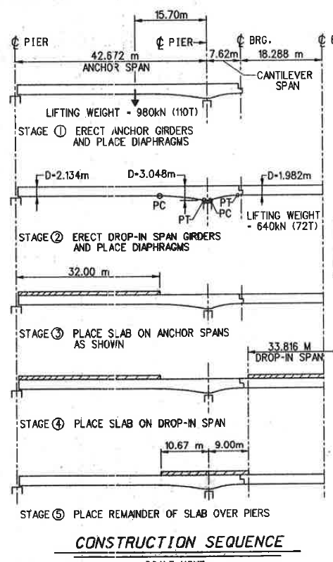
* Stage 6 is superimposed dead load which in the case of this bridge is only the weight of the barriers.

## 1.

The sequence of construction does not result in any uplift due to the self-weight of the girders. The following table lists the responses of the structure at key locations under the various dead load cases.

|  |  |  |  |  |  |
| --- | --- | --- | --- | --- | --- |
| Load Case | Anchor Span Reaction (kip) | Reaction over interior support (kip) | Moment @ 0.4L (kip-ft) | Moment over interior support (kip-ft) | Moment at center of drop-in span (kip-ft) |
| DL1 | 97.80 | 37.27 | 3254.02 | -455.50 | 0.06 |
| DL2 | -15.01 | 84.08 | -851.71 | -2101.84 | 2515.81 |
| DL3 | 58.60 | 0.01 | 1904.51 | -7.7E-04 | -1.0E-03 |
| DL4 | -8.97 | 50.29 | -509.45 | -1257.21 | 1605.11 |
| DL5 | 1.18 | 25.65 | 66.49 | -370.41 | 7.26 |
| DL6 | 7.86 | 13.11 | 200.65 | -408.33 | 150.42 |
| Total DL | 141.46 | 210.41 | 4064.50 | -4593.29 | 4278.66 |

At no point during the construction do dead loads result in uplift or moment reversal. This is because the uplift generated by the drop-in span is only 15% of the magnitude of the downward force generated from the anchor span beam self-weight. Furthermore, live load concentrated on the drop-in span would cause uplift forces, however, their magnitude would be