### Introduction

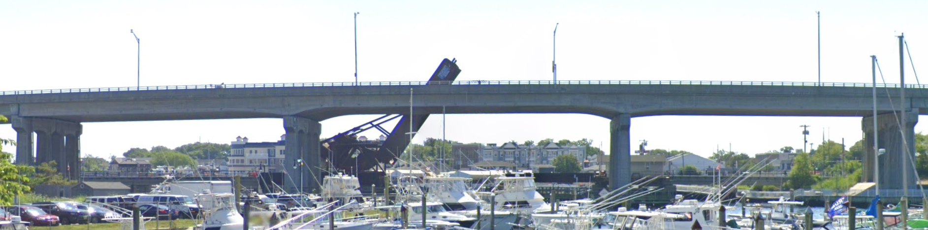

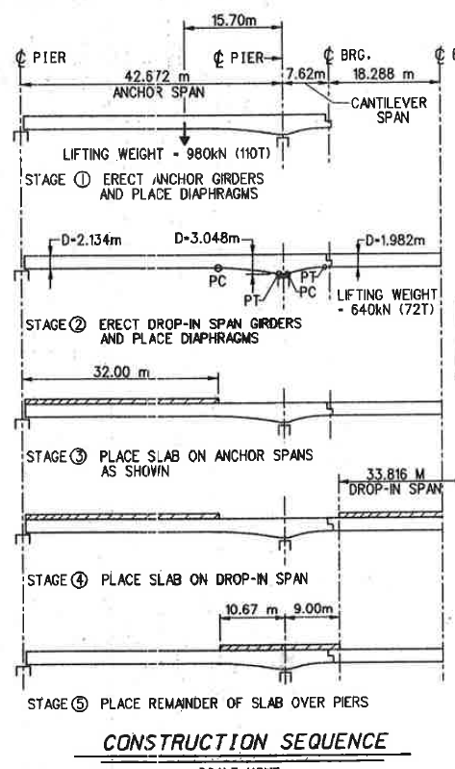[1311150](http://bridgereports.com/1366791) is a 3 span continuous bridge with prestressed girders (haunched).

The following questions were provided by NJDOT:

* Contract documents always do not include shop or as-built drawings, requiring several assumptions to be made for load rating. What are the critical conditions/assumptions for different continuity configurations?
* What span arrangement, construction sequence, etc. might cause uplift?
* Confusion exists about DL continuity (although DL continuity for the subject bridge structural arrangement is very unlikely, and 1311150 was continuous for SDL and LL only). What happens if DL continuity was implemented?

### Methods and Effort:

Taking the structure 1311150 as an example, parametric studies will be performed to determine different critical situations. The details of these studies are as follows:

#### Effect of Span Length (ratio of end spans to middle span)

This study will consider the following parameters:

* Ratios of middle to end span of 0.8 to 2.5 (increments of 0.1).
* Mid-span lengths of 50 feet to 250 feet.
* Cantilever distance of 10% ,15%, and 20% of anchor span length.

The effect of these parameters on the following structural responses will be reported

* Uplift forces at bearings of end spans (inclusive of dead-weight)
* Tension stresses at midspan of side spans
* Optional: Midspan rating of side spans (Strength I, Svc III)

Full-factorial sampling of the parameter space will be performed. Bridge/girder sections will be designed, limited to AASHTO and Bulb-Tee sections. Structural analysis will be performed to generate the resulting structural responses to drop-in deck placement. The structural analysis will first be performed for the subject structure and compared to the responses calculated

#### Sequence of Deck Pour on Demands

If the deck were to be poured in a different sequence, what would the effect be on midspan (anchor span) demands (and stresses) and uplift forces. The following sequences will be examined.

* Poured from one side to the other
* Poured center, then end spans, (then neg. moment region)
* Poured center (including cont. joint), allowed to set, then pour end spans
* The actual case: poured ends, poured center, poured neg. moment region (incl cont. joint)

The structural response of the subject bridge to these different construction sequences will be computed. The responses will also be computed for those structures deemed worst case scenario by the previous parametric study. In this way we will demonstrate the effect of deck and closure pour sequencing of structural demands.

#### Secondary Moments due to Losses and Continuity

Due to the nature of how the prestressed spans were manufactured, no secondary moments were introduced in the beams. However, once the spans were made continuous (after the deck pour) any losses, would be applied to the continuous structure, inclusive of the deck which is acting compositely.

To quantify these secondary moments, the following computations will be performed.

* Calculate and bound various losses.
* Determine resulting secondary moments (additional tension in neg. moment region)
* Compare to DL and LL demands and remaining capacity (considering reinforcement in deck)

### Deliverables:

* Prepare report for three span structure
* Goal is to develop methodology for assets that do not have plans. What assumptions should be made?
* Deliver a webinar upon completion of the work.