The test-case models were created so as to have varied geometry and stiffness while remaining representative of real structures. This was accomplished by basing the models on existing bridges. These bridges have varying length, width and skew. Furthermore, the dynamics of the bridges had been determined from previous field tests, and have first natural frequencies ranging from 2 to 10 Hz.

Road profiles are assigned to a line that defines the vehicle path. Each vehicle path includes an approach length of 320 feet. This approach length is more than sufficient to account for vehicle initial conditions.

# 140 ft. span

The 140 ft span models were based on the geometry of I76—a multi-girder highway bridge with steel plate girders. Simple beam elements were used in place of the cross-frame diaphragms that existed on the actual bridge, but the beam elements were assigned stiffness values such that butterfly modes matched those for the real structure, thereby assuring the transverse stiffness was adequately represented in the model.

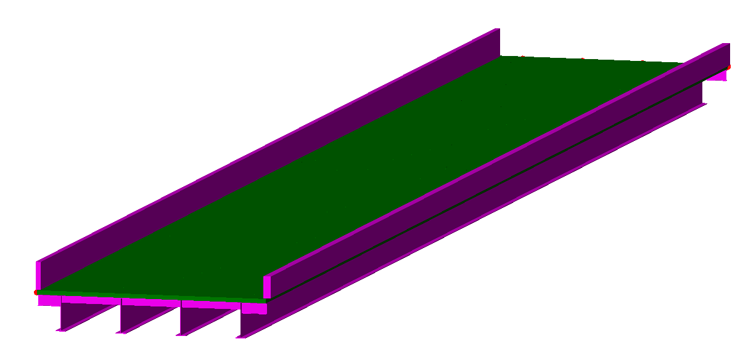

The first natural frequency is 2.08 Hz. A path of travel was defined over the first interior girder. The midspan displacements of that girder due to a point load (twin point loads spaced 6’ apart, totaling 1 lb) on the path at midpsan are given below.

|  |  |  |  |  |  |
| --- | --- | --- | --- | --- | --- |
| 1 span | | | 2 span | | |
|  | in/lb | lb/in |  | in/lb | lb/in |
| Path 1, Girder 2 | -4.49887E-6 | 222278 | Path 1, Girder 2 | -4.04871E-6 | 246992 |

# 100 ft. span

This set of bridges was created based on a 2-lane bridge in Maryland with structure number [80053010](http://bridgereports.com/1240581): a continuous bridge with two spans with a length of 100 feet and with (5) AASHTO Type IV girders. Diaphragms are located at the center of each span and at the ends of the spans. The deck is 9.5” thick; no sidewalks are present; 4’ tall by 2’ wide concrete barriers are placed along either side.

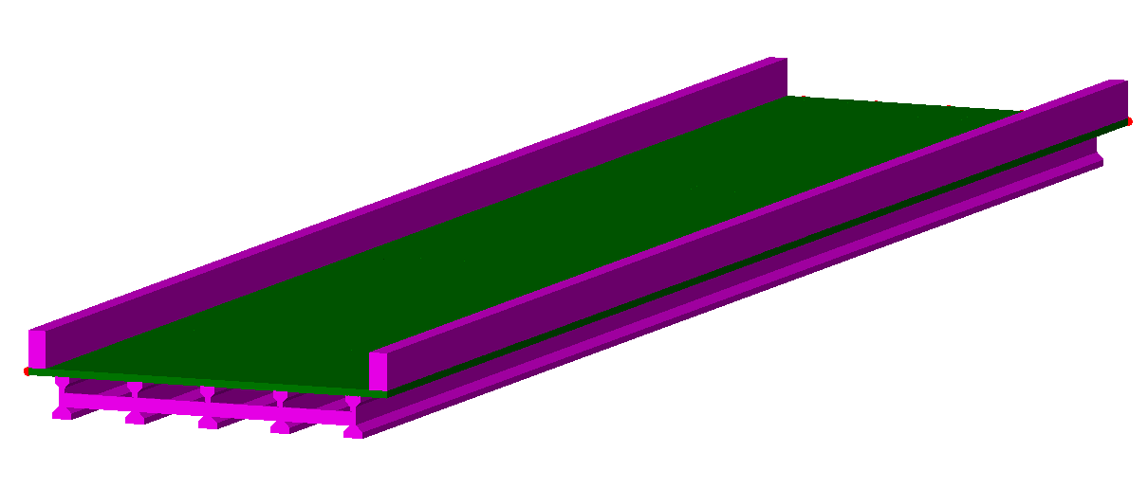

The first natural frequency is 3.99 Hz. Three paths were defined on this model for simulations. Their locations are at 4’, 10.5’ and 16.5’ from the exterior girder. The midspan displacements of the girder closest to each path due to a point load (twin point loads spaced 6’ apart, totaling 1 lb) on the path at midpsan are given below.

|  |  |  |  |  |  |
| --- | --- | --- | --- | --- | --- |
| 1 span | | | 2 span | | |
|  | in/lb | lb/in |  | in/lb | lb/in |
| Path 1, Girder 1 | -2.00994E-6 | 497527 | Path 1, Girder 2 | -1.49518E-6 | 668815 |
| Path 2, Girder 2 | -1.56329E-6 | 639676 | Path 2, Girder 3 | -1.21648E-6 | 822043 |
| Path 3, Girder 3 | -1.49866E-6 | 667262 | Path 3, Girder 3 | -1.19393E-6 | 837570 |

# 40 ft. Span

This set of bridges was based on a 2-span simply supported bridge located in Maryland with structure number: [70042010](http://bridgereports.com/1240510). The bridge features a 15 degree skew, (7) wide-flange (rolled) steel girders, channel diaphragms and concrete barriers. The deck is 8.5” thick and the barriers are 32” tall by 19” wide; there is no sidewalk. The skew of the models was increased to 16 degrees for ease of modeling.

The first natural frequency is 9.95 Hz. The simulations were performed with 10 global modes included. Path 1 was located over the first interior girder and path 2 was located 16’ (transversely) from the exterior girder. The midspan displacements of the girder closest to each path due to a point load (twin point loads spaced 6’ apart, totaling 1 lb) on the path at midspan are given below. It’s midspan displacement is also given below.

|  |  |  |  |  |  |  |
| --- | --- | --- | --- | --- | --- | --- |
| 1 span | | |  | 2 span | | |
|  | in/lb | lb/in | DL disp |  | in/lb | lb/in |
| Path 1, Girder 2 | -1.70148E-6 | 587723 |  | Path 1, Girder 2 | -1.38695E-6 | 721006 |
| Path 2, Girder 3 | -1.90733E-6 | 524293 |  | Path 2, Girder 3 | -1.51232E-6 | 661235 |

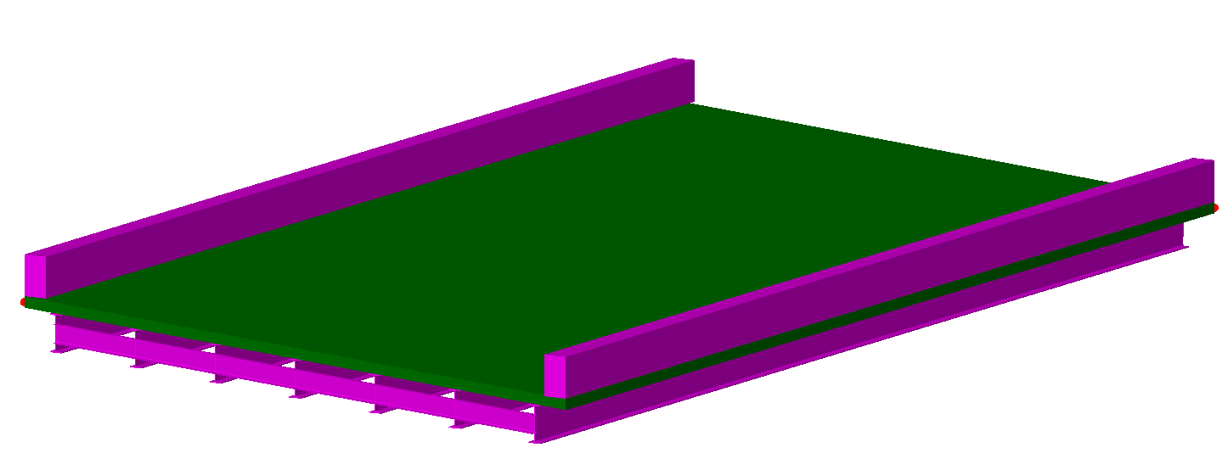

# Vehicle Models

For each model, a vehicle model was created with a natural frequency just slightly above the first natural frequency of the bridge. Vehicle models consisted of a single sprung mass with viscous damping (10%). The following table details the parameters for each vehicle model.

|  |  |  |  |  |
| --- | --- | --- | --- | --- |
|  | 40 ft span | 100 ft span | 140 ft span |  |
| Mass | 200.00 | 200.00 | 200.00 | slinch |
| Spring Stiffness | 8.7929E+05 | 1.6150E+05 | 4.9846E+04 | lb/in |
| Damping Coefficient | 2652.23 (10%) | 1136.67 (10%) | 631.48 (10%) | lb-s/in |
| Damped Natural Frequency | 10.5 | 4.5 | 2.5 | Hz |

A vehicle model was also created that was used in analyses across all models. This vehicle model was a single sprung mass with a natural frequency of 2.8 Hz. The parameters were as listed below.

|  |  |  |
| --- | --- | --- |
| Mass | 200 | Slinch |
| Spring Stiffness | 61902.2 | Lb/in |
| Damping Coefficient | 1407.43 (20%) | Lb-s/in |