# Description

This state-space model is developed from the equations of motion for a single sprung mass traveling over a 2-span continuous beam with distributed mass and stiffness. The beam is reduced to a single degree-of-freedom by assuming it deforms according to a shape function. A sinusoidal shape function was chosen to capture the excitement of the beam’s first mode of vibration (1st bending). The beam has a uniform stiffness parameter (EI), uniform mass distribution, and equal span lengths (L). Damping of the beam is not included. The vehicle is reduced to a single point mass (*m*t) with specified spring stiffness (kt), viscous damping coefficient (ct), and traveling at a specified velocity (*v*).

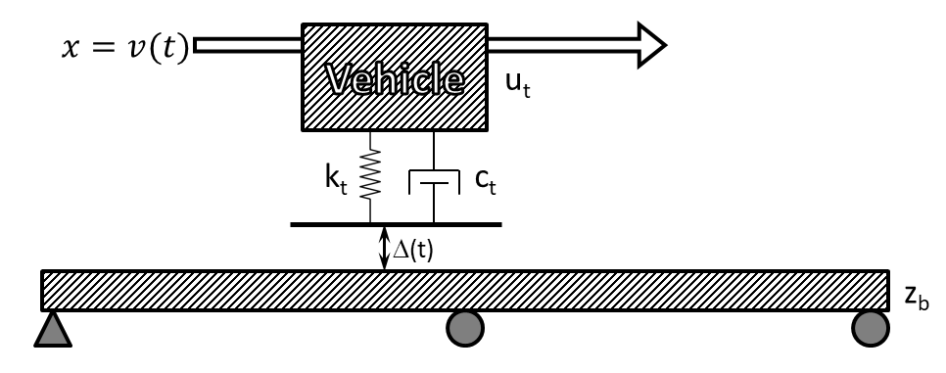

# Validation

To assess the ability of this model to estimate beam response to a moving sprung mass, a test case scenario was simulated with the state-space model as well as an FE model. The FE model was given the same properties (mass, E, I) as were used in the state-space model, and the sprung mass was assigned equivalent mass, damping and stiffness values. An artificial profile, constructed with ISO 8608 standards, was imposed on the models.



The above plot shows that the state-space model is limited to the assumed deformation shape and thus under-predicts displacement. However, as the plot below shows, the displacement amplification is accurately predicted with the state-space model and is conservative. The displacement amplification is computed as the dynamic response divided by the maximum static response.





To demonstrate the ability of the model to estimate the additional response due to excitation of the bridge mass, the following plot illustrates the bridge displacement minus the static response.



This model cannot exactly simulate a beam with a moving sprung mass; however, it seems that it can satisfactorily estimate the dynamic response of the beam. Further studies will show whether this model is capable of estimating dynamic amplification of a bridge.

# Correlation with full bridge FE model

The goal of this section is to establish scenarios for which the 2-span continuous state-space model is capable of accurately estimating bridge dynamic amplification.

The scenarios consist of several different bridges and several different profiles.

# Governing Equations

## Assumed deformation shape function

for

## Distributed mass and stiffness

## Distributed damping

## Force transformation

## Equations of motion for when vehicle is on bridge:

For

## State Definitions

; ; ;

## Input

;

## State Space Equations

;

## State Space matrices for vehicle off bridge: