I-76 Viaduct Vibration Investigation

Work Plan

In Cooperation with PennDOT Disctrict 6

Drexel University

A. Emin Aktan

Ivan Bartoli

Rutgers University

Franklin Moon

John DeVitis

John Braley

Contents

Overview 3

Test Specimen: I-76 Viaduct 3

Objectives and Deliverables 4

Constraints 5

Activities & Timeline 5

Preliminary Survey 5

Focused Survey 5

Instrumentation Plan 6

Preliminary Accelerometer Placement 6

Secondary Accelerometer Placement 6

Preliminary Analysis 7

Instrumentation Installation Methods 8

Accelerometers 8

Cables 8

DAQ 9

Breakdown 9

# Overview

## Test Specimen: I-76 Viaduct



**Description:** The viaduct was first constructed in 1952. The superstructure was replaced in 1986, while reusing the original piers and foundations. The structure runs along the banks of the Schuylkill River and carries the Schuylkill Expressway (I-76) with a total of four lanes of traffic. Bridge users have reported experiencing unusually high levels of vibration while on the structure.

**Network:** The bridge is located on a major highway and carries more than 57,000 vehicles a day with 4% truck traffic. The bridge spans an access road and a railroad (spans 9 & 10). Testing of this bridge will not require access in the vicinity of the railroad.

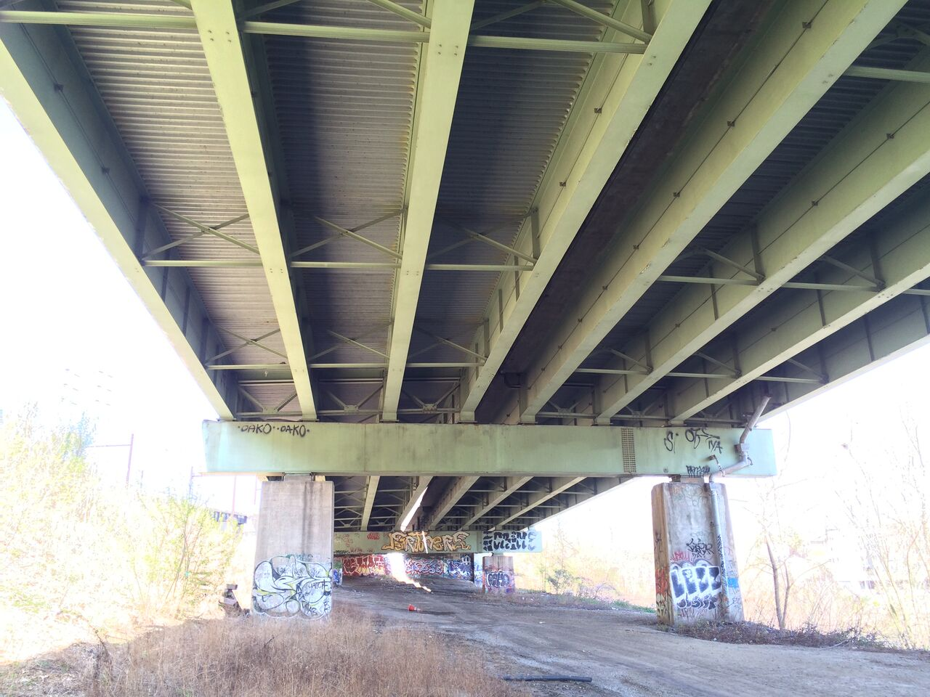**Superstructure:** The structural type is steel multi-girder. Eight girders run longitudinally, resting on steel box girders that span transversely and are supported by the concrete piers. A reinforced concrete composite deck was cast in place, with a “raked” finish and no overlay. There is no skew. The bridge has eleven spans. The maximum span length is 140’-0”. The out-to-out width is 76’-6”. Three spans are simply supported, while the remaining eight are two-span continuous. Each span has five interior rows of X-framed diaphragms and chevron diaphragms over the piers.

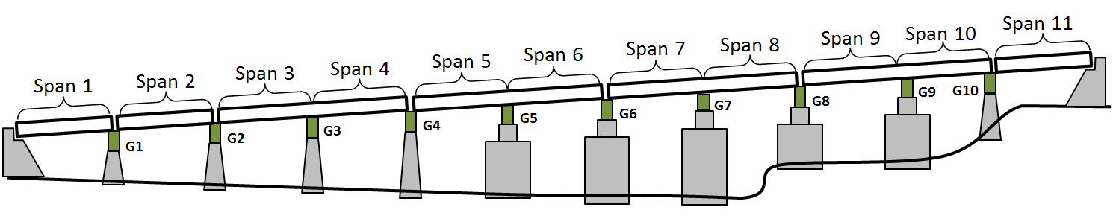

**Substructure and Bearings:** The concrete piers and abutments were constructed in 1952 and are all that remains of the original structure. They are supported by driven piles. Elastomeric bearing pads are installed on top of the piers and support the transverse box girders.

|  |  |
| --- | --- |
|  |  |

**Condition:** Visually, the deck appears to be in good condition, with no major cracking visible. Minor damage was observed in some regions of the center concrete barrier. The girders appeared in excellent condition. No major rusting was observed, and the girders appeared well maintained. The access hatches on many of the box girders had been left open. Any ill effects from this could not be immediately observed. The piers exhibited very little efflorescence and virtually no spalling. Repairs had been performed on several piers, where an embedded drainage pipe had rusted and cause a portion of concrete to spall off.

Table 1: NBI Structure Information

|  |  |
| --- | --- |
| NBI Structure Number | 000000000027280 |
| Year Reconstructed | 1986 |
| Owner | PennDOT |
| Skew | 0° |
| Deck Width | 76’-6” |
| Maximum Span Length | 140’-0” |
| ADT | 57410 (2013) |
| Deck Condition | 6 (Satisfactory Condition) |
| Superstructure Condition | 7 (Good Condition) |
| Substructure Condition | 5 (Fair Condition) |
| Sufficiency Rating | 70 |

## 

## Objectives and Deliverables

The main objective of this effort is to characterize the vibrational characteristics of the structure and determine if the bridge is experiencing larger than normal levels of vibration. The vibration survey will produce the following:

1. Identification of “liveliest” section
2. Acceleration time history
3. Identification of fundamental frequencies and mode shapes
4. Validated Finite Element Model of 2-span section

## Constraints

This bridge carries a major highway, and as such experiences high traffic volume. Because of this, topside access is extremely limited, and activities should be limited to the underside. The bridge spans open ground, with a clearance over 50 feet in places. Access will therefore only be possible through the use of an aerial lift.

## Activities & Timeline

A preliminary survey will be completed to determine which section of the viaduct experience the greatest vibration. The results of that survey will dictate which section of the viaduct will be extensively instrumented and monitored.

The preliminary survey will take place on July 6th, with July 7th as a contingency date. The focused survey will take place July 25th through the 29th. The following week (first week of August) will serve as contingency dates.

The general schedule of events is detailed in the timeline below.

|  |  |  |  |  |  |  |
| --- | --- | --- | --- | --- | --- | --- |
|  | Day 1 | Day 2 | Day 3 | Day 4 | Day 5 | Day 6 |
| **Preliminary Survey** |  |  |  |  |  |  |
| Glue Accels |  |  |  |  |  |  |
| Attach Accels on Girders |  |  |  |  |  |  |
| Run Cables |  |  |  |  |  |  |
| Record Data |  |  |  |  |  |  |
| **Focused Survey** |  |  |  |  |  |  |
| Attach Accels on Girders |  |  |  |  |  |  |
| Run Cables |  |  |  |  |  |  |
| Record Data |  |  |  |  |  |  |
| **Breakdown** |  |  |  |  |  |  |

### Preliminary Survey

Accelerometers will be placed on the transverse box girders as well as on the concrete piers. The installation and recording will be completed over the course of one day. Two days will be reserved for data processing and interpretation.

### Focused Survey

Accelerometers will be installed in various locations as detailed in the “Instrumentation Plan” section. Sensor installation will require a maximum of two days. Two days will be reserved for recording data. A single day will be required for breakdown.

# Instrumentation Plan

## Preliminary Accelerometer Placement

Accelerometers will be placed at several pier locations to determine if one section of the viaduct is livelier than others. At each location 4 accelerometers will be installed. One accelerometer will be installed at the top of each pier on the box girder, oriented longitudinally. Another accelerometer will be placed on the underside of the box girder, oriented vertically. A final accelerometer will be placed on the end of the box girder oriented transversely.

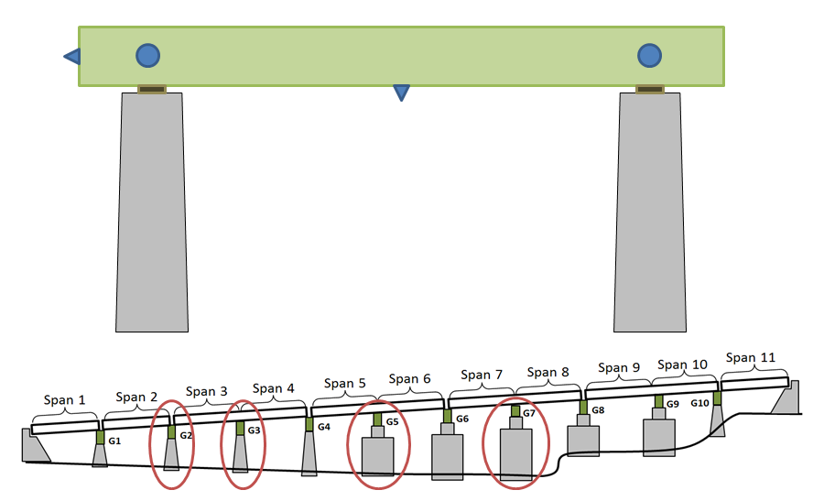

## Secondary Accelerometer Placement

A total of 32 accelerometers will be installed via magnets on the underside of the girders. They will be attached via magnets and oriented vertically. Cables will be run to the central box girder to minimize required cable length. The sensor layout illustrated below is subject to change pending the results of the preliminary survey.

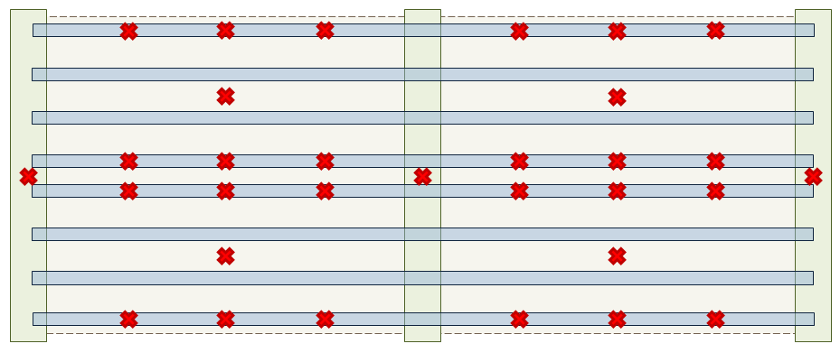

## Preliminary Analysis

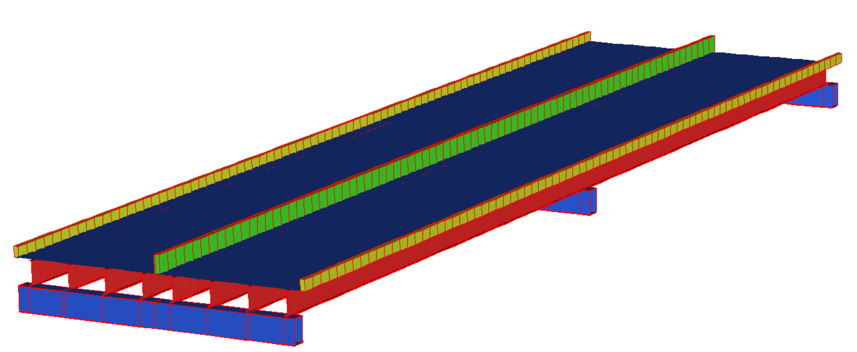

An *a-priori* finite element model was created, based on structural drawings. This model was analyzed using a natural frequency solver. The model exhibited several plausible modes of vibration below 10 Hz.

|  |  |
| --- | --- |
| Mode 1 | Mode 2 |
| Mode 4 | Mode 11 |

A list of the modes we expect to observe during the test is given in the table below.

|  |  |
| --- | --- |
| Mode 1 | 2.04 |
| Mode 2 | 2.31 |
| Mode 3 | 2.47 |
| Mode 4 | 2.68 |
| Mode 5 | 3.04 |
| Mode 6 | 3.13 |
| Mode 7 | 3.15 |
| Mode 11 | 5.12 |
| Mode 12 | 5.47 |

A modified CoMAC was performed for these analytical modes to help identify regions of the bridge that will experience the greatest response for the modes of interest. The modified CoMAC is displayed below.

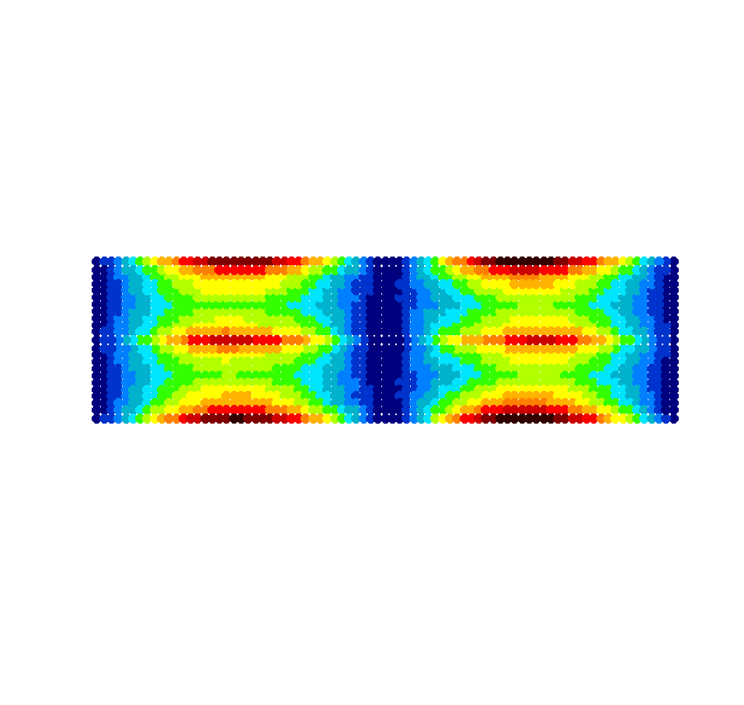

Sensor locations were decided based on the resulting CoMAC. Regions displayed in red and black are the regions that experienced the highest response, while dark blue regions experienced the least. Additional sensors were placed along the central box girder to capture its bending as suggested by mode 11.

# Instrumentation Installation Methods

## Accelerometers

The accelerometers are uni-axial, and have studs installed in their bases.

For the superstructure, this stud will be attached to a magnet. The magnet will be used for attaching the accelerometers to the underside and center of the bottom flange as well as to the metal pans beneath the deck in locations where the accelerometer is to be installed between girders.

If the pier is to be instrumented, the accelerometers will be glued to the concrete surface.

## Cables

Cables are to be routed along the girders on the top of the bottom flanges, periodically held in place with hand clamps. The following cable lengths will be required.

|  |  |  |  |
| --- | --- | --- | --- |
| Preliminary Survey | | Focused Survey | |
| Length (ft) | Quantity | Length (ft) | Quantity |
| 600’ | 4 | 150’ | 6 |
| 400’ | 8 | 120’ | 8 |
| 100’ | 4 | 100’ | 17 |

For cable lengths greater than 100 feet, additional cable will be connected to the already prepared 100 ft. coaxial cables via couplers. Excess cable length will be wrapped and hung near the DAQ from a girder.

## DAQ

A National Instruments Compact RIO (cRIO) acquisition system will be utilized for this test. The cRIO will be configured with NI9234 cards for sampling the piezoelectric accelerometers. They will be sampled at 200Hz. The DAQ will be powered by 12V, 10 amp-hour batteries. All data will be saved locally on a USB drive mounted on the cRIO. The system will be monitored via wifi to ensure the acquisition system is functioning properly.

# Breakdown

Accelerometers will be removed using the aerial lift. Because they are attached with magnets, they can easily and quickly be removed. Breakdown will take no longer than one day.