I-76 Case Study

**Notes on Structural Health Monitoring Efforts**

**October 5, 2017**

**Franklin L. Moon**

**John Braley**

**Department of Civil & Environmental Engineering**

**School of Engineering**

**Rutgers, The State University of New Jersey**

Table of Contents

Chapter 1 State of the Structure 4

Objective 4

Structure Introduction 4

Description 4

Network 4

Superstructure 5

Substructure and Bearings 5

Condition 6

Chapter 2 Vibration Survey 7

Phase 1 Testing 7

Phase 2 Testing 8

Test Results and Conclusions 10

Time History Observations 10

Frequency Content and Mode Shape Extraction 13

Summary 14

Chapter 3 Vehicle-Bridge Testing 15

Test Objectives and Methodology 15

Test Plan 15

Bridge Instrumentation 16

Truck Instrumentation 17

Test Execution 17

Test Results and Conclusions 18

Truck Characterization 18

Truck-Bridge Characterization 20

Summary 21

Chapter 4 StID through FE Modelling 23

Bridge to Model 23

Model Forms 23

Model Calibration 23

Understanding Transmissibility 23

Simulating Test Results/Observations 25

Model Evolution 25

Bridge Profile 25

Leveraging Model 25

Stress Levels 25

Dynamic Amplification 25

Parametric Studies 25

Extrapolation of Observations to Bridge Population 25

# Chapter 1 State of the Structure

## Objective

The Pennsylvania Department of Transportation (PennDOT) owns and operates a bridge along the Schuylkill Expressway in Philadelphia that routinely receives complaints about excessive vibration levels. The goal of this effort was to help PennDOT understand the extent of the problem and then develop effective mitigation strategies, if needed. Specifically, the following three objectives were identified to guide this study:

1. Quantify the level of vibration displayed by the I-76 viaduct under normal operating conditions and compare with established criteria
2. If the vibration levels are deemed unacceptable based on the results of (1), identify the mechanisms that give rise to the large vibration levels
3. Identify and evaluate a series of interventions to reduce the level of vibration

## Structure Introduction



Photo of bridge elevation

### Description

The viaduct was first constructed in 1952. The superstructure was replaced in 1986, while reusing the original piers and foundations. The structure runs along the banks of the Schuylkill River and carries the Schuylkill Expressway (I-76) with a total of four lanes of traffic.

### Network

The bridge is located between mile 338 and 339 of Interstate 76 (Schuylkill Expressway) and carries more than 57,000 vehicles a day with 4% truck traffic. The bridge spans an access road and a railroad (spans 9 & 10). Testing of this bridge will not require access in the vicinity of the railroad.

### Superstructure

The structural type is steel multi-girder. Eight girders run longitudinally, resting on steel box girders that span transversely and are supported by the concrete piers. A reinforced concrete composite deck was cast in place, with a “raked” finish and no overlay. There is no skew. The bridge has eleven spans. The maximum span length is 140’-0”. The out-to-out width is 76’-6”. Three spans are simply supported, while the remaining eight are two-span continuous. Each span has five interior rows of X-framed diaphragms and chevron diaphragms over the piers.

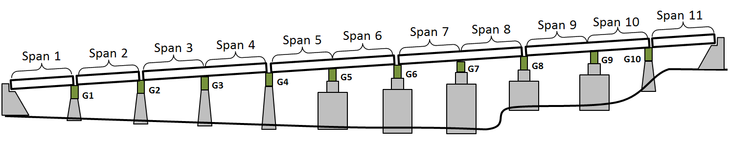

Diagram of Bridge System

### Substructure and Bearings

The concrete piers and abutments were constructed in 1952 and are all that remains of the original structure. They are supported by driven piles. Elastomeric bearing pads are installed on top of the piers and support the transverse box girders. Rocker bearings or pedestals are installed between the box girders and longitudinal girders at those locations which are in the center of continuous spans. Elastomeric bearings are installed between the box girder and the longitudinal girders at the remaining locations.

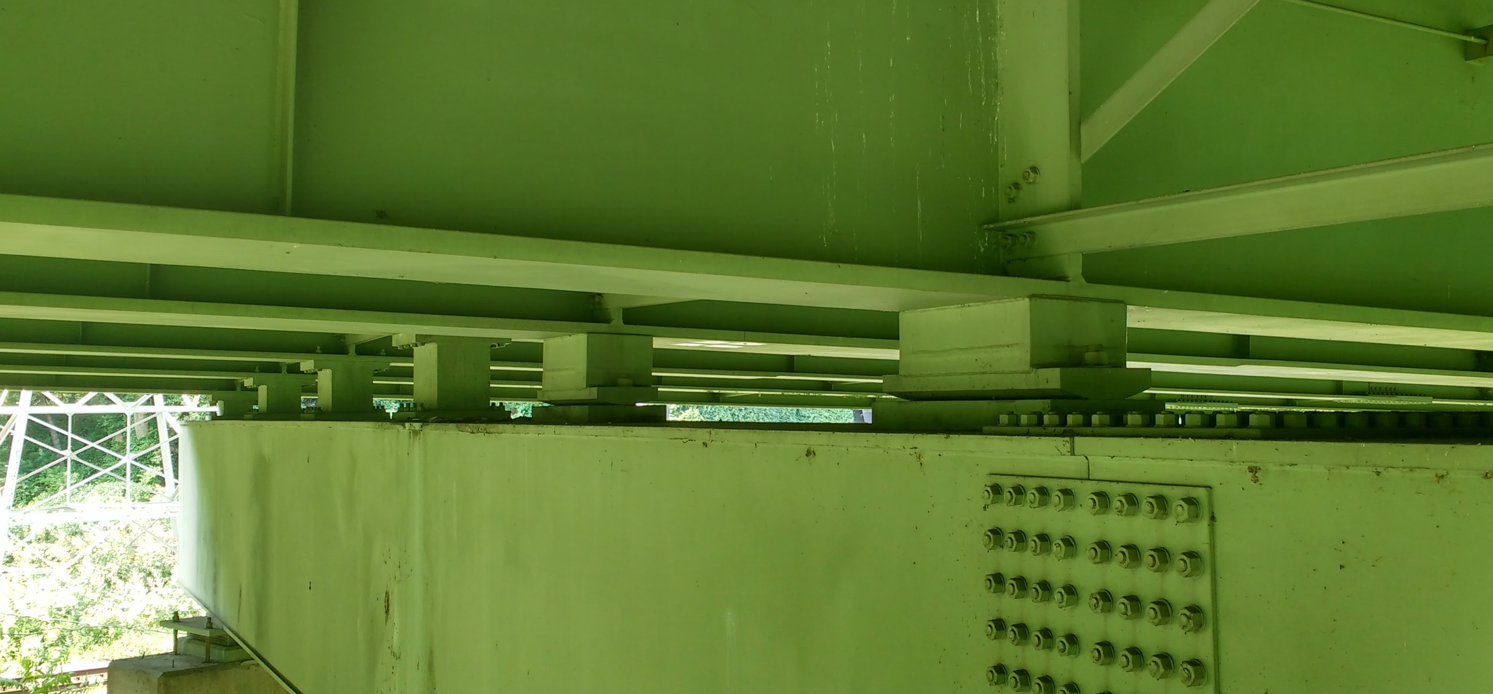

Bearings under Continuous Spans

### Condition

Visually, the deck appears to be in good condition, with no major cracking visible. Minor damage was observed in some regions of the center concrete barrier. The girders appeared in excellent condition. No major rusting was observed, and the girders appeared well maintained.

# Chapter 2 Vibration Survey

To satisfy Objectives 1 a two-phased monitoring program was designed and carried out. The first phase employed a sparse instrumentation plan to examine the variability of vibration levels across the various spans. The second phase employed a much denser instrumentation plan to fully characterize the vibration levels, modal frequencies, and mode shapes of a few spans that were selected based on the results of Phase 1.

## Phase 1 Testing

This first test took place on July 6th and 7th of 2016. The cross girders at piers 2, 3, 5 and 7 were instrumented with accelerometers.



The first test showed that similar levels of vibration were occurring at each location tested. A root-mean-square average of the acceleration data was computed to compare vibration magnitudes at the various locations.

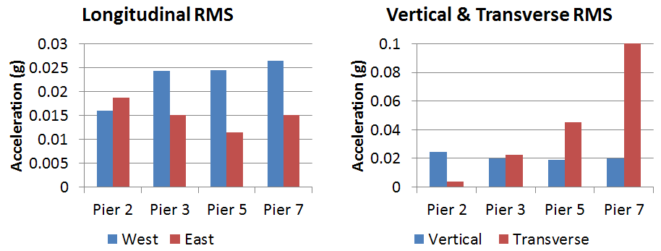

Pier 7 experienced the greatest transverse acceleration, the greatest longitudinal acceleration (on the west side), and similar levels as the other piers for vertical and east longitudinal acceleration. These observations led us to select spans 7 and 8, which straddle pier 7, as subjects of a more in depth investigation.

## Phase 2 Testing

Instrumentation of spans 7 and 8 was performed on July 26th and 27th of 2016. Data was recorded on July 27th and 28th. Sensors were removed on July 29th.

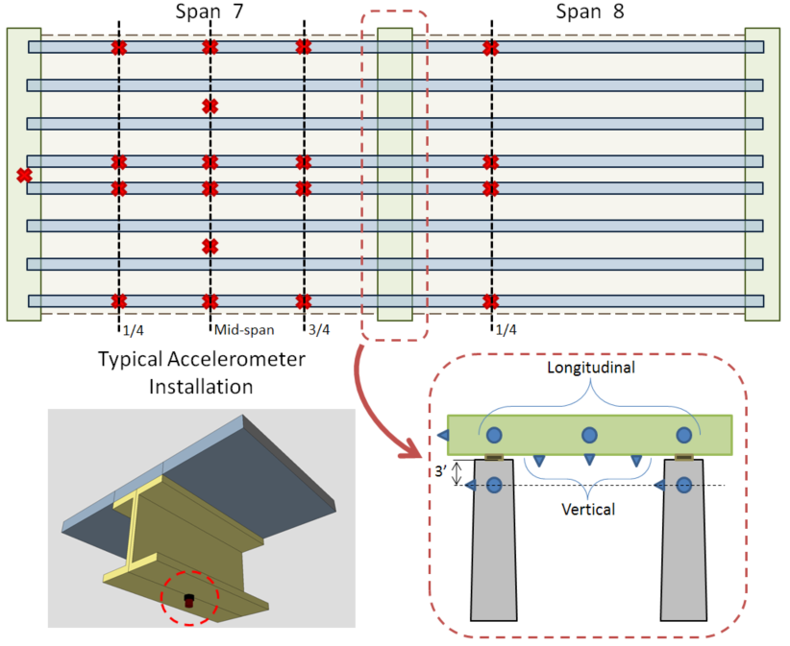

* 30 accelerometers
* Sampled at 200 Hz over a period of 2 days, recording a total of 14 hours of data
* Sensor layout chosen to capture maximum acceleration and provide spatial resolution for mode shape extraction

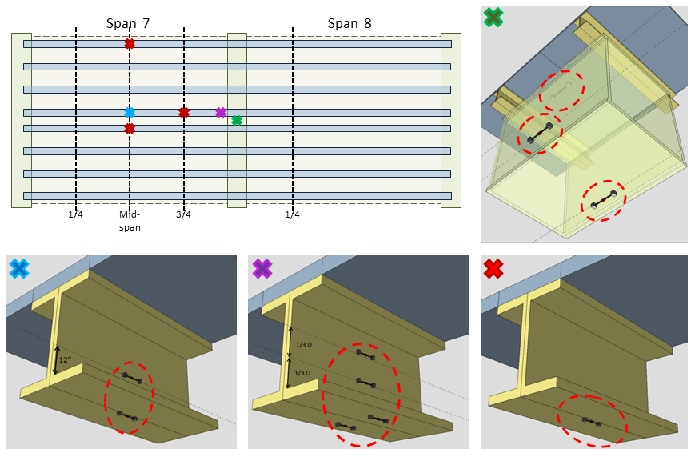

* 12 - 6” vibrating wire accelerometers installed with epoxy
* Surface prep: paint sanded off
* Sampled at 50Hz for 12 hours; at 20Hz for additional 8 hours over night
* Sensor locations chosen to capture maximum girder strain in positive moment region and negative moment region
* Locations on box girder to fully characterize the strain distribution in the cross section

## Test Results and Conclusions

### Time History Observations

* Acceleration in piers is negligible compared to that of the superstructure (no figure)

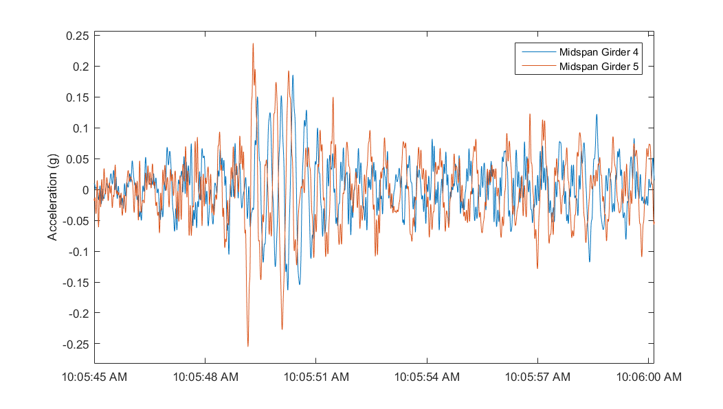

* Filtered acceleration of girders (midspan-vertical) is consistently 10% g with peaks as high as 25%g
* Filter: 6th order lowpass elliptic filter with 0.5 dB of passband ripple and 40 dB of stopband attenuation and a passband edge frequency of 20 Hz.

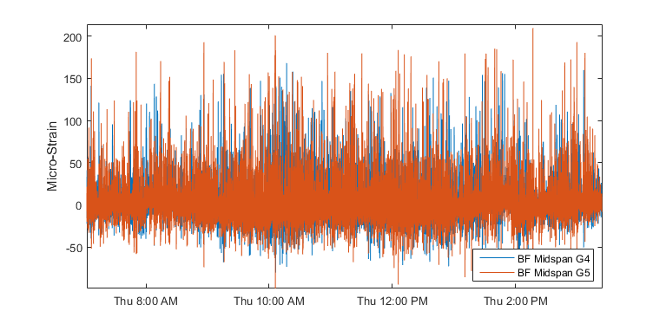

* Bottom flange strain frequently exceeds 100 microstrain with occasional spikes above 200 microstrain

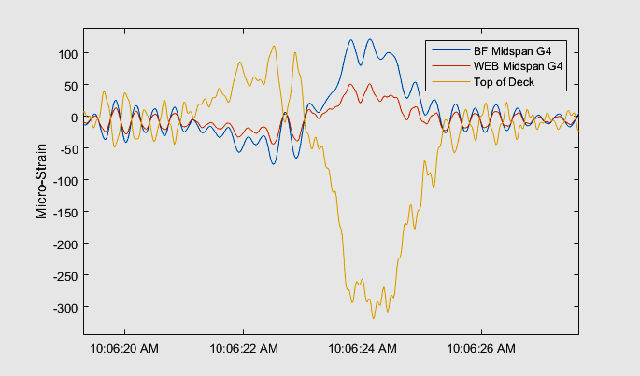

* Extrapolated stress/strain in concrete deck at levels for which long term fatigue cracks begin to form

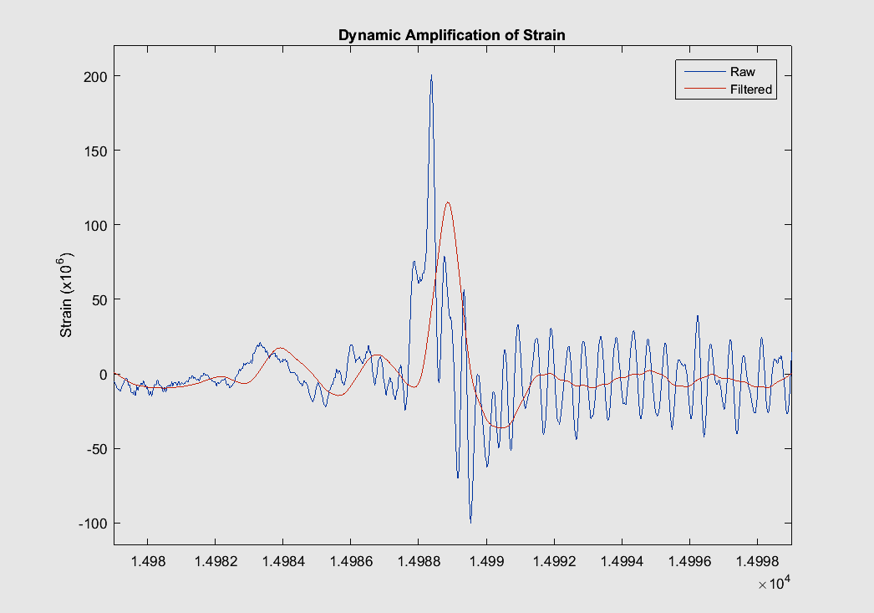

* Strain data filtered (removed >1.5Hz) to approximate dynamic amplification: ~75%

### Frequency Content and Mode Shape Extraction

| Torsion Mode with Spans Out of Phase | Torsion Mode with Spans in Phase |
| --- | --- |
|  |  |

* Many apparent repeated mode shapes due to geometry (2 bridges side by side)
* 1st mode at 2 Hz
* At least 9 modes (all of which are 1st bending/torsion) between 2 and 4 Hz
* The displacement associated with acceleration of 0.25 g at 2 Hz = 0.6 in

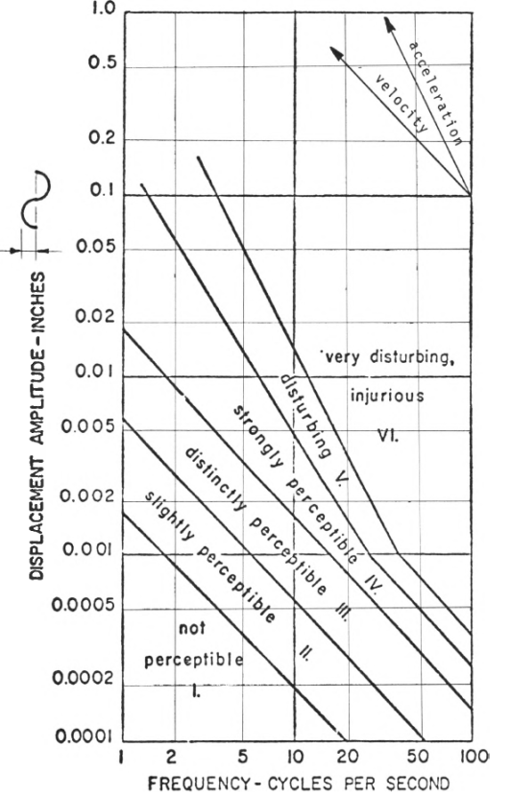

* The nature of the vibration occurring is rated as disturbing to very disturbing by human comfort standards

### Summary

* Large magnitude acceleration is occurring at frequencies that is resulting in vibration that is disturbing to bridge users
* The vibration is causing large amplification (>>33%) in bridge response
* The amplification is reflected in girder bottom flange strain, as well as in the extrapolated top of deck strain, which is at the upper limit for concrete durability
* The operational level of strain recorded is higher than commonly seen on highway bridges
* Mode shapes and frequencies were obtained that may be used in FE model calibration.

# Chapter 3 Vehicle-Bridge Testing

## Test Objectives and Methodology

While the previous tests provided evidence of the levels and character of vibration experienced by the bridge, we wished to gain further understanding of the bridge response with known input (i.e. vehicle loading). By capturing both the input and the response we would not only gain a more complete understanding of the system, but also have better information for simulation efforts. The following objectives were established to guide the test:

1. Record bridge response due to a known input (test vehicle)
2. Investigate bridge-vehicle interaction
3. Identify scenarios that result in the largest amplifications

To accomplish these objectives we would need to address the following challenges:

1. Characterize vehicle (mass and suspension)
2. Record bridge and vehicle response simultaneously and synchronously
3. Record vehicle location on the structure
4. Record traffic patterns during testing

## Test Plan

This test consisted of instrumenting the bridge at several locations with accelerometers. In addition, a dump truck, filled with crushed rock, was instrumented with accelerometers.

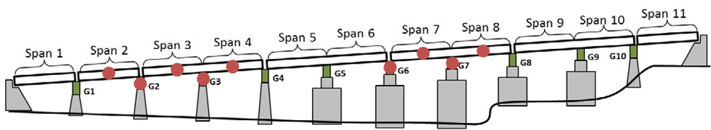

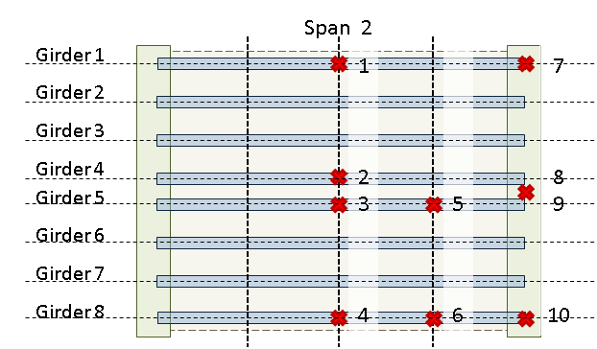

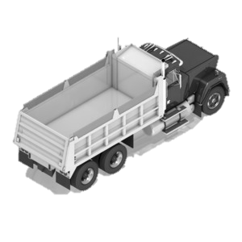

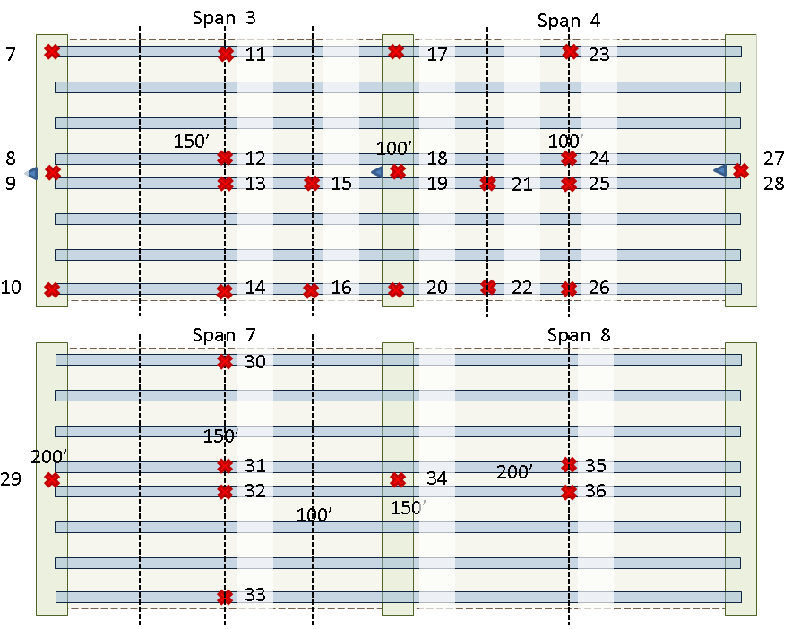

### Bridge Instrumentation

* 36 accelerometers located to capture primary modes of vibration and peak response for spans 2, 3, 4, 7 and 8.
* 2 strain gauges placed on the bottom flange at midspan of span 3 on girders 4 and 5 (to be sampled at 20Hz).
* Accelerometers sampled by NI cRIO at 1652 Hz. GPS time also recorded for synchronization between DAQs.

### Truck Instrumentation

A tandem dump truck (3 axles) filled with crushed rock was provided by PennDOT. Truck scales were used to measure the weight of the truck (at each wheel). The truck was outfitted as follows:

* 4 accelerometers oriented vertically at the 4 corners of the truck bed to characterize load movement.
* 1 accelerometer oriented longitudinally to record acceleration of truck travel
* 1 accelerometer held by truck passenger for “tap-to-mark” meta data recording
* Accelerometers sampled by NI cRIO at 1652 Hz. GPS time recorded to synchronize with bridge DAQs

## Test Execution

Sensors were installed on the bridge on June 26th and 27th of 2017. On June 28th the test truck was acquired, weighed and instrumented. The testing took place between 10 am and 3 pm of June 28th.

Bridge data was acquired continuously for the duration of the test. A passenger in the test truck operated the DAQ and recorded data for every pass over the bridge, beginning each record well before entering the bridge, and ending it only after exiting the bridge. By tapping the hand held accelerometer upon entering the bridge and again upon exiting, the passenger introduced “spikes” in the data record that would provide convenient markers for later processing efforts.

* 14 passes were made by the test truck over the bridge
* Truck velocity ranged from 10 mph to 60 mph
* Both sides of the bridge and all 4 lanes were traversed
* Passes were made in various traffic conditions (light traffic, medium traffic, heavy traffic)
* Passes were made between 10:20 am and 12:20 pm
* Video was recorded at 3 locations: the ends of the bridge and above span 2 facing spans 3 & 4
* Additional data was recorded of the operational response on the afternoon of June 28th and the early morning of June 29th

All sensors were removed from the bridge on Thursday June 29th.

## Test Results and Conclusions

### Truck Characterization

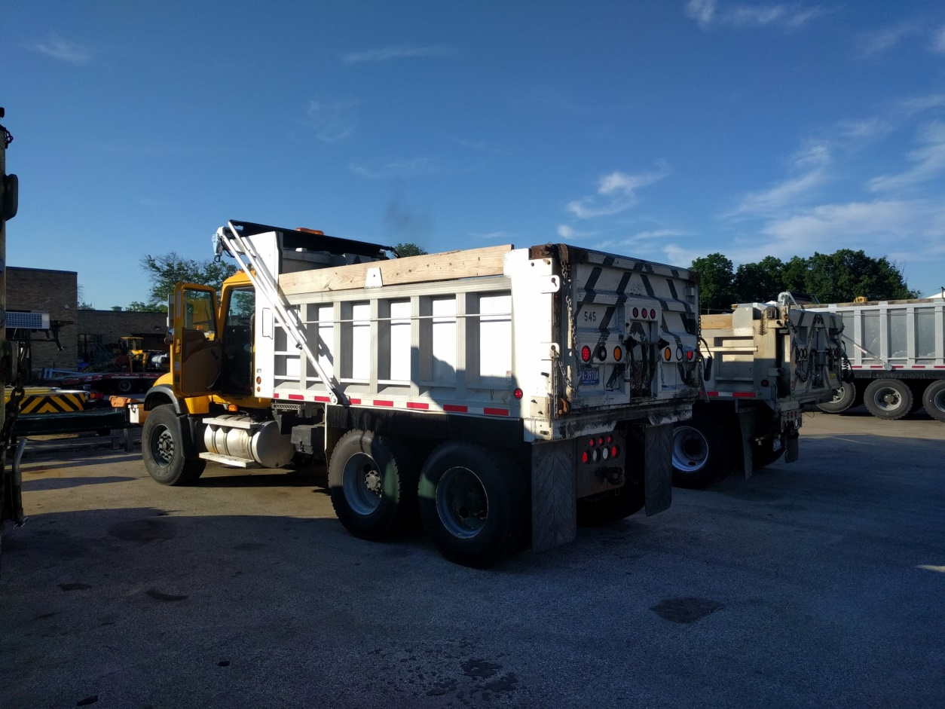

Table : Truck Weight at Wheels (lb)

|  |  |  |  |
| --- | --- | --- | --- |
| Driver Front | 6500 | Passenger Front | 6960 |
| Driver Middle | 12180 | Passenger Middle | 11680 |
| Driver Back | 12080 | Passenger Back | 12000 |
| **Total** | **61400** |  |  |

The acceleration of the truck was recorded while it was *en route* to the bridge. This data was processed to avoid bridge modes of vibration contaminating the truck vibration. The power spectral density of the truck acceleration was computed. The location of peaks in the plot represent the frequencies at which the truck most often vibrates (i.e. natural mode of vibration).

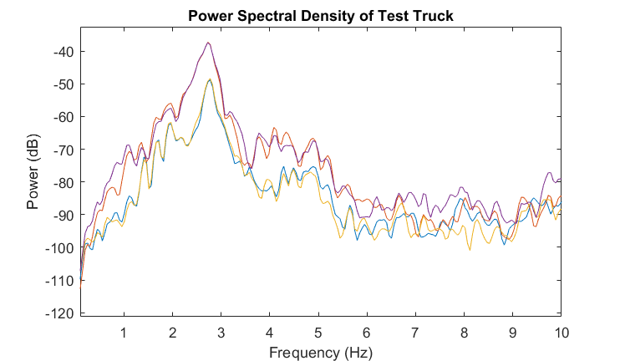

* The first mode is all degrees of freedom bouncing up and down together (in phase) and is centered near 3 Hz
* Because of the high degree of non-linearity inherent to the truck suspension, the peak is very broad with a lot of vibration between 1.5 and 3.5 Hz

Wavelet analysis was performed to evaluate how the spectral density differed on and off the bridge.

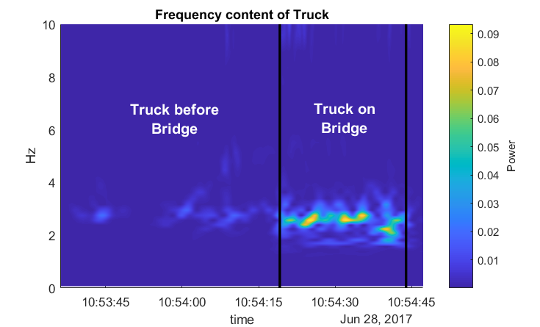

* The magnitude of vertical acceleration greatly increases as soon as the truck enters the bridge
* The first mode between 2 and 3 Hz is excited when traversing the bridge
* Acceleration magnitude quickly drops after exiting the bridge

### Truck-Bridge Characterization

Examining first the truck acceleration at different speeds but in the same lane reveals that the truck experiences much higher vibration magnitudes at higher speeds (>30 mph).

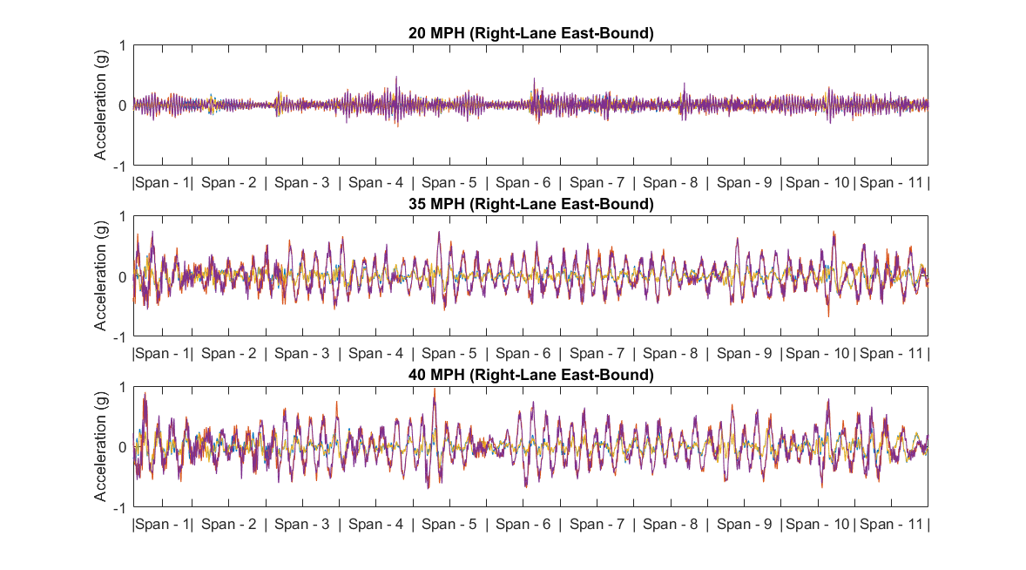

By plotting the bridge acceleration alongside the truck acceleration we can see the interaction. For the plots below, the x-axis represents the same time line in both plots.

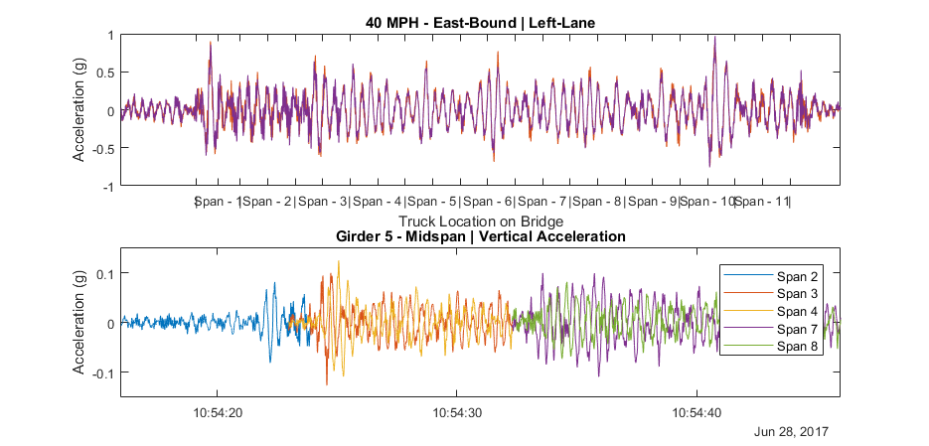

* Truck acceleration increases upon entering the bridge
* Certain locations along the bridge cause a jump in truck acceleration
* The bridge is excited by test truck, each span quickly transitioning to high vibration once truck enters the span.
* The truck experiences nearly 10x the magnitude of acceleration as that experienced by the bridge

### Summary

* The bridge is excited by the test vehicle
* The test vehicle experiences much higher vibration when on the bridge
* The test vehicle experiences higher vibration at higher speeds

Resulting hypotheses:

1. The profile of the bridge is such that it causes large vibrations in the test vehicle, especially at higher speeds, consequently increasing the loads felt by the structure.
2. The natural modes of vibration of the bridge are very similar to that of the test vehicle (and traffic), thus vehicle is able to drive the structures modes.
3. The non-linearity and damping of the test vehicle (and traffic) allow the vibration of the bridge to tune the vehicle response to match the bridge.
4. The low frequency modes of the structure, its low damping, and the proximity of mode frequencies to those of traffic, create a scenario in which the bridge vibration is easily induced and resonates for a long period of time, thus making it easier for the next event to cause high vibrations

# Chapter 4 StID through FE Modelling

## Bridge to Model

### Model Forms

### Model Calibration

## Understanding Transmissibility

This bridge was introduced to us because motorists had been complaining about the vibration levels they felt while in their vehicle. Driving over the bridge myself, I could only perceive the vibration of the bridge when sitting still in traffic. However, this begs the question: why would the bridge still be vibrating at perceptible levels when the traffic is not moving? How can vibrations caused by free-flowing traffic in the opposing lanes be transmitted to the congested side when the two sides are only connected by a box girder at the supports?

A model of a two span continuous portion of the bridge was used to investigate the transmissibility of vibration from one side of the bridge to the other. A series of moving vehicle loads were applied to one side of the model. The acceleration of girders at midspan on both sides of the model was solved for.

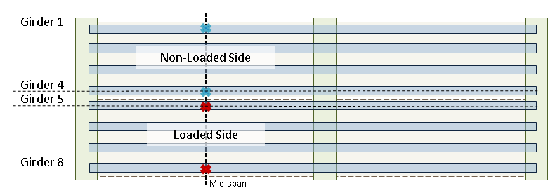

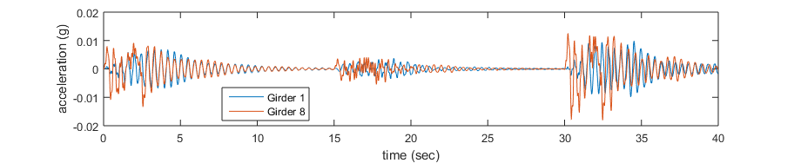

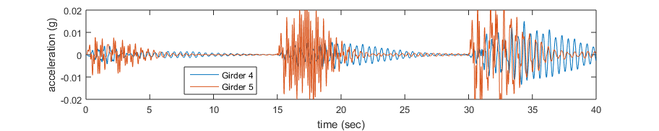

* Vehicle loading pattern: 1 truck right lane, 1 truck left lane, 2 trucks side-by-side
* Blue lines correspond to acceleration on unloaded side
* Vibrations on the unloaded side can be 75% of loaded side
* Vibration transmitted through cross girder

An FFT of the simulated acceleration data on the unloaded data, displayed above, was performed.

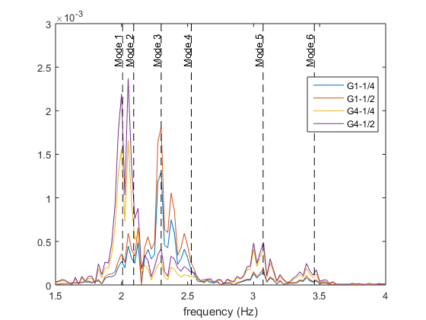

The modes of vibration that require deformation of the cross girder are those which are evident in the FFT, and thus the modes that are best able to be transmitted by the cross girder.

|  |  |
| --- | --- |
| Mode 1 | Mode 2 |
| Mode 3 | Mode 4 |

Motorists sitting in traffic on one side of the bridge are feeling vibrations because the vibrations occurring on the other side, induced by free-flowing traffic, are being transmitted by the cross girder.

## Simulating Test Results/Observations

### Model Evolution

### Bridge Profile

## Leveraging Model

### Stress Levels

### Dynamic Amplification

### Parametric Studies

## Extrapolation of Observations to Bridge Population