*TOPR No. HRDI30180034PR Task Order # 9*

*Technical Support Services Contract (TSSC) for the Long-Term Infrastructure Performance (LTIP) Team*

*Contract No. DTFH6117D00001*

# **Subtask 2 – Finalize the Experimental Plan - Instrumentation**

# **Draft Summary of Developed Fixed Instrumentation Plan for the Accelerated Testing of First Specimen at BEAST Facility**

Saeed Babanajad, John Braley, Franklin Moon

06 February 2019

*This draft summary of fixed instrumentation plan was developed as required by Subtask 2, Task Order 9 issued by the LTIP, FHWA under the Contract # DTFH6117D00001.*

## Introduction

The purpose of this subtask is to document the finalized fixed instrumentation plan that was discussed and approved by FHWA (Dr. H Azari) during the monthly conference call on December 05, 2018. The finalized plan details the continuous data collection activities for both Phase 1 and 2 testing. The document would be distributed along the FHWA technical offices for any potential review and suggestions. Given most of the system is already purchased and programmed, it might not be possible to implement major modifications to the finalized plan. Upon any requested modification, Rutgers will work closely with FHWA to potentially implement those changes. The subsequent sections of this report provide a description of the fixed instrumentation plan.

## Summary of the Proposed Fixed Instrumentation Plan

Given that accelerated testing will take place over the course of months, “continuous” data collection is defined as acquisition of data on a regular hourly or daily (or multiple times a week) basis. The following types of data are expected to be captured over the duration of this study:

1. Load measurement captured from the support reaction of each supporting steel girder;

2. Continuous measurements from strain gages, etc.

3. Continuous collection of digital images and or video;

4. Local displacements and stiffness of the deck systems;

5. Global displacements and stiffness of the superstructure;

6. Reinforcing bars strains within the bridge deck;

7. Sectional curvatures at critical sections; and

8. Continuous collection of environmental characteristics, inclusive of temperature and humidity.

In the following subsections, the details of instrumentation layout, type of sensors, measurement configuration, data collection and management will be thoroughly discussed:

***Instrumentation Layout***

To fully cover the data collection from the entire specimen, the proposed plan will have a series of separate instrumentations for deck (surface and embedded), steel girders, as well as the additional instrumentations for joints, pedestal, and reaction supports.

Figure 1 demonstrates the schematic of the deck specimen along its longitudinal and transversal cross sections. The girder and wheel (truck tires) layouts are indicated with dashed and grey lines, respectively. The longitudinal and transversal deck rebar layouts are also shown with black dots in their opposite cross sections. Given to the symmetry of specimen, only two quarters of the specimen on the right side of the specimen will be instrumented. To provide more clarity in tracking Fig. 1’s details, Fig. 2 maps a general layout of BEAST facility in terms of the specimen layout, beam locations, geometry, and adjacent facilities. Since slightly different instrumentations are considered for sections over girders, between girders (removable framework), and between girders (stay-in-place (SIP) formwork), Figs. 3 through 5 provide more detailed and accurate configurations for each individual cross section.

***I put the sensors on the Exp side. Is that fine?***

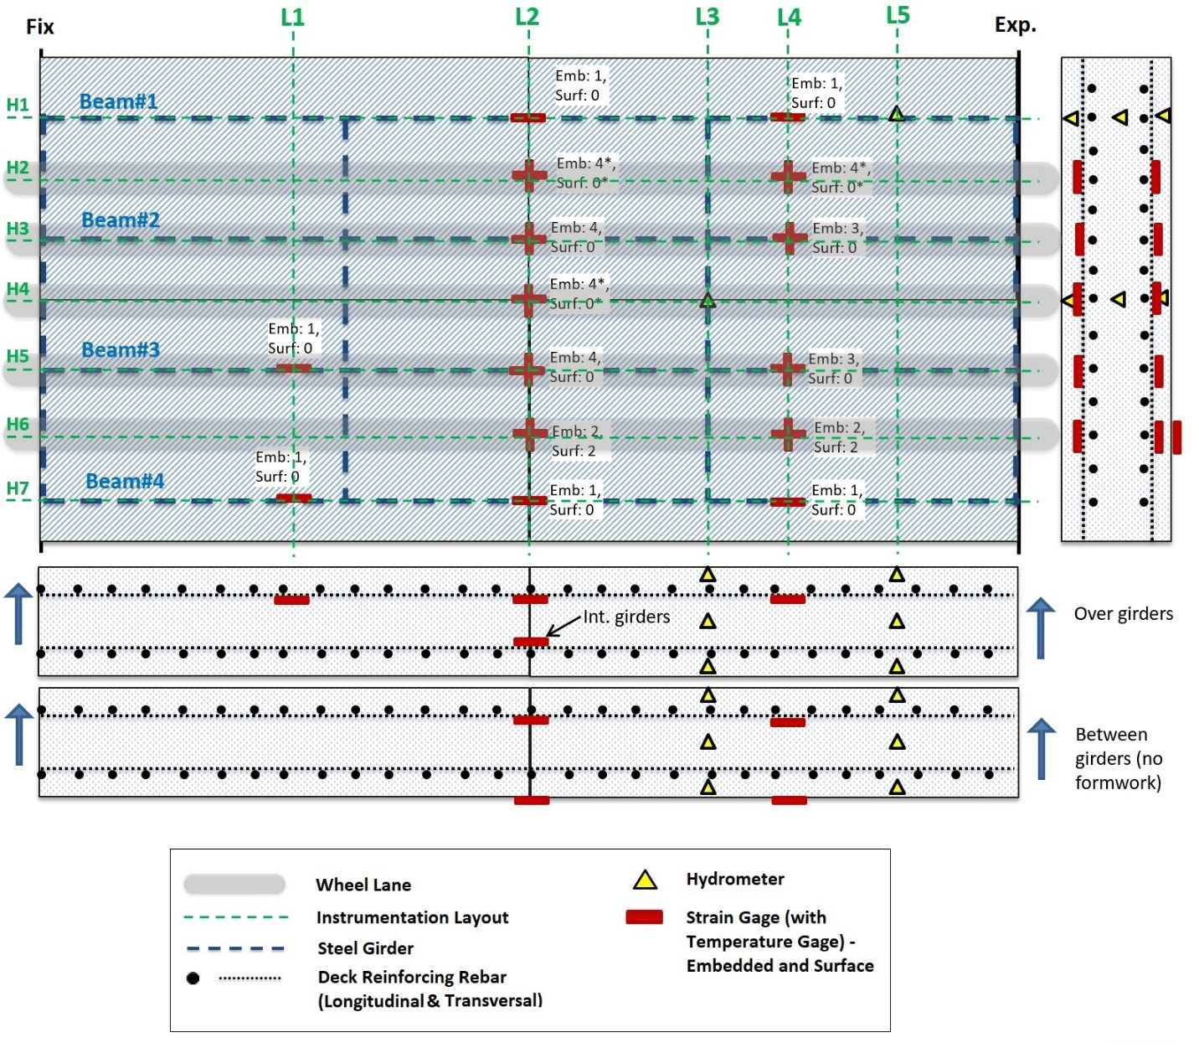

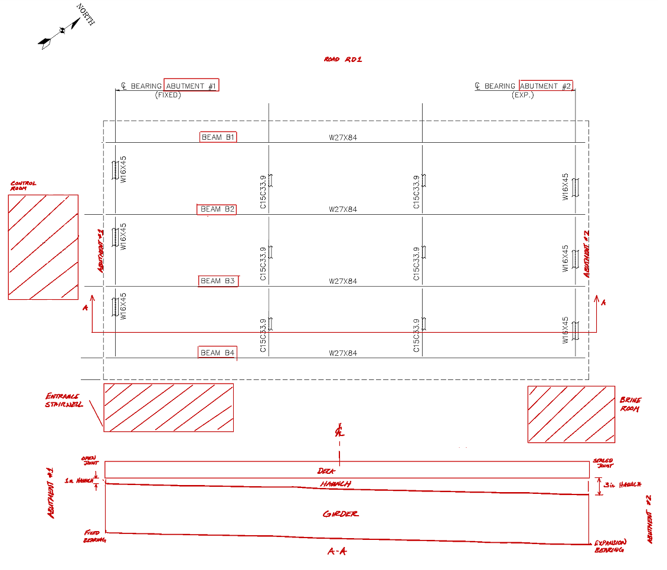

In particular, four different sets of data will be collected from the deck specimen. First, the longitudinal strain will be collected from embedded reinforcing bars within the bridge deck. To do so, a #2 sister rebar (36 inch) articulated with a strain gage (2 inch vibrating wire) will be tighten to the actual reinforcing bar (#5) in order to measure the strain of the reinforcing bar at the designated locations. By connecting this sister rebar to the reinforcing bar in both longitudinal and transversal directions (at both top and bottom of deck depth), valuable structural information regarding the mechanism of embedded strain transfer along the deck specimen as well as the load distribution among the girders will be captured. A total of 36 sensors is outlined for installation. Second, the surface mounted strain will be collected by regular long-gage strain gages (6 inch vibrating wire) mounted at the bottom of deck surface, especially when removable formwork is employed. At the presence of SIP formwork between girders B1 and B2, no surface strain gage would be mounted to the deck’s bottom surface. A total of 4 sensors is outlined for installation. Third, the temperature will be collected through the deck specimen for a) navigating the temperature variation during the testing, and b) temperature compensation of strain gages in order to measure the pure strain induced by external wheel loading. Tracking the temperature variation in the deck is very important during the deck curing (fresh concrete) as well as the freeze-thaw cycles. A total of 40 sensors is outlined for installation. In fact, each of the applied strain gages (both embedded and surface) is additionally instrumented by a temperature sensor, therefore, no separate temperature sensors will be installed. Fourth, the humidity and moisture content will be collected by the hydrometers embedded in the deck. Measuring the level of moisture content is important in assessing the potential corrosion progression inside the concrete, specifically at the rebar locations. Since the measurement of humidity inside the concrete deck is very sensitive, two types of wired and wireless humidity sensors will be employed. A total of 10 sensors is outlined for installation.

**H1** - *L2, L4, & L5* (2 strain gages + 3 hydrometers)

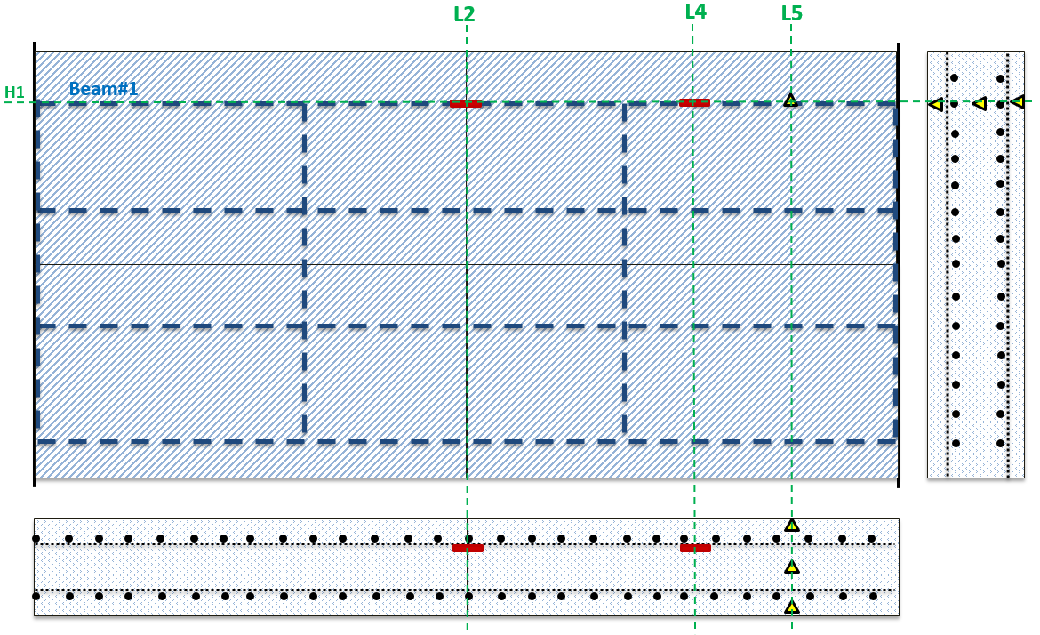

**H2** - *L2 & L4* (8 strain gages)

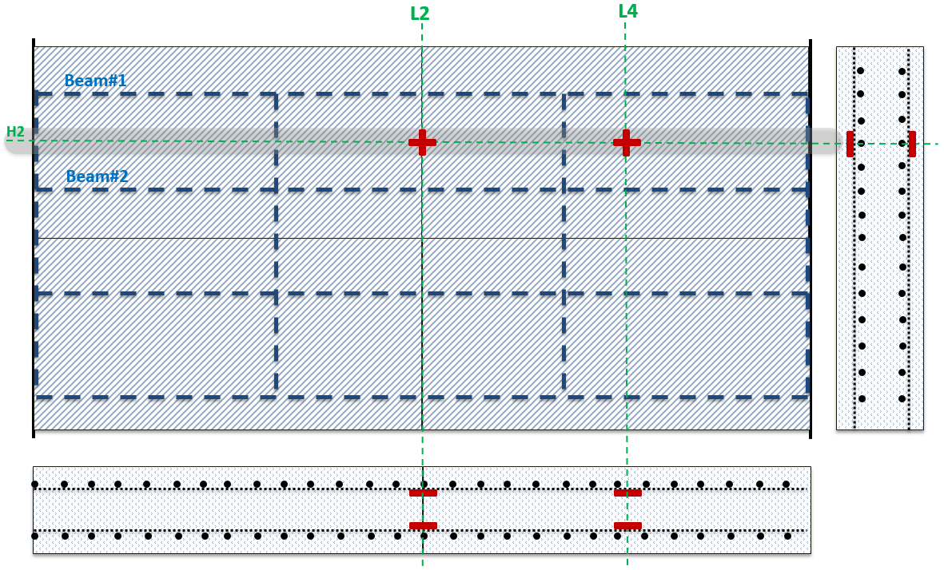

**H3** - *L2 & L4* (2 strain gages + 3 hydrometers)

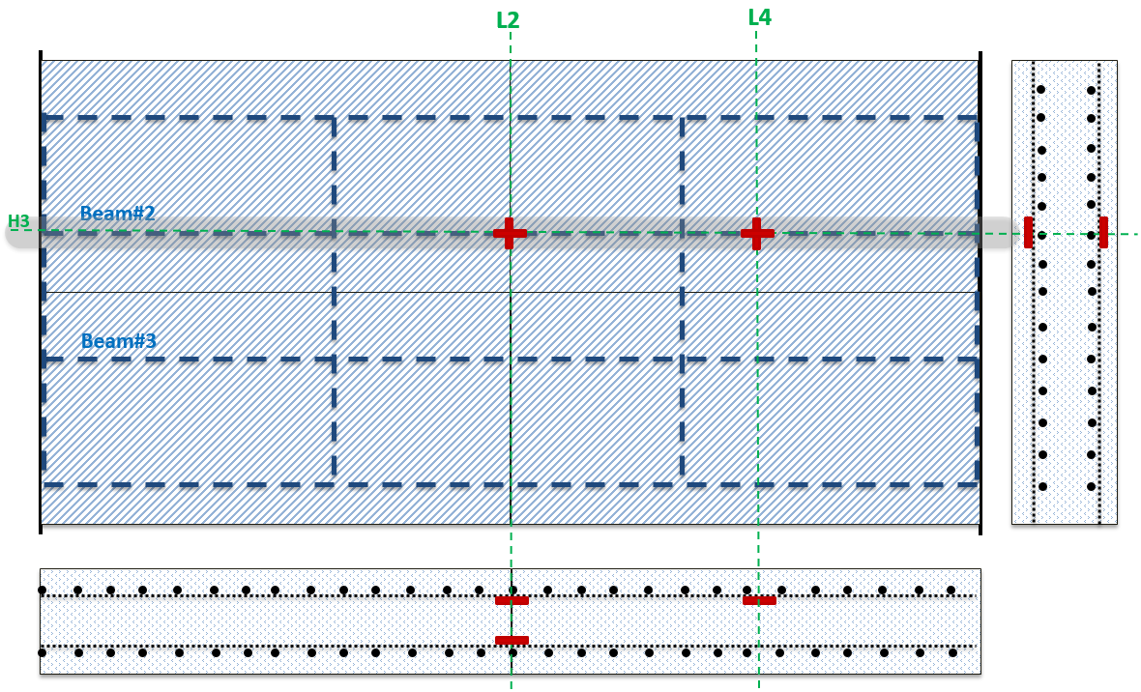

**H4** - *L2 & L3* (4 strain gages + 3 hydrometers)

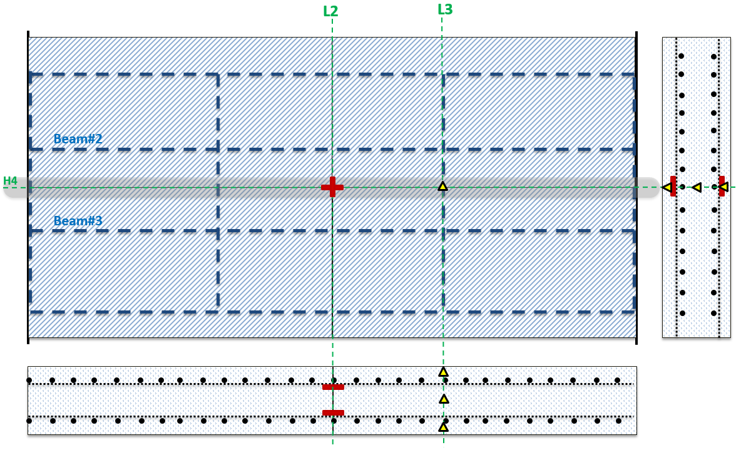

**H5** - *L1, L2, & L4* (2 strain gages + 3 hydrometers)

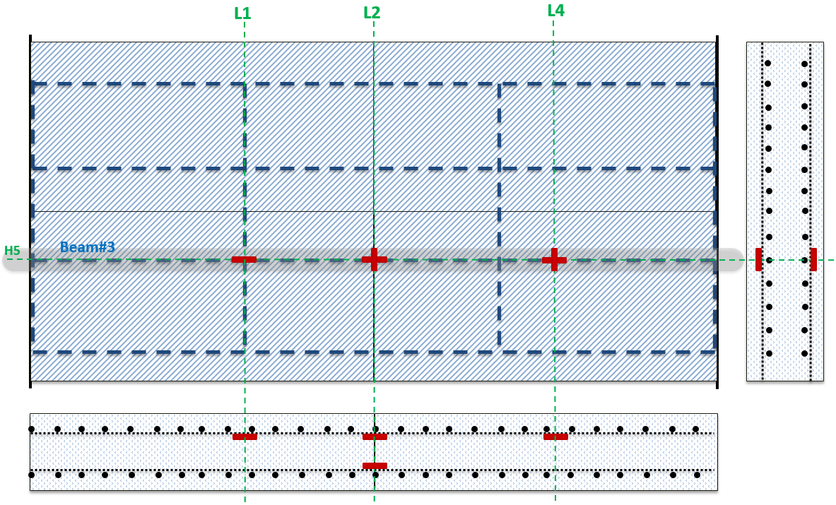

**H6** - *L2 & L4* (8 strain gages)

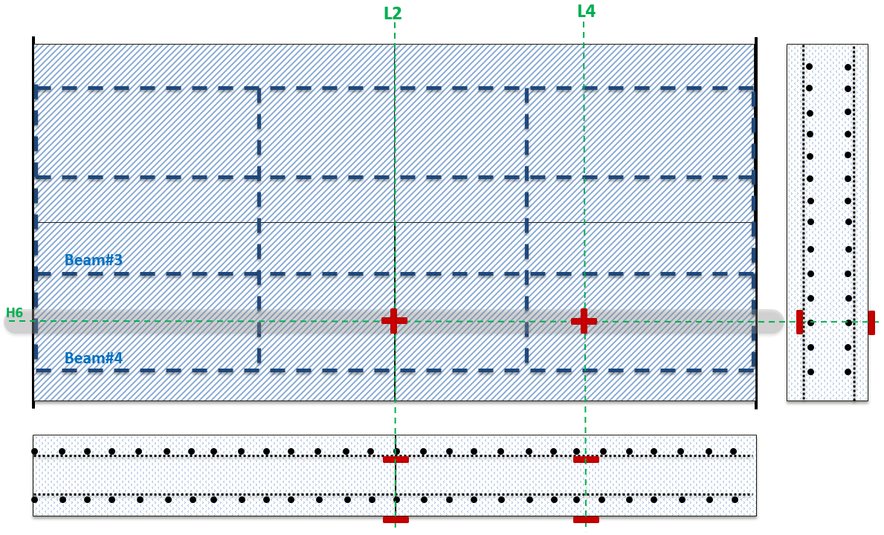

**H7** - *L1, L2, & L4* (3 strain gages)

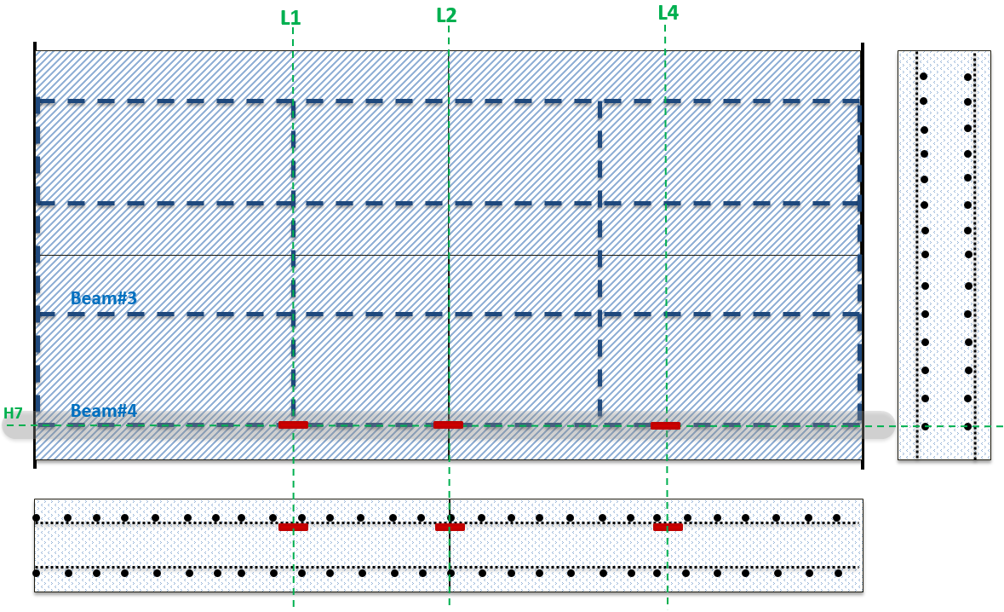

In addition to deck, steel girders will be instrumented to collect the necessary information regarding the stiffness, load distribution, deflection, and dynamics of the specimen. The girders will be instrumented once the fabricator puts them in place (before pouring the concrete). This will exactly provide the zero-load level, and once deck is placed, the dead load will be measured. Upon the beginning of the test and running the loading wheels, the live load effects could be easily separated from the ones imposed by the dead load. Alternatively, the distribution of dead load during deck construction will be thoroughly investigated. It is anticipated that potential member buckling and torsion will be observed and monitored during the deck construction period. Figure 6 demonstrates the schematic of the girder profiles from top view. While all the four girders are instrumented, the external girders would get a few more flexural sensors at the bottom flange mainly due to the potential bucking and torsion of those girders. Figure 6 also shows the cross sections of the steel girder (I-beam) for both internal and external girders. In order to capture potential beam torsion at the external girders (only at mid-span), two flexural strain gages are installed over the bottom flange in both sides. For the rest of locations along the quarter spans (external girders) as well as the mid and quarter-spans on internal girders, only one strain gage at the bottom flange would be installed. Along the web on all locations along the girders, one single strain gage would be installed at the 2/3 height of the girder from the top flange. The comparison of the strain from the gages installed on the web and bottom flange(s) would determine the location of the neutral axis (and the level of composite action) during the testing.

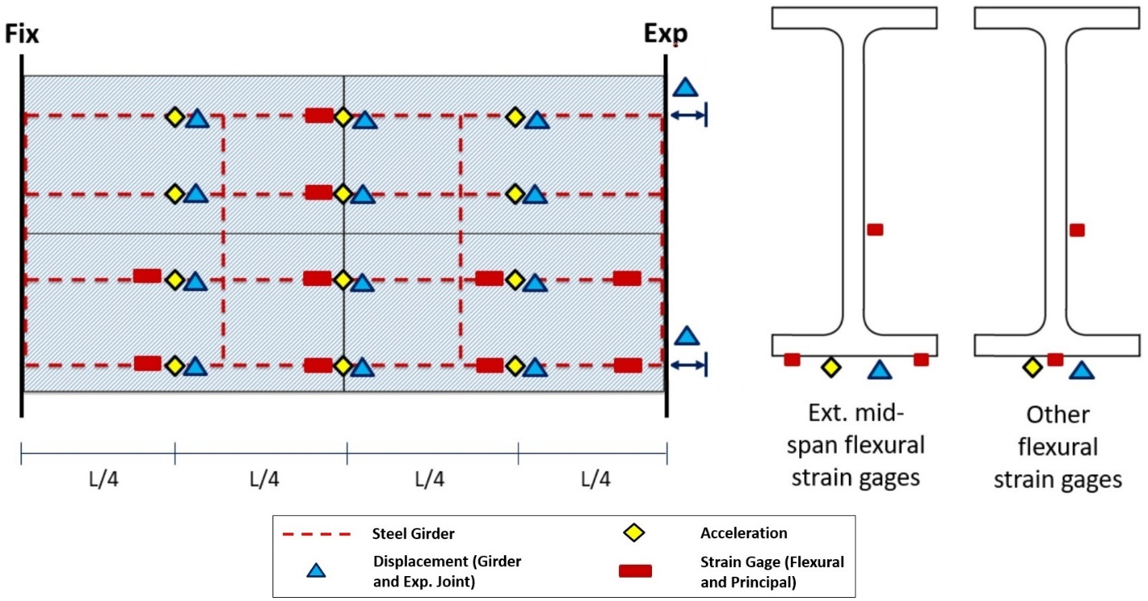

Further on, Figure 7 represents the longitudinal layout of the sensors along the girders. The main intent is to measure the deflection, flexural strain, and acceleration at the quarter and mid-span. In addition, the expansion joint movement will be monitored by having the displacement joints on two external girders. To capture the support reaction forces, flexural strain gages are to be installed along the reaction pedestals on all eight supports. Further, the principal stress components will be acquired by having three strain gages being installed at 60 degree at the end of one internal and one external girder. The strain gages will be installed with a small distance (at least the height of the girder - 27 inch) from the girder end to avoid stress perturbation zones around support reactions. In total, 40 strain gages for strain measurement (18 for longitudinal flexural, 6 for principal strains, and 16 for pedestal), 12 accelerometers, and 14 displacement gages (12 for girders vertical deflection and 2 for expansion joints movement) will be employed for girder and support continuous monitoring. All the strain gages used for girder instrumentation would be of 6-inche vibrating wire ones which each carries an additional temperature sensor. The strain gages will be welded to the steel girder using micro-dot welding device.

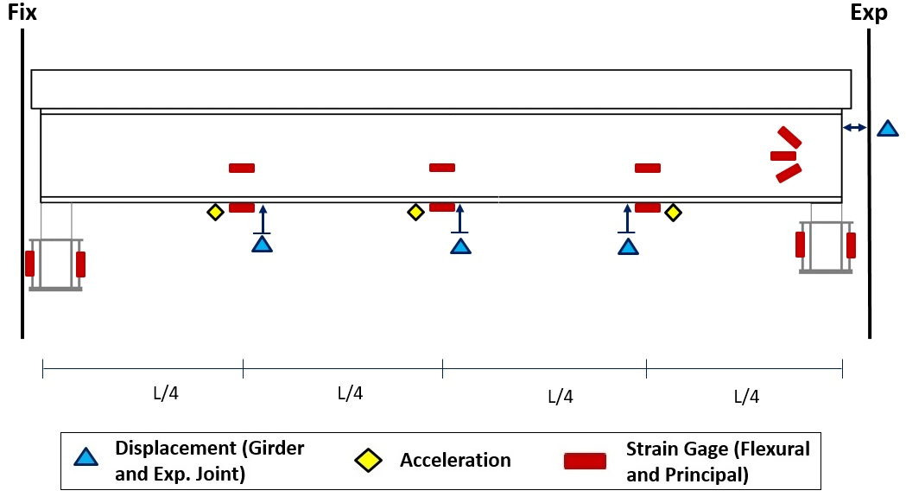

***Should I talk about the instrumentation of yellow beams?***

***Type of Sensors***

John could you please complete this section?

Please put a summary of the sensor types, DAQ, and communication. I think we would not need to provide the exact and detailed model of the sensors and DAQ. Only the type, picture, manufacture, and geometrical spec. Any thoughts?

***Measurement Configuration***

As noted earlier, a continuous data collection from the specimen is overlooked to be conducted over the course of months. However, since there are over 100 sensors being installed and most of the sensors would collect data with over 25 Hz (LTBP Protocol XXX), the storage and management of the data would be very difficult. To overcome this issue and to ensure all the necessary pieces of information would be safely kept, two approaches will be simultaneously implemented during the monitoring campaign. First, the entire data from all sensors will be collected and stored for a fixed period of time within a larger time interval. At beginning, it is proposed that 5 mins of data in every hour of the testing will be recorded and stored from all the sensors. The length of proposed 5 mins time interval is an initial guess and will be fine-tuned after the end of the first week of testing. Assuming constant levels of loading and environmental protocols during every hour, 5 mins of recorded data (either from the beginning, middle, or end of the 1 hour) could be a reasonable representative of the specimen condition for the corresponding 1 hour duration.

Alternatively, the second approach, so-called event-based data collection, would be more subjective on the type of event structure undergoes. Meaning that the data will be constantly buffered to the data acquisition system and certain user-defined criteria (threshold/pattern) will be cross-checked. If the buffered data meets the predefined criteria, the system will store the data and red-flag the event with all the necessary information (such as time, temperature, load level, sensor, etc.). If the buffered data will not meet the criteria, the buffered data will be permanently eliminated. An example of this approach could be referred to the condition when the mid-span deflection exceeds a certain threshold. Another example of such criteria could be associated with occasions when the tire pressures or the ambient temperature suddenly drop a certain level. This data collection approach is a common technique often employed for conventional SHM campaigns. Some of the advantages of this approach refer to its capability in effective data reduction, faster data analysis, and more system reliability in terms of emergency events.

As known, the triggered data acquisition routine will sample sensors measuring the structural response due to the influence of dynamic events (live load). For initial trigger thresholds, per the LTBP Protocol XXX recommendation, a finite element model or simple hand calculations may be used to establish preliminary thresholds. However, the thresholds should be fine-tuned using actual data collected from the structure. If dynamic testing is desired, it is recommended to have a quick modal analysis to extract the natural frequencies. Depending on the nature of dynamic test and features of the bridge, the protocol requires to choose the highest desired modal frequency. According to the Nyquist Theorem, the sampling rate must be at least twice the selected frequency component.

To that extent, a 3-D model of the specimen is built in SAP2000.

As discussed, both approaches will be thoroughly examined during the first week of actual test. It is anticipated that this examination to be revisited every two-weeks to ensure the valuable information are not missed.

|  |  |  |  |
| --- | --- | --- | --- |
| **Measurand** | **Deck Age** | **Derived Parameter** | **Minimum Frequency** |
| Strain | New and Existing | Surface strain on flange, web, and slab components | 10 events* per half an hour, if the strain exceeds a certain threshold ** |
| Displacement | New and Existing | Bearing/joint displacement, vertical/horizontal drifts | 10 events per half an hour, if the displacement exceeds a certain threshold |
| Rotation | New and Existing | Bearing rotation | 10 events per half an hour, if the tilt exceeds a certain threshold |
| Corrosion | New | Corrosion within the concrete deck | * For the first 90 days of deck age: 1 measurement per 3 hrs * For the deck age over 90 days: 2 measurements per day |
| Temperature | New and Existing | For temperature compensation of surface strain gages and correlation of measurements with temperature | Concurrently with the corresponding strain or displacement sensors |
| Embedded strain/temperature | New | For capturing curing strains and temperature effects within a new concrete deck | * For the first 28 days of deck age: 1 measurement (average of 2 mins recording) per 10 mins * For the deck age over 28 days: 10 events per half an hour, if the tilt exceeds a certain threshold |
| Site weather | New and Existing | Ambient temperature, humidity, wind speed for characterizing environmental parameters | 1 measurement per an hour for every parameter |
| Acceleration | New and Existing | Acceleration of the bridge can be transformed into parameters (frequencies, mode shapes, damping) describing the mass and stiffness of the structure | 10 events per half an hour, if the acceleration exceeds a certain threshold |

***Data Collection and Management***

##### The sampling rate for triggered or event-based monitoring requires determining how fast to sample as well as how long to sample before and after the event. Setting the sampling rate can be done by determining how many samples per unit length of the bridge are to be collected. One sample per foot is recommended. To determine the sample rate, the test designer can obtain the speed limit for the roadway and add 10-20 mph to account for speeding vehicles traveling above the speed limit.

##### Vroadway – speed limit of the roadway (mph)

##### Vspeeding – additional speed to account for vehicles traveling over the speed limit (recommend adding 20mph)

##### Example:

##### Many data acquisition systems have a fixed set of sampling rates as well as a maximum sampling rate, so the test designer may need to choose a higher or lower sampling rate than the theoretical sampling rate calculated using the equations in this protocol.

##### Data Acquisition Trigger Thresholds

##### The triggered data acquisition routine will sample sensors measuring the structural response due to the influence of dynamic events (live load). For initial trigger thresholds, a finite element model or simple hand calculations may be used to establish preliminary thresholds. However, the thresholds should be fine-tuned using actual data collected from the structure. For example, in the case of longitudinal strain gages installed on the bottom flange, the model should consider the minimum level of strain caused by nominal trucks. The code-specified trucks (e.g. HS20) could be a good starting point for preliminary analysis, but the strain induced by this loading is likely larger than an average truck event. The same procedures have to be followed separately for web strain gages, displacement, and rotation sensors. With all in mind, a preliminary monitoring program or static truck load test should be used to fine-tune thresholds to be used in triggered data acquisition routines.

##### If dynamic testing is desired, it is recommended to have a quick modal analysis to extract the natural frequencies. Depending on the nature of dynamic test and features of the bridge, the highest desired modal frequency has to be selected. According to the Nyquist Theorem, the sampling rate must be at least twice the selected frequency component.

##### A preliminary monitoring program could include performing monitoring of live traffic for several days or weeks to establish a snapshot of the structural response under operating traffic. The static truck load test would provide structural responses due to a known load for use in developing trigger thresholds. Specifying trigger thresholds without some knowledge regarding the parameter being measured can lead to missing data or collecting excessive data. Therefore, using preliminary monitoring or a truckload test can assist with finalizing trigger thresholds.

##### Data Acquisition Pre-trigger and Post-trigger

##### To determine the amount of data to collect before and after the triggered event, the test designer should take the minimum anticipated speed expected, which could be 5 or 10 mph for a slow-moving heavy load and then take the distance of the trigger sensor or sensors from the end of the bridge and compute how long it would take the vehicle to reach the trigger sensor.

##### Example:

##### 𝑃𝑟𝑒𝑡𝑟𝑖𝑔𝑔𝑒𝑟=

##### where,

##### Dsensor = Distance to trigger sensor from the beginning of the bridge

##### Vslow = Anticipated slow speed for the roadway

##### To compute the amount of data to collect after an event, a similar procedure to the pre-trigger calculation should be used with the distance to the sensor from the beginning of the bridge switched to the distance from the trigger sensor to the end of the bridge. For bridges carrying traffic in both direction, the largest pre- and post-triggers shall be used. As data is collected per the defined sampling rate, pre-trigger, and post-trigger may require adjustment.

Long Term Monitoring of Concrete Decks, Joints

And Bearings - Test Design

LTBP Protocol #: PRE-PL-TD-005

#### Slow speed sampling routines shall be used to sample sensors measuring quasi-static or slow changing structural responses. These structural responses are generally influenced by environmental parameters such as temperature. Periodic measurement of strains, displacements, rotations, and other sensors measuring slow changing responses should be sampled at a maximum interval of 30 minutes. The data may also be continuously averaged and saved at less frequent times. Temperatures at each sensor location should be also measured to provide data for temperature compensation as well as identification of the thermal response of the structure.

##### The following Table 1 proposes suggested time frames for conducting long-term data collection for the instrumented bridge. These are suggested “rules of thumb”, however, and, depending on any bridge specific constraints or data use cases, a comprehensive preliminary test may be required to establish or modify these times. It is also necessary to frequently transfer and back up the recorded data to avoid data loss due to lack of storage space in the on-site data acquisition unit or cloud. Routine check-ups have to be set in order assure the proper functioning of the data collection, storage, and transferring procedures to avoid any interruption due to the loss of power or communication.

##### * Trigger Thresholds: The triggered data acquisition routine will sample sensors measuring the structural response due to the influence of dynamic events (live load). For initial trigger thresholds, a finite element model or simple hand calculations may be used to establish preliminary thresholds. However, the thresholds should be fine-tuned using actual data collected from the structure. For an example case of longitudinal strain gage installed on the bottom flange, the model should consider the minimum level of strain caused by regular trucks. The code-specified trucks (e.g. HS20) could be a good starting point for preliminary analysis. The same procedures have to be followed separately for web strain gages, displacement, and rotation sensors. With all in mind, a preliminary monitoring program or static truck load test should be used to fine-tune thresholds to be used in triggered data acquisition routines.

##### A preliminary monitoring program could include performing monitoring of live traffic for several days or weeks to establish a snapshot of the structural response due to live loads. Monitoring should be performed at various times during the day to ensure the accurate representation of traffic loading and patterns. A static truck load test would provide structural responses due to a known load for use in developing trigger thresholds. Specifying trigger thresholds without some knowledge regarding the parameter being measured can lead to not capturing enough data or capturing too much data. Therefore, using preliminary monitoring or truckload test can assist with finalizing trigger thresholds.

##### The sampling rate for triggered or event-based monitoring requires determining how fast to sample as well as how long to sample before and after the event. Determining an appropriate sampling rate can be done by determining how many samples per unit length of the bridge are to be collected. As concluded in protocol PRE-PL-TD-005, one sample per foot is recommended. To determine the sample rate, the test designer can obtain the speed limit for the roadway and add 10-20 mph to account for speeding vehicles traveling above the speed limit.

##### Vroadway – speed limit of the roadway (mph)

##### Vspeeding – additional speed to account for vehicles traveling over the speed limit (recommend adding 20mph)

##### Example:

##### Many data acquisition systems have a fixed set of sampling rates as well as a maximum sampling rate, so the test designer may need to choose a higher or lower sampling rate than the theoretical sampling rate calculated using the equations in this protocol.

##### To determine the amount of data to collect before and after the triggered event, the test designer should take the minimum anticipated speed expected, which could be 5 or 10 mph for a slow-moving heavy load and then take the distance of the trigger sensor or sensors from the end of the bridge and compute how long it would take the vehicle to reach the trigger sensor.

##### Example:

##### 𝑃𝑟𝑒𝑡𝑟𝑖𝑔𝑔𝑒𝑟=

##### Dsensor – Distance to trigger sensor from the beginning of the bridge

##### Vslow – Anticipated slow speed for the roadway

##### Depending on the location of the sensor’s instrumentation line (A or B) from the beginning of bridge (relative to the traffic direction), pre-trigger calculation may vary. For instance, Figure 4 represents a strain gage installed on the bottom flange of girder G2 along the instrumentation line A. Given the total length of bridge is 100 ft, the below calculation estimates the pre-trigger time to be at least 3 s for the select sensor:

##### 

**Figure 4. Schematic of the strain gage installed on girder G2 along the instrumentation line A**

##### To compute the amount of data to collect after an event, use a similar procedure to the pre-trigger calculation and swap the distance to the sensor from the beginning of the bridge to the distance from the trigger sensor to the end of the bridge. For sensor located along the instrumentation line A, shown in Figure 4, this distance would equal to 50 ft plus 6 ft, which equals to 56 ft. The computation of the required time for the post-trigger data collection would be as follows:

##### Depending on the geometry of the bridge and traffic lanes (one direction versus two directions) more than one set of trigger sensors, pre-triggers, and post-triggers may need to be developed. As data is collected per the defined sampling rate, pre-trigger, and post-trigger may require adjustment.

Once the deterioration starts developing in the deck during Phase 1 and between the deck and overlay during Phase 2, the Rutgers team will, with the approval of COR/TOCOR, increase the testing frequency to every two weeks. The Rutgers team will collect GPR and IR data at the higher spatial and temporal resolutions of 6 in. and two weeks. The Rutgers team will document the metadata associated with all data collection activities, including:

• Air and surface temperature of the bridge deck each hour of testing duration

• Details associated with the deck surface (presence and orientation of grooving or other surface texture that could influence test data)

• Location (grid map) of all collected data

• Notes describing any issue or unique occurrences during data collection

• Specific information for installed sensor technologies and NDE equipment (name, manufacturer and model of sensors, GPR antenna center frequency and polarization, GPR control unit and number of channels, GPR scan direction and start/end of scan location, IE sampling rate and number of samples, IE sampling duration and sensor impactor distance (in.), USW sampling rate and number of samples, USW sampling duration and sensors 1 and 2 distance to source (in.), ER surface resistivity resolution and probe spacing, ER range and accuracy, camera resolution, make and model).

Following data collection, the Rutgers team will process the data and present the results in two-dimensional color-coded contour plots for all NDE data collected. All contour plots will be placed in a landscape orientation, adequately titled and labeled including reference to the type of test/technology and test date. Dimensional scale (length and width along specimens) and data bin limits for all two-dimensional contour plots will be consistent for each NDE technology to facilitate comparisons. All processed data will be reported using consistent scale, font, color scheme, and chart size. For all GPR datasets, two-dimensional contour plot results will consist of (a) depth corrected GPR signals, (b) reinforcement concrete cover map, (c) top most reinforcement layer location map, and (d) concrete condition map. All primary units will be in the U.S. Customary English System.

The Rutgers team will develop and submit to the COR/TOCOR a detailed instrumentation and data acquisition plan prior to construction of the specimen and prior to construction and overlay systems. Unless noted otherwise, the Rutgers team will be responsible for collecting, storing, and post-processing collected data. This plan will include a list of equipment to be used for data collection, measurement spatial and temporal resolutions, as well as provisions for storage of data, metadata, and images prior to transfer to the FHWA.

Measurement Configurations

Frequency of Data Collection and Database Management

The continuous data collection does not necessitate the interruption of load application. Since the specimen will run 24/7 and the amount of recorded data will be extremely huge and very difficult to handle, two major data management approaches would be deployed. The first approach is called “Fixed Time” data collection, in which the real-time data will be collected and stored for a limited period of time (such as 10 mins) in every hour of testing.

Hooman