The cracks observed are a result of the loading condition as well as influenced by the bridge deck profile. The stringers are supported by the top flanges of the floor girders. At joint locations (i.e. locations over which the stringers are discontinuous) the configuration of bearings results in very high differential loading on the flanges (and eccentric to the web). When a vehicle crosses at a joint location, there is a sudden reversal in loading as the full stringer shear load is applied first to one side of the flange and then to then almost instantly to the other as the vehicle passes over the joint. The deformation of the floor girder is illustrated in the figures below. These plots depict the cross-sectional deformation of the floor girder as captured by accelerometers (at one instant in time).

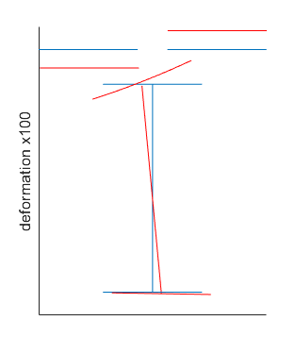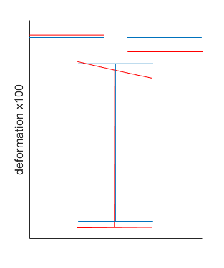

It is likely this problem is further exacerbated by the bridge deck roadway profile. While the exact nature of the deck and its effect cannot be understood without directly measuring it, it seems likely that a difference between deck elevation at joints would significantly amplify the vehicle load and bridge response.

The best way to remedy the situation would to correct the connection between stringers and floor girders such that the forces flow more directly in the floor girder web and a more continuous shear transfer. However, methods to accomplish this are impractical as a retrofit (i.e. offset stringers so they may extend completely over the web).

The plots below depict typical event time-histories. The RMS plot serves to compare the amount of acceleration experienced by different sensors.

|  |  |
| --- | --- |
|  |  |



|  |  |
| --- | --- |
|  |  |