**Structural Health Monitoring of Representative Cracks in the Manhattan Bridge**

Saeed Babanajad, John Braley, Franklin Moon

Center for Advanced Infrastructure and Transportation (CAIT), Rutgers University

December 10, 2018

**Task 3 Instrumentation Plan**

This phase of monitoring is meant to fulfill the following objectives:

* Quantify dynamic amplification of flexural stress in transit beams (at good and poor splice locations)
* Quantify dynamic amplification of shear stress in transit beams (good and poor splice locations)
* Quantify dynamic amplification of flexural stress in floor girders
* Quantify dynamic amplification of shear stress in floor girders
* Monitor and compare stress in web of floor girder caused by out-of-plane deformation as a result of stiffener plate detailing (locations with and without cracking)

To meet these objectives, an instrumentation plan has been developed to record operational responses at critical locations (e.g. experience maximum response, have minimal reserve capacity, or have demonstrated inadequate performance such as fatigue cracks). They will be spatially distributed to provide various responses (e.g. shear strain, axial strain) in different load carrying members (e.g. transit beams, floor girders).

The figure below depicts the layout of strain gauges on span 1 of the Manhattan approach for the south transit (west subway) framing. This layout calls for a total of 30 gauges and is intended to acquire global responses.

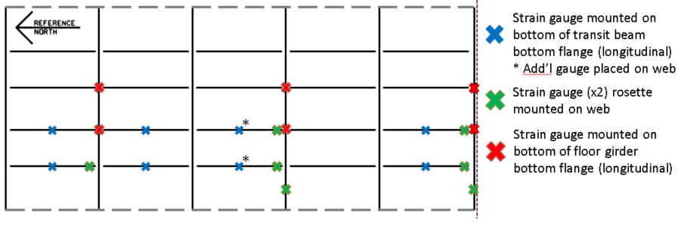

Figure : Instrumentation Layout for Global Response Monitoring

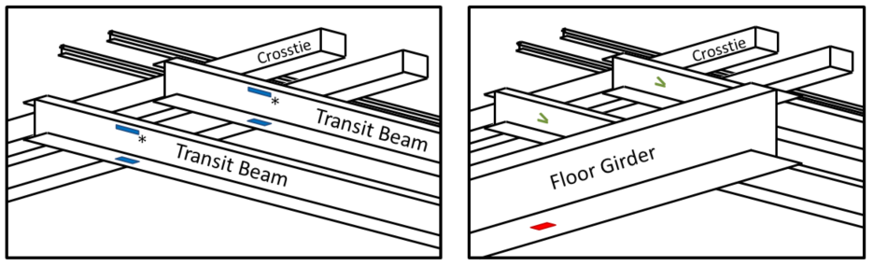

Figure : Typical Gauge Mounting Locations

Gauges will also be installed at locations that have demonstrated to be prone to fatigue cracking. These cracks have occurred where the transit beams frame into the floor girder, as detailed in the figure below. The connection detail features a stiffener plate terminating in the web of the floor girder, thereby applying large out-of-plane forces on the web. In some locations the stiffener plate has been replaced with one that connects into the bottom flange. Gauges will be installed in locations where cracking has been recorded as well as locations with both the original detail and the retrofit to provide comparison. Responses at these locations will serve to monitor crack growth/formation resulting from dynamic loading and assess the performance of previously implemented retrofits. A total of 8 gauges will be installed for monitoring fatigue cracks.

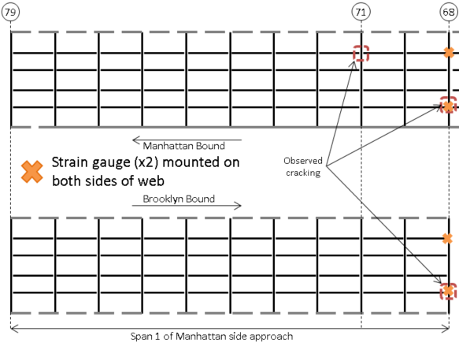

Figure 3: Instrumentation Layout for Fatigue Crack Monitoring

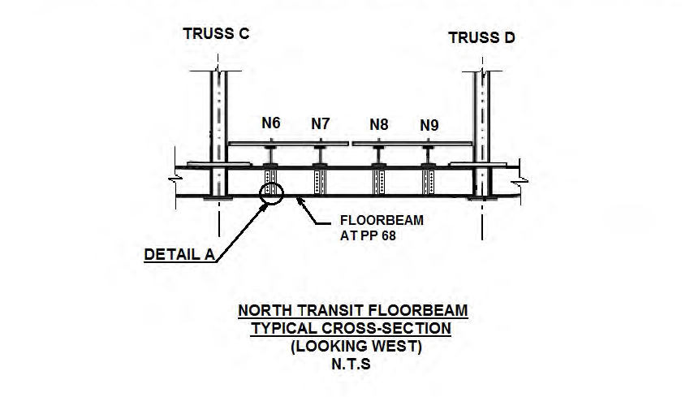 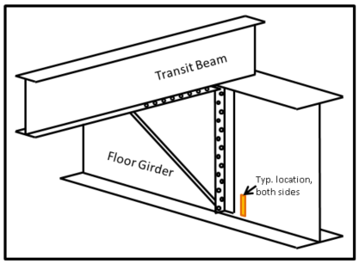

Figure : Typ. Framing Detail in Locations with Fatigue Cracking

Figure : Typ. Gauge Location for Fatigue Crack Monitoring

Temperature gauges will also be installed to monitor the temperature of the structure. Their locations will be as indicated in the diagram below.

