Objectives

* Establish operating level bridge responses under trains
* Determine effect of rail deviations on bridge response
* Determine level of dynamic amplification due to trains traveling over rail deviations

Test plan

Accelerometers will be installed on the floor beams (transverse) at several locations. These locations will be determined by visually locating suspected locations of vertical track misalignment/deviation as well as regions that have no alignment issues so measurements may be compared.

The total number of accelerometers to be installed will be determined based on site conditions. At least eight (8) and as many as sixteen (16) will be installed. The accelerometers will be wired to a National Instruments data acquisition system (DAQ) capable of sampling at more than 3200 Hz. It is expected that a high sampling rate will be required to adequately capture the short duration effects caused by the track irregularities. The DAQ will be battery powered, and thus no power will be required on site.

Structure acceleration will be recorded continuously for several hours or until several loading events are captured (e.g. several train crossings, vehicular traffic without train crossings). Details of the loading events will be recorded for later reference including accurate time of events for data processing.

The figure below illustrates the typical sensor locations. Accelerometers will only be placed on the floor beams, and on the bottom flange when possible.

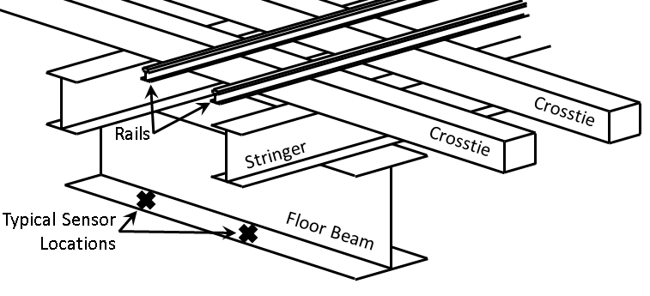

Access

Visual inspection of the rails will be completed on the sidewalk (no special access required). Access for sensor installation and data acquisition will require rooftop access to the building (XX) beneath the bridge for the duration of the test day. We will provide our own step-ladder to provide access to the underside of the structure.

What to bring

* Painter-pole rig
* Ladder
* Accels
* Magnets
* Batteries
* Battery chargers
* Cables
* DAQs
* Extra cards (9234)