# ABSTRACT OF THE DISSERTATION

Title

by John Braley

Dissertation Director:

Franklin L Moon

Begin text here.

# Table of Contents

ABSTRACT OF THE DISSERTATION ii

Table of Contents iii

List of Tables v

List of Illustrations vi

Introduction 1

Heading 2 2

Heading 3 2

Part 1: Understanding vehicle-bridge interaction and dynamic amplification 3

Experimental Case Study 3

Description of Test Structure 3

Phase 1 Testing 3

Phase 2 Testing 3

Phase 3 Testing 4

Conclusions 4

Mechanisms and Influential Attributes 4

Part 2: Estimating Dynamic Amplification 4

Visualizing the Problem 4

In-Situ Measurement 5

Finite Element Analysis 5

2D Condensation & State-Space 5

IRI & Other Vehicle-Only Models 5

Part 3: Applications of 5

Remediation 5

Smoothness 5

Vehicle Configurations 5

Traffic 5

Truck Trains 5

# List of Tables

# List of Illustrations

# Introduction

This document aims to explain and demonstrate the behavior of a bridge under a moving vehicle. Before I embark on that effort I feel obliged to define a few terms that you may notice to abound throughout the following pages.

The first is “vehicle-bridge interaction” (VBI), which refers to the scenario in which one dynamic system (vehicle) traverses a second dynamic system (bridge). The vertical translation of the vehicle is coupled to that of the bridge at the wheel contact locations. Vehicle-bridge interaction therefore refers to the behavior of the combined system.

The second term is “dynamic amplification”, which quantifies the inability of static analyses to predict the maximum response of a dynamic system. It is expressed as a ratio of maximum dynamic response to static response. For a bridge, moving vehicles excite the coupled system resulting in bridge motion which in turn causes member level responses unequal to those that would result from the force of the vehicles’ weight alone (static).

For many civil applications, static analyses have proven adequate for determining the demands of structures. Structures often remain near enough to a motionless state that the structure can be described as a static system, and the resulting error from employing this assumption can be accounted for with a small increase in the factor of safety. However, in other cases, the deformation experienced by a structure associated with its motion is appreciable, as is seen in seismic events.

Live load demands have historically been estimated using static analysis. The dynamic amplification factor that should be used depends on the design specification with jurisdiction. According to AASHTO, a maximum factor of 1.33 is to be used. However, there have been numerous reports of bridges experiencing dynamic amplification well in excess of this number. Extensive structural monitoring was performed on one such nonconformist as detailed herein.

These bridges with excessive dynamic amplification suggest that old assumptions are no longer conservative for every bridge. We are therefore compelled as designers, builders and operators to identify the shortcomings of old assumptions and develop more accurate methods as required. State of the Art

## Heading 2

### Heading 3

#### Heading 4

Text: The quick brown fox jumps over the lazy dog. The quick brown fox jumps over the lazy dog. The quick brown fox jumps over the lazy dog. The quick brown fox jumps over the lazy dog. The quick brown fox jumps over the lazy dog.

The quick brown fox jumps over the lazy dog. The quick brown fox jumps over the lazy dog. The quick brown fox jumps over the lazy dog. The quick brown fox jumps over the lazy dog. The quick brown fox jumps over the lazy dog. The quick brown fox jumps over the lazy dog.

More information can be found here: [https://gsnb.rutgers.edu/academics/electronic-thesis-and-dissertation-style-guide#sample](https://gsnb.rutgers.edu/academics/electronic-thesis-and-dissertation-style-guide%23sample).

Image Placeholder

Figure 1: Test Image

# Part 1: Understanding vehicle-bridge interaction and dynamic amplification

This first part details the experimental testing and investigation of a real bridge and documents the knowledge gained from such efforts. Recording a phenomenon is the first step in understanding it.

## Experimental Case Study

The case structure was brought to our attention by local transportation officials. By their report, motorists have repeatedly contacted local police to report what they perceived to be excessive vibration. This prompted a series of field tests in which various structural responses were recorded under typical operational conditions. The testing activities, results and conclusions are summarized in the following sections.

### Description of Test Structure

The structure is an 11-span viaduct that carries 4 lanes of a major interstate highway. The viaduct was first constructed in 1952 but the superstructure was replaced in 1986 while retaining the concrete piers. East bound and west bound lanes are carried by adjacent steel multi-girder spans, which are supported by steel box-girders spanning between two piers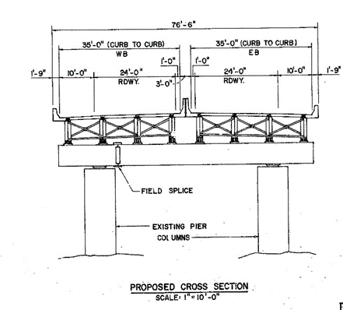 (figure caption). The structure was overall in good condition with no significant cracking or corrosion visible. Further description of the bridge may be found in the appendix.

Several tests were conducted on this test structure in a continuing effort to understand its behavior. Testing objectives were driven by the DOT’s directive to identify and characterize the bridge vibration and determine if they may be detrimental to the structure’s performance.

### Phase 1 Testing

The objective of the first phase of testing was to merely survey the structure so as to determine which portions of the structure were experiencing large vibrations, and begin to characterize those vibrations that may be “problematic”. Testing of the viaduct took place on July 6th and 7th of 2016. The cross girders at piers 2, 3, 5 and 7 were instrumented with accelerometers in an effort to determine which spans experienced the highest levels of vibration.

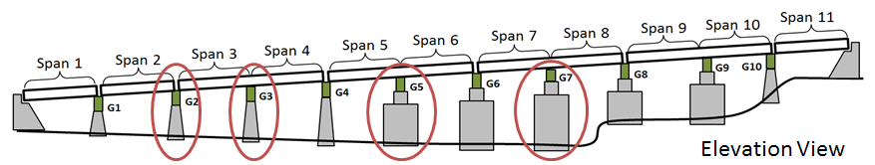

All instrumented cross girders experienced similar levels of vertical and longitudinal acceleration, while the cross girder at pier 7 experienced much higher transverse acceleration. As a result, spans 7 and 8 were chosen for further investigation.

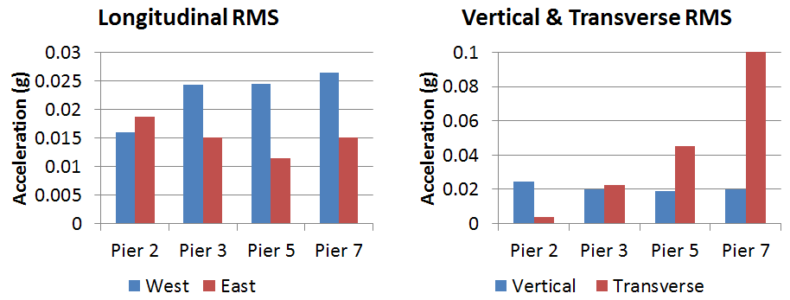

### Phase 2 Testing

The objectives for the second phase of testing were (1) to characterize operational vibrations and strains at critical locations and locations of maximum response under various traffic conditions, and (2) to gather data for modal parameter identification (i.e. frequencies and mode shapes).

A total of 30 accelerometers (PCB Model 393A03) and 12 strain gauges (Geokon 6" vibrating wire) were installed on the chosen region of the viaduct (span 7 & 8). They were positioned to capture maximum response as well as to characterize the modes (shapes) of vibration. Accelerometers were therefore spatially distributed while strain gauges were concentrated near mid-span and over the negative moment region. A full description of the sensor layout can be found in the appendix.

Instrumentation of spans 7 and 8 was installed on July 26th and 27th of 2016. Data was recorded on July 27th and 28th. Sensors were removed on July 29th.

#### Results & Interpretation

Over a period of 24 hours frequent traffic events were recorded for which the structure experienced acceleration in excess of 0.2g. One such event is plotted below. Of further interest, is the vibration that occurs after the large traffic event. Rather than experiencing a free decay back to nearly zero acceleration, the bridge continues to vibrate at nearly 50% of the peak value as a result of the low damping of the structure, and likely the continued input of lighter traffic.

Spectral analysis of the records further reveals that much of the motion occurs at low frequencies; between 2 and 4 Hz. Vibrations in this frequency range would be classified as “very disturbing” according to the human comfort criteria established by Reiher and Meister (1931). Furthermore, the deformation of the structure associated with this vibration is roughly ½” and therefore significantly contributes to the live-load demands.

A low pass filter of strain records for a typical event demonstrates the amplification of bridge response as a result of the vibrations. By considering the response content under 2 Hz as the static response, we may estimate the dynamic amplification factor. This structure is routinely experiencing dynamic amplification of strain (and stress) in excess of 1.75. Furthermore, this amplification is occurring at design-level load events.

Spectral analysis was also performed to extract the first 18 natural modes of vibration and their corresponding frequencies. They all occur within a frequency range of 2 to 10 Hz. The 18 mode shapes are plotted with their frequencies in the appendix.

#### Analysis Methods

Data filtering was performed with a 6th-order low-pass elliptic filter with 0.5 decibels of peak-to-peak passband ripple and 50 decibels of stop-band attenuation.

Mode shapes were extracted using the Complex Mode Indicator Function (CMIF). A more detailed description of modal parameter estimation methods can be found in the appendix.

#### FE Simulation

Several models were created with varying levels of detail including a 3D element-based model of spans 7 & 8. The model was calibrated/validated with the mode shapes and frequencies obtained experimentally. Multiple parameters were explored as a part of the calibration process. Ultimately, once moment releases were assigned to barrier beam elements at locations corresponding to joints, the model achieved close agreement with experimental results. A description of general modeling practices used throughout these studies is provided in the appendix.

The calibrated models were used to assess the impact of observed dynamics on the bridge’s ability to carry load and its continued performance. Refined load ratings revealed that due to design conservatism there was sufficient reserve capacity to handle dynamic amplification even as high as 1.75. Furthermore, the calibrated FE model had parameter values all within very reasonable bounds (i.e. there are no structural abnormalities contributing to the vibration issues). This iteration of testing therefore concludes that although the bridge is experiencing large vibrations, it does not appear to pose a risk to the bridge’s performance. However, the test results and simulations are unable to identify the cause of the vibrations.

### Phase 3 Testing

Previous testing demonstrated that vehicles were capable of exciting the mass of the structure. It became clear that we needed to better understand the coupled behavior of bridge and vehicle as it traversed the bridge. A test was therefore designed to capture the motion of a vehicle and bridge synchronously.

Accelerometers were distributed along the length of the bridge as well as placed on a test vehicle. This necessitated distributed data acquisition systems, one of which had to operate in a moving vehicle. GPS synchronization

made possible 3 data acquisition systems that were all synchronized to within

was therefore obtained using GPS Records were synchronized based on GPS time

Time obtained from GPS receivers provided signals Records were synchronized with GPS based time, accurate to within

Therefore if further knowledge were required The main objective of this phase of testing was to gain further understanding of the vehicle-bridge interaction. This required that we

#### Test Objectives and Instrumentation Layout

#### Data Interpretation

#### FE Simulation

#### Results

### Conclusions

## Mechanisms and Influential Attributes

# Part 2: Estimating Dynamic Amplification

## Visualizing the Problem

The excitation of the vehicle-bridge system is due to the contact force between the vehicle tire and roadway surface. This contact force is dependent on the difference in vertical position of the bridge surface and the vehicle body. The bridge surface elevation is the combination of bridge motion at the vehicle position and elevation added by the profile. It therefore follows that any model of vehicle-bridge interaction must include the following:

* The mass of bridge excited by the vehicle-induced forces
* The stiffness of the bridge
* The mass of the vehicle
* The suspension characteristics of the vehicle
* The vehicle velocity
* The roadway profile accurately positioned on bridge

This last element, an accurately positioned profile, is critical. The effect of a profile feature (bump) is partially dependent on the location of the feature, therefore an accurate model must also include longitudinal (along path of travel) bridge geometry (e.g. span length).

There are many different methods of representing all of these elements in a model, but the success of a model is ultimately judged by its ability to reliably estimate the response of interest. For this study that response of interest is the amplification of peak responses during live load events (vehicle-crossing). The following sections will present several model types of varying complexity, document their construction and demonstrate their ability to predict dynamic amplification.

## In-Situ Measurement

There is no substitute for directly measuring a phenomenon. This section provides guidance on methods of directly measuring the dynamic amplification being experienced by a bridge that is in-service.

### Operational Monitoring

Often operational monitoring, whereby bridge response is recorded during normal operation, is the cheapest method and least disturbing to traffic and provides responses to typical loading conditions. Members that are expected to experience the largest responses as well as those suspected to have the least reserve capacity should be instrumented. Sensors should be carefully selected based on required response, range, accuracy, etc. This study is principally interested in material level responses (i.e. stress). Strain is directly related stress and thus strain gauges are preferred for measuring dynamic amplification. Displacement gauges can be used but tend to overestimate amplification as discussed previously (Part 1). Acceleration gauges may be used to estimate displacement if they remain accurate at frequencies near zero. This requirement is true of any gauge chosen, but is more likely to be an issue with capacitive accelerometers.

The process of determining dynamic amplification from operational responses has been already detailed by other researchers. Regardless of the exact method used, the data is filtered to remove high frequency content leaving behind the content associated with quasi-static loading. The dynamic amplification is then estimated by computing the ratio of the maximum of the original data to the maximum of the filtered data. A demonstration of this process can be found in the case study presented in the first part.

The filter parameters should be selected such that the pass-band upper limit is less than the first natural frequency but greater than the frequency of loading. In reality, some loading events occur faster than the first natural frequency of the structure. In these cases the filtered response under-estimates static response, subsequently resulting in an over-estimation of amplification. This problem is mitigated by the large mass of the bridge which resists rapid motion, but is always an inherent source of error when estimating static response from operational responses. Furthermore, it is unlikely that the “worst-case” scenario occurred during the record interval and thus the estimated amplification can be non-conservative, but can be appropriate for operational limit states and is a valuable approximation for assessing in-service performance.

### Load Testing

The static response of the bridge can be measured directly when the load is applied statically as in a load test. Responses should be recorded for the test-vehicle (loaded truck) motionless as well as travelling over the bridge at speeds corresponding to minimum, typical, and maximum traffic speeds. Dynamic amplification computed from the resulting static and dynamic responses will be accurate for that specific test-vehicle, but is not guaranteed to remain conservative for all loading events. A bridge’s performance in design or evaluation is measured by its ability to carry limit-state loads. Test-vehicles should therefore be loaded to a weight similar to the legal load limit. When possible, test-vehicles should also be chosen with a body-bounce natural frequency similar to that of the first-bending mode of vibration of the bridge as this has been shown to result in the greatest dynamic amplification.

The test-vehicle should be placed at locations that produce maximum response or made to “crawl” at speeds low enough to maintain “quasi-static” conditions for the static portion of the load test. The dynamic load test should occur at various speeds and along all paths of travel. The test vehicle must begin a significant distance from the start of the bridge to account for vehicle motion as a result of traversing the approach roadway. The test-vehicle should maintain the set speed from a distance of at least 65 feet (20 meters) away from the beginning of the bridge until it exits the bridge.

### Profile Measurement

In some cases it becomes necessary to simulate the bridge response to moving vehicles. Any simulations of vehicle-bridge interaction must include bridge deck profile. The profile should contain paired position and elevation information along the entire length of the bridge and approach roadway for every reasonable path of travel. Elevation data may be recorded along a single line or along multiple wheel lines. The spatial resolution should be set small enough to capture all features of interest. Bridge motion is most effected by profile features with a length of several feet and more. Commercial profilographs have sampling intervals on the order of one inch and thus can be expected to produce perfectly adequate profile measurements.

## Finite Element Analysis

There are often scenarios in which it is impractical or even impossible to implement certain loading events or measure certain responses. In such circumstances it becomes necessary to perform simulation of the loading event to predict expected responses. The selection and construction of a suitable model for these simulations is critical to accurate predictions.

A 3D element-level FE model is capable of representing all mechanisms and features that are a part of vehicle-bridge interaction and influence dynamic amplification. By creating a model that is geometrically consistent with the real structure the mass and stiffness can be accurately modeled and spatially distributed. The model should be error-screened and calibrated with experimental data from the real structure and should have at least the first natural frequency matching that of the real structure.

It is not the aim of this paper to provide guidance on constructing and validating FE models. The exact methods of model construction and analysis are dependent on the FE software package employed. The selected FE software should be capable of simulating moving sprung masses over a specified profile and bridge model. The model should be constructed using best practices and should be validated with experimental data whenever possible. Validation with dynamic data (e.g. frequencies and mode shapes) is preferable and ensures the model dynamics match those of the structure.

The vehicle can be modeled after a real vehicle by assigning equivalent mass (weight) and by setting suspension characteristics that result in matching body-bounce natural frequencies. If there is no reference vehicle, a worst-case vehicle model may be created that has a mass equal to the legal limit, low damping (e.g. 10%), and a suspension stiffness that results in a body-bounce frequency 10% greater than the bridge’s first-bending natural frequency.

Static responses can be simulated with vehicle at a crawl-speed (i.e. <1mph) or with a static linear analysis of the vehicle placed in locations that produce maximum response. Simulated responses should be recorded at locations of maximum response or particular vulnerability. Dynamic amplification can be computed for a given location as the ratio of maximum dynamic response to maximum static response.

The case study provided in the first part of this document demonstrates the process of estimating dynamic amplification with 3D FE analysis. The plot below compares bridge responses that were recorded during operational monitoring to those predicted by 3D FE simulation.

## 2D Condensation & State-Space

Although 3D FE analysis is capable of accurately simulating vehicle-bridge interaction and estimating dynamic amplification, it is often impractical for current engineering practice due to the required time and expertise. It is therefore advantageous to develop models that require minimal time and expertise while still providing accurate estimates of dynamic amplification.

### Description

The following pages present a model type that includes all of the mechanisms involved with vehicle bridge motion as listed in the beginning of this part. The model reduces the bridge to a generalized single degree-of-freedom (SDF) system for which its deformation at any point along the bridge’s length is defined by a shape function (. The vehicle is also represented as a single sprung mass and is coupled to the bridge degree-of-freedom. The equations of motion for this generalized SDF system are relatively simple and are used to develop state-space equations that define the position of both bridge and vehicle. A full description of this model and supporting derivations are provided in the appendix. The following image illustrates the model components.

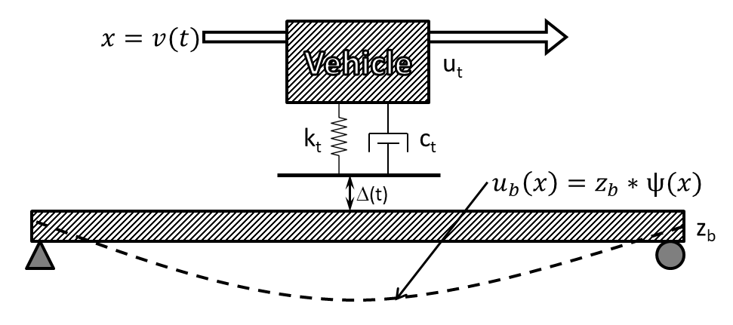

Models were developed for singles-span bridges and for 2-span continuous bridges with equal span lengths. Although these models include every mechanism that plays a role in dynamic amplification they have several inherent limitations.

A sine wave ($\left(x\right)= \sin\left(\frac{πx}{L}\right)$) was chosen for the shape functions that generalize the distributed systems by defining the shape of the beam deformation. While this shape function accurately describes the deformation associated with the first-bending mode of vibration, it is incorrect for point loading (or any other loading). Furthermore, the single shape function cannot account for the excitation of the bridge’s higher modes of vibration. Furthermore, by modeling the bridge as a single beam, the lateral distribution of mass and stiffness is neglected. While these and other limitations leave the models much less capable than a full 3D FE model, they may still prove useful for estimating dynamic amplification and require a fraction of the time investment and computing power.

### Implementation

The first step in determining the appropriate parameters for defining the state-space model is to define a beam that can approximate bridge response due to a vehicle traveling along specified path of travel. The distributed stiffness (EI) can be approximated by first determining the stiffness of the bridge to a point load at midspan along the path of travel. This stiffness value may be determined experimentally or with a refined FE model. The appropriate EI value is subsequently calculated that produces a beam with an equivalent stiffness value. Stiffness is assumed to be uniformly distribute (i.e. EI is constant along the length of the beam. The following equations describe that calculation for single-span and two-span models.

$$EI=$$

Once the distributed stiffness of the beam is determined, the distributed mass of the beam may be calculated such that the beam has a first-bending natural frequency equal to that of the bridge. Mass was assumed to be uniformly distributed along the length of the beam for the models presented herein.

The vehicle is also reduced to a single degree-of-freedom based on known mass and natural frequency as described for FE simulations. Conservative vehicles may be implemented that have mass equal to legal limits and suspension stiffness that results in a body-bounce natural frequency approximately 10% greater than the bridge natural frequency. The profile should be measured and provided in the form of sequential distance and elevation measurements. The distance values should be monotonically increasing.

Full instruction on how to implement the state-space model is provided in the appendix and accompanying computer code is available upon request (if not already publicly available). While the state-space model directly computes bridge displacement, the amplification (and other response quantities) is easily computed and is the quantity reported in many of the supporting figures. It became quickly evident that the error of these simplified models was mitigated by computing amplification rather than deflection. This is not surprising as it serves to reduce the effect of bridge stiffness, a parameter which is represented in vastly different ways (3D element-level vs SDF). It should also be noted that structural responses (e.g. displacement) should not be interpreted directly from these simplified models. Rather these models are intended to predict the amplification of responses.

### Validation and Performance Assessment

The models previously described were implemented in MATLAB. The models were error screened by first comparing output to FE models of corresponding beams. Some error was expected (and observed) because the state-space models are still an approximate representation of beam behavior. That error was more pronounced for models of two-span continuous beams. Additional details of the benchmarking can be found in the appendix.

It is always preferable to measure a model against ground truth values, which in this case would be the dynamic amplification as recorded on an actual structure. However, there are not enough structures that have been instrumented for the determination of dynamic amplification and have also had their profile measured. There are simply too few samples from real structures to adequately assess the performance of the state-space models. As a result, the performance of the state-space models was evaluated by comparing the dynamic amplification predicted by the model to that predicted by a 3D FE model. A total of six 3D FE models were constructed based on actual structures that had been previously subjected to dynamic testing. The roadway width of some of the models was great enough to accommodate multiple lanes and therefore multiple paths of travel were defined. A more detailed description of the FE models is provided in the appendix.

A total of 15 profiles were evaluated. Three of the profiles were obtained from the profiles recorded from the case study bridge. Another twelve were artificial and generated using the methods defined by the ISO 8608 standards. This standard defines a roughness metric, but also describes the process whereby the profile is defined by frequency content and is generated through the summation of sine functions.

Several vehicles were defined with parameters that resulted in body-bounce natural frequencies equal to the first natural frequencies reported by the FE models. The mass of all vehicles was set to 200 slinches (77.2 kips). Three vehicle models were assigned damping ratios of 10%; one was assigned 20%. Further description of modeling decisions and parameters are provided in the appendix.

The four parameter categories (i.e. bridge, path of travel, vehicle, and profile) were sampled to obtain a total of 239 different scenarios. Each scenario was simulated with a detailed 3D FE model and with a state-space model. The predicted amplification is compared in the plots below. It can be observed from these plots that the state-space models are more conservative for scenarios that result in high levels of amplification, but more accurate at lower amplification levels. It is not expected that dynamic amplification will reach such high values on real structures. These values were obtained in simulations with unrealistically rough artificial profiles, but still serve to demonstrate the performance of the state-space models.

## IRI & Other Vehicle-Only Models

There are several methods already widely used to assess the roughness of roadway profiles. The International Roughness Index (IRI) is the most complex and simulates a specified vehicle (golden quarter-car) traveling over the profile. Other metrics ignore the vehicle and deal only with the profile data. The ISO 8608 parameters, for example, describe the spatial frequency content of the profile. However, all of these roughness metrics fail to consider the bridge or the position of the profile. Studies were performed to examine if these metrics had any ability to predict dynamic amplification.

ISO 8608 parameters describe the spatial frequency content of the profile. Studies presented in the first part of this document show that the spatial frequency of the profile content does influence dynamic amplification. However, these parameters ignore any transient features and ignore the phase angle distribution and therefore are inadequate for predicting dynamic amplification. This is evidenced by the plot below which compares the bridge response for two profiles with identical ISO parameters but different distribution of phase angles. The inadequacy is further demonstrated by the supplied correlation plot.

PLOTs

The IRI includes the vehicle in its model and may be expected to demonstrate better ability to predict dynamic amplification. However, a correlation plot shows that the IRI cannot reliably predict dynamic amplification. The plot also reveals that while profiles with high IRI may not always result in high dynamic amplification, bridges with high dynamic amplification have high profile IRI values. This provides further encouragement to encourage and mandate a smooth deck surface.

PLOT

Another simple model was assessed that included representation of the vehicle, but ignored bridge behavior. Position of the profile on the bridge was included by applying a sine window to the vehicle response over the time period for which the vehicle is on the bridge. The maximum of the windowed contact force is reported as a factor of the vehicle self-weight. This contact-force amplification metric is compared to FE predictions in the plot below. The metric consistently correlated with dynamic amplification for some bridges, but was not widely applicable and therefore is not recommended for any amplification predictions.

PLOT

## Summary

* The vehicle and bridge comprise a coupled dynamic system that is energized by the vehicle traversing a profile.
* Dynamic amplification estimated by filtering operational monitoring data may over-estimate amplification.
* Determining dynamic amplification of in-service bridges may be performed with operational monitoring or a load test. In either case, strain gauges are recommended over displacement gauges or accelerometers.
* A 3D FE model is capable of simulating vehicle-bridge interaction and is recommended for predicting dynamic amplification for structures with complex geometry or that are otherwise ill-suited to the state-space models.
* A simple model that reduces both the bridge and vehicle to SDF systems has been shown to reliably predict dynamic amplification, and is recommended if FE simulation is not practical.
* Any metric that is to be used for predicting dynamic amplification must include a representation of the bridge. Therefore dynamic amplification should not be predicted by current roughness metrics (e.g. IRI and ISO 8608) that only consider the profile and vehicle.

# Part 3: Applications in Vehicle-Bridge Interaction

Several tools have been shown capable of simulating vehicle-bridge interaction and are leveraged in the following pages to further our understanding of dynamic amplification.

## Remediation and Smoothness Criteria

If a bridge is suspected to exhibit large dynamic amplification as a result of a rough roadway, the bridge owner may wish to grind the roadway smooth. Furthermore, to reduce dynamic amplification in new construction, deck profile specifications should provide smoothness targets. Currently, smoothness criteria are prescribed differently for different locations. Most US states

The ability of these criteria to limit dynamic amplification is assessed by examining a problematic profile, and then evaluating the reduction in amplification if the profile is smoothed according to specified criteria.

The IRI which is widely used as a smoothness criterion by providing upper limits, has already been shown to influence dynamic amplification. The IRI is a measure of vehicle response and can therefore only be implemented as a performance metric. As such it provides no methods for specifying or monitoring of smoothness during construction or grinding and will not be presented in this section. However, if a deck profile is shown to have a high IRI, intervention should be considered.

Rolling straightedge requirements are widely used for specifying localized roughness criteria and are expressed in terms of deviation over a certain length. Parameters commonly range from 1/8 to ¼ inch deviation over a 10 to 16 foot distance. The plots below illustrate the ability of straightedge requirements to limit dynamic amplification.

PLOTS

The straightedge requirements effectively target features within a range of lengths. At normal traffic speeds profile features with lengths of **5-20 feet** result in forcing frequencies within the range of natural frequencies commonly exhibited by bridges. Therefore, the straightedge length should be specified long enough to avoid/remove long features. The effects of a variety of straightedge lengths are compared below.

PLOT

## Vehicle Configurations

The many simulations that have thus far been reported, have considered a single vehicle traversing a bridge. In reality, bridges experience a large variety of different live-load configurations and many times are subjected to multiple vehicles at the same time.

### Traffic

The scenario of multiple-vehicle loading is accounted for in most design methodologies through the use of multi-presence factors. These factors serve to reduce the load presented by vehicles in adjacent lanes based on the assumption that vehicles with legal-limit weights are unlikely to occupy adjacent lanes at the same time. While this assumption may be valid for bridge response to static loads, other vehicles, including light vehicles (e.g. small passenger vehicles) may contribute to the dynamic response. The effect of other vehicles (traffic) on a bridge’s dynamic response and the dynamic amplification of a major load event are investigated.

### Truck Trains

### Future Work