## General Model Construction

The model form chosen for modeling in LUSAS is very similar to a grillage model. As can be seen in the image below, the geometry of the bridge is reduced to a single plane, with the exception of the box girders. Modeling in this way results in a simpler model, thereby reducing file size and computational requirements when analyzing the model. By specifying matching discretization of the longitudinal girders and barriers with the deck, the nodes of the two element types coincide, thus enforcing compatibility at those points and effectively simulating composite action. In contrast, the diaphragms do not act compositely with the deck and therefore are specified with disparate discretization.

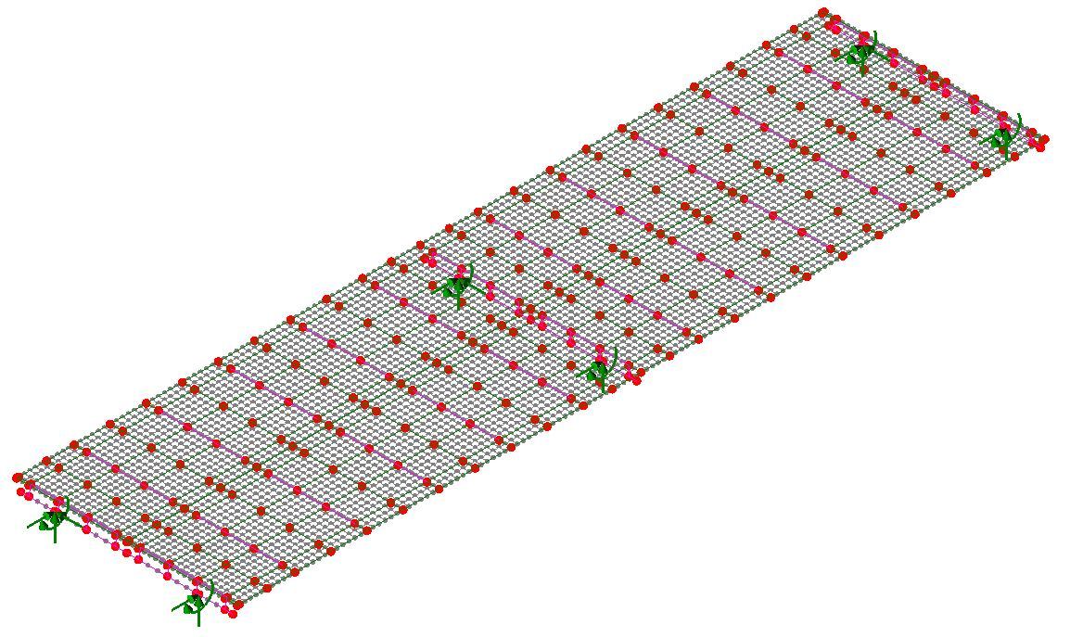

The box girders were modeled at a separate elevation thereby allowing for correct placement of boundary conditions and making it easier for a given box-girder to support adjacent discontinuous spans. Support conditions were applied to the box-girder at the locations where it is affixed to the concrete piers. Translation was restrained in all three principle directions as well as rotation about the girder’s length. The rotational restraint was necessary to maintain stability and accurately represent the bolted connection between pier and box-girder. The longitudinal girders were connected to the box-girder via beam elements with very high stiffness, zero density and with rotations at the end released, thereby providing connections that behave like pedestals.

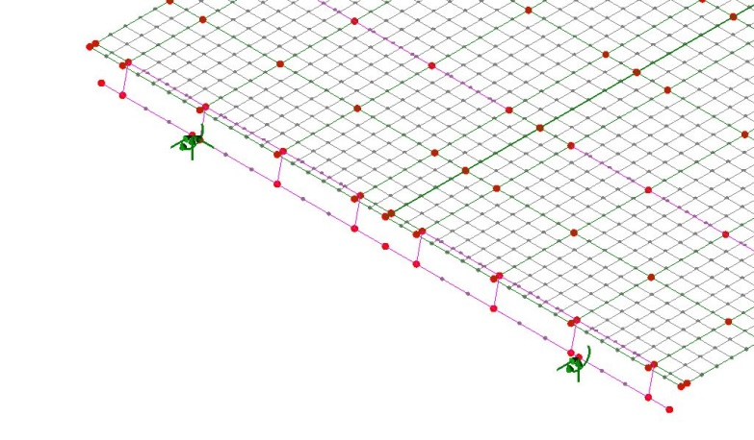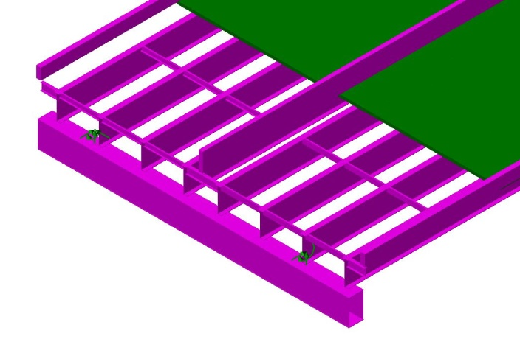

The elevation of those elements which act compositely with the deck is important for accuracy, and while they were modeled on a single plane, the eccentricity of the elements was specified to effectively offset the elements to the correct elevation while maintaining the simplicity of the model. The image above shows the effective elevation of components when rendered with specified eccentricities.

The diaphragms, which consist of chevrons and cross-frames, were reduced to single beams with equivalent stiffness, thus allowing them to conform to the grillage form. The barriers were modeled as beams that act compositely with the deck.

## Model Updating/Validation

**Barriers**

An initial comparison of experimental and model predicted mode shapes revealed that the predicted first bending mode had significantly higher deflection along the exterior of the bridge compared to the experimental results.

|  |  |
| --- | --- |
| FE Predicted 1st Mode | Experimental 1st Mode |

The discrepancy suggested that the exterior regions of the bridge had less mass/greater stiffness, or the center region had greater mass/decreased stiffness. The barriers are the major components that differ for these two regions, therefore these were the first to receive further scrutiny.

Upon re-examination of construction documents and pictures of the bridge it became clear that the center barriers had saw cuts at approximately every twelve feet. These cuts were represented by releasing rotations and longitudinal translation at beam ends (approximately every 12 feet). Alternatively, the stiffness of the barriers could be set nominally low; however, this method tends to create unreal local modes of vibration. The exterior barriers were released over the central supports, as they appeared to be discontinuous at this point in pictures. These releases consisted of all three principle rotations, along with translation in the transverse and longitudinal directions (global).

**Box Girders**

After making the described adjustments to the barriers in the model, the natural modes and frequencies were recalculated and compared with experimental results. While the shape and frequency of the first mode was now in good agreement, the predicted frequency of a higher mode was nearly 0.4 Hertz lower than that determined experimentally, while the rest of the predicted mode shapes were in good agreement with experimental results.

|  |  |
| --- | --- |
| FE Predicted 3rd Mode – 2.45 Hz | Experimental 5th Mode – 2.8 Hz |

To increase the predicted frequency of this mode, those components that experienced significant curvature were examined first, especially those that experienced relatively little curvature in other modes. The moment of inertia of the I-girders in the negative moment region was checked and found to be consistent with the drawings as well as have little impact on the frequency of the mode.

The central box girder displayed significant deformation for this mode and was the next component to be investigated. The mode was found to be sensitive to its stiffness by studying the effects of altering its moment of inertia. However, as there was a high degree of confidence in the girder’s section properties, the boundary conditions of the box girder were ultimately chosen for modification. The box-girder supports were already represented with fixed translational degrees of freedom as well as rotation about the transverse axis. Rotation about the longitudinal axis was restrained by specifying a spring stiffness of 5x1010 lb-in/rad. This value was determined through incremental adjustment until the predicted and experimental frequencies sufficiently matched.

With the aforementioned adjustments completed, the natural frequency results of the FE model were in good agreement with the experimental results. The final modes are summarized below.

|  |  |
| --- | --- |
| 2.03 Hz | 2.0 Hz |
| 2.07 Hz | 2.1 Hz |
| 2.49 Hz | 2.44 Hz |
| 2.50 Hz | 2.54 Hz |
| 2.82 Hz | 2.83 Hz |
| 3.14 Hz | 3.2 Hz |
| 3.63 Hz | 3.56 Hz |
| 3.63 Hz | 3.56 Hz |

The following table summarizes the error associated with the FE predicted natural frequencies.

|  |  |  |  |
| --- | --- | --- | --- |
|  | Experiment | LUSAS FEM | % Error |
| Mode 1 | 2.0 | 2.03 | 1.5% |
| Mode 2 | 2.1 | 2.07 | 1.4% |
| Mode 3 | 2.44 | 2.49 | 2.0% |
| Mode 4 | 2.54 | 2.50 | 1.6% |
| Mode 5 | 2.83 | 2.82 | 0.4% |
| Mode 6 | 3.2 | 3.14 | 1.9% |
| Mode 7 | 3.56 | 3.63 | 2.0% |
| Mode 8 | 3.56 | 3.63 | 2.0% |

## Full Model

Once the two-span model was satisfactorily modeled, a more comprehensive model was constructed that included all eleven spans of the viaduct. Deck elements were left separated by ½” where discontinuous spans met. Furthermore, by utilizing adjacent “pedestal” elements, the box-girder element could support the two different spans without forcing continuity between their components (deck and girders).

