**Smithers Bridge**

Smithers, WV

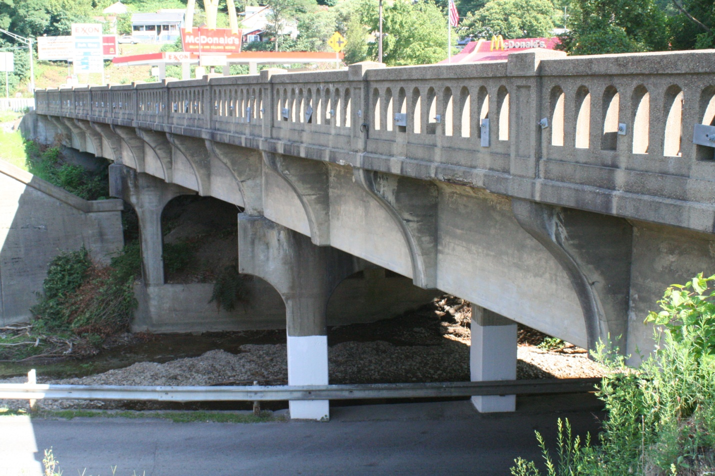

***Summary of Site Visit – 08.22.08***

***General Information- See attachment #1***

* Concrete T-beam construction
* 3- spans = 48’ each
* Simply supported on concrete piers
* Skew = 19°
* Bridge spans a creek and a roadway
* ADT = 7600
* Roadway width = 42’

***Observations of the Condition – See attachment #2***

* Bridge is posted
* Middle span appears to have rotated/shifted
* Damage is prevalent mainly at piers
  + Connection to beams
  + Underside of pier
* Roadway has cracking at piers
* Rest of superstructure appears in fairly good condition

***Access and Other Considerations for Testing***

* Underside access is very good for two spans
* Access to the midspan is slightly more difficult because of the creek
* Roadway under the bridge will have to be closed (scaffolding)
* Bridge will likely have to remain open to emergency vehicles

***Preliminary Modeling and Load Rating – See attachment #3***

* Preliminary SAP2000 model
  + Frame and Shell Elements
  + Simple Supports
  + No Modeling of the Piers
* Preliminary ABAQUS Model
  + Solid Elements
  + Fixed Supports
  + Piers Included

Attachment #1 – Structural Plan and Site Elevation



Attachment #2 – Photo Summary of Condition

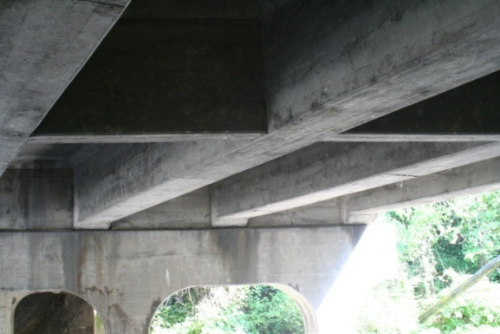

Underside of the Superstructure – Very Little Damage

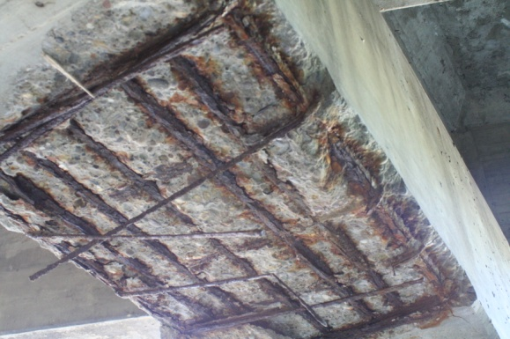

Extensive Damage Underside of Pier

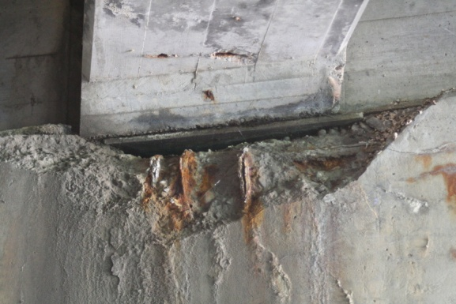

Damage beneath Beam Seat

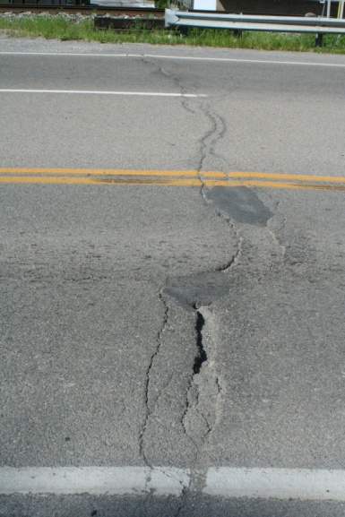

Cracking in Roadway above Piers

Attachment #3 – Modeling Summary

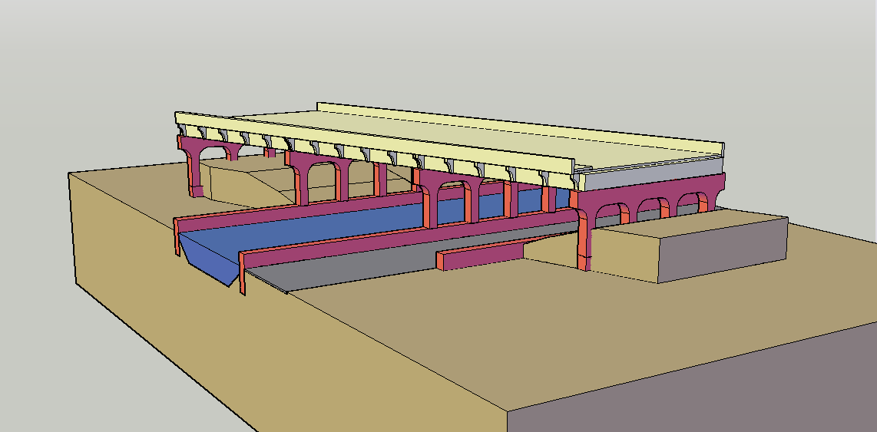

CAD Model of the Bridge and Site

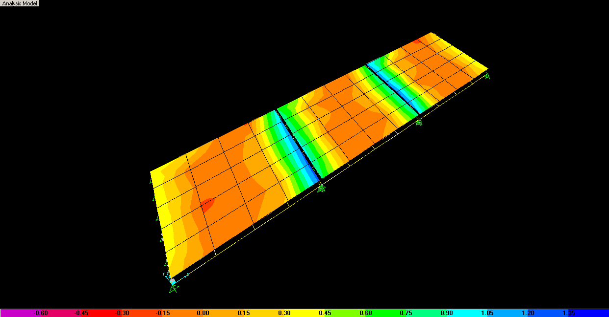

Simple SAP Model of Superstructure

Mode 1.tif

Simple ABAQUS Model Including Piers