Technology Implementation Results and Conclusions

Bridge Introduction

Additional Information

## Excessive Vibrations: I-76 Case Study

### Bridge Introduction

#### Motivation

The bridge presented in this case study was brought to our attention by the bridge owner. Local police and government officials were receiving frequent complaints from motorists who were concerned about the vibration of the bridge and its safety. The bridge is a major route and receives more than 57,000 vehicles per day on its four lanes of traffic. It is therefore vital that this bridge remains in good performance. The owner wished to quantify the vibration levels and determine if they compromised the bridges ability to safely carry traffic.

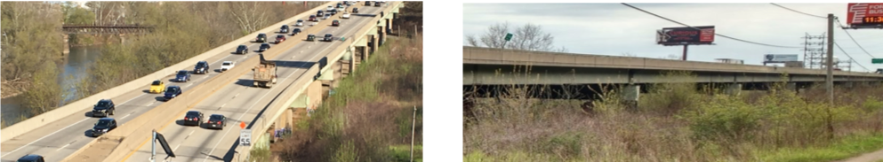

#### Bridge Description

The system herein described is comprised of adjacent bridges that share a substructure. The bridge was first constructed in 1952, but the superstructure was rebuilt in 1986 while reusing the original piers and foundations. The bridges are steel multi-girder with a cast-in-place deck. There are 11 spans of varying length, some of which are simply-supported, while others are 2-span continuous. Spans 1 and 11 are 111'-8" long, while spans 2 through 10 are 140 feet long. The steel longitudinal girders are supported by steel box-girders which rest on concrete piers.

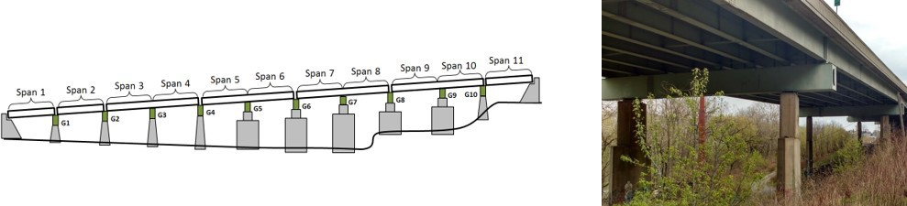

The concrete piers and abutments were constructed in 1952 and are all that remain of the original structure. They are supported by driven piles. Elastomeric bearing pads are installed on top of the piers and support the transverse box girders. Rocker bearings or pedestals are installed between the box girders and longitudinal girders at those locations which are in the center of continuous spans. Elastomeric bearings are installed between the box girder and the longitudinal girders at the remaining locations.



The bridge appears in good condition with no significant corrosion or deterioration.

Bridge Introduction

Results and Conclusions

Additional Information

Technology Implementation

## Excessive Vibrations: I-76 Case Study

### Technology Implementation

#### Description

Operational monitoring was conducted to understand the magnitude and characteristics of the bridge vibrations. This method of testing consists of recording the response of the bridge to operational conditions (i.e. traffic). In this case, accelerometers were used to capture the motion of the bridge. The recorded acceleration, in addition to characterizing bridge vibration, can be processed to determine the bridge's natural frequencies of vibration, which can be used to calibrate an FE model.

Load testing was also performed in-situ, whereby a loaded dump truck traversed the bridge while traffic was allowed to flow freely. This method of testing has the advantage of being able to gather information of both the energy input to the bridge by the truck, as well as the resulting bridge response. The profile of the bridge roadway was measured using a portable profiler that operated at normal traffic speeds and recorded profile elevations at approximately one inch intervals.

#### Methods

Two phases of operational monitoring were conducted. The first was meant to determine the relative levels of vibration of different spans. Therefore, accelerometers were installed on several box-girders to measure the vertical, transverse, and longitudinal acceleration.

A second phase of monitoring focused on spans 7 and 8. Accelerometers (18) were installed on the bridge superstructure. Another 12 accelerometers were installed on the box-girders and piers. Strain gauges (12) were also installed on several girders. Data was gathered under operational conditions for more than 12 hours.

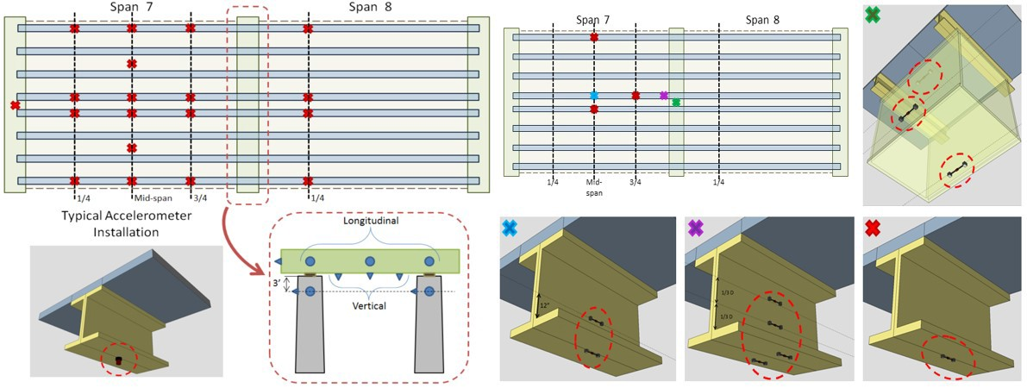

The load test was performed with a single dump truck with a loaded weight of approximately 60 kips. Accelerometers were attached to the two back corners of the dump body and to the frame near the front of the dump body. Accelerometers were also installed on spans 2, 3, 4, 7 and 8. They were spatially distributed to capture maximum bridge response and to capture vibration in all modes of interest. A total of 14 passes were made by the truck with speeds ranging from 10 mph to 60 mph. Bridge and truck acceleration was recorded synchronously.

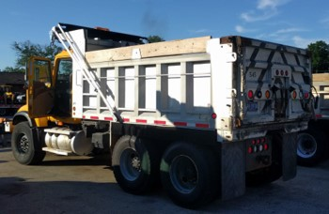

The profile of the roadway was collected by a contracted professional using an Ames Engineering Model 8300 Portable Profiler. Roadway elevation measurements were taken at highway speeds approximately every inch. All three lanes were measured with 2 passes in each lane to ensure accuracy.

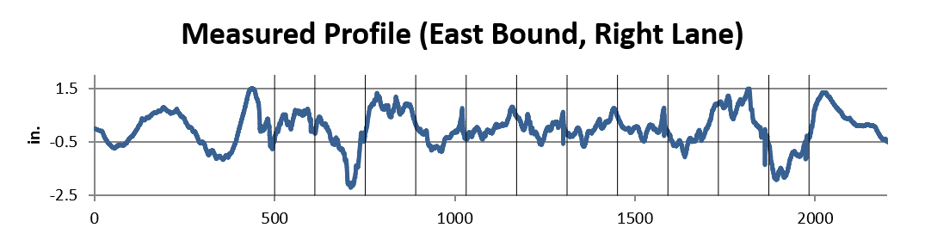

Several FE models of this structure with varying scope and detail were created. A detailed element-level FE model of spans 7 and 8 was first constructed with geometry consistent with the real structure. This model was calibrated using the obtained frequencies and shapes of the natural modes of vibration. Only the stiffness of the concrete barriers needed modification to bring the model into agreement with the experimental results.

Additional models were also created with varying levels of complexity. These included grillage models of select spans and a grillage model of the complete 11 span system. These models were also checked against the experimental results and already calibrated model to ensure it had properly distributed mass and stiffness and thus capable of accurately simulating the bridge’s behavior.

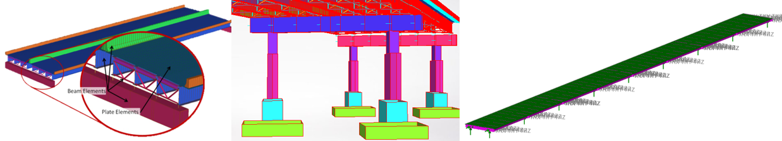

Simulations of the test events were performed whereby the truck was modeled as a sprung mass-damper. Its mass matched that which was measured in the field, and its spring stiffness was calculated based on its determined natural frequency. The profile of the roadway (and 500’ of approach) was included in the simulations.

# [Virtual Lab (../index.html)](http://vlab.asklab.tk/VirtualLab/index.html)

Bridge Introduction Technology Implementation

Results and Conclusions

Additional Information

## Excessive Vibrations: I-76 Case Study

### Results & Conclusions

Preliminary monitoring showed that all spans experienced similar levels of vertical vibration, and the spans with taller piers experienced greater levels of transverse acceleration. These observations led to spans 7 and 8 being chosen for further monitoring.

The focused operational monitoring revealed that the bridge was experiencing high-magnitude acceleration at low frequencies and strains in the bottom flange that frequently exceeded 100 microstrain. Vertical acceleration of nearly 0.25 g was recorded. Modal processing identified 18 modes of vibration, 13 of which fell between 2 and 4 Hz.

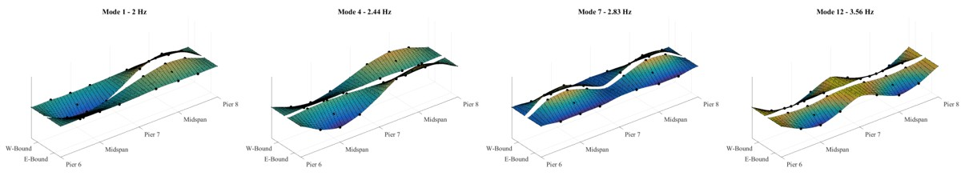

This vibration corresponds to approximately ½” of displacement which places this bridge in the category of “very disturbing” according to human comfort criteria (Reiher and Meister, 1931). The strain in the deck was extrapolated at mid-psan and the negative-moment region, revealing that frequent events were causing strain in excess of 100 microstrain – levels for which long term fatigue cracks begin to form. Dynamic amplification of approximately 75% was estimated by filtering out content greater than 1.5 Hz.

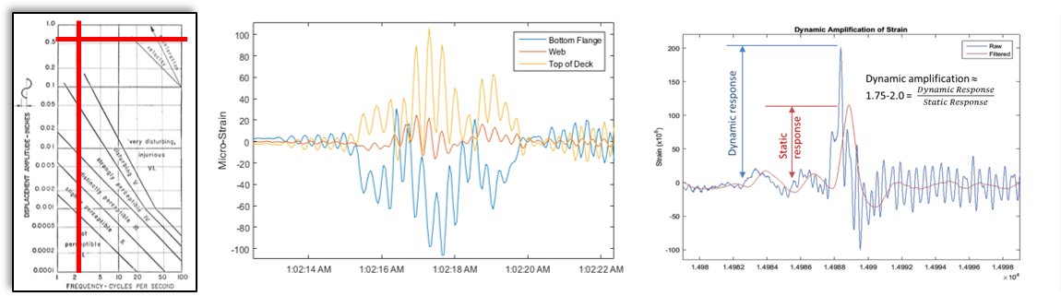

The calibrated FE model was used to perform a refined load rating. The ratings were computed with the specified amplification factor (IM) maximum of 33% and again with the observed amplification factor of 75%. The controlling rating factors were greater than 1.0 for both cases. This is due to the bridge’s reserve capacity from

conservative design assumptions, perhaps chief of which is the distribution factor. The design used a distribution factor of 0.91 while FE model resulted in a distribution factor of 0.79.

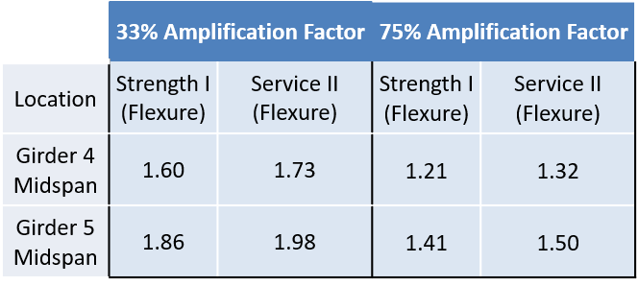

The load test revealed that the bridge induced vibration in the truck, and the truck caused significant vibrations in the bridge. These results indicated that the bridge vibrations were the result of a coupled system (vehicle- bridge) and the interaction must be considered in FE simulations.

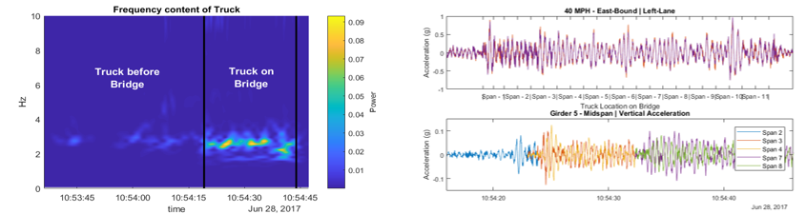

Simulations were performed in which a sprung-mass model of the truck was traversed across an element-level model of the bridge. These simulations did not come close to matching the experimental results until the profile was included in the simulations. The graph below compares the simulation with the profile included with what was recorded in the field as well as with a simulation that did not include the profile.

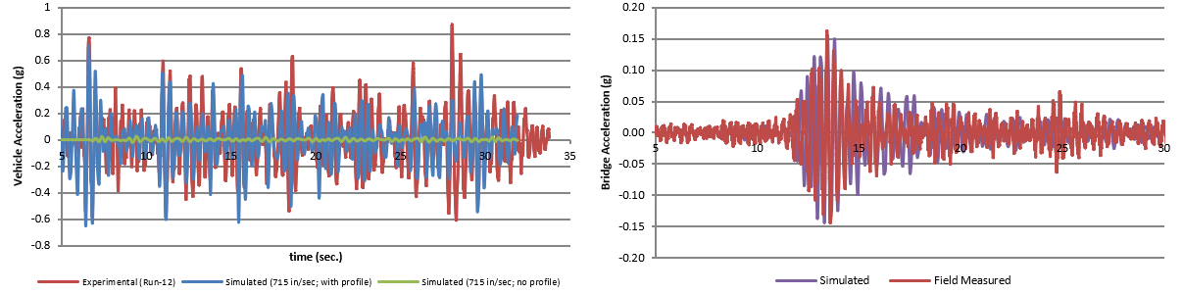

The simulations are consistent with the field measurements and indicate that the roadway profile is responsible for the excessive vibrations.

#### Summary

The bridge violates an “unidentified” service limit state (i.e. vibrations case human discomfort) which is not addressed by design/evaluation codes

The bridge is experiencing acceleration at magnitudes that cause appreciable bridge responses

The vibration is causing large dynamic amplification (>>33%) in bridge response

The amplification is reflected in girder bottom flange strain, as well as in the extrapolated top of deck strain, which is at the upper limit for concrete durability

The profile of the bridge is such that it causes large vibrations in the test vehicle, especially at higher speeds, consequently increasing the loads felt by the structure and exciting the bridge’s natural modes of vibration.

The low frequency modes of the structure, its low damping, and the proximity of mode frequencies to those of traffic, create a scenario in which the bridge vibration is easily induced and resonates for a long period of time, thus making it easier for the next event to contribute to even larger vibrations.

In spite of large dynamic amplification, the bridge rates and does not have any life-safety concerns.

Long-term bridge performance and durability may be threatened from the increased loads and their cyclic nature.

The problem can be alleviated by grinding the deck smooth to remove the problematic profile.

# [Virtual Lab (../index.html)](http://vlab.asklab.tk/VirtualLab/index.html)

Bridge Introduction Technology Implementation Results and Conclusions

Additional Information

## Excessive Vibrations: I-76 Case Study

### Additional Information

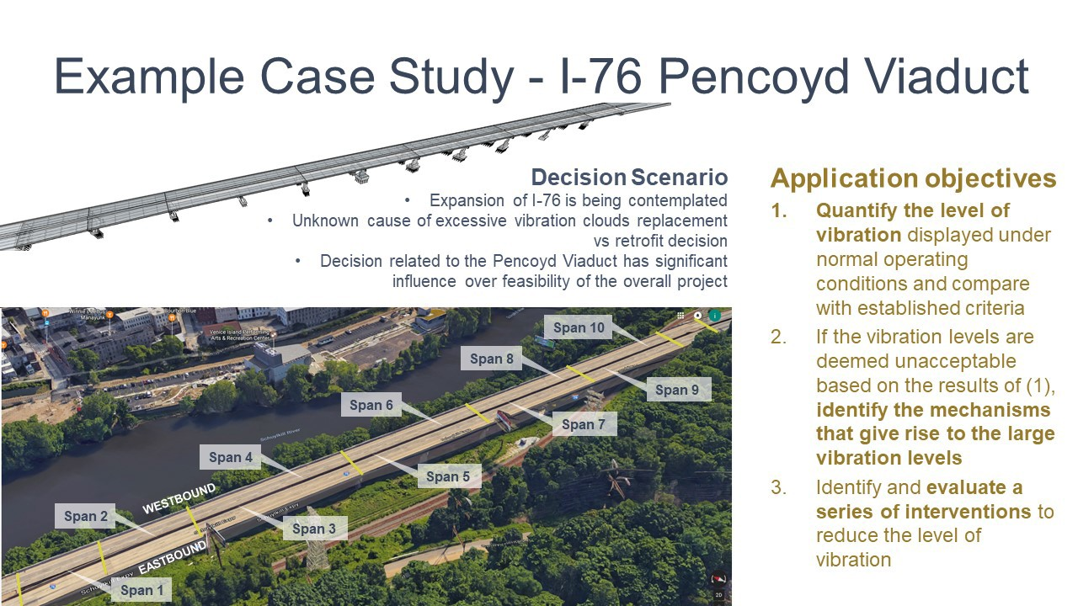



[(./data/./CS3-exc-vibr/images/I76_CaseStudy.pdf)](http://vlab.asklab.tk/VirtualLab/BridgeTechnology/data/CS3-exc-vibr/images/I76_CaseStudy.pdf)

#### [LiDAR Geometry Capturing (http://13.82.235.200/IRIS_Viewer/Bridge_/examples/bridge.html)](http://13.82.235.200/IRIS_Viewer/Bridge_/examples/bridge.html)

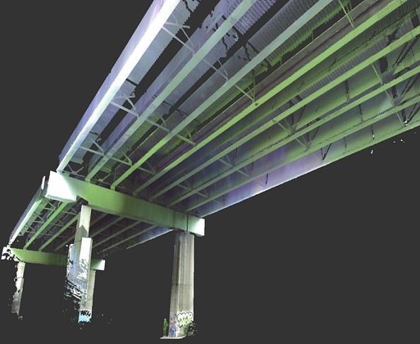

[(http://13.82.235.200/IRIS_Viewer/Bridge_/examples/bridge.html)](http://13.82.235.200/IRIS_Viewer/Bridge_/examples/bridge.html)

#### [Operational Monitoring of the I76 Viaduct (http://vlab.asklab.tk/VirtualLab/TrafficEvents/)](http://vlab.asklab.tk/VirtualLab/TrafficEvents/)

Aknowledgements:

The videos shown herein were created by synchronizing video recordings of traffic and time histories from different sensors installed on the structure.

The researchers would like to thank the significant work of Dr. Yundong Li (Associate Professor, Electronic and Information Engineering, North China University of Technology, Beijing, China)

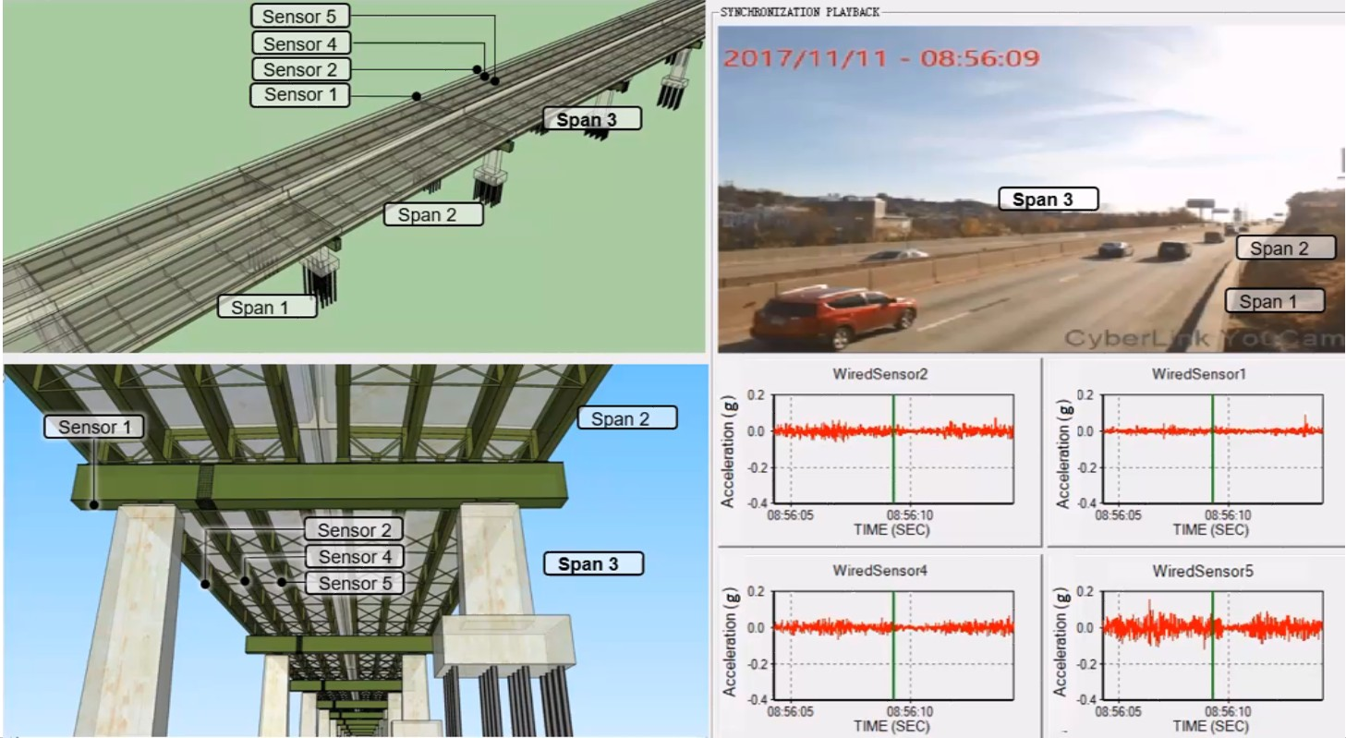

[(http://vlab.asklab.tk/VirtualLab/TrafficEvents/)](http://vlab.asklab.tk/VirtualLab/TrafficEvents/)

Drexel University, 3141 Chestnut Street, Philadelphia, PA 19104, © All Rights Reserved. **Version 3.0**